Project 2 – Chain of Responsibility Hotel Room Bidding System
Course: CIS 476 – Software Architecture and Design Patterns
Student: Michael Asman
Date: November 10, 2025

UML Class Diagram
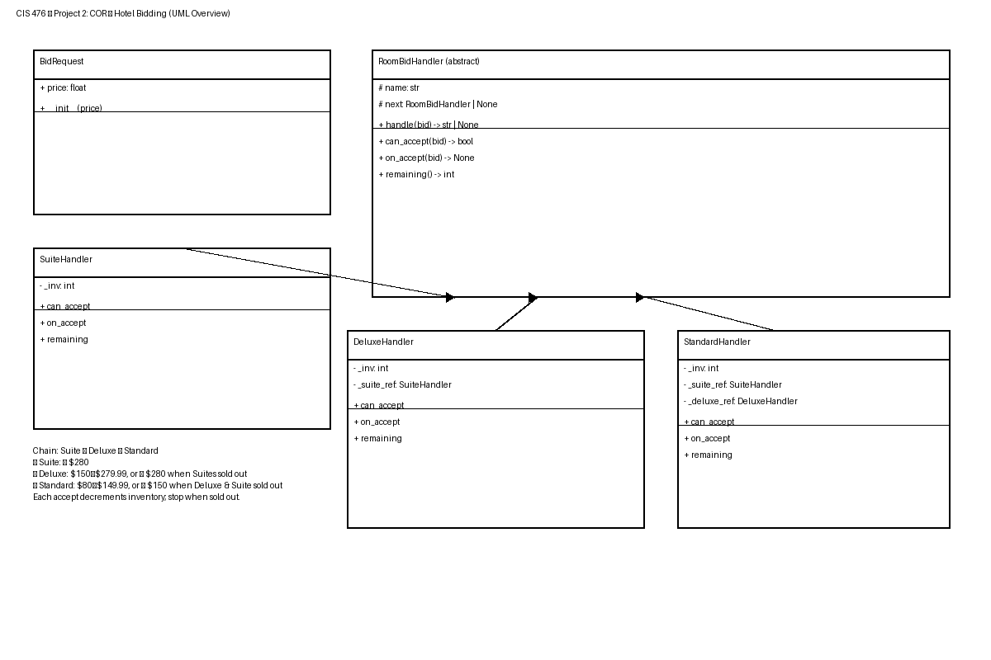
Figure 1. UML overview of the COR-based hotel bidding system.

Execution Scenarios (Screenshots)
Scenario 1:
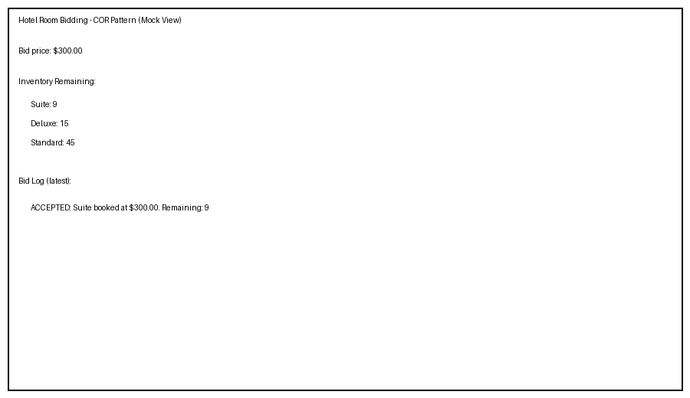
Scenario 2:
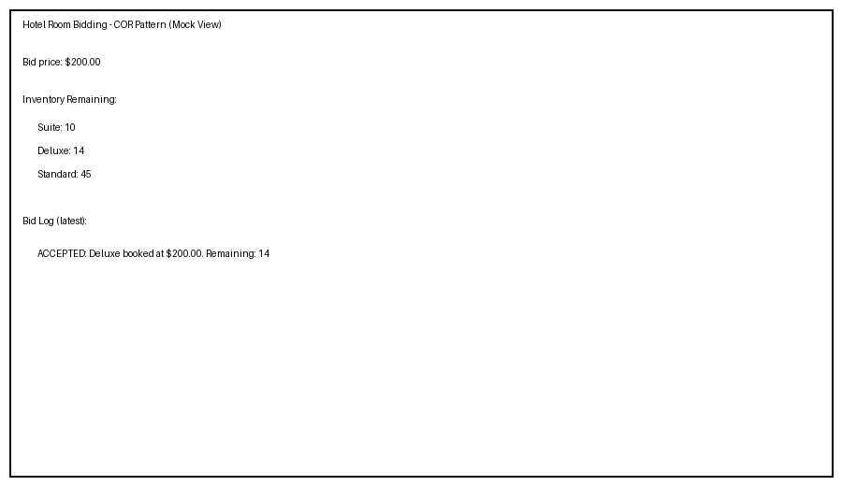
Scenario 3:
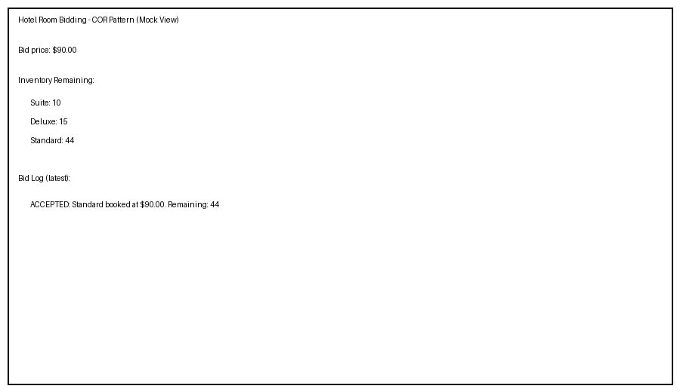
Scenario 4:
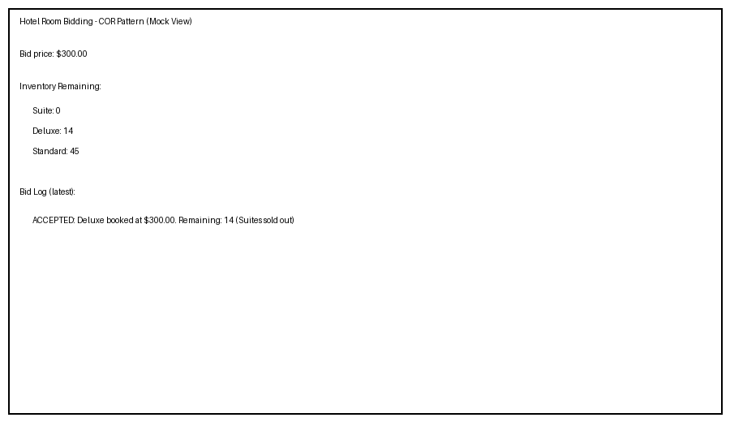
Scenario 5:
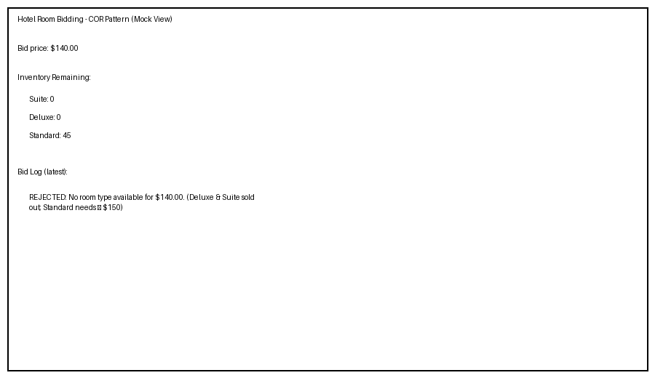

How to Run
1) Ensure Python 3.x is installed.
2) Run: python src/hotel_bidding_cor.py
3) Enter a bid and click "Place Bid".

Design Notes
Chain of Responsibility with Suite → Deluxe → Standard. Pricing rules and inventory enforced per handler.

