Data Analysis and Visualization CA1
Premier League Team Performance Composite Index
Index Generation and Visualisation Project
Student: Michael Atagamen
Programme: BSc (Hons) in Computing in Software Development
Module: Data Analysis and Visualization
GitHub Repository: https://github.com/MichaelAtagamen/premier-league-performance-index
Report note: this report is written to match the CA1 specification headings, including theoretical framework, data selection, imputation, multivariate analysis, normalisation, weighting and aggregation, links to other indices, visualisation, version control, and final deliverable documentation.

Report Structure
- Introduction and Theoretical Framework
- Data Selection
- Missing Data and Imputation
- Multivariate Analysis
- Normalisation
- Weighting and Aggregation
- Cluster Analysis
- Link to Other Indices
- Visualisation of Results
- Version Control
- Limitations
- AI Acknowledgement
- Conclusion

1. Introduction and Theoretical Framework
The aim of this project is to develop a composite indicator for comparing Premier League teams using match performance data. A composite indicator is suitable because football team performance is multidimensional: a team cannot be judged properly using one statistic only, such as total points or goals scored.
This project defines overall team performance as a combination of three dimensions: attacking output, defensive strength, and discipline. These dimensions are represented as sub-indices and then aggregated into one final composite score. This gives a single number that can be used to compare team-seasons while still preserving the interpretation of the underlying performance dimensions.
The unit of analysis is team-season. This means each row in the processed dataset represents one Premier League team in one season. This is appropriate because league performance is normally assessed at season level, and it allows comparison across teams and across multiple seasons.
The final index is called the Premier League Team Performance Composite Index. It is not intended to replace the league table, but to provide a broader statistical view of performance based on attacking, defensive, and disciplinary indicators.

2. Data Selection
The project uses five season-based Premier League CSV datasets from Football-Data.co.uk. Each file represents one Premier League season and contains match-level football data. The seasons included are 2020/21, 2021/22, 2022/23, 2023/24, and 2024/25.
Dataset | Description | Role in Project
E0_2020_21.csv | Premier League match data for 2020/21 | Historical season input
E0_2021_22.csv | Premier League match data for 2021/22 | Historical season input
E0_2022_23.csv | Premier League match data for 2022/23 | Historical season input
E0_2023_24.csv | Premier League match data for 2023/24 | Historical season input
E0_2024_25.csv | Premier League match data for 2024/25 | Latest season input
The raw data includes variables such as home team, away team, full-time goals, match result, shots, shots on target, corners, fouls, yellow cards, and red cards. These variables were selected because they are measurable, available consistently across seasons, and relevant to football performance.
The selected variables were transformed from match-level data into team-season data. This involved calculating totals and per-match rates for each team in each season. Per-match rates were used where appropriate to keep variables comparable across the same league structure and to make the indicators easier to interpret.

3. Missing Data and Imputation
The selected variables were checked for missing values during the initial data inspection stage. The core variables used for the index did not contain missing values after the selected seasons were loaded and combined.
Because no missing values were found in the key indicators, no major imputation was required. This is a strength of the dataset because the index is based on observed match statistics rather than estimated values.
If missing values had been present, median imputation would have been used for numerical variables. Median imputation would be appropriate because football performance data can include outliers, and the median is less sensitive to extreme values than the mean.

4. Multivariate Analysis
Multivariate analysis was used to examine relationships between the selected indicators before constructing the final index. This is important because a composite indicator should not combine variables blindly. The analysis helps identify whether variables are related, whether they measure different aspects of performance, and whether the index structure is reasonable.
The correlation between Composite Index and Points across all team-seasons was 0.92. This strong positive relationship suggests that the index is broadly aligned with real league performance. The correlation between Composite Index and League Rank was -0.88; the negative value is expected because a lower league rank number indicates a better table position.
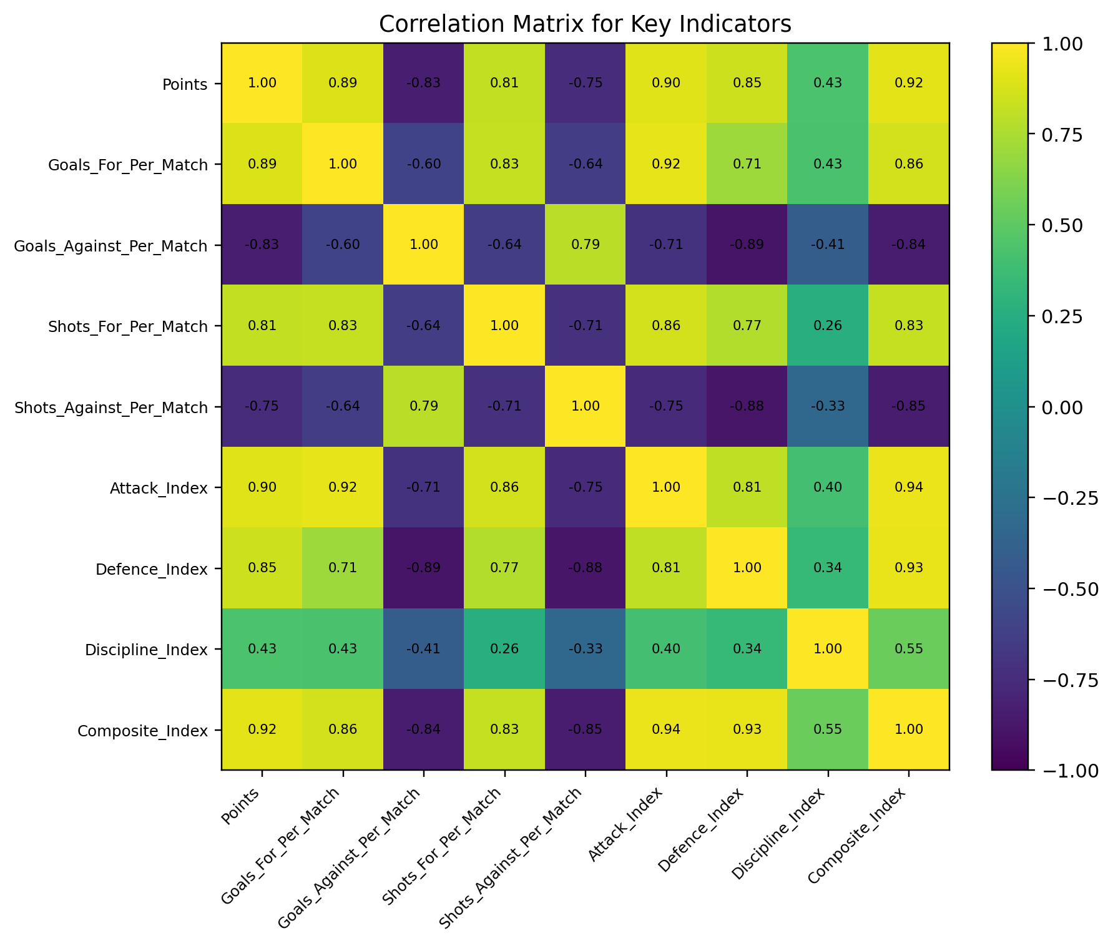
Figure 1. Correlation matrix showing relationships between core indicators and sub-indices.
The correlation matrix supports the use of sub-indices because attacking, defensive, and disciplinary variables do not all measure the same thing. Attack-related indicators are most directly connected to scoring output, while defensive indicators are connected to limiting opposition chances and goals. Discipline adds an additional behavioural dimension.

5. Normalisation
Normalisation was required because the selected indicators are measured on different scales. For example, goals per match, shots per match, clean sheets, fouls, yellow cards, and red cards cannot be combined directly without scaling.
Min-Max normalisation was used to transform indicators to a common 0 to 1 scale. This makes the variables comparable before weighting and aggregation. A score closer to 1 represents better performance after normalisation.
For negative indicators such as goals against, shots against, fouls, yellow cards, and red cards, the normalised values were inverted so that higher scores consistently represent better performance. This is important because the final composite index should be easy to interpret: higher scores should always mean stronger performance.

6. Weighting and Aggregation
The final composite index was created by combining three sub-indices: Attack Index, Defence Index, and Discipline Index. The weighting structure was chosen to reflect the importance of each dimension to football performance.
Sub-Index | Indicators Included | Weight
Attack Index | Goals for per match, shots for per match, shots on target for per match, corners for per match, shot conversion rate | 40%
Defence Index | Clean sheets per match, goals against per match, shots against per match, shots on target against per match | 40%
Discipline Index | Fouls per match, yellow cards per match, red cards per match | 20%
The aggregation formula was:
Composite Index = (0.4 x Attack Index) + (0.4 x Defence Index) + (0.2 x Discipline Index)
Attack and defence were weighted most heavily because scoring goals and preventing goals are the most direct aspects of football success. Discipline was included at a lower weight because it can influence team performance, but it is less direct than attacking and defensive output.

7. Cluster Analysis
K-means clustering was applied to group team-seasons with similar statistical profiles. Clustering adds value because it moves beyond a simple ranking and identifies groups of teams with similar attack, defence, discipline, and overall index characteristics.
Cluster | Number of Team-Seasons | Interpretation
0 | 28 | Performance group identified from the selected index variables
1 | 51 | Performance group identified from the selected index variables
2 | 21 | Performance group identified from the selected index variables
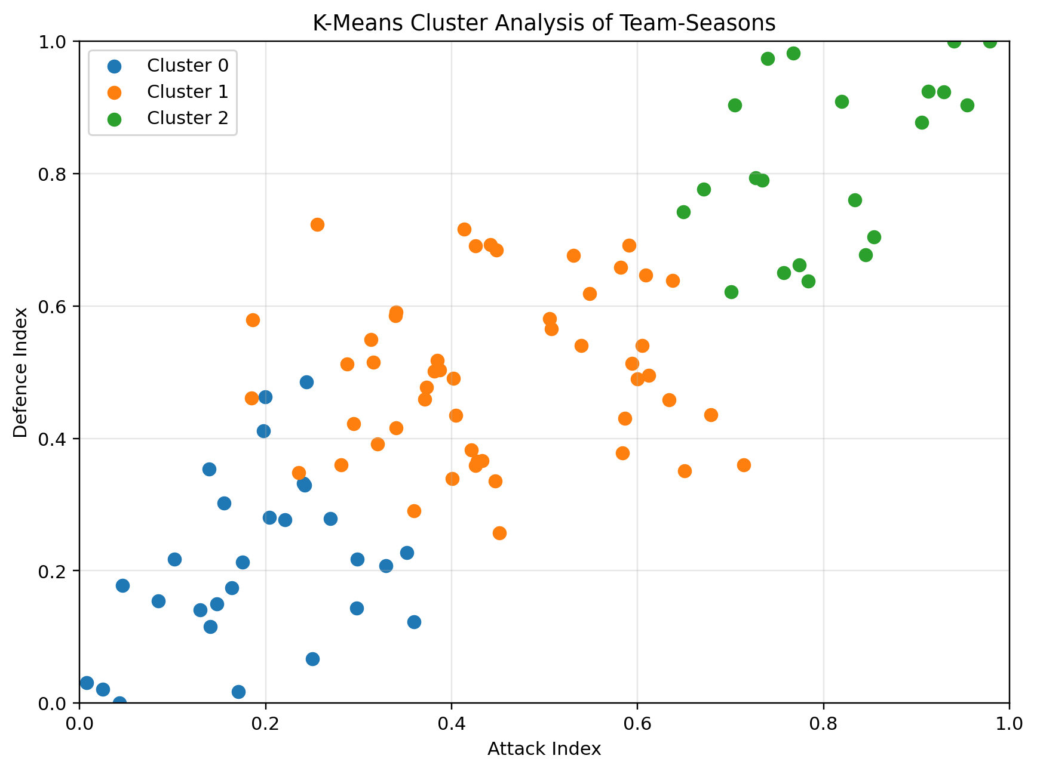
Figure 2. K-means clustering of team-seasons using attack and defence index values.
The clusters show that Premier League teams can be grouped into broad performance profiles. Higher-performing team-seasons generally appear in areas with stronger attacking and defensive scores, while weaker team-seasons tend to appear lower on one or both dimensions. This supports the idea that the selected sub-indices capture meaningful variation between teams.

8. Link to Other Indices
The brief asks for links to other indices where possible. In this project, the main external benchmark is the actual Premier League table, based on points and league rank. The league table acts as a real-world ranking system against which the composite index can be compared.
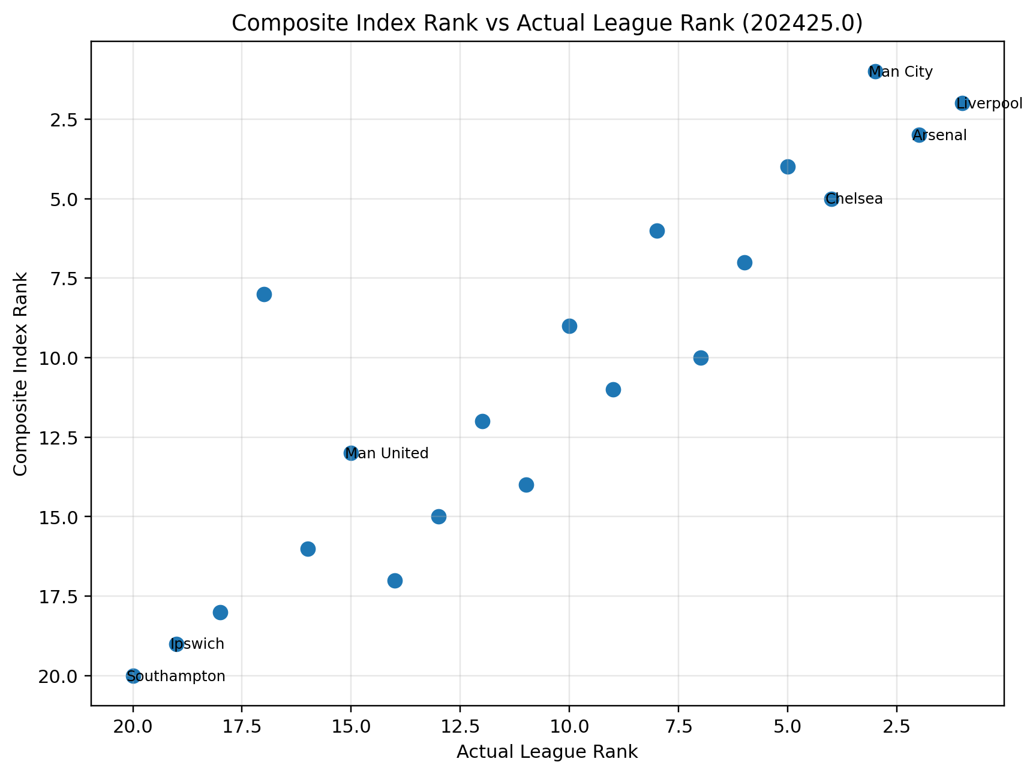
Figure 3. Composite Index Rank compared with actual league rank for 202425.0.
For the latest season (202425.0), the correlation between Composite Index and Points was 0.94, showing a strong positive relationship. This suggests that the index broadly reflects real-world performance outcomes. However, the index can still rank some teams differently because it includes statistical performance indicators beyond points alone.
This comparison helps validate the index. If the composite index broadly follows the league table, it suggests that the selected indicators and weightings are reasonable. Differences between the composite index and actual rank are still useful because they may highlight teams with strong underlying statistics but weaker results, or teams with efficient results despite less dominant statistical profiles.

9. Results and Interpretation
In the latest season (202425.0), the top five teams by Composite Index were:
Composite Rank | Team | Composite Index | Points | League Rank
1 | Man City | 0.869 | 71 | 3
2 | Liverpool | 0.856 | 84 | 1
3 | Arsenal | 0.774 | 74 | 2
4 | Newcastle | 0.696 | 66 | 5
5 | Chelsea | 0.675 | 69 | 4
The highest-ranked team-seasons generally had strong attacking and defensive scores. This supports the theoretical framework that overall team performance is multidimensional and cannot be measured with one variable alone.
The bottom five teams by Composite Index in 202425.0 were:
Composite Rank | Team | Composite Index | Points | League Rank
20 | Southampton | 0.082 | 12 | 20
19 | Ipswich | 0.178 | 22 | 19
18 | Leicester | 0.208 | 25 | 18
17 | West Ham | 0.373 | 43 | 14
16 | Wolves | 0.454 | 42 | 16
Because I am a Manchester United supporter, I also examined Manchester United across the included seasons. The index shows fluctuation across seasons rather than a consistently high ranking, which reflects the club’s inconsistent performance profile during the period.
Season | Composite Index | Composite Rank | Points | League Rank
202021.0 | 0.652 | 5 | 74 | 2
202122.0 | 0.428 | 11 | 58 | 6
202223.0 | 0.599 | 6 | 75 | 3
202324.0 | 0.434 | 11 | 60 | 8
202425.0 | 0.539 | 13 | 42 | 15
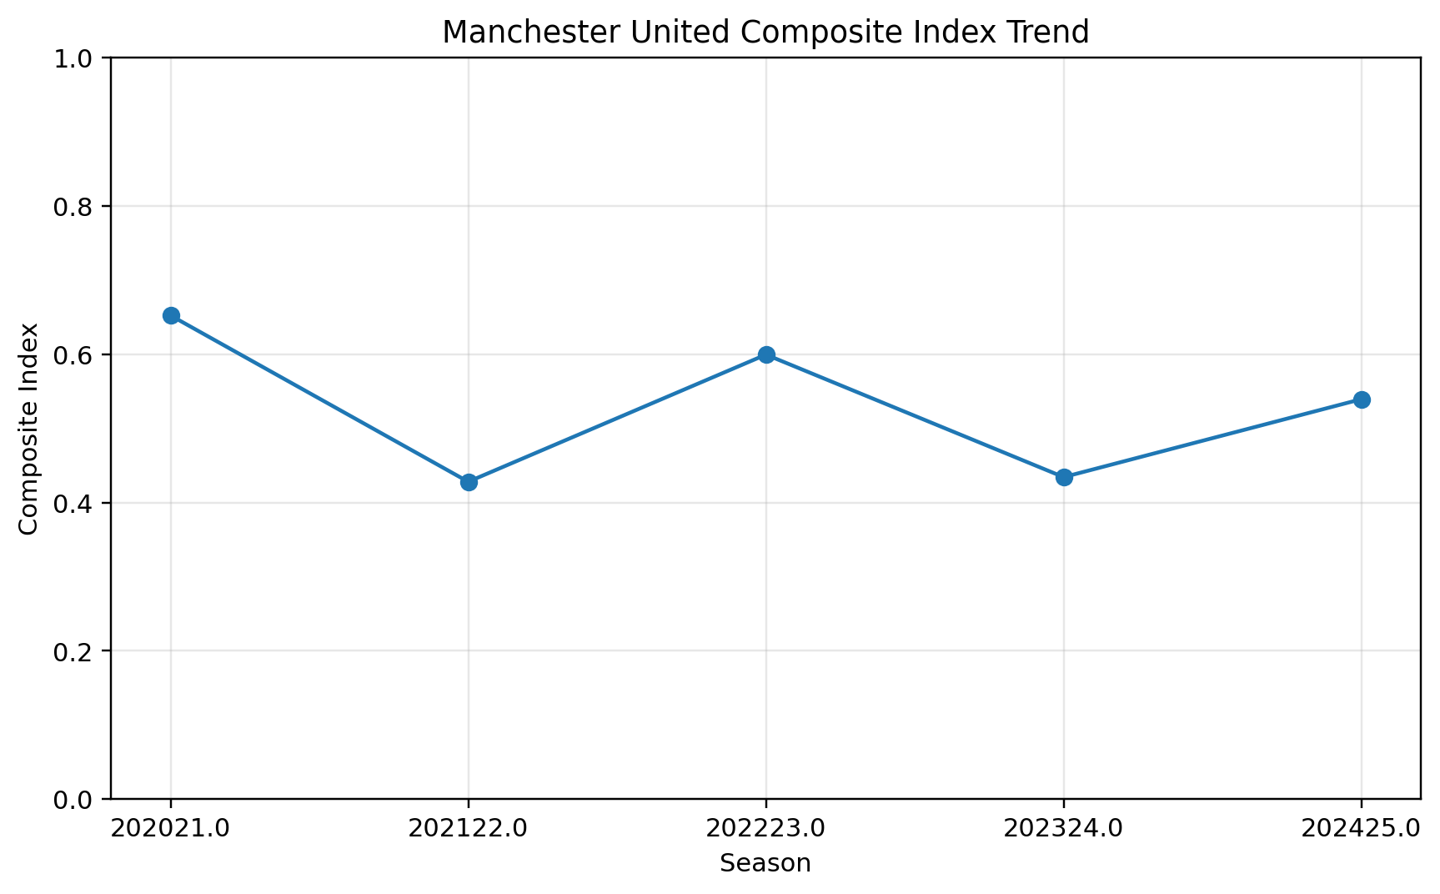
Figure 4. Manchester United Composite Index trend across the included seasons.

10. Visualisation of Results
Several visualisations were produced to make the composite index and sub-indices easier to interpret. The aim of the visualisations is not only to show rankings, but also to explain the structure of the index and the relationships between its components.
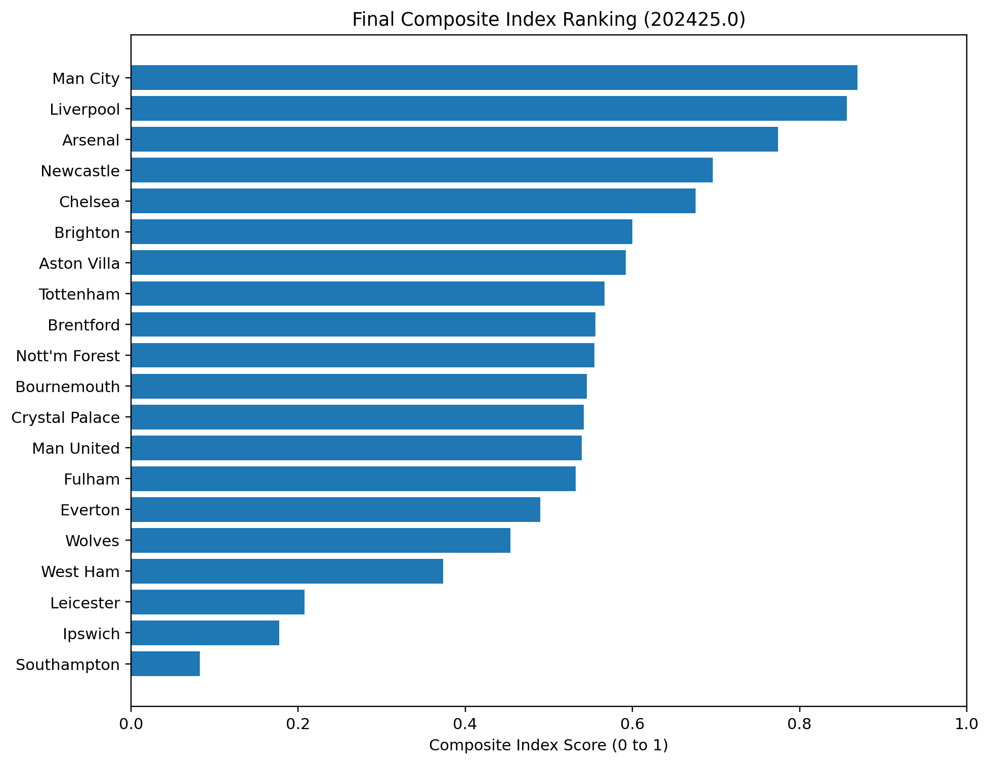
Figure 5. Final Composite Index ranking for 202425.0.
The final ranking chart is the main output of the project. It shows the teams ordered by their composite index score and makes it easy to compare overall performance.
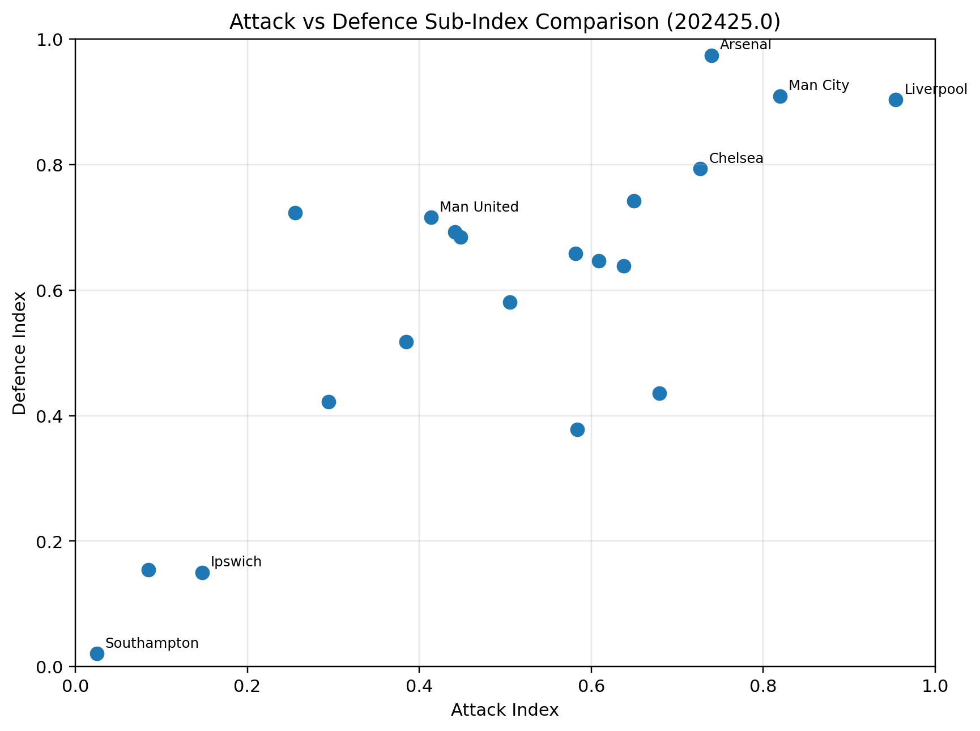
Figure 6. Attack Index versus Defence Index for 202425.0.
The attack versus defence scatter plot shows whether teams are balanced or stronger in one particular area. A team in the upper-right region is strong in both attack and defence.
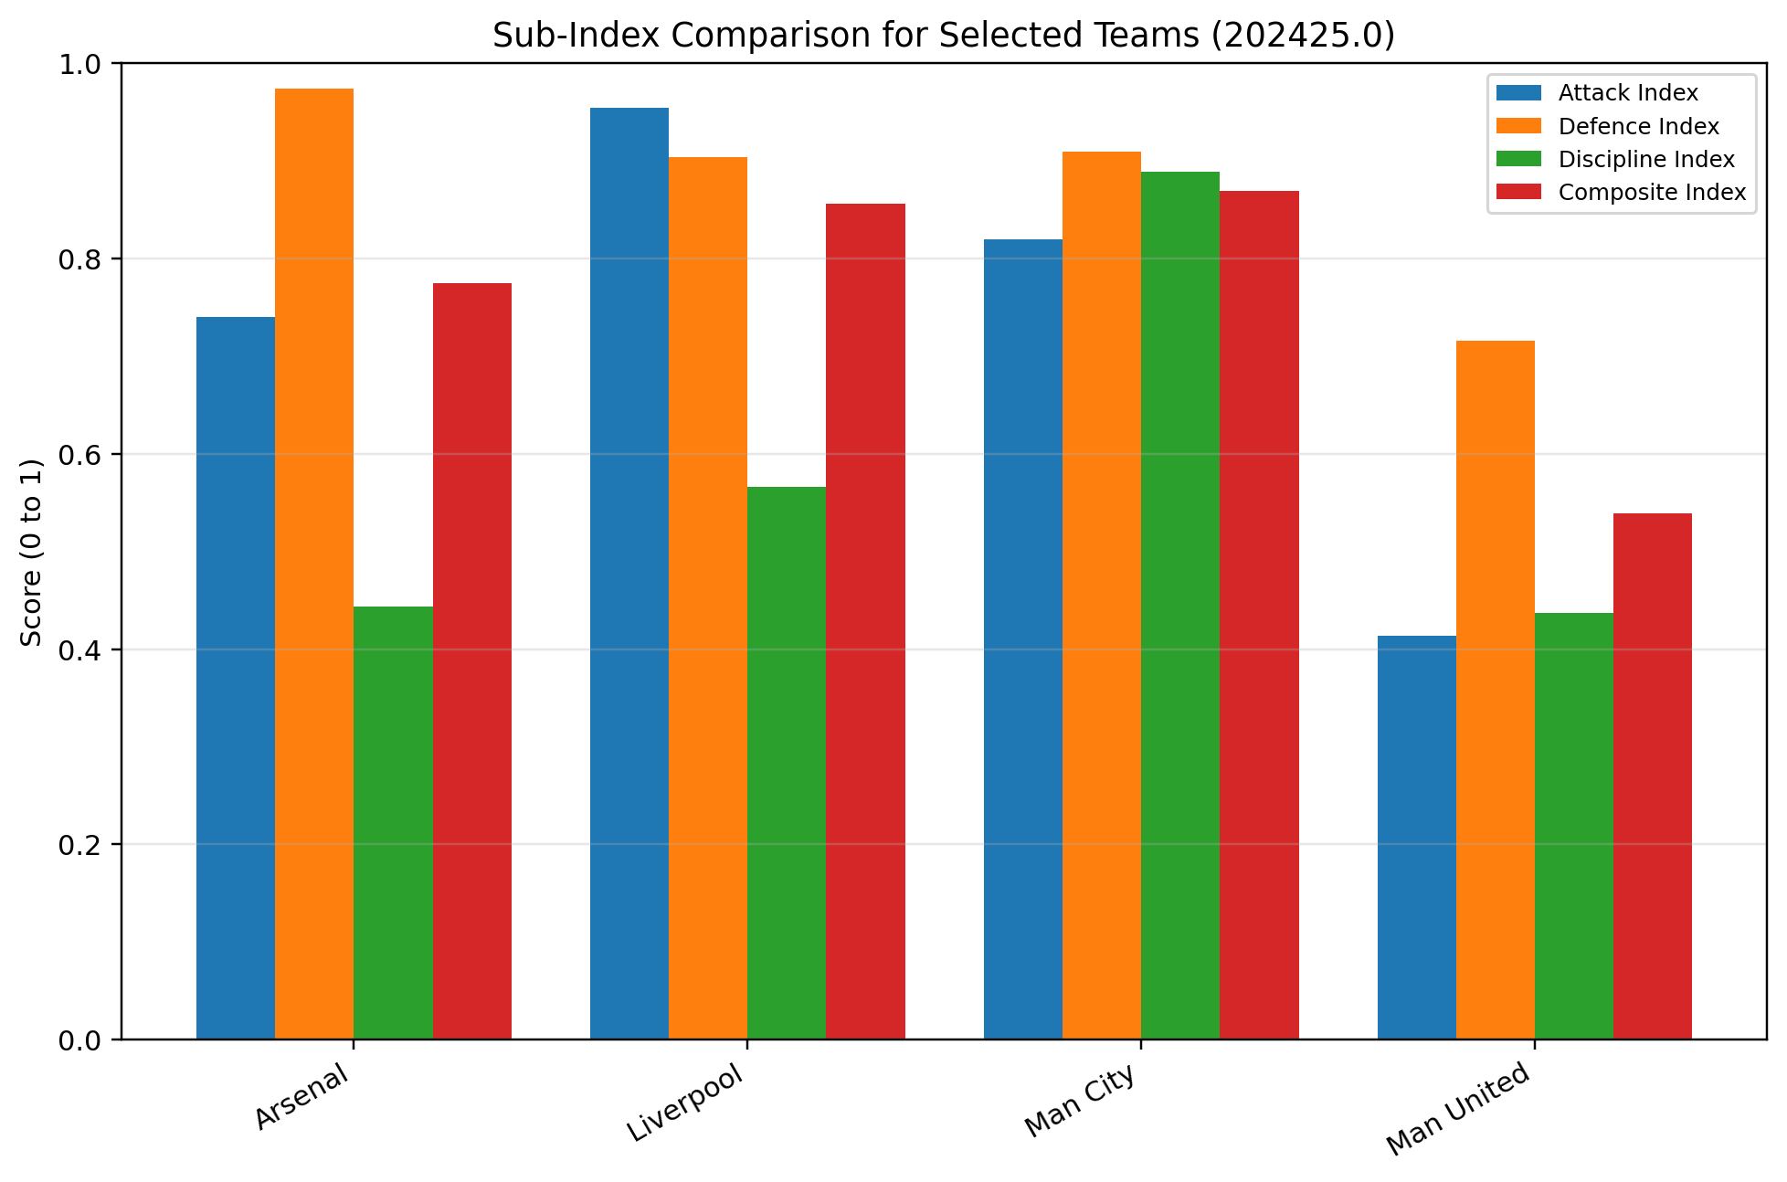
Figure 7. Sub-index comparison for selected teams in 202425.0.
The sub-index comparison chart shows how the final index is built. It demonstrates that teams can reach high composite scores through strong attack, strong defence, strong discipline, or a balanced combination.

11. Version Control
Version control was used through Git and GitHub. The repository tracks the development of the project from setup through data loading, index construction, visualisation, report writing, and final documentation.
Meaningful commits were used to show progress, including adding the notebook, adding datasets, creating the team-season dataset, generating visualisations, updating the README, and writing the report. This supports the version control requirement in the brief.
GitHub Repository: https://github.com/MichaelAtagamen/premier-league-performance-index

12. Limitations
The index provides a useful statistical comparison of Premier League teams, but it has limitations. It is based on match statistics only and does not include player injuries, squad market value, transfer spending, fixture difficulty, tactical style, managerial changes, or expected goals data.
The weighting system is also based on reasoned judgement rather than expert consultation. Attack and defence were weighted most heavily because they are central to football performance, but another analyst could choose different weights.
Discipline was included because fouls and cards affect team behaviour and risk, but discipline is less direct than attacking and defensive output. Therefore, the index should be interpreted as a structured statistical indicator rather than a complete measure of team quality.

13. AI Acknowledgement
Generative AI was used to support project planning, code structuring, debugging, report organisation, and explanation drafting. The final project decisions, code execution, result interpretation, and submission preparation were reviewed and adapted by the student.

14. Conclusion
This project developed a Premier League Team Performance Composite Index using five season-based CSV datasets. The project transformed match-level data into a team-season dataset and created sub-indices for attack, defence, and discipline.
The project applied the key methods required by the brief: data selection, missing value checks, multivariate analysis, normalisation, weighting and aggregation, clustering, visualisation, version control, and report documentation.
The results show that the composite index broadly aligns with the league table while also providing additional insight into underlying performance profiles. This demonstrates how a composite indicator can be used to compare football teams using multiple dimensions of performance rather than one statistic alone.

References / Data Sources
Football-Data.co.uk. Premier League match data CSV files. Available at: https://www.football-data.co.uk/data.php
Dundalk Institute of Technology. Data Analysis and Visualization CA1 Specification: Index Generation and Visualization.
OECD/JRC. Handbook on Constructing Composite Indicators: Methodology and User Guide.

