**1-Omar Wael Abdelaziz**

**2-Omar ayman mohammed**

**3-Mostafa Hussien Mahmoud**

**4-Michael Awad Eissa**

**Q2-**

**Create two simple html pages named “page1.html, page2.html” then use the suitable**

**directive to automatically redirect from localhost/page1.html to localhost/page2.html.**

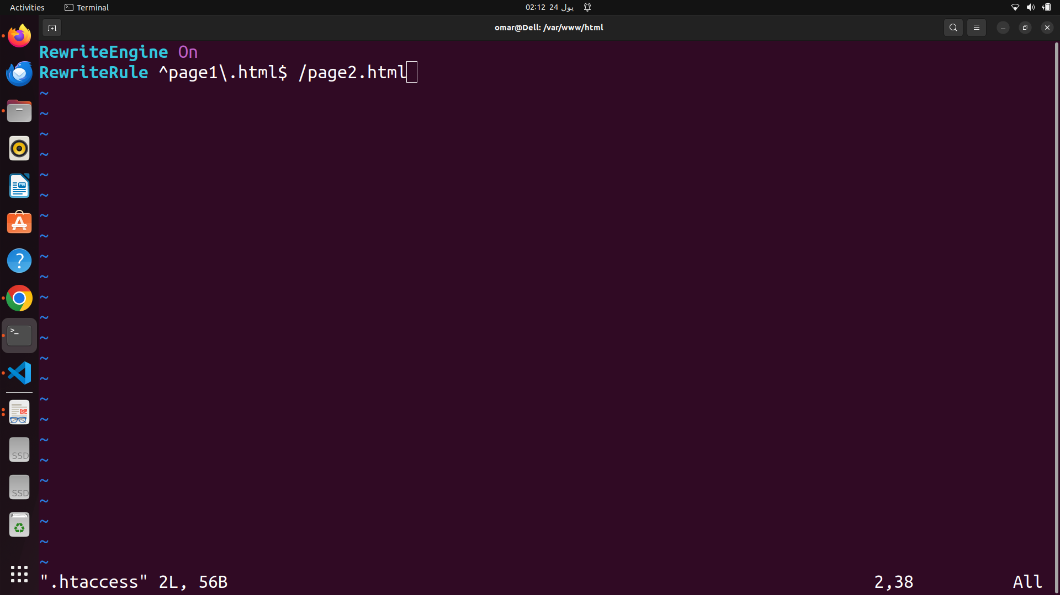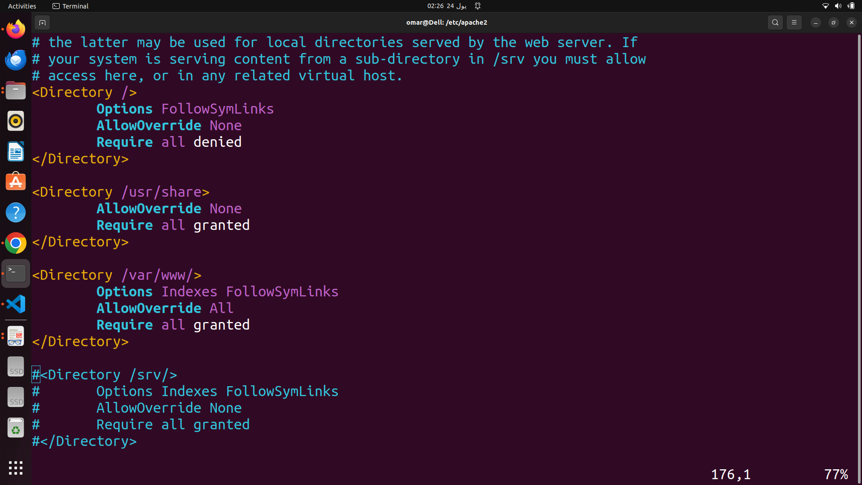

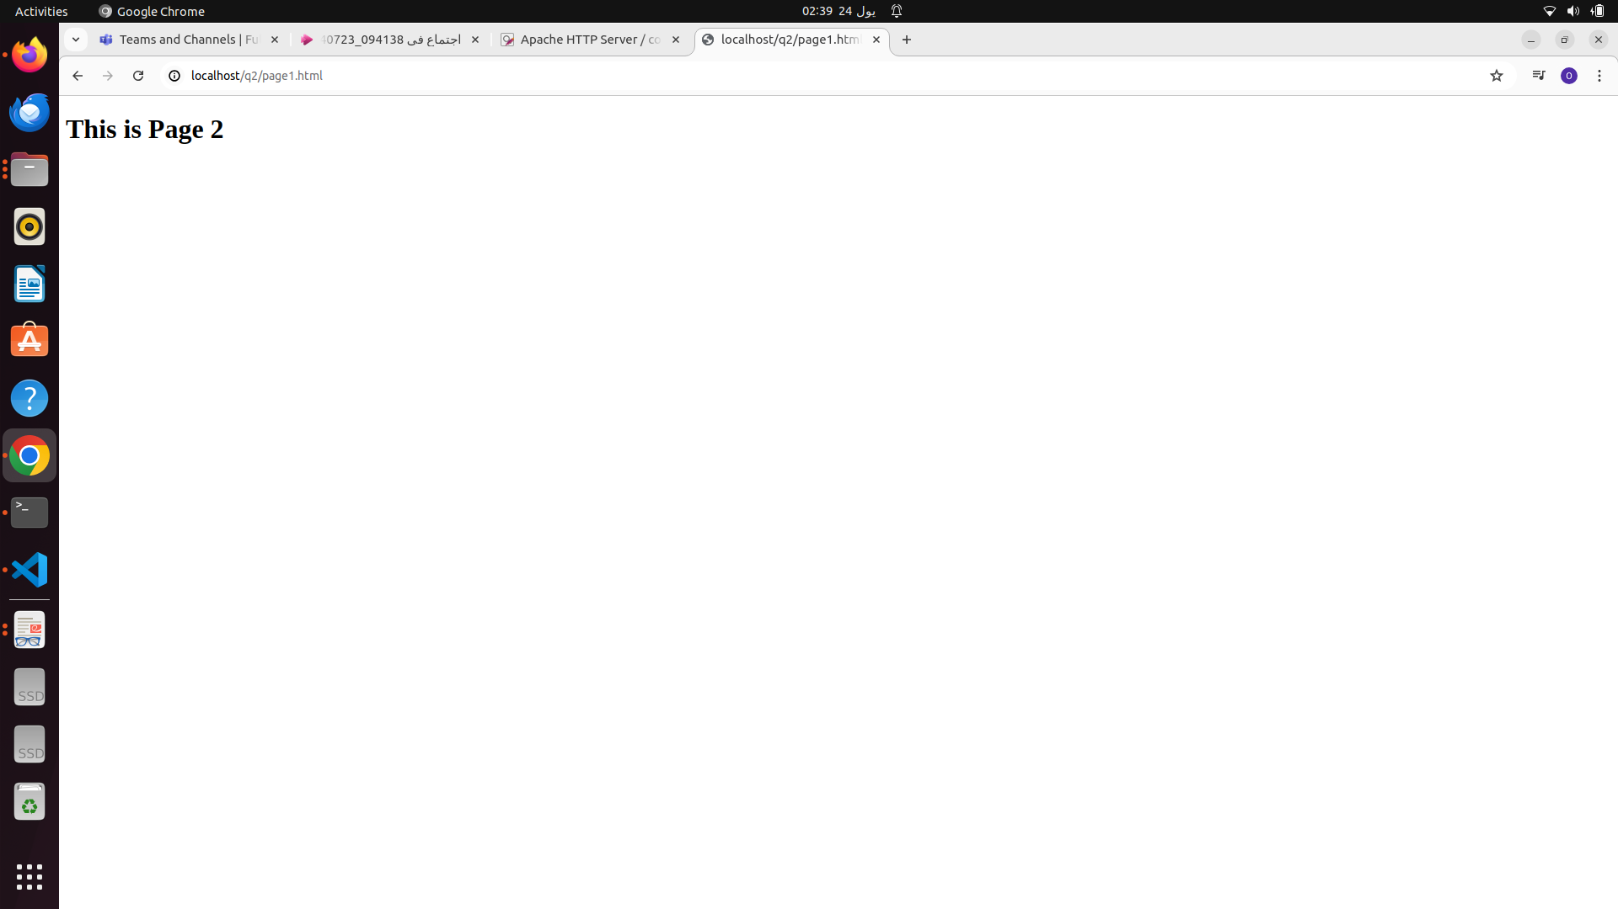

**Q3. Ask for user name and password when accessing a directory**

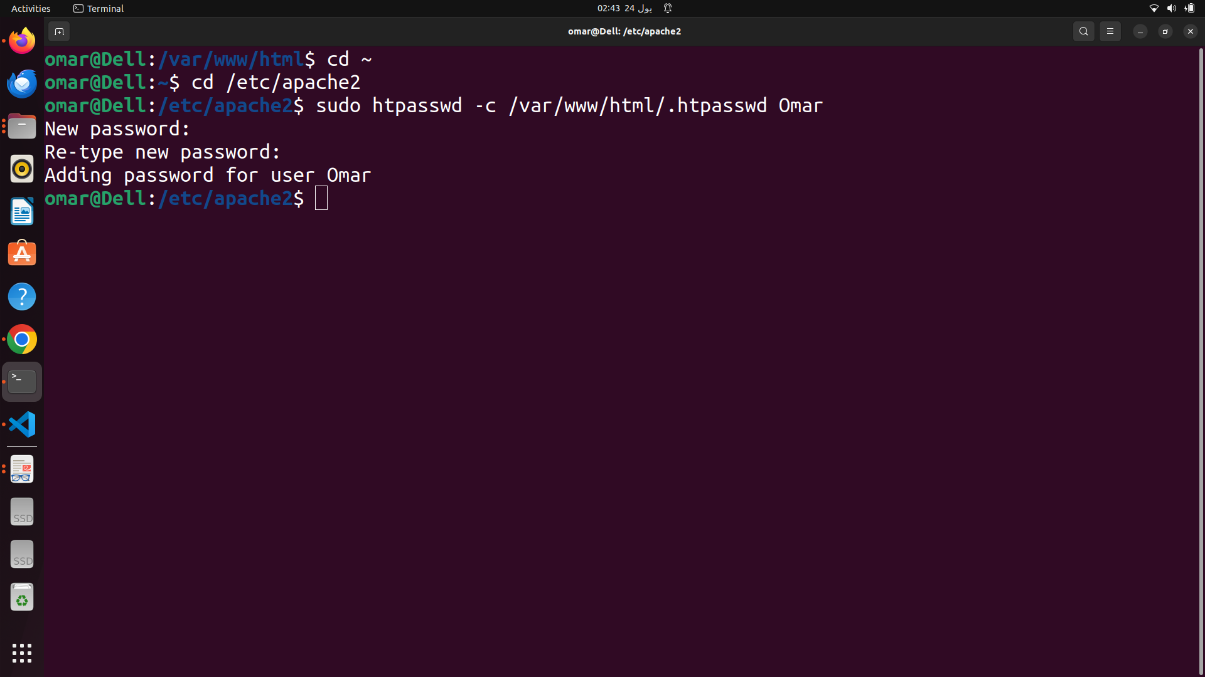

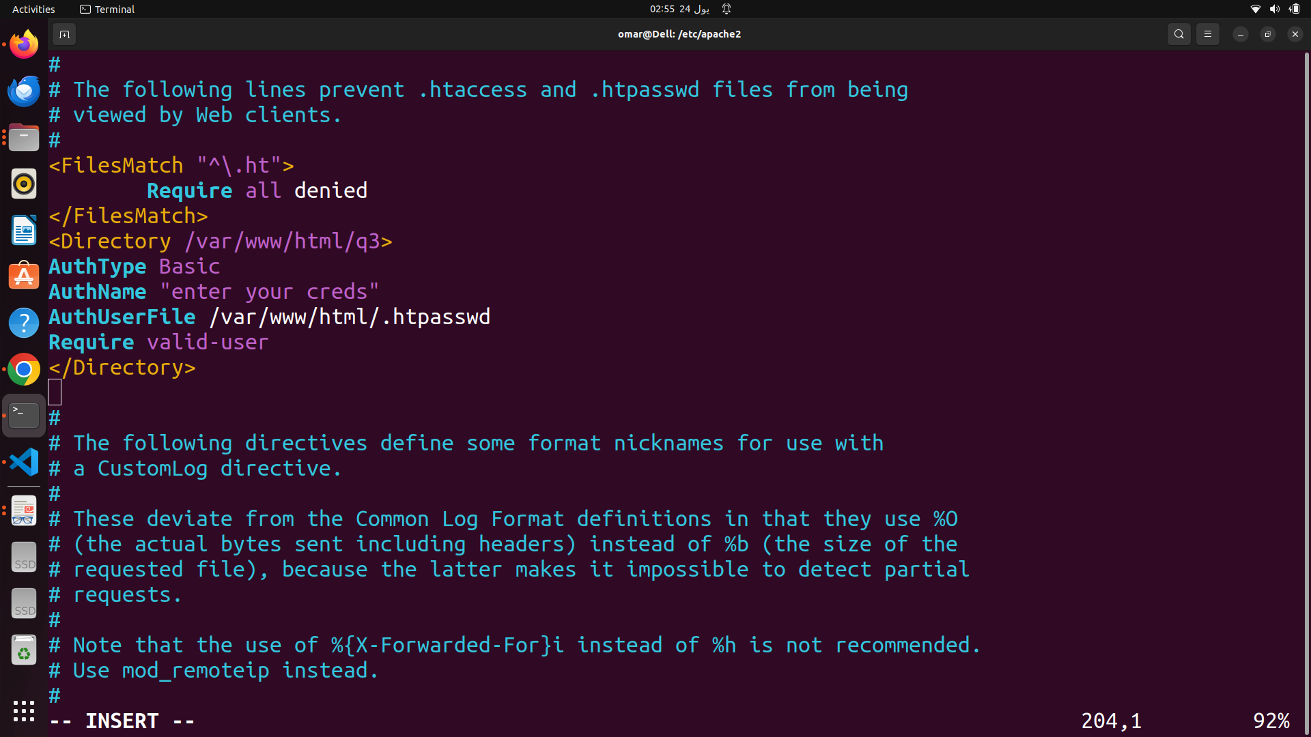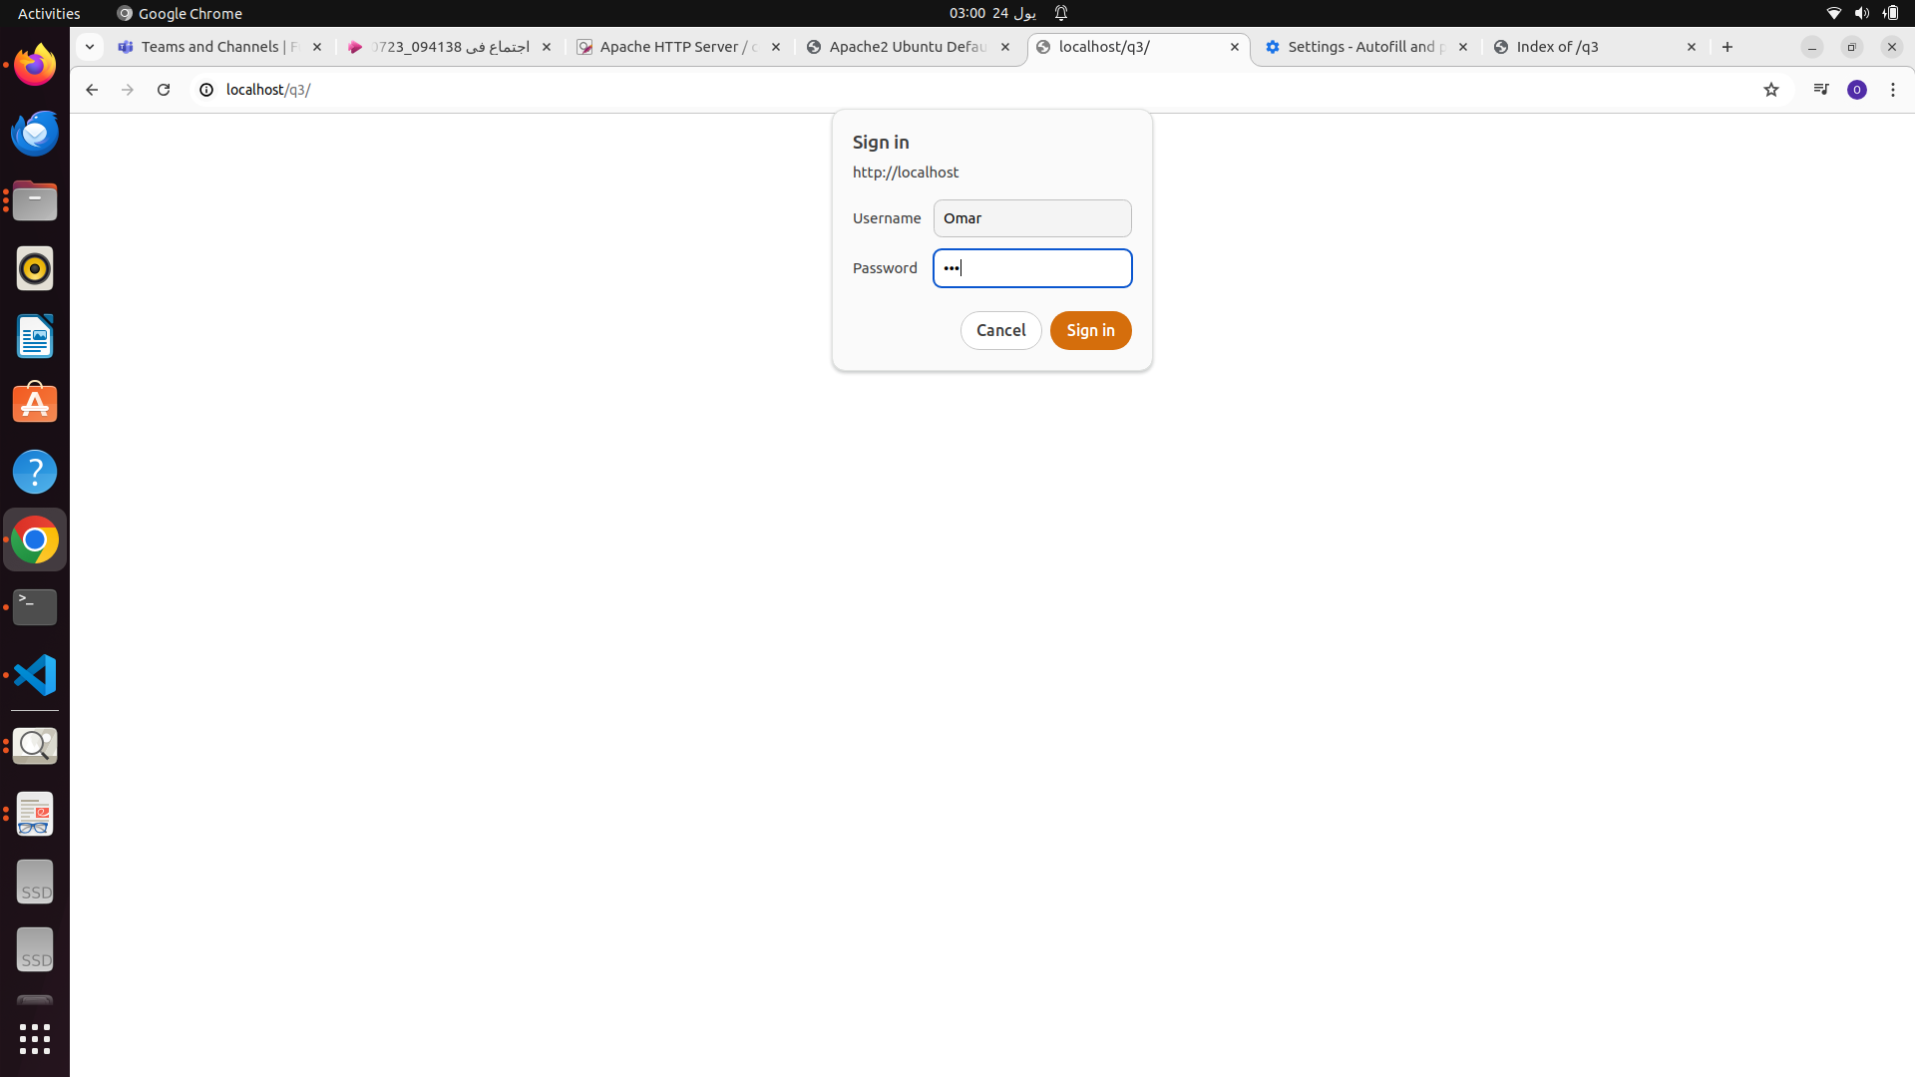

**Q4- Apply authentication before downloading PDF files.**

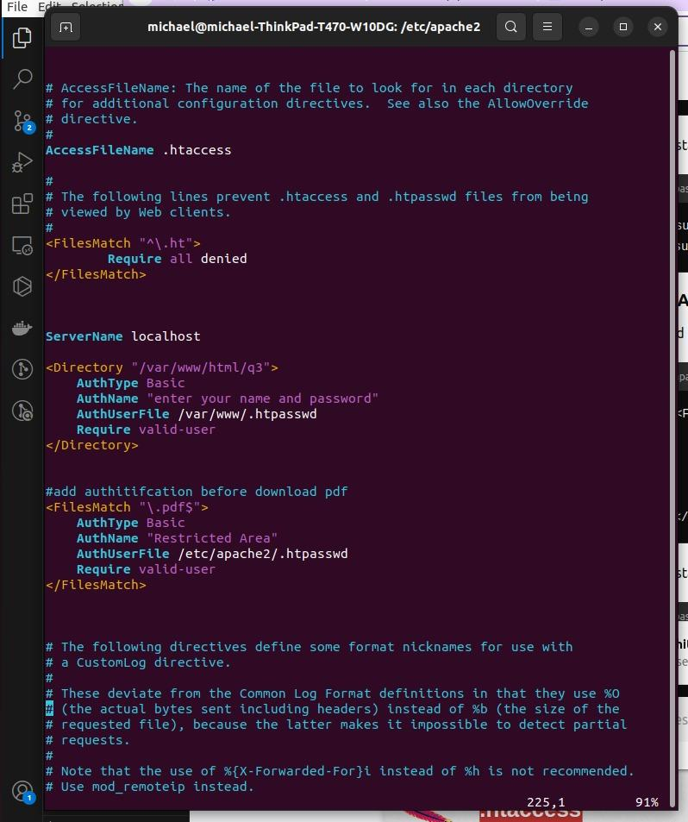

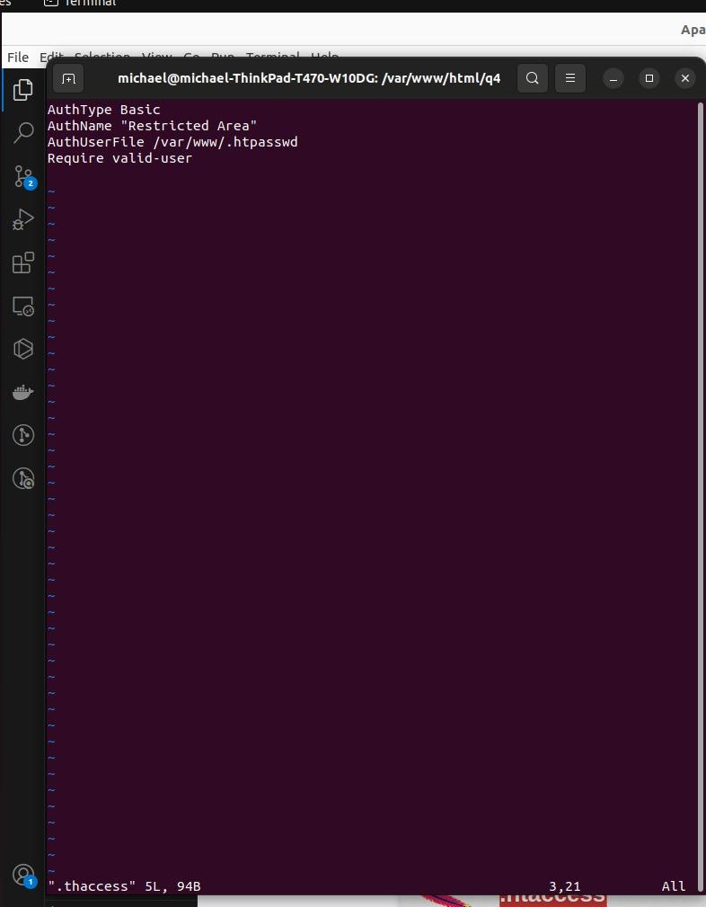

**Q5- Create a directory then allow access to one of your classmates only.**

**Q6-Disable listing the directory content (hint use indexs)**