**Bullseye Sporting Goods**

**Inventory Management System Analysis**

Prepared by

OOAD Team #007

Brady Walsh, Mike McDonald, Bailey Peters

April 11th, 2022

**Contents**

**Introduction** 3

**Interview report** 6

**Current System** 7

**Use Case 1 Create Store Order** 7

**Create Store Order - State Chart Diagram** **Error! Bookmark not defined.**

**Use Case 2 Prepare Store Order** 12

**Use Case 2 Prepare Store Order Activity Diagram** **Error! Bookmark not defined.**

**Use Case 3 Deliver Store Order** 15

**Use Case 4 Create Reports** 17

**Executive Summary** **Error! Bookmark not defined.**

# **Introduction**

The purpose of this document is to provide a detailed analysis of Bullseye Sporting Goods’ current inventory management system, procedures, and practices. Team #7 was approached about developing a new system to replace the current system in use by the company. Our first step in the development of this new system is to understand how the current system functions in its present state, such is the intent of this document. This analysis will not provide any suggestions for improvement of the current system, nor make any recommendations regarding a new system implementation.

The information and data used in this analysis was obtained through several interviews with various members of the company, including Eduardo Concepcion (Regional Manager), Monica Munoz (Finance Manager), Chris Patstone (Warehouse Foreman), and Jose Perez (Store Manager). Our initial assessment was primarily conducted with the Saint John store and warehouse as a focal point for understanding how the current system functions, with relations to the other 7 locations in the Atlantic region. Group #7 would like to thank the members of Bullseye Sporting Goods for their contributions to this portion of the development process.

# **Executive Summary**

This summary serves as a high-level overview of the documents in this Project. This summary will outline some issues discovered during the information gathering process of the analysis. During interviews with key members of staff the analysis team outlined the following logistical, administrative, and software issues.

During the interviews, stakeholders expressed a desire to implement a new inventory management system, to replace the current system in use by pre-existing storefront’s, newly acquired locations, and the regional inventory warehouse. It was stated that the current system is not conducive to their needs on the ground-level and does not promote synchronicity between an expanded network of retail locations. The goal is to design, develop and implement a new system for BullsEye to handle the new influx of orders after the recent acquisition of seven new retail storefronts. The information contained within this document will focus solely on the analysis of the current system.

Our initial assessment involved mapping out the current system(s) in use between stores and the regional warehouse. Through our research, we were able to map out the communication between the parties involved with managing orders both sent and received by the regional warehouse, as well as how these orders are handled once they are sent or received by the storefront. We’ve developed a series of 12 use cases for the current system, including state chart diagrams, which demonstrate the varying degrees of cooperation required between the current systems and facilities in use by the company. Below is an overview of some current areas of opportunity within the current system, from logistics to software issues.

*Logistical Issues*

* During Interview #1 it was made clear through verbal communication that Dispatches are sent individually based on completion of each order, instead of a regulated schedule.

* During interview #1, Chris Patstone explained how emergency orders are handled on a case-by-case basis, with no uniform process for communicating these orders between the store and the warehouse. It was described that the lack of structured procedure ends up in redundant orders caused by lack of communication and ambiguity due to orders being completed by verbal communication in most instances.

* Currently, all orders are received and processed manually by the warehouse staff. Chris Patstone stated during interview #1 that this causes backorders not being communicated to stores, leading in an increase in shipping expenses when the stores inevitably place a new order to request the backordered items.

*Administrative Issues*

* During Interview #1 it was made clear through verbal communication that there is currently no standardized process for processing returns at the regional level.

* During interview #1, it was explained Chris Patstone that orders are still placed using print documentation, creating a risk of important payroll documents being discarded, causing delays in payment between BullsEye Sporting goods and third-party shipping companies involved with BullsEye.

* Currently, the warehouse manager is required to manually complete weekly summaries on warehouse activity in a text format, leading to productive time lost by the warehouse manager.

*Software Issues*

* During Interview #1 it was made clear through verbal communication that Store Managers don’t have access to warehouse inventory data, a centralized inventory system, or a standardized system at the store level

* During interview #1, Eduardo Concepcion, Regional Manager, explained that currently, some stores are operating on an independent inventory management system, inherited from the previous owners of these locations. This leads miscommunication and a less synchronized network as not all uniquely identifiable product codes are uniform in their naming conventions.

# **Interview report**

Speaking with the management of the company and stores, we were able to establish a broad baseline to work with. The systems used by the stores across the company are not universal, meaning stock levels cannot be seen by anyone outside the store, leading to confusion about stock levels and orders. Because of the lack of systems across the company, order placements are inconsistent, being placed on different days from other stores in the area, creating more costly deliveries than necessary. The use of “emergency orders” by the stores also creates more deliveries than necessary, as backorders are not communicated back to the stores.

After our interview with Chris Patstone, we gained an understanding of the existing system used by Bullseye’s warehouse. The system is standalone, much like the individual stores, and orders must be manually entered into it for processing. Because of the manual entry and no connected systems to the stores, store managers are unable to see the warehouse’s inventory when making orders, leading to backorders being made to complete the orders. However, the backorders are not communicated to the stores, leading the stores to think their orders were not completed, them placing another order to fill the stock they requested, and added stress for delivery drivers when stores get angry about the incomplete orders.

The miscommunication and lack of a connected system are causing most of the issues for Bullseye, creating unnecessary stress, confusion, and costs for the company. With a system that is synchronized across the entire company, stock levels can be accurately adjusted and compared, orders and backorders can be recorded and communicated to the stores, and unnecessary delays, such as counting orders before and after deliveries, can be avoided. A complete system will create a streamlined and transparent process for Bullseye to follow and maintain.

# **Current System**

**Use Case Glossary**

|  |  |  |  |  |
| --- | --- | --- | --- | --- |
| ID | Use Case Name | Primary Actor | Other Actors | Description |
| UC-001 | Create Store Order | Store Manager | Warehouse Manager | The Store Manager places an order into the inventory management system which is then authenticated automatically and verified by the Warehouse Manager |
| UC-002 | Prepare Store Order | Warehouse Manager | Store Manager | The Warehouse Manager uses the Manifest Produced by the Inventory Management System to prepare the order for delivery |
| UC-003 | Deliver Store Order | Driver | Store Manager | The Driver delivers the specific goods requested by the store manager at the approved time |
| UC-004 | Create Reports | Regional Manager | Store Manager | Store Manager spends time generating weekly reports |
| UC-005 | Update Store Inventory | Store Manager | Warehouse Manager | The Store Manager manually enters information about the inventory of their store |
| UC-006 | Verify Order | Driver | Warehouse Manager | Cross Reference Manifest and BOL before leaving DC |
| UC-007 | Create Emergency Order | Store Manager | Warehouse Manager | Create stock order for store with maximum priority (all other orders on hold) |
| UC-008 | Create Vendor order | Warehouse Manager | Vendor | Create order based on inventory requests aggregate for bulk |
| UC-009 | Create Back Order | Warehouse Manager |  | When stock is not available, backlog order created, sequential priority (first come first serve) |

|  |  |  |  |  |
| --- | --- | --- | --- | --- |
| UC-010 | Return Stock | Store Manager |  | Store Manager Determines if stock can be resold, if not, stock is disposed of at the store level |
| UC-011 | Add Backorder Stock to Next Order | Warehouse Manager | Store Manager | Store Managers can’t see this data at this time, but back orders in the current state are added to weekly orders as they become available |
| UC-012 | Order from Other Store | Store Manager | Other Store Manager | Through Phone Communication, one store manager requests a courier delivery of stock from another store. This process is not tracked in the IMS |

**Use Case 1 Create Store Order**

|  |  |  |  |
| --- | --- | --- | --- |
| **Use Case ID** | UC-001 | **Version** |  |
| **Use Case Name** | Create Store Order | **Date** | 2022/03/28 |
| **Author** | Brady Walsh, Bailey Peters, Mike McDonald | **Complexity** | Medium |
| **Priority** | High | **Use Case Type:** | |
| **Source** | Store Manager | **Business Requirement**  **System Analysis** | |
| **Primary Business Actor** | Store Manager |
| **Other Participating Actors** | Warehouse Manager | | |
| **Other Interested Stakeholders** | Regional Manager | | |
| **Description** | The Process taken when a store manager requests more inventory | | |
| **Precondition(s)** | The Store Manager creates an order, sent to the warehouse | | |
| **Trigger(s)** | Order info arriving at Warehouse system | | |
| **Basic Flow**  **(Typical Course of Events)** | **Actor Action,** | **System/Result, Info required** | |
| Store Manager: Creates Order  Warehouse Manager: Validate Order  Warehouse Manager: Process Order | Order Verified: Valid Inventory order  Verify Order: Valid Inventory order  Info stored in system: Inventory order | |
| **Alternate Flow** | **Actor Action, System/Result, Info required** | | |
| Store Manager: submits Invalid order -- Order Not verified: Valid Inventory order  Warehouse Manager: Verify order – Order cannot be verified  Warehouse Manager: Process Order -- Order cannot be processed | | |
| **Conclusion** | Store Order Created | | |
| **Post condition** | Valid Inventory order, stored locally | | |
| **Business Rules** | Must use existing system to Create Order. | | |
| **Implementation Constraints and Specifications** | Both store and Warehouse are operational and have communications | | |
| **Assumptions** | The Store and Warehouse Managers both understand how to make and verify an order | | |
| **Notes / Open Issues** |  | | |

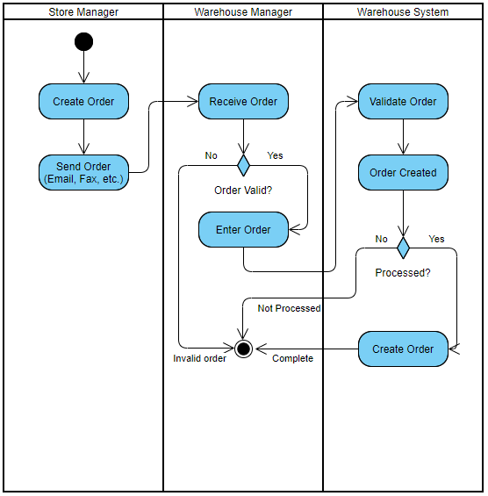

**Use Case 2 Prepare Store Order**

|  |  |  |  |
| --- | --- | --- | --- |
| **Use Case ID** | UC-002 | **Version** |  |
| **Use Case Name** | Prepare Store Order | **Date** | 2022/03/28 |
| **Author** | Brady Walsh, Bailey Peters, Mike McDonald | **Complexity** | Low |
| **Priority** | Medium | **Use Case Type:** | |
| **Source** | Warehouse Manager/Staff | **Business Requirement**  **System Analysis** | |
| **Primary Business Actor** | Warehouse Manager |
| **Other Participating Actors** | Warehouse Staff, Store Manager | | |
| **Other Interested Stakeholders** | Regional Manager, Delivery Company | | |
| **Description** | The Process of preparing the order for delivery at the Warehosue | | |
| **Precondition(s)** | Available stock, Ability to move product, Valid Emergency or Weekly Store Order | | |
| **Trigger(s)** | Valid Store Order in system | | |
| **Basic Flow**  **(Typical Course of Events)** | **Actor Action,** | **System/Result, Info required** | |
| Warehouse Manager: creates docs  Warehouse Staff: Prepare Order  Warehouse Manager: check order | BOL, Manifest created: Valid Order  Prepared Order: Manifest  Checked order: Manifest | |
| **Alternate Flow** | **Actor Action, System/Result, Info required** | | |
| Warehouse Staff: Cannot find stock -- Order placed on backorder  Warehouse Manager: incorrect stock – Order rechecked | | |
| **Conclusion** | Delivery Driver picks up delivery | | |
| **Post condition** | Delivery is ready to be loaded, and is the correct assortment | | |
| **Business Rules** | Deliveries must be checked by Store Manager | | |
| **Implementation Constraints and Specifications** | Warehouse Manager and Staff require correct documentation (Manifest) to verify order. | | |
| **Assumptions** | Warehouse Manager and Warehouse Staff understand the system in place | | |
| **Notes / Open Issues** | Lacking Digital verification, the Warehouse Manager needs to check each order manually, costing the company time and resources. | | |

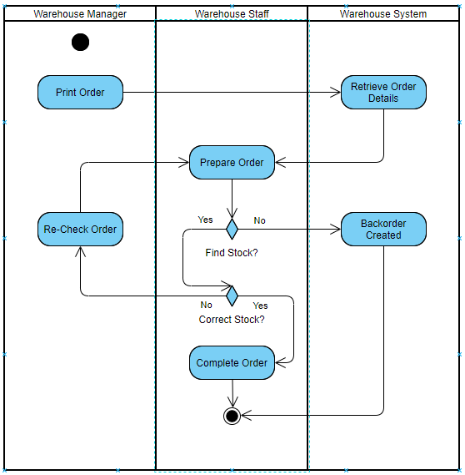

**Use Case 3 Deliver Store Order**

|  |  |  |  |
| --- | --- | --- | --- |
| **Use Case ID** | UC-003 | **Version** |  |
| **Use Case Name** | Deliver Store Order | **Date** | 2022/03/28 |
| **Author** | Brady Walsh, Bailey Peters, Mike McDonald | **Complexity** | Low |
| **Priority** | High | **Use Case Type:** | |
| **Source** | Delivery Driver | **Business Requirement**  **System Analysis** | |
| **Primary Business Actor** | Warehouse Manager |
| **Other Participating Actors** | Store Manager, 3rd Party dispatch | | |
| **Other Interested Stakeholders** | Regional Manager, Store Manger | | |
| **Description** | A valid Sore Order is delivered to the predetermined store (on schedule) | | |
| **Precondition(s)** | The Driver has required information (ie. Addresses, timeline, documentation) | | |
| **Trigger(s)** | Driver is given dispatch to deliver order | | |
| **Basic Flow**  **(Typical Course of Events)** | **Actor Action,** | **System/Result, Info required** | |
| Delivery Driver: Checks Order  Delivery Driver: Delivers Order | Checked Order: stock and Manifest  Delivered Order: Time and Address | |
| **Alternate Flow** | **Actor Action, System/Result, Info required** | | |
| Store Orders only Use Case Flow depends on valid orders and pre-determined timeline, there is no alternate path as verification is done before the driver arrives. | | |
| **Conclusion** | Store Receives Order | | |
| **Post condition** | Order is Correct and on time | | |
| **Business Rules** | Driver must arrive and depart both locations at pre-determined time set by 3rd party dispatch | | |
| **Implementation Constraints and Specifications** | Weekly Orders can only be delivered on that store’s specified delivery date | | |
| **Assumptions** | The Delivery Driver can deliver orders and understands the task at hand. | | |
| **Notes / Open Issues** | How Many deliveries can one driver do in a day? | | |

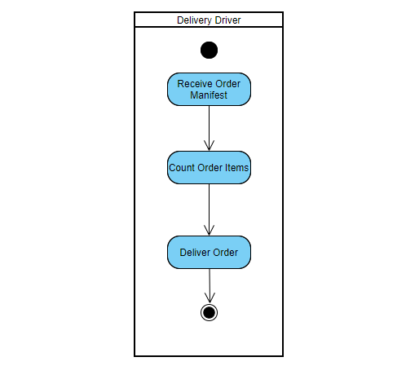

**Use Case 4 Create Reports**

|  |  |  |  |
| --- | --- | --- | --- |
| **Use Case ID** | UC-004 | **Version** |  |
| **Use Case Name** | Create Reports | **Date** | 2022/03/28 |
| **Author** | Brady Walsh, Bailey Peters, Mike McDonald | **Complexity** | Medium |
| **Priority** | Medium | **Use Case Type:** | |
| **Source** | Warehouse Manager | **Business Requirement**  **System Analysis** | |
| **Primary Business Actor** | Regional Manager |
| **Other Participating Actors** | N/A | | |
| **Other Interested Stakeholders** | Store Manager | | |
| **Description** | Weekly, the Warehouse Manager Submits reports on all activity done by the Warehouse that week, this is done manually | | |
| **Precondition(s)** | Warehouse Manager has access to Text Editor | | |
| **Trigger(s)** | 7 days since last report | | |
| **Basic Flow**  **(Typical Course of Events)** | **Actor Action,** | **System/Result, Info required** | |
| Warehouse Manager: Makes Report | Report Made: Warehouse Info | |
| **Alternate Flow** | **Actor Action, System/Result, Info required** | | |
| Warehouse Manager: Fails to Make Report -- Report not Made: Lack of Info | | |
| **Conclusion** | Report Made and Submitted to Regional Manager | | |
| **Post condition** | A complete and legible report with all the necessary info | | |
| **Business Rules** | Reports must be submitted weekly | | |
| **Implementation Constraints and Specifications** | Currently Done Manually | | |
| **Assumptions** | Warehouse Manager knows how to use Word | | |
| **Notes / Open Issues** | This Process can be automated with proper investment | | |

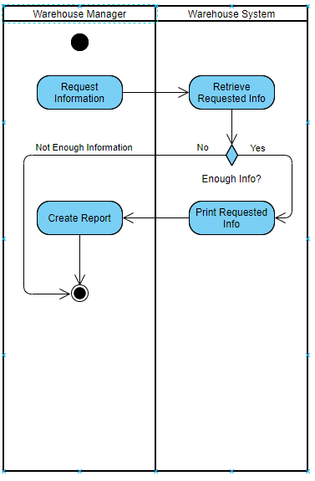

|  |  |  |  |
| --- | --- | --- | --- |
| **Use Case ID** | UC-005 | **Version** |  |
| **Use Case Name** | Update Store Inventory | **Date** | 2022/03/28 |
| **Author** | Brady Walsh, Bailey Peters, Mike McDonald | **Complexity** | High |
| **Priority** | Medium | **Use Case Type:** | |
| **Source** | Store Manager | **Business Requirement**  **System Analysis** | |
| **Primary Business Actor** | Store Manager |
| **Other Participating Actors** | Warehouse Manager | | |
| **Other Interested Stakeholders** | Regional Manager | | |
| **Description** | Store Manager counts and updates their current inventory | | |
| **Precondition(s)** | Store has Inventory | | |
| **Trigger(s)** | Store Manager deems it needed | | |
| **Basic Flow**  **(Typical Course of Events)** | **Actor Action,** | **System/Result, Info required** | |
| Store Manager: Counts Inventory  Store Manager: Updates Inventory | Inventory Counted: Inventory Data  Inventory Updated: Inventory Count | |
| **Alternate Flow** | **Actor Action, System/Result, Info required** | | |
| Store Manager: Forgets how to count – Inventory not Counted | | |
| **Conclusion** | Updated Inventory Data | | |
| **Post condition** | Inventory Management System (Updated) | | |
| **Business Rules** | Updates performed on a “as needed” basis | | |
| **Implementation Constraints and Specifications** | Access to inventory management system required  Valid User must enter data | | |
| **Assumptions** | Store Manager knows how to count, Store Manager understands how to update info in system | | |
| **Notes / Open Issues** | Can be done automatically | | |

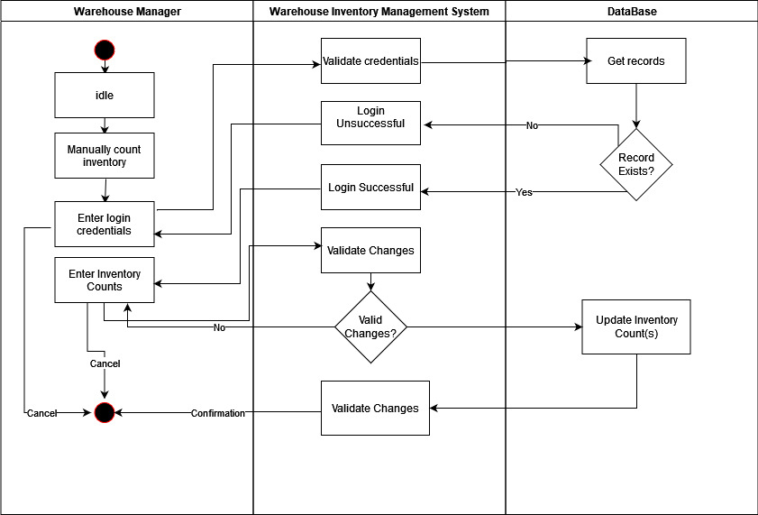

|  |  |  |  |
| --- | --- | --- | --- |
| **Use Case ID** | UC-006 | **Version** |  |
| **Use Case Name** | Verify Order | **Date** | 2022/03/28 |
| **Author** | Brady Walsh, Bailey Peters, Mike McDonald | **Complexity** | Low |
| **Priority** | Low | **Use Case Type:** | |
| **Source** | Deliver Driver | **Business Requirement**  **System Analysis** | |
| **Primary Business Actor** | Delivery Driver |
| **Other Participating Actors** | Warehouse Manager, Store Manager | | |
| **Other Interested Stakeholders** | Regional Manager | | |
| **Description** | The Delivery Driver Acquires Manifest and assures that it is accurate based on the order that he/she is picking up | | |
| **Precondition(s)** | Manifest Made, Order Prepared, Dispatch Created | | |
| **Trigger(s)** | Dispatch Created | | |
| **Basic Flow**  **(Typical Course of Events)** | **Actor Action,** | **System/Result, Info required** | |
| Driver: Verifies Order | Order Verified: Manifest | |
| **Alternate Flow** | **Actor Action, System/Result, Info required** | | |
| Driver: Cannot Verify Order -- Manifest Required (not available) | | |
| **Conclusion** | Verified Order | | |
| **Post condition** | An order that is verified | | |
| **Business Rules** | Drivers must verify order before loading | | |
| **Implementation Constraints and Specifications** | Time made available to the driver as well as dock space to check order | | |
| **Assumptions** | Driver understands how to check order | | |
| **Notes / Open Issues** | Drivers don’t always check the order before loading. | | |

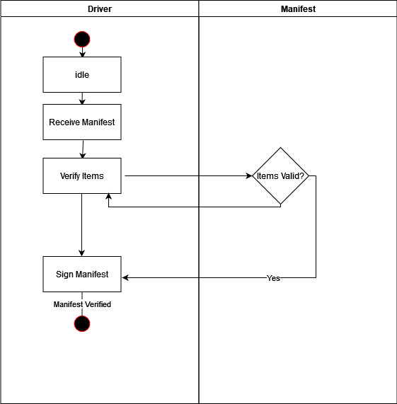

|  |  |  |  |
| --- | --- | --- | --- |
| **Use Case ID** | UC-007 | **Version** |  |
| **Use Case Name** | Create Emergency Order | **Date** | 2022/03/28 |
| **Author** | Brady Walsh, Bailey Peters, Mike McDonald | **Complexity** | Medium |
| **Priority** | High | **Use Case Type:** | |
| **Source** | Store Manager | **Business Requirement**  **System Analysis** | |
| **Primary Business Actor** | Store Manager |
| **Other Participating Actors** | Warehouse Manager | | |
| **Other Interested Stakeholders** | Regional Manager | | |
| **Description** | An order is created without a specified delivery date and given rush priority | | |
| **Precondition(s)** | Store does not have any available stock for specific items, warehouse has item in stock | | |
| **Trigger(s)** | Item is out of stock at store level | | |
| **Basic Flow**  **(Typical Course of Events)** | **Actor Action,** | **System/Result, Info required** | |
| Store Manager: Creates Emergency Order  Warehouse Manager: Sends Order | Emergency Order made: Valid Order  Emergency Order sent: In Stock | |
| **Alternate Flow** | **Actor Action, System/Result, Info required** | | |
| Store Manager: Creates Order -- Item not in Warehouse Stock: Not in Stock | | |
| **Conclusion** | Emergency order made | | |
| **Post condition** | A valid order with rush priority | | |
| **Business Rules** | Store Manager is the only one that can make emergency orders on behalf of store | | |
| **Implementation Constraints and Specifications** | Deliveries made during business hours,  Emergency orders with Rush Priority are processed before all other orders | | |
| **Assumptions** | The Store Needs a product that is not in stock,  The Warehouse has product in stock | | |
| **Notes / Open Issues** | More Constraints should be put on emergency orders | | |

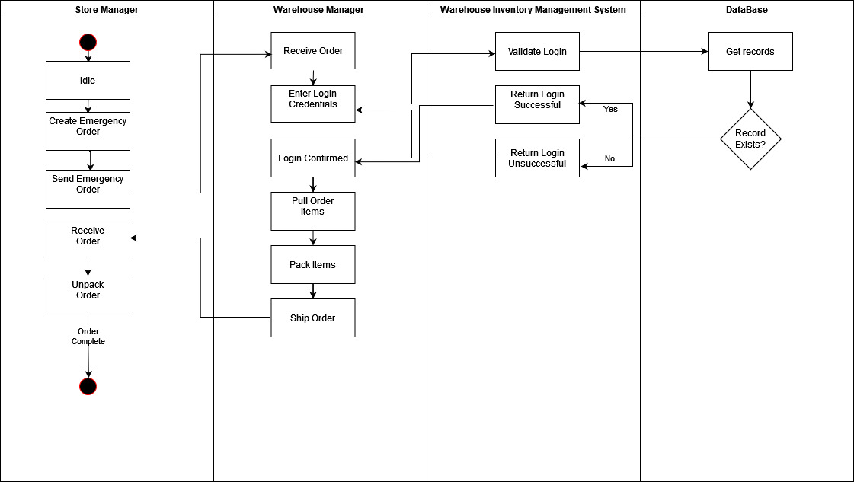

|  |  |  |  |
| --- | --- | --- | --- |
| **Use Case ID** | UC-008 | **Version** |  |
| **Use Case Name** | Create Vendor Order | **Date** | 2022/03/28 |
| **Author** | Brady Walsh, Bailey Peters, Mike McDonald | **Complexity** | Medium |
| **Priority** | Medium | **Use Case Type:** | |
| **Source** | Warehouse Manager | **Business Requirement**  **System Analysis** | |
| **Primary Business Actor** | Warehouse Manager |
| **Other Participating Actors** | Vendor | | |
| **Other Interested Stakeholders** | Store Manager, Regional Manager | | |
| **Description** | An order is made for the warehouse to receive a product from a vendor | | |
| **Precondition(s)** | Valid Vendor, Valid order | | |
| **Trigger(s)** | Warehouse runs out of stock of specific items | | |
| **Basic Flow**  **(Typical Course of Events)** | **Actor Action,** | **System/Result, Info required** | |
| Warehouse Manager: Creates order | Order Created: item Out of Stock | |
| **Alternate Flow** | **Actor Action, System/Result, Info required** | | |
| N/A | | |
| **Conclusion** | Vendor Order Created | | |
| **Post condition** | Valid Order | | |
| **Business Rules** | Reasonable discretion encouraged on behalf of Store Manager | | |
| **Implementation Constraints and Specifications** | Vendor Must have item in stock,  Vendor must accept an order from the Warehouse Manager,  Warehouse must be Out of Stock of specified item | | |
| **Assumptions** | Warehouse Manager can determine if something is out of stock,  The Warehouse Manager can contact the vendor | | |
| **Notes / Open Issues** | This Process can be automated | | |

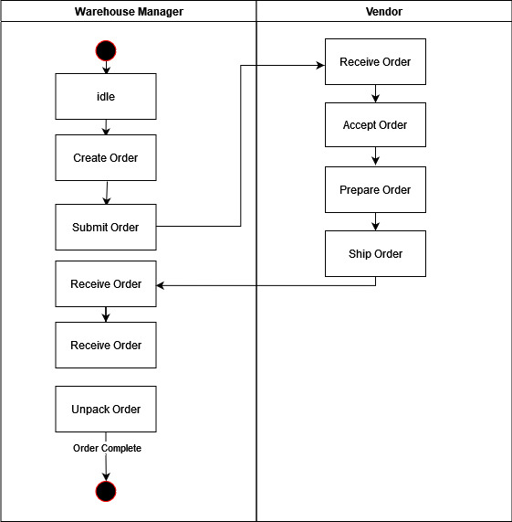

|  |  |  |  |
| --- | --- | --- | --- |
| **Use Case ID** | UC-009 | **Version** |  |
| **Use Case Name** | Create Back Order | **Date** | 2022/03/28 |
| **Author** | Brady Walsh, Bailey Peters, Mike McDonald | **Complexity** | Medium |
| **Priority** | Medium | **Use Case Type:** | |
| **Source** | Warehouse Manager | **Business Requirement**  **System Analysis** | |
| **Primary Business Actor** | Warehouse Manager |
| **Other Participating Actors** | N/A | | |
| **Other Interested Stakeholders** | Regional Manager | | |
| **Description** | When an item is out of stock but part of a store order, the warehouse manager creates a backorder of that item | | |
| **Precondition(s)** | Item is out of stock at warehouse level | | |
| **Trigger(s)** | Store Level order is made while item is out of stock at warehouse level | | |
| **Basic Flow**  **(Typical Course of Events)** | **Actor Action,** | **System/Result, Info required** | |
| Warehouse Manager: Creates Backorder | Backorder Created: info on Out-of-Stock Items | |
| **Alternate Flow** | **Actor Action, System/Result, Info required** | | |
| Warehouse Manager: does not Create Backorder -- Item already in stock | | |
| **Conclusion** | Backorder Created | | |
| **Post condition** | Specified items are out of stock at warehouse level | | |
| **Business Rules** | Only the Warehouse Manager can create back orders | | |
| **Implementation Constraints and Specifications** | Back orders can only be created if the stock is not available at both the store and warehouse level | | |
| **Assumptions** | Warehouse Manager capable of determining the availability of products in the warehouse | | |
| **Notes / Open Issues** | This Process can be automated | | |

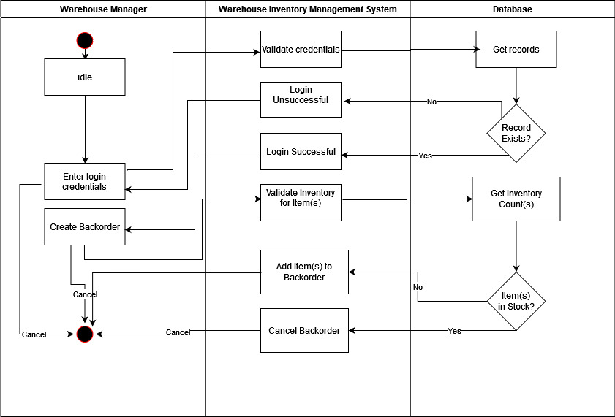

|  |  |  |  |
| --- | --- | --- | --- |
| **Use Case ID** | UC-0010 | **Version** |  |
| **Use Case Name** | Return Stock | **Date** | 2022/03/28 |
| **Author** | Brady Walsh, Bailey Peters, Mike McDonald | **Complexity** | Low |
| **Priority** | Medium | **Use Case Type:** | |
| **Source** | Store Manager | **Business Requirement**  **System Analysis** | |
| **Primary Business Actor** | Store Manager |
| **Other Participating Actors** | N/A | | |
| **Other Interested Stakeholders** | N/A | | |
| **Description** | Store Manager assesses value and determines outcome for return process | | |
| **Precondition(s)** | Store Manager receives return from customer | | |
| **Trigger(s)** | Customer Requests Return | | |
| **Basic Flow**  **(Typical Course of Events)** | **Actor Action,** | **System/Result, Info required** | |
| Store Manager: Returns Product | Product on shelf: Manager Deemed product fit for resale  Product Disposed of: Manager deemed product not fir for sale | |
| **Alternate Flow** | **Actor Action, System/Result, Info required** | | |
| N/A | | |
| **Conclusion** | Refund given at point of sale; warehouse does not see returned product. | | |
| **Post condition** | Valid Return requested be customer | | |
| **Business Rules** | All returns are deemed valid by the Store Manager at their discretion | | |
| **Implementation Constraints and Specifications** | No Constraints beyond Store Manager discretion | | |
| **Assumptions** | Store Manager has good discretion and knows how to refund a customer | | |
| **Notes / Open Issues** | Should be done at warehouse level and logged in the correct database | | |

|  |  |  |  |
| --- | --- | --- | --- |
| **Use Case ID** | UC-0011 | **Version** |  |
| **Use Case Name** | Add Back Order, to next order | **Date** | 2022/03/28 |
| **Author** | Brady Walsh, Bailey Peters, Mike McDonald | **Complexity** | Low |
| **Priority** | Medium | **Use Case Type:** | |
| **Source** | Warehouse Manger | **Business Requirement**  **System Analysis** | |
| **Primary Business Actor** | Warehouse Manager |
| **Other Participating Actors** | Store Manager | | |
| **Other Interested Stakeholders** | Regional Manager | | |
| **Description** | The Warehouse Manager adds stock from back order to next weekly order for store | | |
| **Precondition(s)** | Store has weekly order and back order on file | | |
| **Trigger(s)** | Back order is on file when weekly order is triggered | | |
| **Basic Flow**  **(Typical Course of Events)** | **Actor Action,** | **System/Result, Info required** | |
| Warehouse Manager: adds stock | Stock Added: backorder | |
| **Alternate Flow** | **Actor Action, System/Result, Info required** | | |
| Warehouse manager: does not add stock -- Stock Not Added: no backorder | | |
| **Conclusion** | Warehouse Manager has added the stock onto the existing order | | |
| **Post condition** | 1 complete order ready for delivery | | |
| **Business Rules** | Only the Warehouse Manager can add back orders to regular orders | | |
| **Implementation Constraints and Specifications** | Only done when both backorder and regular order on file. | | |
| **Assumptions** | Backorder is valid and will not overload the Delivery Truck | | |
| **Notes / Open Issues** | N/A | | |

|  |  |  |  |
| --- | --- | --- | --- |
| **Use Case ID** | UC-0012 | **Version** |  |
| **Use Case Name** | Order From Another Store | **Date** | 2022/03/28 |
| **Author** | Brady Walsh, Bailey Peters, Mike McDonald | **Complexity** | Low |
| **Priority** | Low | **Use Case Type:** | |
| **Source** | Store Manager #1 | **Business Requirement**  **System Analysis** | |
| **Primary Business Actor** | Store Manager #2 |
| **Other Participating Actors** | Store Manger #2 | | |
| **Other Interested Stakeholders** | Regional Manager | | |
| **Description** | A Store Manager calls another store manager to request stock from their inventory | | |
| **Precondition(s)** | Store Manager #2 has the item(s) Store Manager #1 needs | | |
| **Trigger(s)** | Store Manger #1 needs an Item that’s out of stock | | |
| **Basic Flow**  **(Typical Course of Events)** | **Actor Action,** | **System/Result, Info required** | |
| Store Manager #1: calls SM#2  Store Manager #2: Sends SM#1 product | Call made: correct Phone Number  Product Sent Via Currier: valid stock and info. | |
| **Alternate Flow** | **Actor Action, System/Result, Info required** | | |
| Store Manager #2: does not have stock/resources to send stock – No Order Sent | | |
| **Conclusion** | Store Manager #1 asks Store Manager #2 for item(s) | | |
| **Post condition** | Items sent via currier to Store Manger #1’s location | | |
| **Business Rules** | N/A | | |
| **Implementation Constraints and Specifications** | N/A | | |
| **Assumptions** | Both Store Managers have each other’s phone number | | |
| **Notes / Open Issues** | This is a bad way to manage store inventory | | |

# State Diagram (Ordering Process)

