SYSTEMS PROGRAMMING

Name: Michael Kofi Badu

Student Number: S1719029

Email: [mkofib200@caledonian.ac.uk](mailto:mkofib200@caledonian.ac.uk)

**Documentation for the Testing with screenshots and descriptions**

|  |  |  |
| --- | --- | --- |
| Test | Expected Result | Actual Result |
| Creating the trashCan Directory | The hidden directory “.trashCan” created in the home directory if the directory is not already in existence. | “.trashCan” directory created if it is not already if it does not exist. |
| Moving a file from its current directory to the trash can. | The file moved should show in the list of items in the trash can with an indication that the “(filename) has been successfully moved to the trashcan directory” | The file moved shows in the list of items in the trash can with an indication that the “(filename) has been successfully moved to the trashcan directory” |
| safeDel.sh (menu output) | A menu displayed on the terminal enabling the user to choose any of the below options  (1)List  (2)Recover  (3)Delete  (4)Total  (5)Watch  (6)Kill  (7)Exit | A menu displayed on the terminal window prompting the user to choose the following options by selecting the respective numbers  (1)List  (2)Recover  (3)Delete  (4)Total  (5)Watch  (6)Kill  (7)Exit |
| list() function from the menu when the user enters option (1) on the terminal.  Alternatively,  list() function using the command line, when the user runs the safeDel script with - l as the parameter. | * **Scenario 1**   In case the “trashCan” is empty - The terminal window would display “Trash can Empty”   * **Scenario 2**   When the “trashCan” is not empty - The terminal window should display all the list of contents in the trash can using the “filename” (without path), “size” (in bytes) and “type” for each file to the user. | * **Scenario 1** When the “trashCan” is empty - The terminal window displayed “Your Trash can is empty” to the user * **Scenario 2** When the trashCan is not empty - The terminal window displayed all the contents of the trash can in the required “filename” (without path), “size” (in bytes) and “type” format for each file |
| recover() function from the menu when the user enters the option(2) on the terminal.  Alternatively,  recover() function using the command line, when the user runs the safeDel script with - r as the parameter. | * **Scenario 1**   When the file to be recovered does not exist - The terminal window is expected to show that “ the file or directory (filename) does not exist.   * **Scenario 2**   The filename specified exists in the trash can: The terminal window should give an option to enable the user to enter the name of the file to be recovered. Then the terminal should prompt that the file has been recovered into the current directory. | * **Scenario 1**   When the file to be recovered does not exist - The terminal window shows the user that “ the file or directory (filename) does not exist.   * **Scenario 2**   The filename specified exists in the trash can: The terminal window gives an option which enables the user to enter the name of the file to be recovered. Then the terminal should prompt that the file has been recovered into the current directory. |
| delete() function from the menu when the user enters option (3) on the terminal.  Alternatively,  delete() function using the command line, when the user runs the safeDel script with - d as the parameter. | * **Scenario 1**   When there are files is in the trash can - The terminal window is expected to show you the list of files in the trash can.  When the file name is selected it should display “are you sure you want to delete the file” then if  **Yes**: Then the terminal should display that “Successfully deleted the file”  **No**: It takes you back to the options in the terminal   * **Scenario 2**   When there is are not files in the trash can:When the user enters the file name it should prompt that the file name does not exist in this trash can” | * **Scenario 1**   When there are files is in the trash can - The terminal window shows you the list of files in the trash can.  When the file name is selected it should display “are you sure you want to delete the file” then if  **Yes**: Then the terminal should display that “Successfully deleted the file”  **No**: It takes you back to the options in the terminal   * **Scenario 2**   When there is are not files in the trash can:When the user enters the file name it prompts that the file name does not exist in this trash can” |
| total () function from the menu when the user enters option (4) on the terminal.  Alternatively,  total() function using the command line, when the user runs the safeDel script with - t as the parameter. | The terminal is expected to display the total usage of the trash can in bytes. | The terminal displays the total usage of the trash can in bytes. |
| monitor() function from the menu when the user enters option (5) on the terminal.  Alternatively,  monitor() function using the command line, when the user runs the safeDel script with - was the parameter. | * **Scenario 1**   When the file is added :Displays file has been added successfully   * **Scenario 2**   When the file is removed:  Displays file has been removed successfully | * **Scenario 1**   When the file is added :Displays file has been added successfully   * **Scenario 2**   When the file is removed:  Displays file has been removed successfully. |
| kill () function from the menu when the user enters option (6) on the terminal.  Alternatively,  kill() function using the command line, when the user runs the safeDel script with - k as the parameter. | Closes the window of the terminal  Where the code is been read | Closes the terminal where the command is been read |
| exit () function from the menu when the user enters option (7) on the terminal. | Expected to exits the menu | Exists the menu |

**Screenshots of Activities**

**Creating the trashCan Directory**

Description: The screenshot shows my name and student Number as specified in the requirements and notifies the user when the trash can is created “ trashCan created successfully!” then the menu is also displayed beneath it.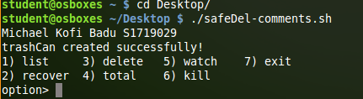

**Moving the file to the trash can**

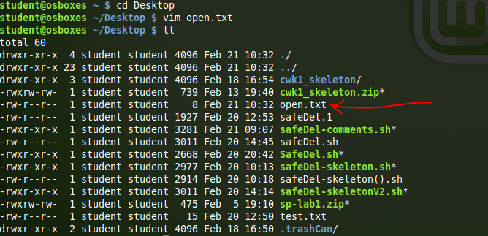

Description: This screenshot shows a file “open.txt” was created onto the desktop

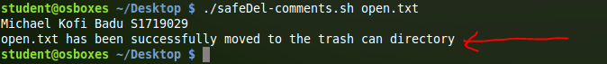

Description: This shows that that file created on the desktop has been moved to the trash can.

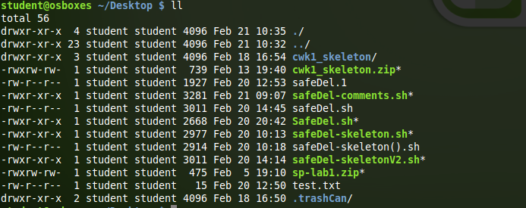

Description: The file “open.txt” does not exist here because it has been moved from the desktop

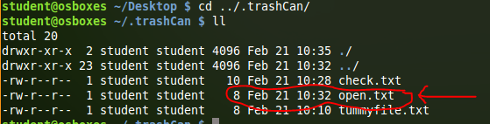

Description: This shows that the file “open.txt” now exist in the trash can listed above.

**Menu Output**

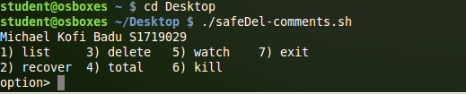

Description: this shows the display of the menu

**List(1)**

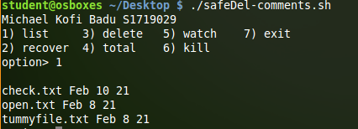

Description: This shows the list of contents in the trash can using the menu option.

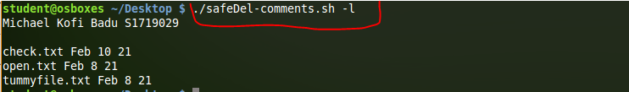

Description: This shows the list of contents in the trash can using the command line ./safeDel-comments.ch-l

**Recover(2)**

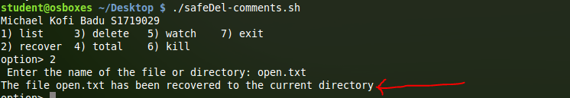

Description: This show the file selected “ open.txt” has been recovered back to the desktop.



Description: This shows the file selected “check.txt” has been recovered using the command line ./safeDel-comments.ch-r

**Delete(3)**

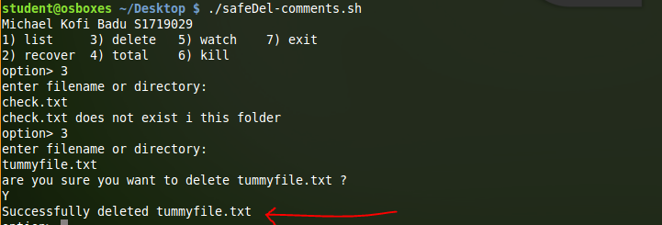

Description: This shows that the tummyfile.txt was successfully deleted from the trash can using the menu options.



Description: Since there was nothing available in the trash can, the file “check file.txt” was moved from the desktop back to the trash can so that another test can be done using the command line.

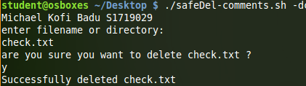

Description: Using the command line.selDel-comments.sh -d, the terminal ask you to enter the filename or directory you are interested in deleting. After inputting the name of the file, it makes you confirm if you actually want to delete the file. If yes you put the Y and no the N. Upon selection of the yes command, it inform the user “Successfully deleted with the (filename)”

**Total(4)**

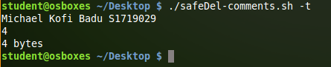

Description: The total in bytes using the command line ./safeDel-comments.sh -t

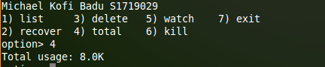

Description: The total in bytes using the menu options (4))

**Monitor(5)**

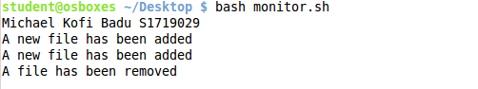

Description: When files are added to the trash can using a command line it displays on the monitor screen that the file.