**Analyzing lapwing behavior during the assays with the Poke-A-Birdie and idTracker softwares**

**Poke-A-Birdie1:**

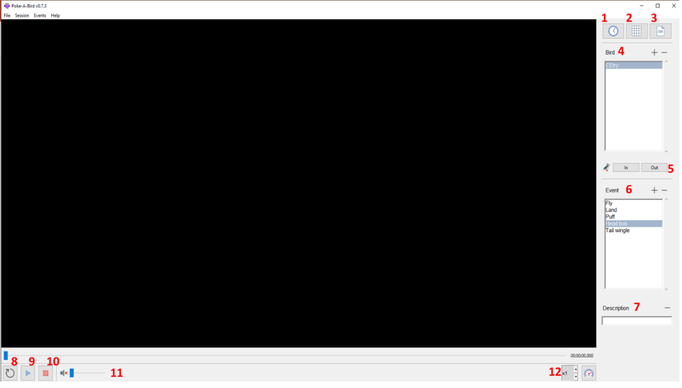Analyzing the time for LTE, as well as monitoring the lapwing behaviors during the OFT and CST assays were made with “Poke-A-Birdie”.

The home screen for Poke-A-Birdie. (1) Set time (2) Add grid (3) CSV to export (4) Add bird name (5) In-Out of frame (6) Choose event (7) Add a new event (8) Reset to time set (9) Play (10) Stop analyzing (11) Volume (12) Video speed

**Working flow**

1. Open the video you want to analyze – “File” -> “Open”
2. Set time (1) to: a. When the bird gets out of the box or B. the start of your video analyzes if you starting from another test
3. 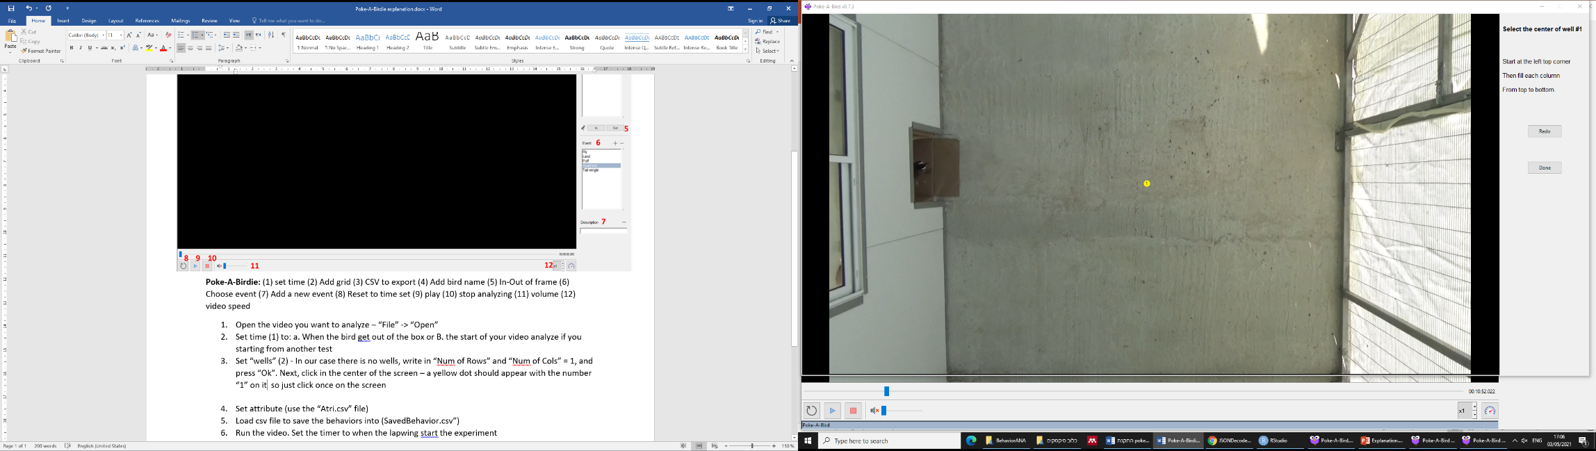Set “wells” (2) - In our case there is no wells, write in “Num of Rows” and “Num of Cols” = 1, and press “Ok”. Next, click in the center of the screen – a yellow dot should appear with the number “1” on it:

Next – click “done”

1. Next, click on “Load Attributes from CSV”, create csv file with a single attribute name “1” to set one "well" and choose it. It should be a csv file with a single attribute name “1” and click “Save”.
2. Load csv file (3) to save the behaviors analyzed into.
3. Add the lapwing name (4, e.g. EE33333)
4. Run the video (9).
5. Every time the lapwing does a certain behavior, choose the behavior from the prepared list (6) and **right-click** on the mouse. If it’s a new behavior, choose a new “description” (7) and add it. You can add if the bird got out of frame or not (5) – while it’s not necessary.

**idTracker**2**:**

This software was used to trace the movement patterns of the lapwings during the OFT and CST assays.

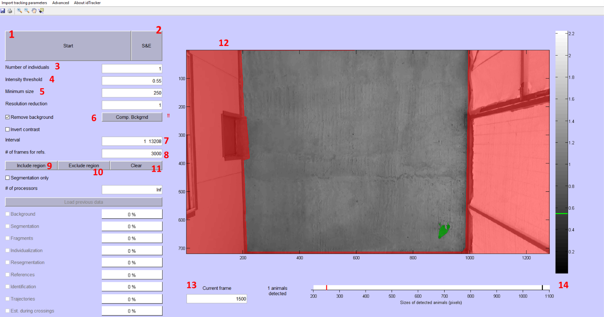

**The home screen of idTracker:** (1) Start analyzing the video (2) Save and exit (3) Number of individuals in the video (4) Intensity threshold of the colors (5) Minimum size of the animal (in pixels) (6) Remove background (7) Start and finish of the video (in frames) (8) reference frames to show when processing (9) choose region (Rectangular/circle/ polygon) (10) exclude the region chosen (11) Clear the region and reset (12) picture of a chosen frame for reference (13) choose frame (14) individual size – red: chosen size, black: minimum size of the smallest object found in the frame.

1. Open the video and cut it so only the part where you want to analyze the movement will be shown (can be easily done with windows media player in “Film & TV” -> “Trim”)

**Important:** It won’t trim if the file is in google drive! Copy the file first to your computer then trim. Trip from the moment the lapwing went out of the box until 7 minutes are done or the dummy went out of the box.

1. Save the part you cut in a new library named after the lapwing ID and test number (e.g., “LapEE33858Test1”). Save the file as the same name you gave the library.
2. Open “idTracker.exe”.
3. After the video is loaded, press on “Select region” (9) -> “Polygon” and choose the whole **white** area without choosing the bars or the exit and press “enter”.

Next choose the threshold and the individual size:

1. Number of individuals (3) -> 1.
2. Intensity threshold (4) -> 0.55 (can play a bit to see what fit best).
3. Minimum size (5) -> 250 (can play a bit to see what fit best).
4. Check the size is correct (14) – red line should be smaller than black line, and it should say “1 animal detected”. Notice that the red line is a lot smaller than the red – it’s so it will be able to detect the lapwing also when flying and sending in “dead zones”. Check that the program finds whole lapwing as well (12, should be colored in red).
5. Press “Comp. Bckgrnd” (6) and wait for the program to calculate the background.
6. Press “Start” (1). This will take approximately 10 minutes.

It will give you this output, as well as a txt file with coordinates:

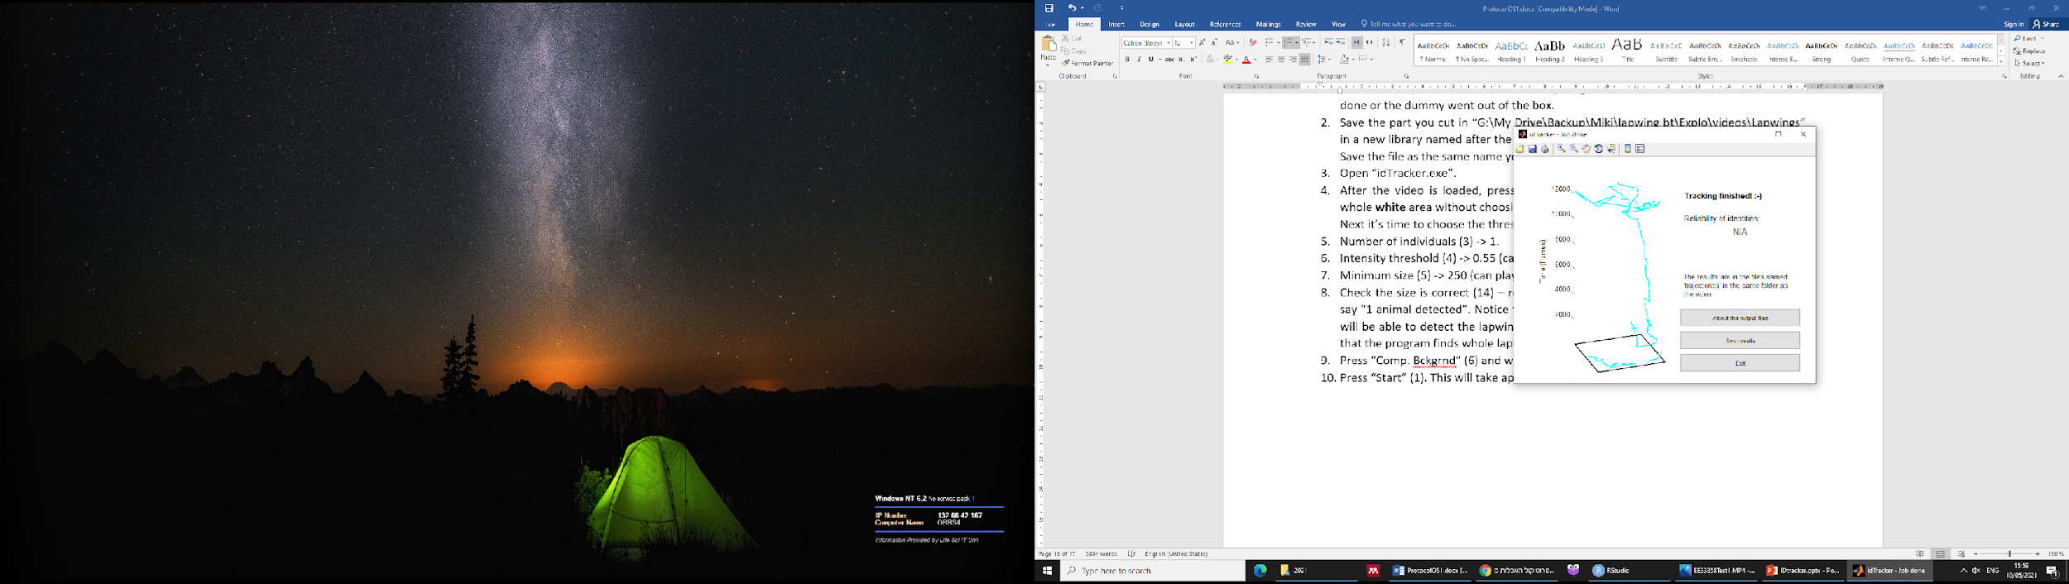

The movement is presented in a 3d format where the Z is time and X+Y is the movement. Check if it makes sense. Press “See results” and check the movement in the video (lines – tracks, Number: the individual tracked).

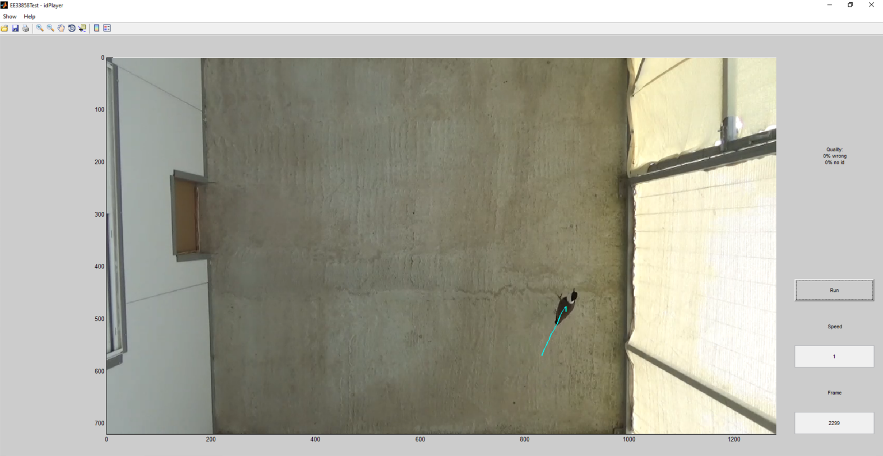

**References:**

1. Keren, M. Video analysis software Poke-a-bird 0.7. http://arnonlotem.weebly.com/technical-tools--code.html (2019).

2. Pérez-Escudero, A., Vicente-Page, J., Hinz, R. C., Arganda, S. & de Polavieja, G. G. idTracker: tracking individuals in a group by automatic identification of unmarked animals. *Nat. Methods* **11**, 743–748 (2014).