**Sensory Glasses for the Visually Impaired**

Michael Barney¹, Jonathan Kilner², Gilmar Brito³, Aida Araújo³, Meuse Nogueira¹

Federal Institute of Education, Science and Technology of Pernambuco (IFPE)

Recife, Brazil

¹{michaelbarneyjunior, meusejr}@gmail.com ²jonathankilner@hotmail.com ³{gilmarbrito, aidaferreira}@recife.ifpe.edu.br

# ABSTRACT

This paper presents the research and development of an assistive device for the visually impaired, based on the transmission of the distance of surrounding objects on the upper torso area through the use of 3D Binaural sound.

# 

# CSS Concepts

* **Accessibility -> Accessibility Technologies.**

# Keywords

Visually Impaired; Glasses; 3D Sound

# 1. INTRODUCTION

The Visually Impaired are more in tune with the remaining senses (taste, touch, hearing and smell) than people that have normal vision, specially hearing, enabling some to even develop the ability of echolocation (locate objects through the reflection of sound)[1]. In addition, their locomotion is usually made by means of walking sticks that help them through the movements of what is in front of them, besides also being used for identification, also known as white cane [3]. Even though it is the most used, the cane can not detect obstacles above the waist, which are present in most industrialized cities, and can thus cause damage to the physical integrity of the handicapped. Besides the cane there is another way for the handicapped to get around, which is to use a guide dog. However, this type of animal usually costs a lot of money and there is a training time for the dog and the handicapped, which often makes this type of locomotion impracticable. Due to these factors there are several electronic equipments which aid the locomotion of the handicapped. Most of these electronic locomotion systems use ultrasonic or infrared sensors [4]. However, only distance measurement is not enough to guide the visually impaired. For this it is necessary to transform this information into a signal that is perceptible and intuitive. This signal can be presented to the disabled through audio (beeps or three-dimensional sound) or by touch (vibrations). But this type of technology is not widespread and is often expensive. A research was carried out with the intention of developing a sensorial spectacle capable of assisting the locomotion of people with visual impairment.

# 2. METHODOLOGY

The research is focused on the development of a simple, efficient and interactive sensing and communication system between the disabled and the environment, in order to assist in their locomotion. Based on the schematic on Figure 1, the prototype was developed using the Arduino microcontroller, an Android Smartphone equipped with Bluetooth, ultrasonic sensors around the glasses and a Bluetooth module. The operation of the glasses revolves around the Arduino (figure 1), programmed in the Arduino IDE (Integrated Development Environment) [1], it is responsible for generating the signal that will be applied in the Trigger of the sensor, which will emit ultrasonic pulses which Hit an obstacle and returns (Echo), thus calculating the time spent for the pulse to go back and forth, see figure 2.

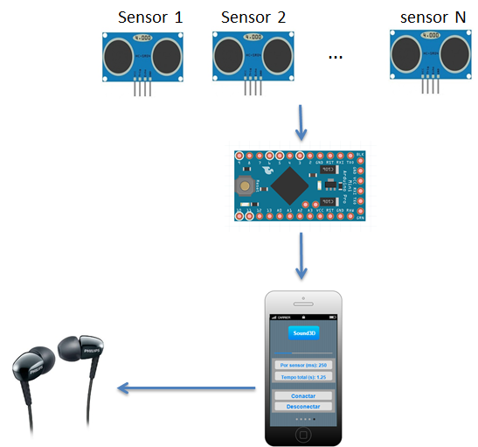

**Figure 1 - Schematic of the project operation.**

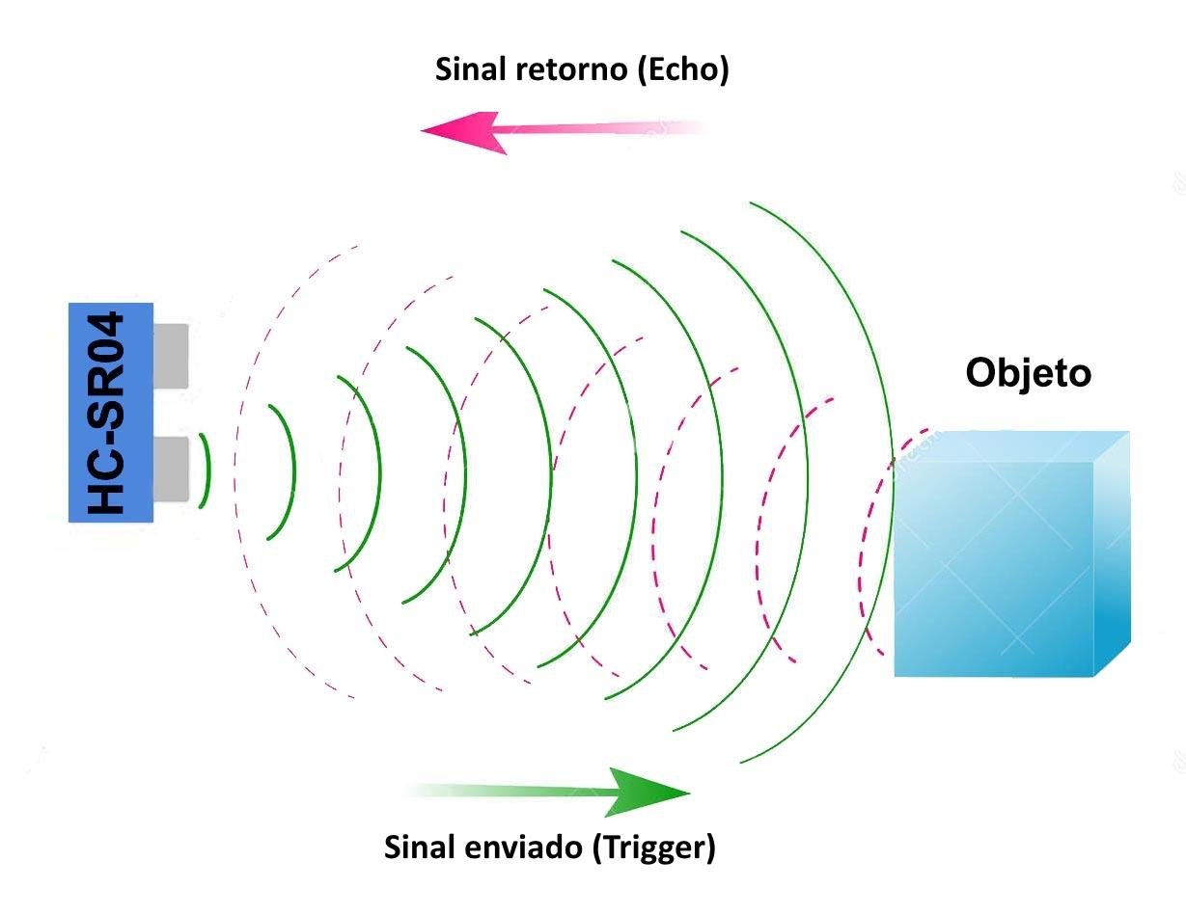

**Figure 2 - Sensor Operation**

Through it the Arduino is able to determine the distance from the glasses to the obstacle. After determining this distance, the calculated value is sent to the Smartphone via the bluetooth module. The smartphone through an application made in Android Studio [2], the IDE that Google offers for creating applications, is capable of generating three-dimensional sound inversely proportional to distance. Through this sound the user is able to mentally map the place in which it is. However, in order to be able to locate with this system it is necessary enough training, since the handicapped needs to be attentive to the sound that leaves the device through the headphones and the sounds of the place where it is, as shown in figure 3.

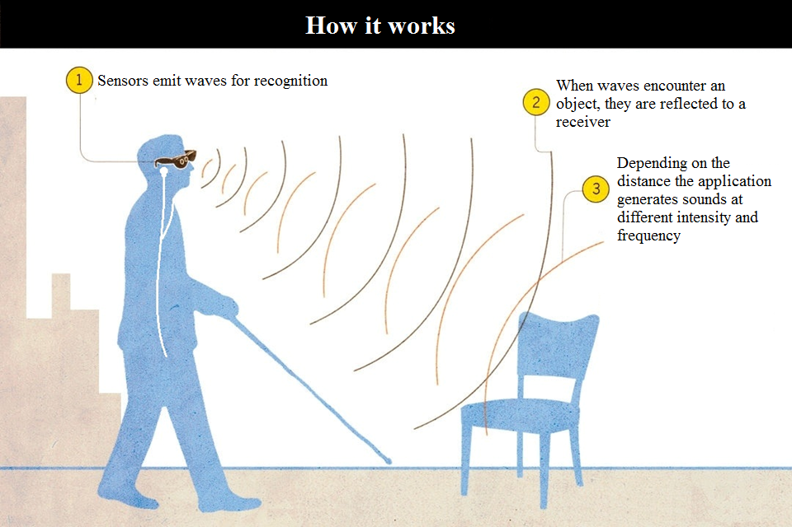

**Figure 3 - Project Operation**

# 3. EVALUATION OF THE DEVICE

After the first prototype was built, a visually impaired volunteer was called to test it. The guest was able to in 30 minutes understand the functioning of the device and was able to perceive the approximation of objects from all sides with sensors while standing still. While the volunteer was walking, it was perceived that the use of the glasses alone were insufficient, still needing the aid of the walking stick to detect objects lower that the glasses field of vision.

# 4. CONCLUSION AND FUTURE WORK

The built device today operates fully functionally using 5 ultrasonic sensors placed in the left, upper-left, front, upper-right and right of the glasses. It emits the calculated and filtered distances to the Android phone that converts that data into 3D binaural sound.

It is still needed further testing to guarantee the majority of visually impaired individuals will be able to effectively use the device.

Further development of the device aims to reach a communication of the device with other Internet of Things enabled devices. In that manner, other information besides the distance of objects may be transmitted through audio, such as signals from traffic lights and guiding information.

This work is Multidisciplinary, since it involved actuations and knowledge in several areas, such as: programming aimed at embedded and mobile devices, electronics in the digital, analogue, sensorial and signal transmission areas, practical knowledge on prototyping, printed circuit modeling, electronic welding, modeling 3D as well as techniques to enable the disabled to be able to use the equipment correctly to get around.

# 5. ACKNOWLEDGEMENTS

The Federal Institute of Science and Technology of Pernambuco for the financiating of Researchers and granting the laboratory space for the project. The Laboratory of Geoprocessing of the IFPE for the instrumentation needed for the device.

# 6. REFERENCES.

1. Arduino. *Arduino.cc*, 2017. <https://www.arduino.cc/>.
2. Android Studio. *Developer.android.com*, 2017. https://developer.android.com/studio/index.html.
3. Farcy, R., Leroux, R., Jucha, A., Damaschini, R., Grégoire, C., Zogaghi, A. Electronic Travel Aids And Electronic Orientation Aids For Blind People: Technical, Rehabilitation and Everyday Life Points Of View. Conference & Workshop on Assistive Technologies for People with Vision & Hearing Impairments. Technology for Inclusion. CVHI 2006, M.A. Hersh (ed.)
4. Jacquet, C., Bellik, Y., Bourda, Y. Electronic Locomotion Aids for the Blind: Toward More Assistive Systems. Intelligent Paradigms for Assistive and Preventive Healthcare, April 2006. pp. 133-163. N. Ichalkaranje, A. Ichalkaranje, L.C. Jain, editors. Springer-Verlag. DOI: 10.1007/11418337_5
5. Mats E. Nilsson and Bo N. Schenkman. Blind people are more sensitive than sighted people to binaural sound-location cues, particularly inter-aural level differences. Hearing Research, Volume 332, February 2016, Pages 223–232. DOI: <http://dx.doi.org/10.1016/j.heares.2015.09.012>