**Verilog Code for Input Conditioning**

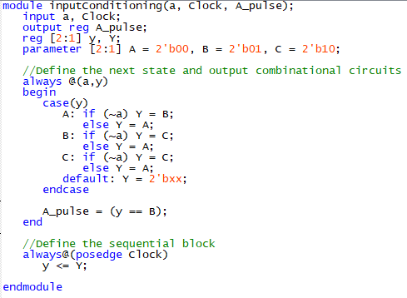

**Simulation for Input Conditioning**

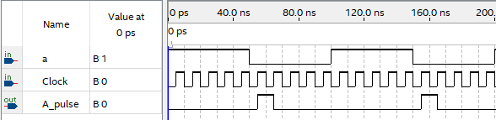

Since the altera board buttons are high when not pressed and low when pressed, we coded the state machine to “swap” the value from a low to a high to make it easier to work with in the rest of our code.

**Verilog Code for hex7seg**

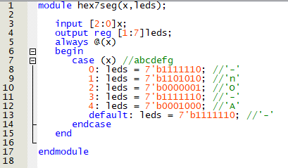

**Simulation for hex7seg**

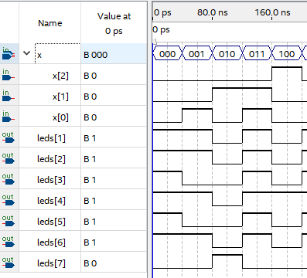Here the hex output is simulated through all possible outputs. The x value changes between 0,1,2,3, and 4. The hex output will display -,n,O,-, and A respectively.

**Verilog Code for Combination Lock**

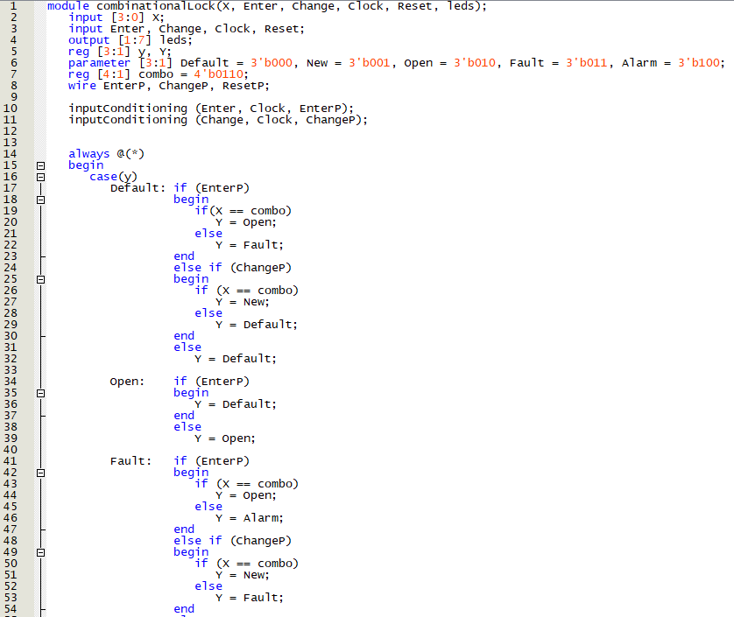

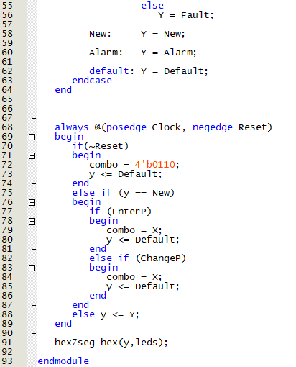

**Simulation for Combinational Lock**

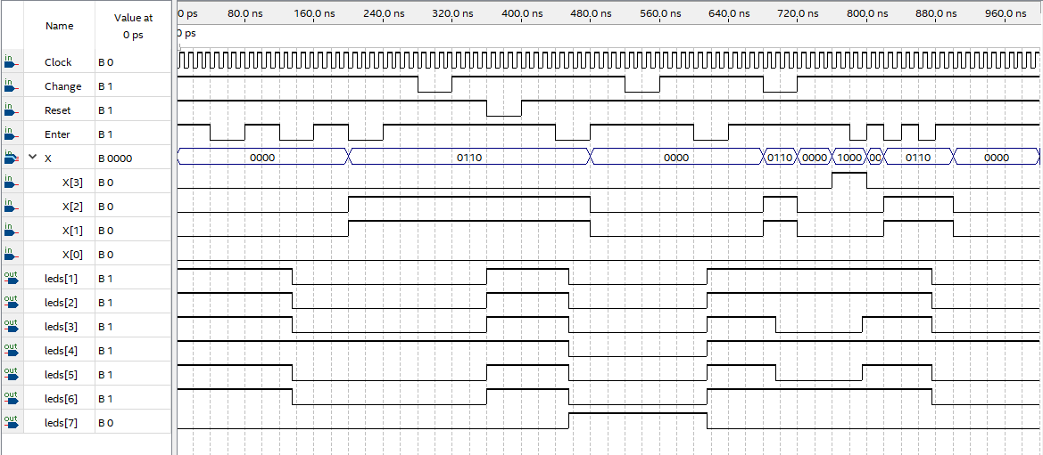

This simulation runs through inputting the wrong combo twice to get to the alarm state, then press change and enter to show that it does nothing. Now press reset to bring back to default. Enter the correct combo then enter to go to the open state. Press change to show that it does nothing. Press enter to go back to default. Change the combination, show that the new combination is now the combination that unlocks it and enter the old password to get to the alarm state.