Contents
- kepel_statvec.m
- ezxzquat.m
- ezxzrmx.m
- rmxquat.m
- delkep.m
- djm.m
- time_to_dayf.m
- inertial_to_terrestrial.m
- rectangular_to_spherical.m
- rigbody
- quatzxz.m
- quatrmx.m
- kepler.m
- rotmaz.m

Example
- demo_propat

Reference
- Vallado, D. A. (2013). Fundamentals of Astrodynamics and Applications (4th ed.). Hawthorne, CA: Microcosm Press.
- Chandeok Park, 2024. Chapter 2. Kepler’s Equation and Kepler’s Problem, ASTRODYNAMICS I, Yonsei University.
- Ohminsik, 2024. Propat-python Kinematics Guide
- D. Rose, 2015. Rotation Quaternions, and How to Use Them

Introduction
This document describes an overview of the MATLAB-based simulation framework designed for spacecraft attitude and orbit propagation. The simulation considers both the translational and rotational motion of a satellite, accounting for orbital perturbations and rigid body attitude dynamics. The core objective is to model the evolution of a satellite's position and orientation over time using Keplerian orbital elements, quaternion-based attitude representation, and numerical integration of the equations of motion.

The translational dynamics are initially derived from Keplerian elements, with additional effects from Earth's oblateness (J2 and J4) considered using analytical perturbation models. The rotational dynamics are modeled through quaternion-based representations and integrated using a rigid body dynamics model. The simulation includes transformations between coordinate frames (inertial and terrestrial), time conversions for use in sidereal time calculations, and magnetic field interactions for active attitude control.

At the end of the document, a simulation example demonstrates how these functions are applied in practice, supported by figures and results generated from the full code.

Function Application Workflow
1. Initial Keplerian Element and State Vector Setup
- The kepel_statvec function converts the initial Keplerian elements (a,e,i,Ω,ω,M) to an ECI position and velocity vector.
- Internally, the conversion from Mean Anomaly M to Eccentric Anomaly E is computed using the kepler function via the Newton-Raphson method.
- The resulting position/velocity vectors in PQW coordinates are rotated to ECI using frame transformation matrices.

Function Name | Brief Description
kepel_statvec | Converts Keplerian elements to ECI state vector (includes PQW → ECI rotation)
kepler | Computes the Eccentric Anomaly (E) from Mean Anomaly (M) using the Newton-Raphson method
rotmaz, rotmax | Generates z- and x-axis rotation matrices used for coordinate transformation
2. Attitude Initialization using Euler Angles and Quaternion Conversion
- The initial spacecraft attitude is defined using Z-X-Z Euler angles.
- These are converted to a rotation matrix via the ezxzrmx function, then transformed to quaternions via rmxquat.

Function Name | Brief Description
Ezxzrmx | Generates a rotation matrix from Z-X-Z Euler angles using rotmaz, rotmax
rmxquat | Converts rotation matrix to quaternion
ezxzquat | Wrapper function that converts Euler angles directly to quaternions

3. Orbital Perturbation Rate Calculation
- The delkep function estimates the secular rates of change of orbital elements due to J2 and J4 geopotential terms.
- These are used for analytical orbit propagation.

Function Name | Brief Description
delkep | Calculates secular change rates of orbital elements due to Earth's oblateness (J2, J4)

4. Time Configuration
- The simulation time is initialized, and UTC time is converted to MJD and seconds-from-midnight for potential sidereal time handling.

Function Name | Brief Description
djm | Converts calendar date to Modified Julian Date (MJD)
time_to_dayf | Converts (hh:mm:ss) time to elapsed seconds of the day in UTC

5. Attitude Propagation using Quaternion Rigid Body Model
- The rigbody function is used as the ODE function for ode45, computing attitude dynamics.
- The quaternion derivative and angular acceleration are computed using Newton-Euler equations.
- Optionally, magnetic torques are added if mag_moment and magnetic_field are provided.

Function Name | Brief Description
rigbody | Computes quaternion and angular velocity derivatives for attitude propagation
sangvel | Constructs the angular velocity skew-symmetric matrix used in quaternion dynamics
quatrmx | Converts quaternion to rotation matrix (used in torque computation)

6. Quaternion-to-Euler Angle Conversion for Output
- After propagation, quaternions are converted back to Euler angles in Z-X-Z order for interpretation and plotting.

Function Name | Brief Description
quatezxz | Converts quaternion back to Z-X-Z Euler angles via quatrmx and rmxezxz

7. (Optional) Frame Transformations and Magnetic Coordinate Conversion
- If magnetic field models or Earth-fixed output is required, coordinate transforms are applied.

Function Name | Brief Description
inertial_to_terrestrial | Transforms state vector from inertial (ECI) to Earth-fixed (ECEF/GTC) frame
rectangular_to_spherical | Converts ECEF position to spherical coordinates (longitude, latitude, radius)

function [statvec] = kepel_statvec (kepel)

Input : semimajor axis, eccentricity, inclination, right ascension of ascending node, argument of perigee, mean anomaly
Output : ECI coordinates state vector $\left(x,y,z,v_{x},v_{y},v_{x}\right)$
Internal functions : kepler, rotmax, rotmay, rotmaz

Detailed Description :
The following description is limited to general elliptical orbits. The length of the long radius is set to a, the length of the short radius is set to b, and the focal length is set to c. When an object forms an elliptical orbit around a focal point, the closest point to the focal point is defined as periapsis, and the farthest point is defined as apoapsis.

(1) semi-major axis[m]: corresponds to the orbital long radius and is the distance from the center of the elliptical orbit to periapsis.

(2) eccentricity: orbital eccentricity and defined as c/a. Or, if the distance from the focal point, which is the center of the elliptical orbit, to periapsis, is r_p and the distance from focal point to apoapsis is defined as r_a, it is also defined as $\frac{r_{a}-r_{p}}{r_{a}+r_{p}}$.

(3) inclination[rad]: defined as the $\left(\vec{h}≡\vec{r}×\vec{v}\right)$ of the orbital plane vector $i=\frac{h_{k}}{\left|\vec{h}\right|}[0,π]$, indicating how inclined the orbital plane is with respect to the kaxis of the ECI coordinate system.

(4) right ascension of ascending node [rad]: The angle $Ω=\cos^{-1}\left(\frac{n_{I}}{\left|\vec{n}\right|}\right)[0,2π]$ formed by ascending node vector$(\vec{n}≡\hat{k}×\vec{h})$ in the direction of $\vec{v}∙\vec{k}>0$ during the intersection of the orbital plane and the IJ plane of the ECI coordinate system with Iaxis, and the value of $2π-Ω$ is used behind the $n_{j}<0$.

(5) argument of perigee [rad]: $ω=\cos^{-1}\left(\frac{\vec{n}∙\vec{e}}{\left|\vec{n}\right|\left|\vec{e}\right|}\right)$, defined as the angle formed by the ascending node vector and the eccentricity vector $\left(=\vec{e}=\vec{r_{p}}\right)$, uses the value of $2π-ω$ if it is $e_{k}<0$.
(6) mean anomaly [rad] : defined as $M≡E-esin(E)$, where E is eccentricity anomaly.

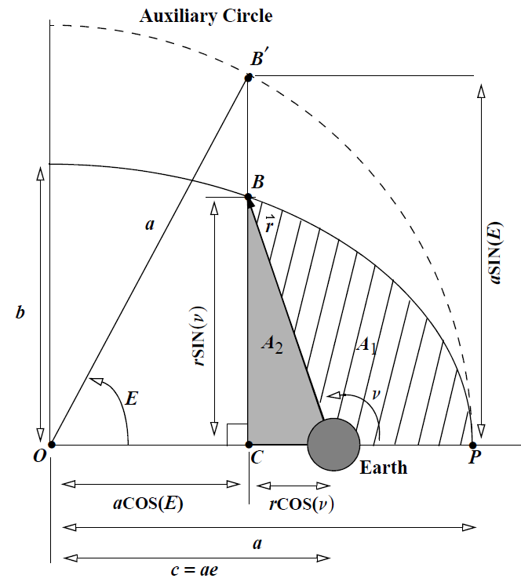
Figure 1 Vallado, D. A. (2013). Fundamentals of Astrodynamics and Applications (4th ed.). Hawthorne, CA: Microcosm Press. (Figure 2-2).
E is the intersection of a straight line perpendicular to the major axis of the ellipse at the point where the object is currently in orbit, and a circle with the same center as the major radius of the ellipse meets, and is located in the same quadrant as the point on the ellipse. It can be expressed $tan\left(\frac{E}{2}\right)=\sqrt{\frac{1-e}{1+e}}tan\left(\frac{ν}{2}\right)$ through ($\vec{υ}$: true anomaly), which means the angle of $\vec{e}$ with respect to $\vec{r}$.

line 36 : orb2iner : transform the state vector on the PQW coordinate system into the state vector on the ECI coordinate system.
$$\left(\begin{matrix}\vec{r_{IJK}} \\ \vec{v_{IJK}}\end{matrix}\right)=\left(\begin{matrix}R_{3}(-Ω)R_{1}(-i)R_{3}(-ω)\vec{r_{PQW}} \\ R_{3}(-Ω)R_{1}(-i)R_{3}(-ω)\vec{v_{PQW}}\end{matrix}\right)$$

The PQW coordinate system is a coordinate system in which the origin is the focal point of the elliptical motion, the preferred direction $\vec{e}$, and the fundamental plane corresponding to the orbital plane.

line 40 : E = kepler(kepel(6), exc); Description below
line 48 : statvec = [[a*(cE - exc), a*c1*sE, 0]*orb2iner', [-c3*sE, c1*c3*cE, 0]*orb2iner'];
The above line converts the state vector $\vec{r_{PQW}}=(a\left(cos⁡(E\right)-e),asinE\sqrt{1-e^{2}},0)$ and $\vec{v_{PQW}}=\left(-\frac{\sqrt{μa}}{r}\sin\left(E\right),\frac{\sqrt{μa\left(1-e^{2}\right)}}{r}\cos\left(E\right),0\right)$ on the PQW coordinates into the state vector on the ECI coordinate system through the rotational transformation of line 36.
Finally, the state vector $\vec{r},\vec{v}$ of the ECI coordinate system are obtained.
function [quaternions] = ezxzquat (euler_angles)

Input : Euler angles from a Z-X-Z rotation
Output : quaternions
Internal functions : ezxzrmx, rmxquat

Detailed Description :

This function uses the ezxzrmx function to transform a given Euler angle into a Z-X-Z rotation matrix.
Next, it converts the Z-X-Z rotation matrix into quaternion using the rmxquat function.
A description of the function is provided below.

function [rot_mat] = ezxzrmx (euler_angles)

Input : Euler angles from a Z-X-Z rotation
Output : rotation matrix (3, 3)
Internal functions : rotmaz, rotmax

Detailed Description :
This function produces a rotation matrix that rotates by a given angle relative to the z-axis(1), x-axis(2), z-axis(3) of the currently set coordinate system.

(1), (2), (3) represent Euler angles from a Z-X-Z rotation

Transform using the rotmaz, rotmax functions in the order of Z-X-Z for the rotational matrix transformation.

rotmaz : This unction produces a rotation matrix that rotates by a given angle relative to the z-axis of the currently set coordinate system.

rotmax : This function produces a rotation matrix that rotates by a given angle relative to the z-axis of the currently set coordinate system.

function [quaternions] = rmxquat (rot_mat)

Input : rotation matrix (3, 3)
Output : attitude quaternions
Internal functions : rotmaz, rotmax

Detailed Description :
This function produces a rotation matrix that rotates by a given angle relative to the z-axis(1), x-axis(2), z-axis(3) of the currently set coordinate system.

(1), (2), (3) represent Euler angles from a Z-X-Z rotation

By Propat-python Kinematics Guide, when rotation matrix is M, quaternions are

$$q_{0}=\sqrt{\frac{Trace\left(M\right)+1}{4}}$$
$$q_{1}=\sqrt{\frac{M_{11}}{2}+\frac{1-Trace\left(M\right)}{4}}$$
$$q_{2}=\sqrt{\frac{M_{22}}{2}+\frac{1-Trace\left(M\right)}{4}}$$
$$q_{3}=\sqrt{\frac{M_{33}}{2}+\frac{1-Trace\left(M\right)}{4}}$$

It defines selec(Remove the root and /4 from the above expression) and auxi,
$$selec=\left[\begin{matrix}\begin{matrix}1+Trace(M) \\ 1-Trace\left(M\right)+2M_{11}\end{matrix} \\ \begin{matrix}1-Trace\left(M\right)+2M_{22} \\ 1-Trace\left(M\right)+2M_{33}\end{matrix}\end{matrix}\right], auxi=max of selec and its index{}$$

To resolve Quaternion's signs, find the largest of q0, q1, q2, q3 and assume its sign is positive. Then compute the remaining components as shown in the table below. Taking the largest magnitude avoids division by small numbers, which would reduce numerical accuracy.
If $q_{0}$ is largest: | If $q_{1}$ is largest: | If $q_{2}$ is largest: | If $q_{3}$ is largest:
$$q_{1}=\frac{M_{32}-M_{23}}{4q_{0}}$$ | $$q_{1}=\frac{M_{32}-M_{23}}{4q_{1}}$$ | $$q_{1}=\frac{M_{13}-M_{31}}{4q_{2}}$$ | $$q_{0}=\frac{M_{21}-M_{12}}{4q_{3}}$$
$$q_{2}=\frac{M_{13}-M_{31}}{4q_{0}}$$ | $$q_{2}=\frac{M_{12}+M_{21}}{4q_{1}}$$ | $$q_{2}=\frac{M_{12}+M_{21}}{4q_{2}}$$ | $$q_{1}=\frac{M_{13}-M_{31}}{4q_{3}}$$
$$q_{3}=\frac{M_{21}-M_{12}}{4q_{0}}$$ | $$q_{3}=\frac{M_{13}+M_{31}}{4q_{1}}$$ | $$q_{3}=\frac{M_{23}+M_{32}}{4q_{2}}$$ | $$q_{2}=\frac{M_{23}+M_{32}}{4q_{3}}$$

function [deltakep] = delkep (kep_el)

Input : semimajor axis, eccentricity, inclination, right ascension of ascending node, argument of perigee, mean anomaly
Output : Change rate of kepler elements due to J2, J4 perturbation (change rate of a, e, i are 0)
Internal functions :

Detailed Description :
The change rate in kepler elements due to J2 and J4 perturbations is obtained.
Since the Earth is not a complete sphere, there is an imbalance in the gravitational field depending on its position. Typically, the radius near the equator becomes larger than the radius of the polar regions due to the rotation of the Earth, and $J_{l}$ perturbations mean perturbations indicating this imbalance.

$l \& m components$ : The Earth's Aspherical Gravitational Potential according to the satellite location is described as follows.

$$U=\frac{μ}{r}\sum_{l=0}^{∞}{P_{l}\left[sinϕ_{gcsat}\right]{\left(\frac{R_{⊕}}{r}\right)}^{l}C_{l,0}+\frac{μ}{r}\sum_{l=1}^{∞}{\sum_{m=1}^{l}{P_{l,m}\left[sinϕ_{gcsat}\right]{\left(\frac{R_{⊕}}{r}\right)}^{l}\left[C_{l,m}cos\left(mλ_{sat}\right)+S_{l,m}sin\left(mλ_{sat}\right)\right]}}}$$
where
$$ϕ_{gcsat} :geocentric latitude of satellite$$
$$λ_{sat} :longitude of satellite$$
$$P_{l}\left[γ\right]=\frac{1}{2^{l}l!}\frac{d^{l+m}{\left(γ^{2}-1\right)}^{l}}{dγ^{l+m}} : series of Legendre polynomials$$
$$P_{l,m}\left[γ\right]=\frac{1}{2^{l}l!}{\left(1-γ^{2}\right)}^{m/2}\frac{d^{l+m}{\left(γ^{2}-1\right)}^{l}}{dγ^{l+m}}={\left(1-γ^{2}\right)}^{m/2}\frac{d^{m}}{dγ^{m}}P_{l}\left[γ\right]$$
$$C_{l,m}^{'}=\int{r_{sat}}\frac{\left(l-m\right)!}{\left(l+m\right)!}P_{l,m}\left[sinϕ_{gcsat}\right]cos(mλ_{sat})dm_{⊕}$$
$$S_{l,m}^{'}=\int{r_{sat}}\frac{\left(l-m\right)!}{\left(l+m\right)!}P_{l,m}\left[sinϕ_{gcsat}\right]sin(mλ_{sat})dm_{⊕}$$
$$C_{l,m}=\frac{C_{l,m}^{'}}{{R_{⊕}}^{l}m_{⊕}},S_{l,m}=\frac{S_{l,m}^{'}}{{R_{⊕}}^{l}m_{⊕}} : Normalized coefficient$$
And $J_{l}$ is defined as $-C_{l,0}$. Where $l$ is degree, $m$ is order.

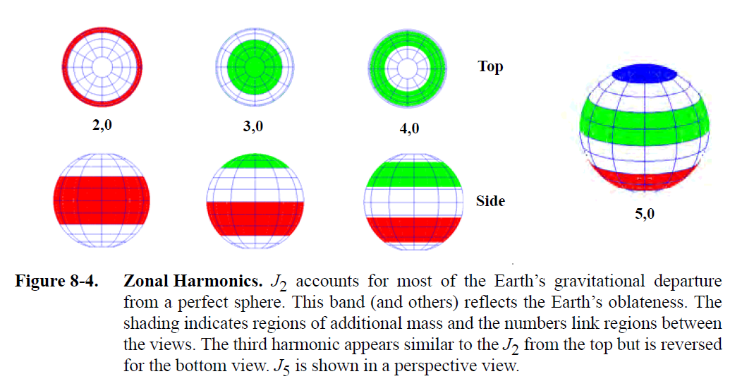
Figure 2 Vallado, D. A. (2013). Fundamentals of Astrodynamics and Applications (4th ed.). Hawthorne, CA: Microcosm Press. (Figure 8-4).

This code shows the changes in $Ω,ω and ν\left(true anomaly\right)$ Kepler elements due to J2 and J4 perturbations, which are mainly affected near i=0$°$. In the case of a, e, and i, the rate of change is treated as zero because there is a short-term periodic change due to the perturbation, but there is no secular change.

Related function : delkep.m

function [diju] = djm (day, month, year)

Input : day(day of month), month(month of the year), year
Output : Modified Julian Date in days, referred to 1950.0.
Detailed Description :
This function calculates (Modified Julian Date, MJD) for a given date (day, month, year). The Julian date refers to the number of days between Jan. 1, 4713 B.C. 12:00 and the current time. Modified Julian Date is defined as follows.
$$MJD=JD-{JD}_{epoch}$$
The epoch used in this code is B1950.0 with a value of ${JD}_{epoch}=2,433,282.42345905$

line 20 : Days(per year) + current days - epoch correction constant + Days(per month) - leap year correction

function [dayf] = time_to_dayf (hours, minutes, seconds)

Input : hours[integer], minutes[integer], seconds
Output : seconds elapsed in the day(UTC)

function [xterrestrial] = inertial_to_terrestrial (tesig, xi)

Input : Greenwich sidereal time in radians, referred to 1950.0., ECI coordinates state vector $\left(x,y,z,v_{x},v_{y},v_{x}\right)$
Output : State vector in Geocentric Terrestrial Coordinates $\left(x,y,z,v_{x},v_{y},v_{x}\right)$
Internal functions : rotmaz
Detailed Description :
This function transforms a geocentric inertial state vector into geocentric terrestrial coordinates. It turns the position vector and the velocity vector through the rotmaz matrix by the (Greenwich sidereal time) with respect to the z-axis.
Related function : gst.m, terrestrial_to_inertial.m

function [spherical] = rectangular_to_spherical (geoc)

Input : State vector in Geocentric Terrestrial Coordinates $\left(x,y,z,v_{x},v_{y},v_{x}\right)$
Output : Geocentric Coordinates Vector (λ[rad],ϕ[rad],r[m])
Internal functions :
Detailed Description :

Calculate the Square of the x and y Components
$$ws=x^{2}+y^{2}$$
Calculate the Geocentric Distance
$$r=\sqrt{ws+z^{2}}$$
Compute the Longitude λ
$$λ=atan2(y,x)$$
Compute the Geocentric Latitude ϕ
$$ϕ=atan2(z,ws)$$

Return the Spherical Coordinates
$$spherical=(λ, ϕ,r)$$

function dxdt = rigbody (time, x, flag, ext_torque, tensin, teninv, ...
mag_moment, magnetic_field)

Input : Propagation time[sec],State vector(4 quaternions, 3 angular velocity(rad/s)), ODE45 options, external torque (perturbation torque + control torque), Inertia matrix of axis-symetric rigid body, Inverse inertia matrix, Magnetic moment torque flag and moment, Earth's magnetic field
Output : Time derivative of the state vector $\left(\dot{q_{0}},\dot{q_{1}},\dot{q_{2}},\dot{q_{3}},\dot{ω_{x}},\dot{ω_{y}},\dot{ω_{z}}\right)$,
Internal functions : sangvel, quatrmx
Detailed Description :

The state vector x is divided into the quaternion q and angular velocity w.

1. Extract Quaternions and Angular Velocity
2. Calculate Quaternion Time Derivative

- sangvel(w) creates a skew-symmetric matrix Ω(ω) using the angular velocity vector
$$ω=\left[ω_{x},ω_{y},ω_{z}\right]$$
This matrix is defined as:
$$Ω\left(ω\right)=\left[\begin{matrix}\begin{matrix}0 & ω_{z} \\ -ω_{z} & 0\end{matrix} & \begin{matrix}-ω_{y} & ω_{x} \\ ω_{x} & ω_{y}\end{matrix} \\ \begin{matrix}ω_{y} & -ω_{x} \\ -ω_{x} & -ω_{y}\end{matrix} & \begin{matrix}0 & ω_{z} \\ -ω_{z} & 0\end{matrix}\end{matrix}\right]$$
- The time derivative of a quaternion $\dot{q}$​ is given by:
$$\dot{q}=\frac{1}{2} Ω\left(ω\right)q$$
3. Calculate Total Torque

- Initially, the total torque is set to the external torque(ext_torque).
- If both mag_moment and magnetic_field are provided, the function calculates the magnetic torque $τ$:
$$τ=m×\left(R∙B\right)$$
m is the magnetic moment, B is the magnetic field, and R is the rotation matrix derived from the quaternion q. This magnetic torque is then added to the total torque.

4. Calculate Angular Velocity Time Derivative

- This step calculates the derivative of the angular velocity, ω˙\dot{\omega}ω˙, using the Newton-Euler rotational dynamics equation:
$$I\dot{ω}+ω×\left(Iω\right)=M$$

Where I is the inertia matrix, ω is the angular velocity, M is the total torque acting on the system.

5. Combine and Return State Derivatives

function [euler_angle] = quatezxz (quaternion)
Input : attitude quaternions
Output : Euler angles from a Z-X-Z rotation
Internal functions : quatrmx, rmxezxz

Detailed Description :
This function determines the size of the input quaternions.
m: Number of rows (should be 4 for quaternions).
n: Number of quaternions provided (each column represents one quaternion).

Iterates through each column of the quaternion matrix, where each column represents a single quaternion.

The quatrmx.m function converts the quaternion into a 3×3 rotation matrix.

The rmxezxz.m function calculates the Euler angles in the Z-X-Z rotation order from the rotation matrix. The resulting Euler angles are added as a new column in the euler_angle matrix using the cat.m function (concatenating along the second dimension).

function [rot_mat] = quatrmx (quaternion)
Input : attitude quaternions
Output : rotation matrix (3, 3)
Internal functions :

Detailed Description :

The quarternion for the axis of rotation $\hat{n}=\left(n_{x},n_{y},n_{z}\right)$ and the angle of rotation $θ$ consists of the following.
$$q=\left[n_{x}∙sin\left(\frac{θ}{2}\right),n_{y}∙sin\left(\frac{θ}{2}\right),n_{z}∙sin\left(\frac{θ}{2}\right),cos\left(\frac{θ}{2}\right)\right]$$

To rotate the vector $\vec{v}$, use the following quaternion product

$${\vec{v}}^{'}=q∙q_{v}∙q^{-1}$$
when $q^{-1}=\left(-q_{1},-q_{2},-q_{3},q_{4}\right)$.

Deployment of the product above according to the Quaternion Multiplication Rule yields the following results
$${\vec{v}}^{'}=\vec{v}+2q_{4}\left(\vec{q}×\vec{v}\right)+2\left(\vec{q}×\left(\vec{q}×\vec{v}\right)\right)$$

Since the above expression consists of linear operations, you can change it to matrix product form.
$${\vec{v}}^{'}=R∙\vec{v}$$

The rotational matrix R transformation equation for quaternion q is derived.

$$R=\left[\begin{matrix}q_{1}^{2}-q_{2}^{2}-q_{3}^{2}+q_{4}^{2} & 2(q_{1}q_{2}+q_{3}q_{4}) & 2(q_{1}q_{3}-q_{2}q_{4}) \\ 2(q_{1}q_{2}-q_{3}q_{4}) & -q_{1}^{2}+q_{2}^{2}-q_{3}^{2}+q_{4}^{2} & 2(q_{2}q_{3}+q_{1}q_{4}) \\ 2(q_{1}q_{3}+q_{2}q_{4}) & 2(q_{2}q_{3}-q_{1}q_{4}) & -q_{1}^{2}-q_{2}^{2}+q_{3}^{2}+q_{4}^{2}\end{matrix}\right]$$

function [eccentric] = kepler (mean_anomaly, eccentricity)

Input : mean anomaly[rad], eccentricity
Output : eccentricity anomaly[rad]
Detailed Description :
Function to calculate Eccentricity anomaly E through mean_anomaly M and eccentricity

The initial guess is
$$E≈M+e\left(1-0.125e^{2}\right)\sin\left(M\right)+0.5e^{2}(\sin\left(2M\right)+0.75esin(3M))$$
which corresponds to the approximate equation of E applied when $e<0.1$.

At this time, the search for E is terminated when the error is less than 1e-12 or the number of repetitions is 10 using the Newton-Raphson method to find a value where the function f(E)=E-esin(E)-M representing the error of E becomes 0.

function [rot_mat] = rotmaz (angle)

Input : rotation angle[radian]
Output : z-axis roation matrix(about given angle)
Detailed Description :
This function produces a rotation matrix that rotates by a given angle relative to the z-axis of the currently set coordinate system.

Example 1 demo_propat
This MATLAB code simulates the propagation of a spacecraft's orbit and attitude using the PROPAT tool. It initializes the spacecraft's orbital elements and attitude, accounts for perturbations due to Earth's oblateness, and propagates the system over a defined time period. The simulation uses an ODE solver to handle rotational dynamics, considering external torques and the spacecraft's inertia matrix. The results, including changes in Euler angles, angular velocity, and orbital elements, are stored and plotted to visualize the spacecraft's behavior over time.

1. Initial Setup and Input Definition
1.1 Setting Orbital Elements (Keplerian Elements)
- The kepel variable defines the initial orbital elements of the satellite, including parameters such as semi-major axis (7000 km), eccentricity (0.01), orbital inclination (98 degrees), etc.
1.2 Conversion to State Vector
- The orbital elements are converted into a state vector, which includes the position and velocity and is used for orbit propagation.
1.3 Attitude Initialization
- The satellite's initial attitude is defined using Euler angles and then converted to quaternions. The angular velocity vector is also set. Quaternions are a stable mathematical representation for 3D rotations.
2. Calculation of Orbital Element Changes
2.1 Orbital Element Changes Due to Earth's Oblateness
- The delkep function calculates changes in orbital elements due to Earth's oblateness (flattening). This predicts how the orbital elements will change over time.
3. Time and Simulation Setup
- The simulation is set to run from 0 seconds to 600 seconds with a time step of 0.5 seconds.
4. Inertia Matrix and Initial Condition Setup
4.1 Setting the Inertia Matrix
- The satellite's inertia matrix and its inverse are defined. This is essential for accurately modeling the satellite's rotational dynamics.
5. Orbit and Attitude Propagation
5.1 Orbit Propagation
- Over time, the orbital elements change according to delk, and these are then converted back into a state vector.
5.2 Setting External Torque and Initial Attitude Vector
- The external torque is set, and the initial attitude vector is defined.
5.3 Attitude Propagation Using ODE45
- ode45, a common MATLAB ODE solver, is used to propagate the satellite’s attitude over time. The rigbody function calculates the changes in the attitude vector over time.
- If flag_mag is set to 1, the attitude propagation considers the effects of Earth’s magnetic field.
5.4 Updating Propagated Results
- The new attitude vector calculated by ode45 is updated. The quaternion is converted back into Euler angles.
6. Storing and Visualizing Simulation Results
6.1 Storing Data
- During the simulation, time, Euler angles, angular velocity, and orbital state are stored for later visualization.
6.2 Visualizing Results
- The stored data is plotted to visualize the simulation results. Each graph shows how the satellite’s attitude and orbit change over time.

