Lecture 6

HW2 Questions:
- top down design
- bottom up

By default, floating point constants are double in C.

- constants in declarations and constants in expressions
- in almost all cases, this does what you expect
- constants may take up more memory than you expect
- there may be some additional conversions that take a couple of instructions
  - Many floating point calculations are done with doubles, where it may look as if they are floats.
  - Generally, not anything to concern yourself with.

Add an ‘f’ to them to make them float.

floating point constants:

for float

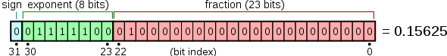

for double

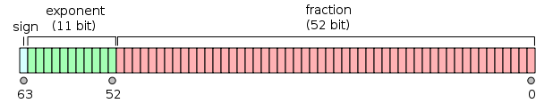

for long double

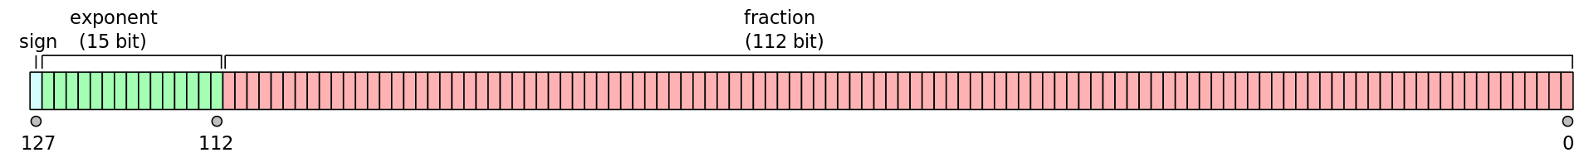

1 #include <stdio.h>
2 int main(int argc,char* argv[])
3 {
4 // lets look at the bit pattern of a float
5 union
6 {
7 float f;
8 int i;
9 } u;
10 // a union makes f and i share the same memory location
11 u.f = 2.0;
12 printf(" %f %x\n",u.f,u.i);
13 u.f = 4.0;
14 printf(" %f %x\n",u.f,u.i);
15 u.f = 8.0;
16 printf(" %f %x\n",u.f,u.i);
17 u.i = 0x41800000;
18 printf(" %f %x\n",u.f,u.i);
19 return 0;
20 }
~

0100 0000 0000 0000 0000 0000 0000
sign = 0
exponent = 100 0000 0
fraction = 000 0000 0000 0000 0000 0000

0100 0000 1000 0000 0000 0000 0000 0000
sign = 0
exponent = 100 0000 1
fraction = 000 0000 0000 0000 0000 0000

Note only a single bit has changed, which is what you would expect.

Not obvious, but there is a decoder ring:

https://en.wikipedia.org/wiki/Single-precision_floating-point_format

Comparing floating point numbers:
- rounding and other imprecision's of floating point math on digital computer make this problematic
- comparing with ‘directly assigned’ numbers almost always works
  - 0.0 is OK, others can be a problem
- ‘almost always’ is not what you want to rely on

Compare against a range for ‘equality’

Floating point math is inexact.

1 #include <stdio.h>
2
3 int main(int argc,char* argv[])
4 {
5 float a;
6 float b;
7
8 a = 0.0;
9 for (int i=0;i<500;i++)
10 a = a + 0.112;
11 b = 0.112 * 500.0;
12
13 if (a==b)
14 printf("they are equal %f %f\n",a,b);
15 else
16 printf("they are not equal %f %f\n",a,b);
17 return 0;
18 }
~
[bdavis@localhost hw3]$ gcc fp3.c -O0
[bdavis@localhost hw3]$ ./a.out
they are not equal 55.999859 56.000000
[bdavis@localhost hw3]$

#include <math.h>

int fpclassify(x);

int isfinite(x);

int isnormal(x);

int isnan(x);

int isinf(x);

Use these in assert() to find errors in the code during development.
Do examples:
- test for 0.0 or a floating point literal
- show divide by 0
- Try to use a NaaN
- assert() detecting a NaaN

1 #include <stdio.h>
2 #include <math.h>
3 #include <assert.h>
4
5 int main(int argc,char *argv[])
6 {
7 float A;
8 float B;
9 A=0.0f;
10 B=1.0;
11 printf("%f %f\n",B/A,A/A);
12 // add a number to them
13 B=B/A+1.0;
14 A=A/A+1.0;
15 printf("%f %f\n",B/A,A/A);
16 // how to always test for a NaN
17 if (A==A)
18 printf("they are equal\n");
19 else
20 printf("they are not equal\n");
21 // easy assertion
22 assert(isfinite(A));
23 assert(isfinite(B));
24 return 0;
25 }
~
[bdavis@localhost hw3]$ ./a.out
inf -nan
-nan -nan
they are not equal
a.out: fp4.c:22: main: Assertion `isfinite(A)' failed.
Aborted (core dumped)
[bdavis@localhost hw3]$

