**ePortfolio:**

(<https://michaelbotha-repos.github.io/ePortfolio-MSc/#SSD>)

Module Reflections

Week 1

This week was challenging because I was completing my preparation for a Python certification in unison with my studies. Which I felt necessary to make myself more marketable as a software developer, but also to further my knowledge of Python related technologies, enabling me to engage at a deeper level with my MSc studies. As seen in Figure 1, I need to work on my understanding of exceptions to be able to make my code more secure.

It was helpful learning about the OWASP standards and support framework provided to programmers. Where the common vulnerabilities to look for in my code and the standard means to rectify them are presented.

I was assigned a teammate for the coding assignment – Gennaro Coppola, who is a fulltime programmer. I look forward to working with him, and seeing what insights I can glean regarding coding and the software industry in general.

Week 2

I found some interesting content online regarding the Agile Scrum methodology and now have a basic understanding of the framework, which will hopefully help with the coding project’s planning. Reading the required chapters regarding the architectural attributes pertaining to good code was very insightful, and will guide me in my thought process when dissecting a system design.

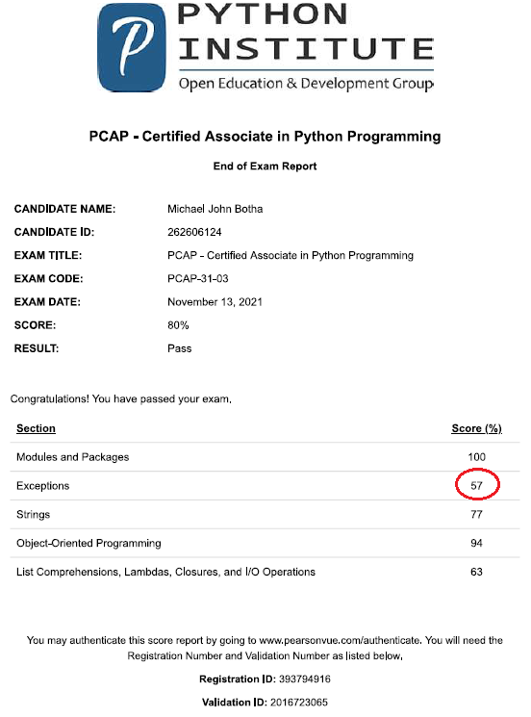

**Figure 1 – Python Certification Test Result**

Week 3

Having to get through many pages of reading has reiterated that at the master’s level one needs to be able to read quickly and effectively through large amounts of new information. Additionally, planning, learning what areas of content not to focus on, and making good notes has become a key feature of success in this domain. “Software Architecture with Python” is really helping me to be aware of more standardised coding patterns.

Reviewing the concept and application of threading and the dangers of buffer overflows reignited my interest in Operating Systems (OSes). I was encouraged to research further into memory allocations with regards to programs during execution, by reading some of “Think OS” which is part of the program’s core reading list. I will need to delve deeper into this subject, perhaps through learning more C, or the newer C++ language. However, my understanding is sufficient for now especially considering Python has a memory manager. Although an awareness of such is still relevant to the Python environment.

Week 4

I find recursion a difficult concept to implement, however can apply it in its basic application, like for a Fibonacci or Factorial algorithm. Noting that it is a dangerous technique to use will keep me clear of jumping to it as a solution. Regular Expressions are useful, however I might prefer to use some of the built-in functionality provided by the many string methods and functions supplied by the standard Python library. I’m enjoying the seminars which are a good time to engage with Cathryn regarding various topics. Communicating with people via video conferencing rather than emails really assists me to collaborate and get a sense of different individuals’ experiences and views.

Week 5

Learning about code testing made me realise that it is a complex science, where various metrics, probabilities, standards, techniques, and tools meet. I do prefer more functional forms of testing rather than theoretical ones like a Cyclomatic Complexity analysis, however I understand that all techniques need to be used to wholistically review a system. This is definitely an area where I will need more practice.

Week 6

A tough week! At this point I felt fatigued after a long hard year, especially after resigning from work to prepare for emigration to Australia. However, from previous experience I knew I needed to put my head down and push hard, focusing on little bits at a time. The first assignment was due and I was slightly behind, yet wanted to submit high-quality work. Gratefully, Gennaro and I managed to submit a fairly well-prepared document. Although, I didn’t have enough time to be involved in the Class and Sequence diagrams. I did however do a lot of the other work, and the UML design was what we had previously discussed. I’m learning that trust is required in teamwork, and that I cannot do everything.

Week 7

I find forming ontologies a basic technique which is helpful to understand all the facets and components of a system. It seems to be something I do naturally, although not always using formalised methodologies.

Week 8 – 11 (General)

Cryptography is vast and steeped in mathematics. I have some experience with it but chose to mostly engage with it in a practical manner for the tutorial and project. When I have extra time I would like to learn more about cryptography’s inner workings.

Engaging with the various methods of achieving scalability has challenged me to see a software system’s interfaces to low and high-level system components. As I learn more about the various architectural attributes of software, I realise how difficult it will be to tie all of them together and in a secure manner without formalised project management tools.

The monolithic vs. microkernels debate once again reminded me of the need to further my studies on OSes. However, I learnt a lot of pertinent characteristics pertaining to the two paradigms.

Week 8-11 (Project)

Fortunately, Gennaro and I quite easily split the programming tasks between us. My skills in using Github as a tool for collaboration needs to be improved. However, Gennaro assisted me and once we got going there weren’t many problems using the platform. One challenge was making the various programming tasks small enough so as not to make too many changes in one go, but large enough so that you don’t have a huge number of tasks to manage.

I had to perform a lot of independent research. Finding the correct practical information was often difficult as many sources utilised varying techniques. I am learning to quickly evaluate sources and pick the best ones.

Using various Python packages can be challenging, because each has a huge amount of functionality on its own. I needed to learn to pick the most apt solution within a short period of time. One area of Python I will focus on in the future is the use of decorators. I understand the basic concept but a lot more practice is required.

Week 12

I really enjoyed the Lecturecast this week, although there was a lot of revision many of the topics were new and inspiring. It is likely that my research project will incorporate one or a combination of these topics.

**WORD COUNT: 1085**