**Priorder Online Help v1.0**



**Topics**

Introduction

Main Menu

Home Page

Task Detail Page

Adding a Task

Adding a Category

Adding a Type

# Introduction

Welcome to the online help for the Priorder app. This is where you can find out how to use the app. Let’s get started!

# Main Menu

The main menu is always located at the top of the screen. It will remain there for every screen you are on.

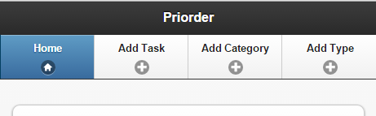

Currently the “Home” page is selected, which is indicated by the blue background colour on the button.

# Home Page

The home page is where you can see you current tasks that you have not yet completed. Here are a few example tasks.

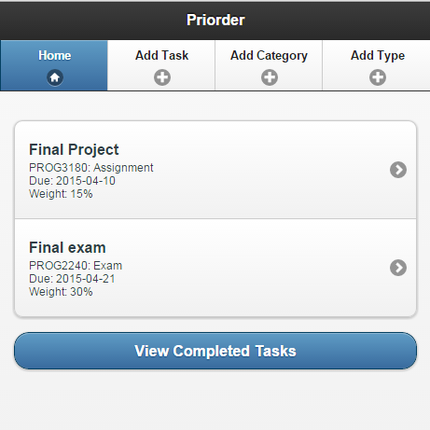

As you can see, there are currently two tasks that have not been completed. If you want to see completed tasks, simply press the “View Completed Tasks” button at the bottom of the page.

If you want to edit a task, or view the task’s information in greater detail, tap the specific task in the list. You will then be taken to the task details page where you can view, update, complete, or delete the task.

# Task Detail Page

The task detail page is where you can view, update, complete, or delete a task. Let’s look at an example task.

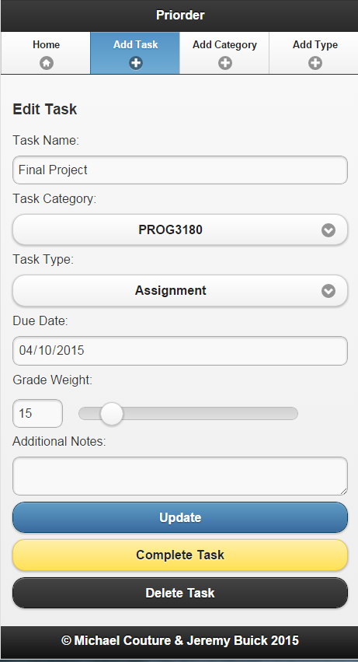

Here, we can see the details of the task. If we want to change one of the details, we can simply edit the detail on this page and press “Update”.

To mark the task as complete, press “Complete Task”. Completed task can be viewed in summary by pressing “View Completed Tasks” on the Home page.

To completely remove the task from the system, press “Delete Task”. If you delete a task, you will not be able to view it again later.

# Adding a Task

Now let’s look at the most important feature, the ability to add a task. In order to add a task, select “Add Task” from the main menu. You will then see the following screen.

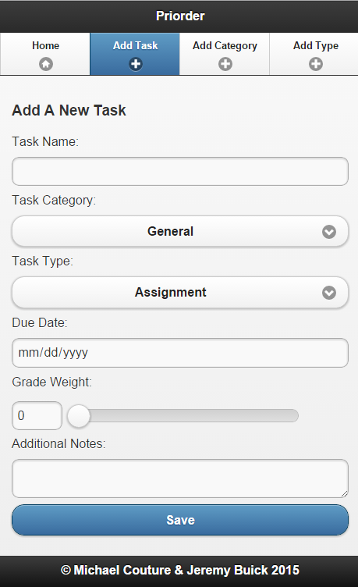

From here, simply enter the task details and press “Save” You will now be able to see your task on the “Home” page.

# 

# Adding a Category

Categories are generally used to represent which course your task is for, but of course you can use whatever categories you like.

To add a category, select “Add Category” for the main menu at the top of the screen. You will then see the “Add A New Category” screen.

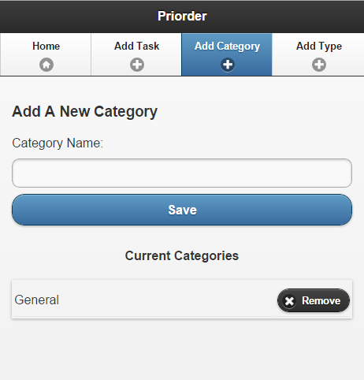

At the bottom of this screen you can see the current categories. To add a new category, simply type in the category name and press “Save”. Your category will now show in the list below. Let’s add the category “Sports” for our extra-curricular activities. We should then see the category in the list.

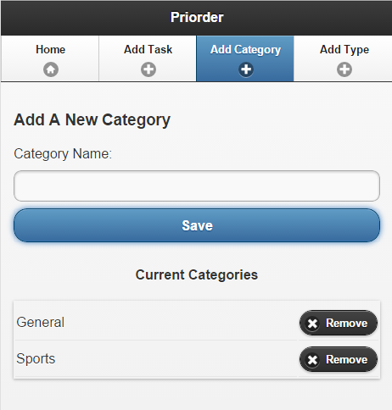

Now, whenever we add or update a new task, the categories in the list at the bottom of the “Add Category” page will be selectable.

To remove a category, simply press the “Remove” button associated with that category in the list. This will remove the category from the list, and remove it from the drop down list when adding or updating tasks. This is useful if you are finishing a semester and want to remove the current courses from the list.

# Adding a Type

Types are generally used to represent what kind of task you are adding. The provided types include: Assignment, Exam, and Test.

To add a type, select “Add Type” for the main menu at the top of the screen. You will then see the “Add A New Type” screen.

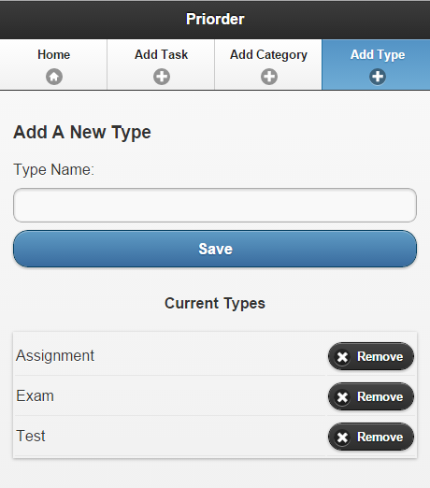

At the bottom of this screen you can see the current types. To add a new type, simply type in the type name and press “Save”. Your type will now show in the list below. You can add types in the same way you can add categories.

Whenever we add or update a new task, the types in the list at the bottom of the “Add Type” page will be selectable.

To remove a type, simply press the “Remove” button associated with that type in the list. This will remove the type from the list, and remove it from the drop down list when adding or updating tasks.