**CS2010  
LabD-XAMPP   
Points: 25**

# LabD-XAMPP Installation, Setup, and Use

# Overview

The information in this document allows a student to set up a XAMPP environment for the CS2010 Net-Centric course. Though XAMPP comes with several components, not all are needed for this course. Sections 1.0 through 3.0 will set up and configure XAMPP for the course. The appendix provides instructions for setting up the other XAMPP components if the student wants a more robust development environment.

XAMPP is a package of applications that provide an easy to setup and use web server environment. It consists of the following applications (the applications in bold will be used during this class):

* **Apache – Web server – Needed for CS2010**
* **PHP – Needed for CS2010**
* FileZilla – FTP Server
* MariaDB – Database server (see appendix)
* Mercury – Mail server (see appendix)
* Tomcat – Application server (see appendix)
* Perl (see appendix)
* phpMyAdmin – Used for managing database. (see appendix)

XAMPP is used to perform development and testing on a local system to support the following:

* Site creation for static and dynamic
* Dynamic page using PHP
* Database connectivity
* Email sending & receiving via localhost only

The package and documentation are available at <http://www.apachefriends.org>.

The instructions in this document will set up XAMPP in a portable configuration. This configuration will allow a user to move the XAMPP folder to a different drive or system. This configuration is ideal if you wish to run XAMPP on an external drive or flash drive.

# 1.0 Preparation

1. Go to the downloads at <https://www.apachefriends.org/download.html>. The download buttons on this page will download the installers. The installers will require the application to be installed on the system it’s running on. **Do not use these installers**, instead go to the next step to locate the downloads that can be ported between systems and drives and run without installing.
2. Click on the **More Downloads** link.

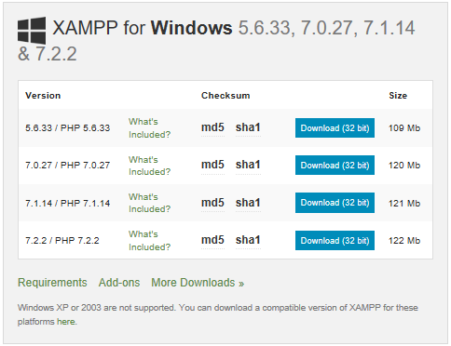

1. Click on the **XAMPP Windows** link.

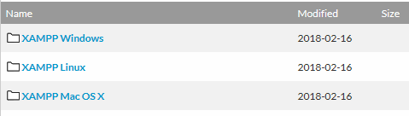

1. Click on one of the latest PHP versions **7.2.2**  in the following example:

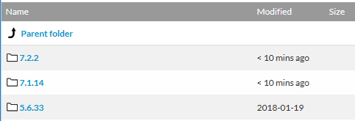

1. Within the folder, download the zip file.

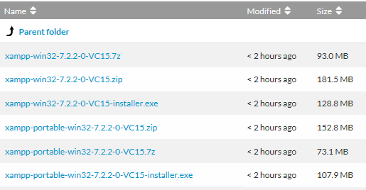

1. Note, do not download the portable version or the installer. The portable version does not contain the FileZilla or Mail servers and is limited. The installer will install XAMPP on the system.
2. Unzip the file into a folder called **xampp**, preferably on the root of the drive.
3. If the system has VMWare workstation installed, then perform these steps to start and stop the VMWare services before running the XAMPP application.
   1. In the **xampp** folder, create the **VMWareStart.bat** and **VMWareStop.bat** batch files.

**VMWareStart.bat** contents:

net start VMAuthdService  
net start VMnetDHCP  
net start "VMware NAT Service"  
net start VMUSBArbService  
net start VMwareHostd

**VMWareStop.bat** contents

net stop VMAuthdService  
net stop VMnetDHCP  
net stop "VMware NAT Service"  
net stop VMUSBArbService  
net stop VMwareHostd

* 1. To run these files, open Windows Explorer, navigation to the **xampp** folder, right-click the file and select **Run as administrator**. The stop should be run before launching XAMPP to ensure the networking services are not taking resources away from XAMPP. If this happens, then XAMPP would fail to start.

1. If you have administration access to the system this will run on, you can update the hosts file to emulate a DNS entry instead of using the IP address. Perform the following to update the hosts file:
2. Copy the **hosts** file from its original location at **C:\Windows\System32\drivers\etc** to a temporary location.
3. Modify the **hosts** file to accommodate XAMPP and include any additional local hosts. Example entries:

127.0.0.1 localhost

127.0.0.1 cs2010.local

1. Copy the **hosts** file from the temporary location back to its original location at **C:\Windows\System32\drivers\etc** and overwrite as necessary.

# 2.0 XAMPP Setup

Ensure the preparation steps are completed before proceeding and the application is located inside the **xampp** folder.

## 2.1 First Time XAMPP Startup

1. If the system XAMPP is being started on has VMWare Workstation installed, then the **VMWareStop.bat** file must be run first. VMWare Workstation utilizes the same ports that XAMPP utilizes. The bat file will stop the related services to allow XAMPP to run. To run the bat file proceed as follows:
   1. Within the **xampp** folder, right-click the **VMWareStop.bat** file and select **Run as administrator**.
   2. Click **Yes** to allow the program to make changes to the computer.
   3. Within the command window answer **Y** to the prompts.
   4. When the services have stopped the window will close and XAMPP can then be started.
   5. Upon completion of using XAMPP, make sure the **VMWareStart.bat** file is run to restart the services or reboot the computer.
2. Run the **setup_xampp.bat** file by double-clicking on it in Windows Explorer. **Do not run it as an administrator**.
3. Within the **xampp** folder, double-click the **xampp-control.exe** file. A first time run will ask what language to use. Select the version and click **Save**.
4. When started the **XAMPP Control Panel** will either be displayed or appear in the system tray. Make sure the control panel is being displayed.
5. If the control panel starts and a “Problem detected!” message is displayed, perform the following:

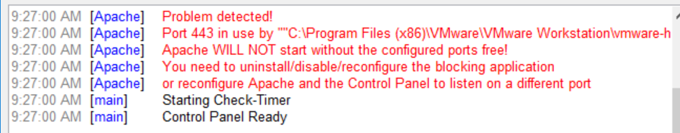

* 1. Close out the control panel by going into the Windows system try and selecting **Quit** for the control panel.
  2. Within the **xampp** folder, right-click the **VMWareStop.bat** file and select **Run as administrator,** (running it one may not have been enough).
  3. Restart the **xampp-control.exe** and it should start without errors.

1. Start the Apache server and ensure the control panel does not show any errors.
   1. If a VMware related error is displayed, quit the control panel and rerun the **VMWareStop.bat** file.
   2. If Apache does not start, may need to setup firewall to unblock required ports.
   3. If a Windows Security Alert appears, select both checkboxes and click **Allow access**:

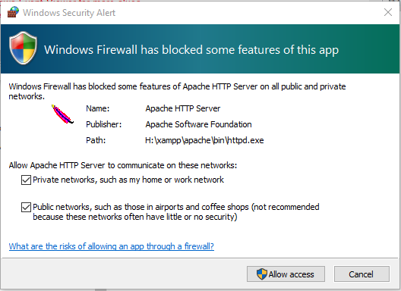

1. Open browser and ensure the following URLs are accessible:

**http://127.0.0.1**  
**http://localhost**  
**http://cs2010.local** – Available if the hosts file was updated as outlined above. NOTE: This must have the protocol in the URL to work.

## 2.2 Setting up Virtual Hosts

1. Ensure the XAMPP control panel is running and the Apache module is stopped before proceeding.
2. When setting up virtual hosts, used name based virtual hosts and set up the basic XAMPP location along with the other virtual hosts.
3. Enter the following into the **\xampp\apache\conf\extra\httpd-vhosts.conf** file, the first virtual host should be in all installations, the second virtual host is an example of a setup for CS2010:

<VirtualHost *:80>

ServerAdmin admin@localhost.com

DocumentRoot "D:/xampp/htdocs/"

ServerName localhost

ServerAlias localhost

<Directory "D:/xampp/htdocs/">

Options Indexes FollowSymLinks Includes ExecCGI

Order allow,deny

Allow from all

</Directory>

</VirtualHost>

If the hosts file was updated on the system, then add the following to the vhosts file:

<VirtualHost *:80>

ServerAdmin admin@localhost.com

DocumentRoot "D:/xampp/htdocs/cs2010"

ServerName cs2010.local

ServerAlias cs2010.local

<Directory "D:/xampp/htdocs/cs2010">

Options Indexes FollowSymLinks Includes ExecCGI

Order allow,deny

Allow from all

</Directory>

</VirtualHost>

1. Create the **cs2010** folder in **\xampp\htdocs** and create a simple HTML file named html-test.html and a simple PHP file named php-test.php to test the site.
2. Start the Apache module and ensure the following links work:

http://localhost  
http://cs2010.local – Available if the hosts file was updated as outlined above. NOTE: This must have the protocol in the URL to work.

1. Click on both files to ensure they work.
2. XAMPP is setup and configured at this point.

## 2.3 Moving XAMPP to a different location

If the XAMPP needs to be moved to a different system or drive letter, then these steps must be performed.

1. Within the **xampp** folder, run the **setup_xampp.bat** file and select the refresh option.
2. The XAMPP should start without issue in the new location.
3. Notes on moving XAMPP:
   1. The setup file will only change drive letters, if the folder is renamed, then it may not work correctly.
   2. If Tomcat is setup, then the system XAMPP is being moved to must have the Java Runtime Environment installed and the JAVA_HOME environment variable must be set. XAMPP will still run if the JRE and environment variable are not available, only Tomcat will not function.

# 3.0 Wrap-Up

After completing the above steps, the XAMPP environment is ready for course CS201. The following modules are available for use:

* Apache

What can be done includes:

* Setting up sites on virtual hosts.
* Running sites on the local drive.

If you wish to utilize more of the XAMPP components, follow the instructions in the Appendix.

# Appendix

The main instructions above are enough to setup XAMPP to run for the CS2010 course. The information in this appendix will set up the other modules in XAMPP if the student wishes to use it beyond this course.

## A.1 Additional Software to Run

In order to perform these steps, the following applications will assist:

|  |  |  |
| --- | --- | --- |
| Mozilla Thunderbird | Portable email client | <https://www.portableapps.com> |
| Java Runtime Environment | Needed for Tomcat | <https://java.com/en/download/> |

## A.2 MySQL

1. Start the MySQL module, select both checkboxes and click **Allow access**:

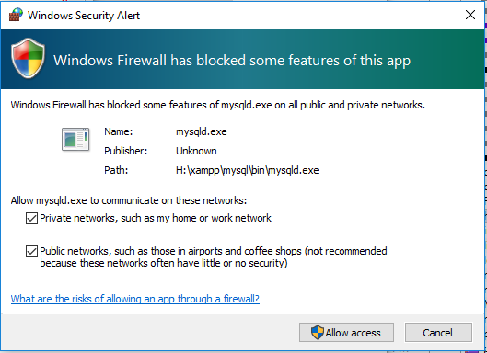

1. XAMPP is ready at this point.
2. To shut down the control panel, ensure all modules are stopped in the control panel.
3. After shutting down XAMPP, run the **VMWareStart.bat** file and select **Run as administrator**.

## A.3 Setting up Mail Server

1. Ensure the XAMPP control panel is running before proceeding.
2. In the XAMPP control panel, start the **Mercury** module.
3. If a Windows Security Alert appears, select both checkboxes and click **Allow access.**
4. Click on **Admin** in the XAMPP Control Panel for the Mercury module.
5. Click **Configuration** then **Protocol modules**.
6. Uncheck **MercuryB HTTP web server**.
7. Restart Mercury by clicking **Stop** on the XAMPP control panel then clicking **Start**. NOTE: Do not close the Mercury/32 panel, use the Stop button on the XAMPP control panel.
8. Click on **Admin** in the XAMPP Control Panel for the Mercury module.
9. Click **Configuration** then **MercuryS SMTP Server**.
   1. On the **General tab** set **Announce myself as** and **IP Interface to use** to **127.0.0.1**.
   2. On **Connection control** tab, add restriction range of 127.0.0.1 to 127.0.0.1 (use defaults for other entries).
10. Click **Configuration** then **MercuryP POP3 Server**.
    1. On the **General tab** set **IP Interface to use** to **127.0.0.1**.
    2. On **Connection control** tab, add restriction range of 127.0.0.1 to 127.0.0.1 (use defaults for other entries).
11. Click **Configuration** then **MercuryE SMTP Server**.
    1. Set **Identify myself as** and **Name servers** to **127.0.0.1** (use defaults for other entries).
12. Stop the Mercury server.
13. Within the **xampp\php\php.ini** file:
    1. Comment out the following lines (around lines 1052 & 1054):

SMTP = localhost  
Smtp_port = 25

1. Restart the Mercury server.

### Create Email User

1. Creating an email user is a two step process.

* Step 1 – Create user within the Mercury mail server
* Step 2 – Create the client mailbox within an email client

1. Mercury Mail Server
   1. Click on the **Admin** button for Mercury.
   2. The Mercury/32 control panel will either be displayed or appear in the system tray. Make sure it is opened.
   3. Click on **Configuration** then **Manage local users**.
   4. Click **Add**.
   5. Enter the **username**, **Personal name**, **Mail password**, and **APOP secret**. Leave all the other user details at their default selections.
      1. usera
         * Username: usera
         * Personal name: User A
         * Mail password: password
         * APOP secret: password
      2. userb
         * Username: userb
         * Personal name: User B
         * Mail password: password
         * APOP secret: password
   6. Click **Ok**.
   7. Click **Close**.
   8. Do not close the Mercury/32 control panel. If you do then the mail server will stop.
2. Thunderbird Email Client
   1. Start the Thunderbird email client.
   2. At the dialog **Would you like a new email address?** Click on **Skip this and use my existing email**.
   3. Enter the appropriate name, email address and password. Names to use will be:
      1. usera
         * Your name: User A
         * Email address: usera@localhost.com
         * Password: password
      2. userb
         * Your name: User B
         * Email address: userb@localhost.com
         * Password: password
   4. Keep **Remember password** checked.
   5. Click **Continue**.
   6. When the **Looking up configuration: Email provider** appears, click **Manual Config**.
   7. At the **Mail Account Setup**, change **Incoming** to **POP3** and enter **127.0.0.1** as the **Server hostname** for both the incoming and outgoing.
   8. Click on **Re-test**.
   9. You should see the message **The following settings were found by probing the given server**. If not, troubleshoot as best you can.
   10. Click **Done**.
   11. If you see a warning message about incoming and outgoing settings not using encryption, check **I understand the risks** and then click **Done**.
   12. After creating the first account, repeat the steps for adding the next account.
   13. Test out the email setup by composing and sending an email from another local account to the new account and then from the new account to an existing account. If the email does not show up, click on **Get Messages** in each mailbox.

## A.4 Starting XAMPP Applications

1. Once XAMPP is running, each application can be started using the appropriate **Start** button on the control panel.
2. After the start button has been clicked, make sure the module that was started turns to green.
3. If something doesn’t start correctly, either troubleshoot the issue as best you can or contact the instructor.

## A.5 Resetting the Root DB Password

1. Ensure the XAMPP control panel is running and the Apache and MySQL modules are started before proceeding.
2. Follow the instructions on **http://localhost/dashboard/docs/reset-mysql-password.html**.
3. From the XAMPP control panel, launch the shell and enter the following command:

mysqladmin --user=root password "localdevadm"

1. The above command will set the password to **localdevadm**. No response will be shown if the command was successful.
2. Stop the MySQL in the XAMPP control panel.
3. In the **\xampp\phpMyAdmin\config.inc.php** file, ensure the following lines are set:

$cfg['Servers'][$i]['auth_type'] = 'http';  
$cfg['Servers'][$i]['user'] = 'root';  
$cfg['Servers'][$i]['password'] = 'localdevadm';

1. Restart the MySQL module.

## A.6 Starting phpMyAdmin

1. This application is used to maintain the MySQL database and allows one to create/maintain databases, tables, run queries, etc.
2. Ensure the XAMPP control panel is running and the Apache and MySQL modules are started before proceeding.
3. Start the application by clicking on the **Admin** button for MySQL.
4. Enter **root** as the username and use the password provided in the previous section.

## A.7 Setting up FileZilla FTP Server

1. Ensure the XAMPP control panel is running and the Apache module is started before proceeding.
2. In the XAMPP control panel, start the FileZilla module.
3. If a Windows Security Alert appears, select both checkboxes and click **Allow access**.
4. Click on **Admin.**
5. At the **Connect to Server** accept the defaults and click **OK**. The default password is blank.
6. Click on **Edit** and then select **Users**.
7. Select the **General** page and under **Users** area, check click on **Add**.
8. At **Add user account** enter **usera** then click **OK**.
9. On the **General** page, under **Account settings** area, check **Password** and enter **password**.
10. Select the **Shared folders** page and add a location that points to the location of the site. Example: **D:\xampp\htdocs\cs2010**.
11. Assign the new user all the options for files and directories and then set the **cs2010** as the home directory.
12. Click **Ok** to close out the Users dialog.
13. Test the **usera** access by launching **FileZilla client** and then connecting as:

Host: cs2010.local  
Username: usera  
Password: password

## A.8 Tomcat Setup

1. If Tomcat server is setup, then the portability of the XAMPP setup is limited. When moving the XAMPP to another drive location on the same system, Tomcat will still function. When moving the XAMPP to another system, then Java must be installed on the new system and the appropriate environment variable must be set.
2. Before proceeding, ensure the Java Runtime Environment is installed and the JAVA_HOME user environment variable is set and points to the Java installation folder.
3. Ensure the XAMPP control panel is running.
4. In the XAMPP control panel, start the Tomcat module. When Tomcat starts, a new terminal window is started. Do not close the new terminal window, if it is closed then Tomcat will shut down.
5. Ensure no errors are displayed in the XAMPP control panel. If errors are encountered, common issues include the JAVA_HOME not set or XAMPP is attempting to access a port already in use. More information about these issues can be found on the web.
6. Review the information in the terminal window. The only errors that should appear should be near the start of the information and would be related to not finding either the JDK or JRE. As long as one of these components are installed, the Tomcat application server will start.
7. Once Tomcat has started, go to **http://localhost:8080/** to ensure Tomcat is running.
8. Within the **\xampp\tomcat\conf\tomcat-users.xml** file, add the following line inside the <tomcat-users> tag area:

<user username="admin" password="admin" roles="manager-gui,admin-gui"/>

1. Restart the Tomcat in the XAMPP control panel.
2. Restart the Apache and Tomcat modules then go to **http://localhost:8080/**.
3. Ensure the three applications on the page are accessible. If credentials are required, use the admin username and password set in the above step.

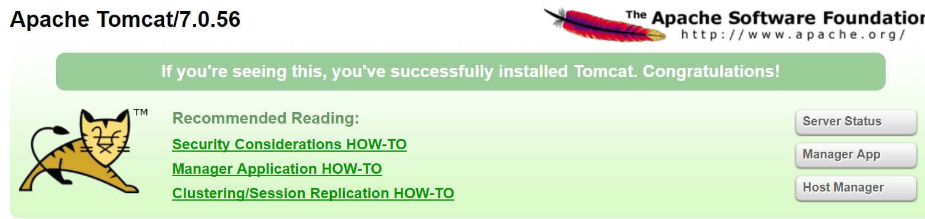

1. If XAMPP is moved to a different system after Tomcat is set up, the system must have the Java Runtime Environment installed and the JAVA_HOME environment variable must be set. XAMPP will still run if the JRE and environment variable are not available, only Tomcat will not function.

# A.9 Wrap-Up

After completing the above steps, the XAMPP environment is ready. The following modules are available for use:

* Apache
* MySQL
* FileZilla
* Mercury
* Tomcat

What can be done includes:

* Setting up sites on virtual hosts.
* Running phpMyAdmin to administer the database.
* Run FileZilla server to emulate the ability to publish a web site.
* Mercury mail server to test email capabilities of a web site.
* CMS systems such as WordPress, Drupal, and Joomla can be installed.
* Tomcat application server to deploy web applications.