**CS2010  
LabA-Hosting  
Points: 25**

# LabA-Hosting Obtaining and Setting Up Web Hosting Service

## Overview

Throughout these instructions, use the class course number in place of **<course number>** (all lowercase and no brackets). Example: cs2010.

If you already have hosting service, you can skip to the section for setting up a sub-domain for this class. Make sure you adjust the instructions to your hosting provider accordingly.

Bluehost is a hosting provider that has a decent discount for students. If you do not have a hosting service that you can create an FTP account on, it is recommended to obtain an account through Bluehost. You can use your Baker One Card to purchase your hosting subscription. The cost is $59.40 for one year at the time of this writing and may vary in the future and the subscription period purchased.

The hosting service will be the place the student will publish their work for this class. The choice of domain name will be up to the student and once created, a sub-domain specific for this class will be created based on the **<course number>**. The domain can be used for any other web design course taken here or any place else and can be used as a portfolio for the student to showcase work for potential employers. The student can also use the domain for any work they wish.

There are four sections in this document:

* Section 1 – Obtaining Bluehost Service
  + If you already have a hosting service, you do not need to do this section.
* Section 2 – Create Sub-Domain For This Class
  + This creates a sub-domain specific for a class.
  + You must have access to the hosting service control panel to perform these steps.
* Section 3 – Set Up FTP For Instructor Access
  + This gives FTP access to the instructor so that the work can be reviewed.
* Section 4 – Password Management
  + This is an informational section that covers how to ensure your passwords are safe and secured.
* Section 5 – Course Setup
  + This section provides instructions on how to set up your local folder and hosting environment to support this class.

## Section 1 – Obtaining Bluehost Service

1. Open a web browser and go to <https://www.bluehost.com/hosting/education/bakercollege>.

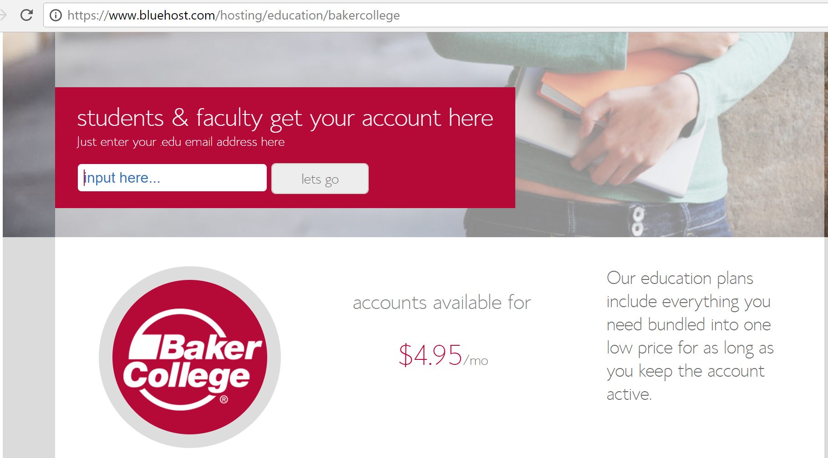

1. Enter your student email address in the input box. Note, this is your Baker email address that ends with **.edu**.
2. After clicking **lets go**, an automatic email will be sent to your Baker email address.
3. While waiting for the email, if you do not already have a domain name to use, utilize the WHOis.net service to verify if your desired domain name is available. If an available domain cannot be easily found, create one based on your Baker student login as shown in this example: **gtramm02-baker**. (The -baker portion is optional. It is suggested as that will help ensure the domain name has a better chance of being unique.)
4. Go to <https://www.whois.net>.
5. Enter the desired domain name (without the www at the beginning) along with the desired top level domain (.com, .net, .org, etc.) then click on the search icon. (For more information about top level domains, see <https://en.wikipedia.org/wiki/List_of_Internet_top-level_domains>.)

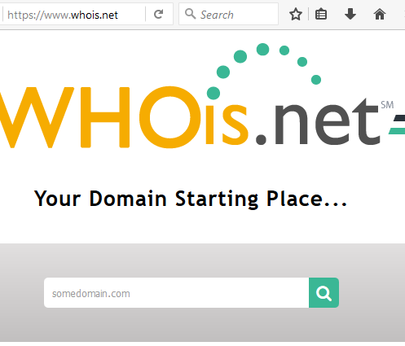

1. After clicking the search icon, the next page will indicate whether or not the domain is available.
2. If it is, you can use it during the Bluehost sign up process.
3. When you receive the email from Bluehost, click on the link provided to begin the sign up process.
4. You will have a choice of either using a **new domain** or **I have a domain name**. Each option has its benefits and drawbacks:
   1. **New domain**
      * Benefit – cheaper as the service will roll in the cost of the domain into the service. Simpler as you do not have to stand up a name service.
      * Drawback – if you plan on changing service providers, the process to move the name over can incur a site outage.
   2. **I have a domain name**
      * Benefit – if you plan on changing service providers later, you can create, or recreate your site, on the new provider then transfer the domain name when the new site is ready. This will minimize site downtime.
      * Drawback – you have to sign up for another service to maintain the domain name which will incur an additional cost.
5. For this class, it is recommended to use the **New domain** option and use the free domain name hosting service.
6. At the **create your account** page, enter your appropriate account information.
7. For the email address, you can use either your .edu address or your regular email address.
8. Select which plan package to purchase. Note: The educational package is the same as the **Plus** plan shown in the following table:

| **Features** | **Basic** | **Plus** | **Pro** |
| --- | --- | --- | --- |
| Websites | 1 | Unlimited | Unlimited |
| Performance | Standard | Standard | High Performance |
| Email Accounts | 5 | Unlimited | Unlimited |
| Storage (GB) | 50* | Unlimited* | Unlimited* |
| File Count | 50,000** | 50,000** | 300,000 |
| Network Bandwidth | Unlimited | Unlimited | Unlimited |
| One Free Domain Registration | 1 Year | 1 Year | 1 Year |
| SubDomains | 25 | 50 | Unlimited |
| One Free Domain Privacy | No | No | Yes |
| Free Dedicated IP | No | No | Yes |
| Free SSL Certificate | No | No | Yes |
| MySQL Databases | 20 | Unlimited* | Unlimited* |
| Database Tables | 1,000 | 1,000 | 3,000 |
| CloudFlare CDN | Basic | Basic | Basic |
| Site Backup Pro | Basic | Basic | Pro |
| SpamExperts | No | 1 Domain | 2 Domains |

1. As of 2/18/2018, the educational pricing compared to the regular Plus pricing is:

| **Plan Term** | **Educational** | **Plus** |
| --- | --- | --- |
| 12 month | 4.95 | 6.95 |
| 24 month | 3.95 | 5.95 |
| 36 month | 3.95 | 4.95 |

1. Select the desired plan term then enter your payment information. If you choose PayPal, the information will be requested after submitting the form.
2. Check the terms of service confirmation checkbox and then click **submit**.
3. If you selected PayPal, you will need to enter your PayPal credentials and continue to making the payment.
4. Upon payment, you will be at the **welcome to bluehost** page.
5. Select **create your password** and enter an appropriately secured password or use the suggest password option.
6. Upon completion you will be provided the option to log in.
7. If you registered your domain name via another service, you will need to go to that service and point the name servers to the Bluehost name servers. See <https://my.bluehost.com/cgi/help/432> for more information. The change could take a few hours to propagate.
8. At this time your hosting service is ready for use.

## Section 2 – Create Sub-Domain For This Class

1. Log into your Bluehost control panel by going to <https://www.bluehost.com>.

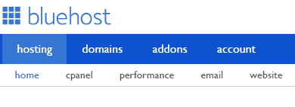

1. Select **domains** in the top navigation area.
2. Select **subdomains** on the next page.

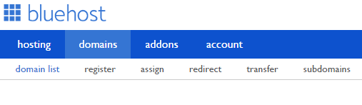

1. Enter the **<course number>** as the subdomain in the following locations:

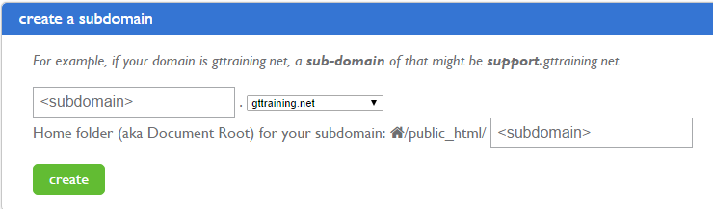

1. Click **create**.
2. All your assignments for this class will reside under <**course number>.<your domain>**.

## Section 3 – Set Up FTP For Instructor Access

1. Log into your Bluehost control panel by going to <https://www.bluehost.com>.
2. Click on the **ftp** option in the top navigation area.

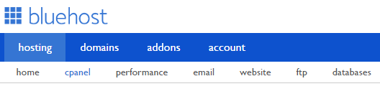

1. Enter **<course number>instructor** as the login name and select **generate password**.

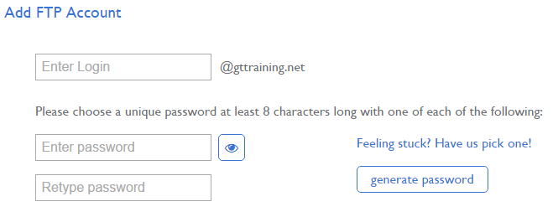

1. Provide the login credentials to the instructor (password and domain).
2. Set the home directory to a sub-directory called **public_html/<course number>** under your main directory. The following is an example, replace **<subdomain>** with the class :

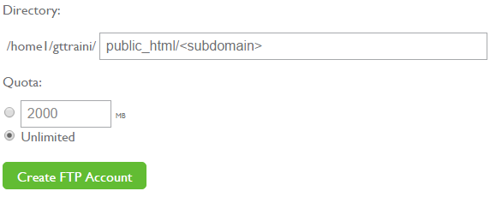

1. Select **Create FTP Account**.
2. Provide the password to the instructor.

## Section 4 – Password Management

Once you have your Bluehost account, it is highly recommended that you do not write down the password or store it onto the PC without some type of password management utility. For a free application that is well rated, check out KeePass at [www.keepass.info](http://www.keepass.info). If you are using a Mac, you can download KeePassX from [www.keepassx.org](http://www.keepassx.org). There are also versions available for smart phones and tablets.

## Section 5 – Course Setup

### Local Drive

The information in this section is not graded. It is provided to help the student keep their course materials organized.

1. Create a folder calls **cs2010** on the drive of choice to store your lab files.
2. Expand the **Student_Course_Files.zip** into the folder.
3. Make sure that under the **cs2010** folder, there are four sub-folders:

* All Book Files – Contains all the files from the companion website for the book.
* Chapter Projects – Contains the files for the chapter projects of the chapters covered in the course. Note, the chapter projects are not required for this course. However, the images within these files may be used for the student project.
* Code Listings – Contains the code listing examples for the chapters covered in the course.
* Labs – Contains the labs that are required for this course.
* Site – Where the files, images, and other assets will be stored by the student prior to publishing the site to the hosting server.

### Hosting Server

The information on the hosting server will be graded. Because web sites can be easily misconfigured if proper standards are not followed, the following requirements will exist for each students’ hosting service as it pertains to this course:

1. There will be eight sub-folders under the main course domain:

* lab03
* lab04
* lab05
* lab06
* lab07
* lab08
* lab09
* project

1. Under each of the folders will be any necessary sub-folders to store the assets as needed to support the exercise.
2. Requirements for the folders and files will be:
   1. No spaces in either folder or file names.
   2. The lab sub-folders will not have any of the lab start or stop sub-folders.
   3. No other folder beyond what is listed above under item 1 under the main course domain will be allowed without prior authorization.
3. When publishing from the local drive to the hosting server, the information under the folder **Site** will contain all the folders, files, and other assets necessary for the exercises.
4. Part of the exercise grading will look to see if the above requirements for 3a and 3b are met and there are no extra files or folders are published that do not support the exercises.