**CS2010  
LabB-FTP   
Points: 25**

# LabB-FTP FTP Transfer via FileZilla

## Overview

These instructions will walk you through the installation of an FTP client, how to use it, and the steps necessary to publish your first web page.

## What is FTP

FTP stands for File Transfer Protocol and is used to transfer files between two systems on a network. A web site designer or developer can use it to transfer their files from their local machine to the system that is hosting their web site. It consists of two components:

* Client – The application that runs on the local system where the web site designer/developer does their work
* Server – The application that runs on the hosting service where the files will be transferred to

There are many various FTP client applications available. The instructions in this document are focused on using FileZilla. Many other FTP applications behave and run in a similar fashion.

For additional information on FTP, review these links out:

* <https://en.wikipedia.org/wiki/File_Transfer_Protocol>
* <https://kb.iu.edu/d/aerg>
* <http://www.deskshare.com/resources/articles/ftp-how-to.aspx>

## Installing and Getting Familiar with FileZilla

### Downloading FileZilla

The application is available for download at <https://filezilla-project.org/download.php?show_all=1>.

If you go to the main FileZilla project web site and then follow it to the download section, make sure you install the **Client** application, not the server.

After downloading, install the application using default options.

### FileZilla Interface

*Figure 1 – FileZilla interface* 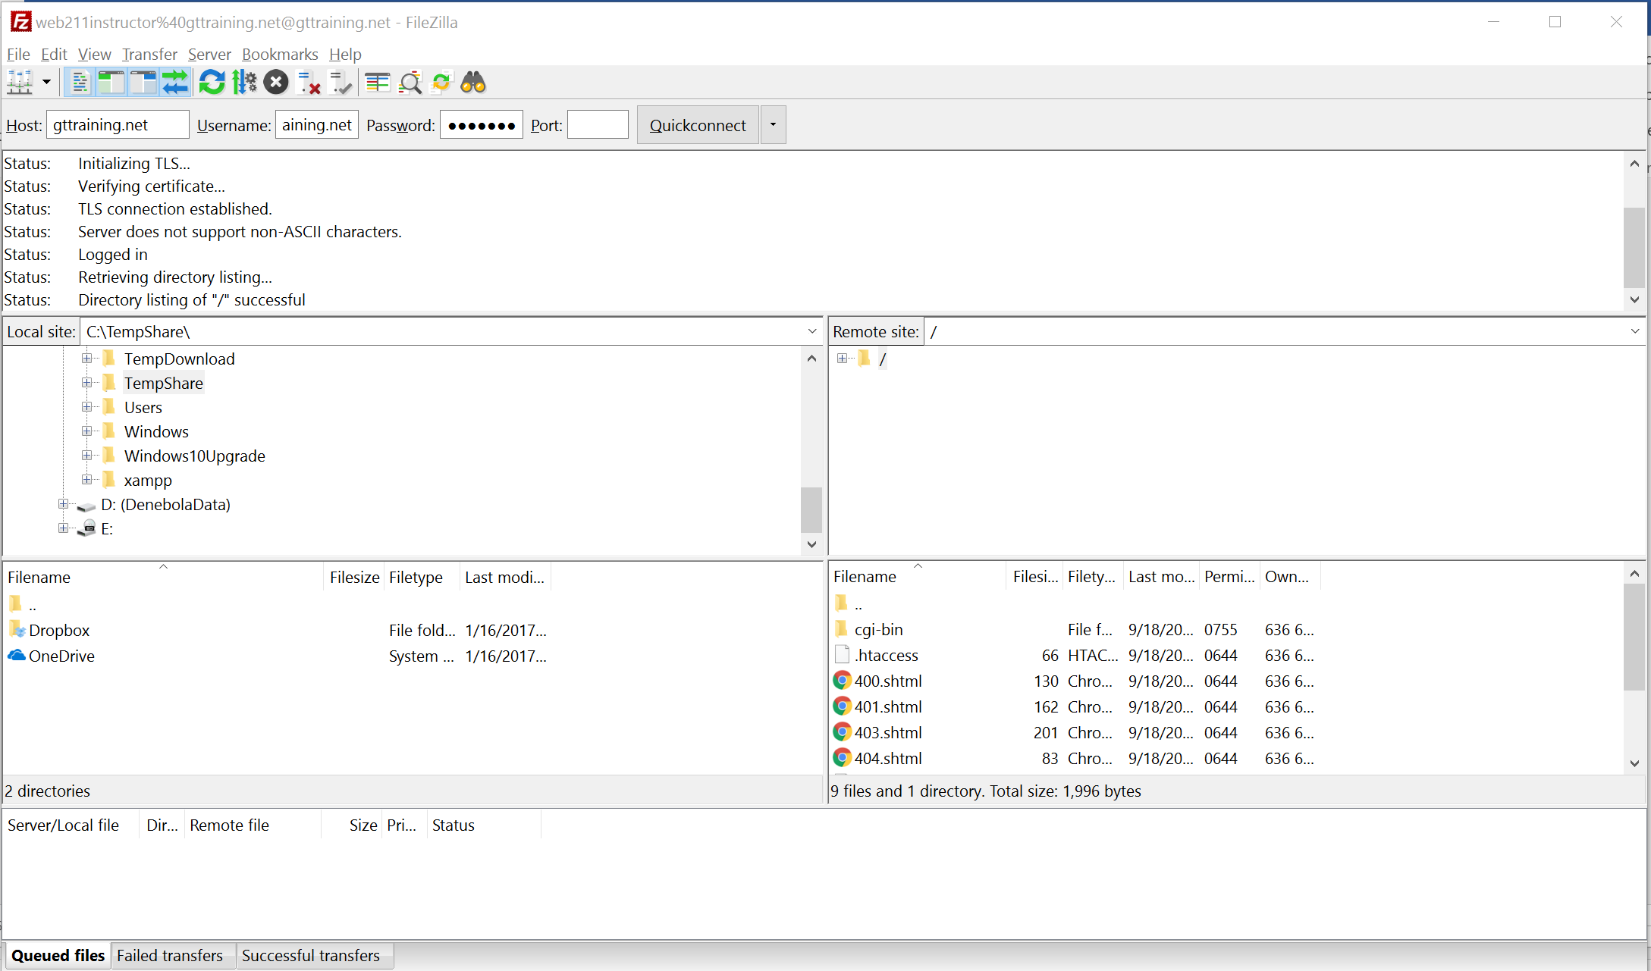

System access entries

System response status messages

Remote folders

* Single-click item to change folders
* Single-click + to expand, - to collapse

Local folders

* Single-click item to change folders
* Single-click + to expand, - to collapse

Local files & folders

* Double-click item to change folders
* Right-click and select upload to publish files

Remote files & folders

* Double-click item to change folders
* Right-click and select download to retrieve files

Transfer status messages

### Connecting to Remote System

1. Within the system access entries input boxes, enter the appropriate information for
   * Host
   * Username
   * Password
2. After entering the information, click on **Quickconnect**.
3. You may encounter the following **Unknown certificate** message shown in *figure 2*:

*Figure 2 – Unknown certificate message*

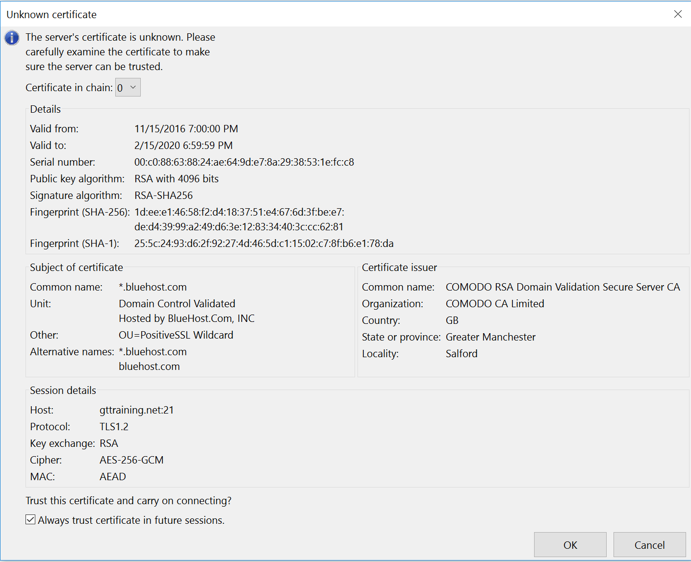

Check the Always trust checkbox

1. If you get the message, check the **Always trust certificate in future sessions** checkbox then click **OK**.
2. After connecting to the server, the FileZilla interface will look similar to *figure 1*.

## Publish Your First Web Page

### Create a Basic HTML Page

1. Open up a text editor. Recommended application is Notepad++ (<https://notepad-plus-plus.org/>).
2. Create a basic HTML page with the following code:

<html>

<body>

<p>My test web page works.</p>

</body>

</html>

1. Name the file as **testpage.html**.
2. Ensure the file is saved as an HTML file, not a text file.

### Transferring files from local system to hosting server

1. Connect FileZilla to the remote system.
2. In the left panel, navigate to the location where the site files are stored.
3. To publish the test page, transfer the file to the root of your domain.
4. When transferring specific files or folders, make sure the correct folders are selected in both the left and right panels.
5. Once all files and folders have been highlighted that need to be transferred, right-click the items on the local side and in the popup menu select **Upload**.
6. Upon completion of transferring files, disconnect from the web server by clicking the server disconnect button or closing FileZilla. See *figure 3*.

*Figure 3 – Server disconnect button*

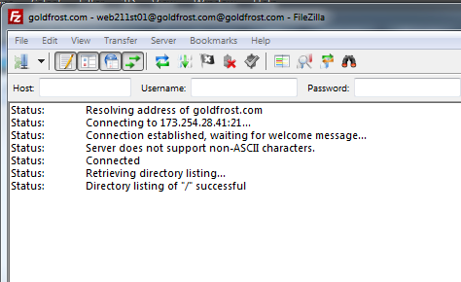

Server disconnect button

NOTE: The hosting provider only allows 8 simultaneous FTP connections. If you do not disconnect from the server your connection remains active for a few minutes and you may eventually get errors when establishing an FTP connection. Always disconnect from the server upon completion.

### Verifying the Web Page

1. Open a web browser and point the URL to **http://<your class subdomain>/testpage.html**
2. Verify the page work as designed.