**Artifacts Overview**

Artifacts are evidence, in the form of a webpage link or an uploaded document, that a teacher or principal can provide as contributing evidence for their evaluation. An artifact can have a focus by aligning it the state and/or instructional evaluation frameworks. When aligning an artifact, the user is presented with a tree view of the framework and the artifact can be aligned to criteria and/or rubric elements within a criteria.

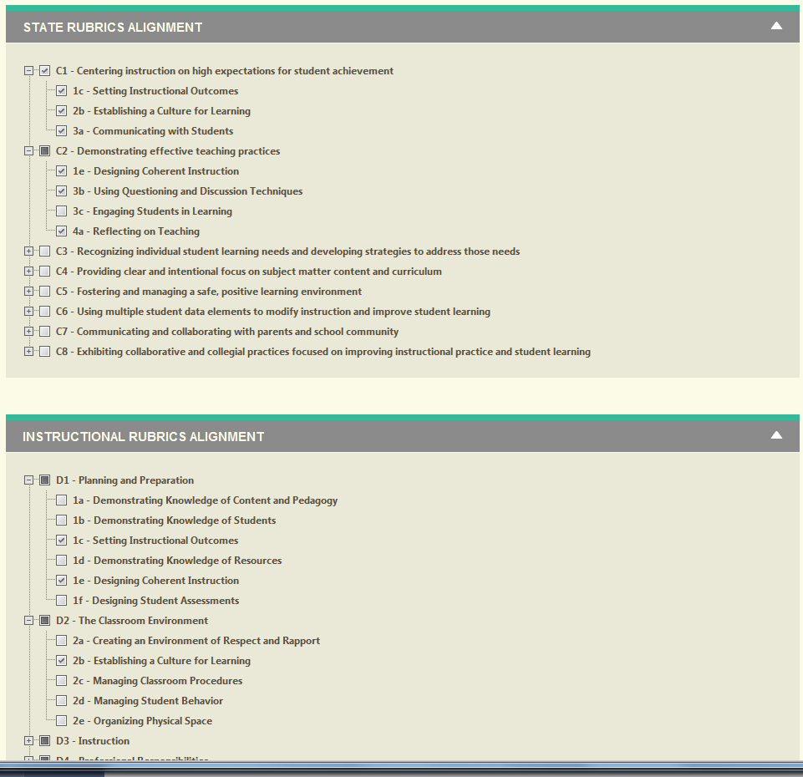

**Where are Artifacts Created?**

There are multiple places within the application where artifacts can be uploaded.

* Top-Level Artifacts section
* Goal Artifacts
* Pre-Conference Question Artifacts
* Post-Conference Reflection Artifacts
* Final Evaluation Reflection Artifacts

**Top-Level Artifacts Section**: Each evaluatee has a top-level Artifacts section where he can upload artifacts and align them to the evaluation frameworks for their district. These artifacts can be categorized as follows:

* Parent Communication
* Professional Development
* Lesson Plan
* Other

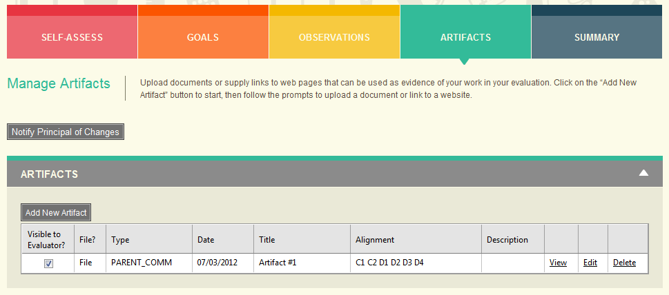

Once an artifact is made visible to their evaluator (see the checkbox in the Visible to Evaluator? Column above), it is displayed on the Final Evaluation Summary screen within the criteria panel to which they are aligned. In the screenshot below it is showing the artifact aligned to the C1 criteria and displays the specific rubric elements to which it is aligned within the C1 criteria.

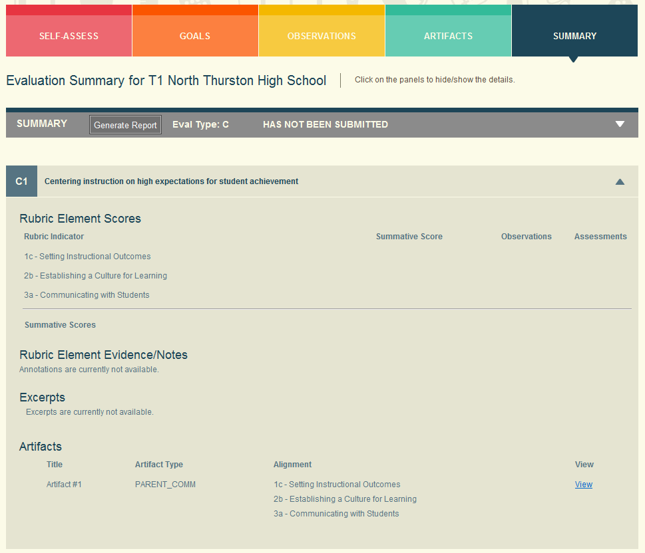

**Goal Artifacts:** An evaluatee can upload an artifact and associate it with a Goal. Goal Artifacts are associated with the Goal on the Goal Details Page. For example, on the Evaluator of Self-Assigned Goals page, you can click on the Details link to take you to the Details page for the Goal. And on the Goal Details page at the bottom, you can associate an artifact with the goal.

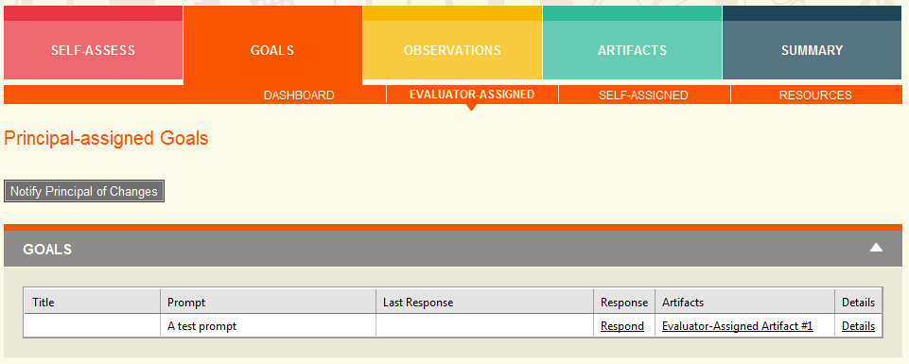

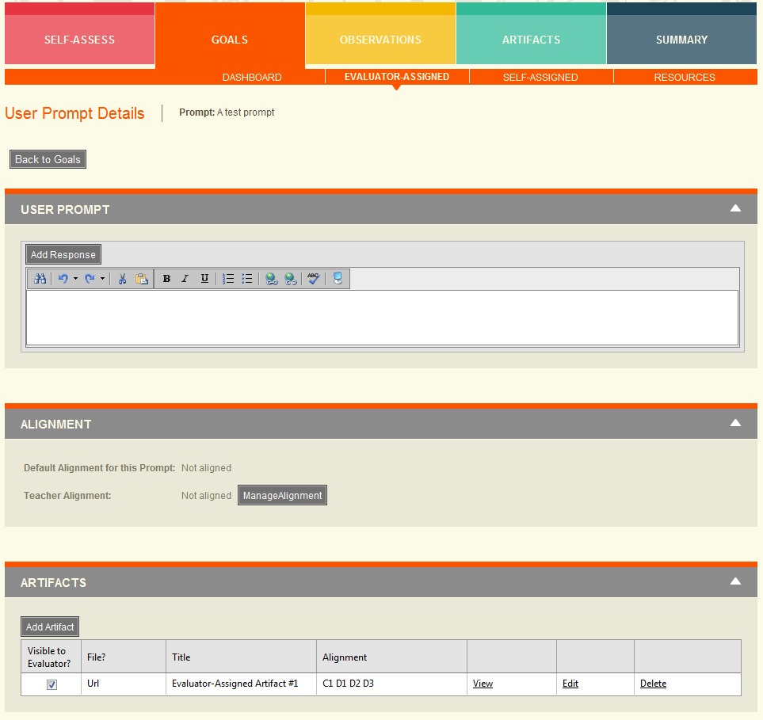

Goal Artifacts (either evaluator or self-assigned) are displayed as links on the Evaluatee Dashboard in the Artifacts column.

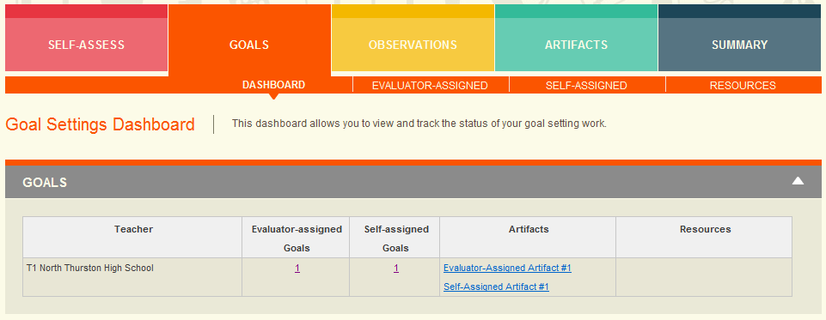

**Pre-Conference Question Artifacts**: An evaluatee can upload an artifact and associate it with a Pre-Conference Question. These artifacts are entered on the Pre-Conference screen for an observation session.

**Post-Conference Question Artifacts**: An evaluatee can upload an artifact and associate it with a Post-Conference Reflection. These artifacts are entered on the Post-Conference screen for an observation session.

**Final Evaluation Reflection Artifacts**: An evaluate can upload an artifact and associate it with a Final Evaluation Reflection. These artifacts are entered on the Final Evaluation Summary screen in the Reflections section.