**District-wide Teacher Evaluator (DTE)**

A district-wide teacher evaluator is a person that can be given permission to be the assigned evaluator and/or perform observations of teachers through their district. The evaluator does not reside at a school, but rather, is associated with the district and is often responsible for the evaluations/observations for teachers with special certification, such as special education teachers.

**Requesting Permission to Evaluate/Observe**: The DTE must request permission to evaluate/observe teachers within the district. This process begins with the DTE making a request in the Setup/Assignment Requests section. The DTE can select any of the teachers in the district and a request will be created that will be visible to the district administrator in the Assignments section.

**DTE Setup/Assignment Requests**

* **Add Assignment Request button**: brings the DTE to a screen where he can select the set of teachers from his district he would like to evaluate/observe. Once selected, they are added to this list of requests.
* **Request Status**: Initially a request’s status is PENDING. The district administrator can either ACCEPT or REJECT the request.
* **Accepted Request Eval Type**: The district admin further configures what type of access the evaluator will be given. An accepted request will allow either:
  + Observations only: the DTE can only perform observations, but is not the assigned evaluator
  + Assigned Evaluator: the DTE is the assigned evaluator and can also perform observations.

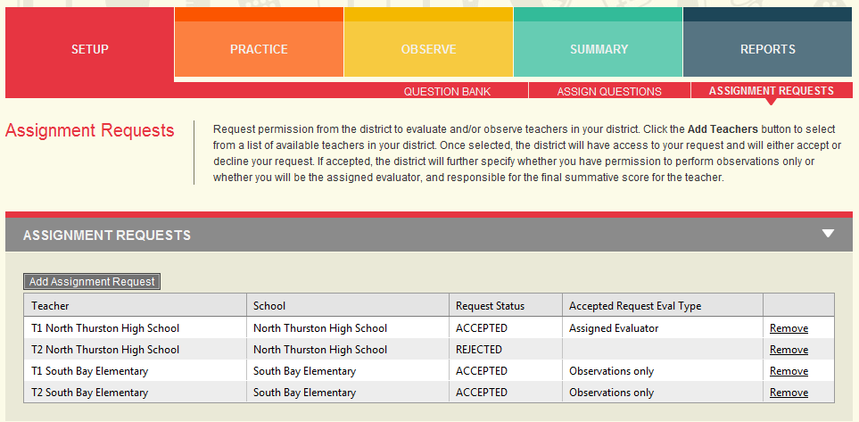

**District Administrator Assignment Processing - Assignments**

Only one DTE can be the assigned evaluator for a teacher. If more than one DTE is requesting permission to evaluate/observe a teacher, accepting a request and giving permission to be the assigned evaluator will cause all other requests to be changed to be for observations only.

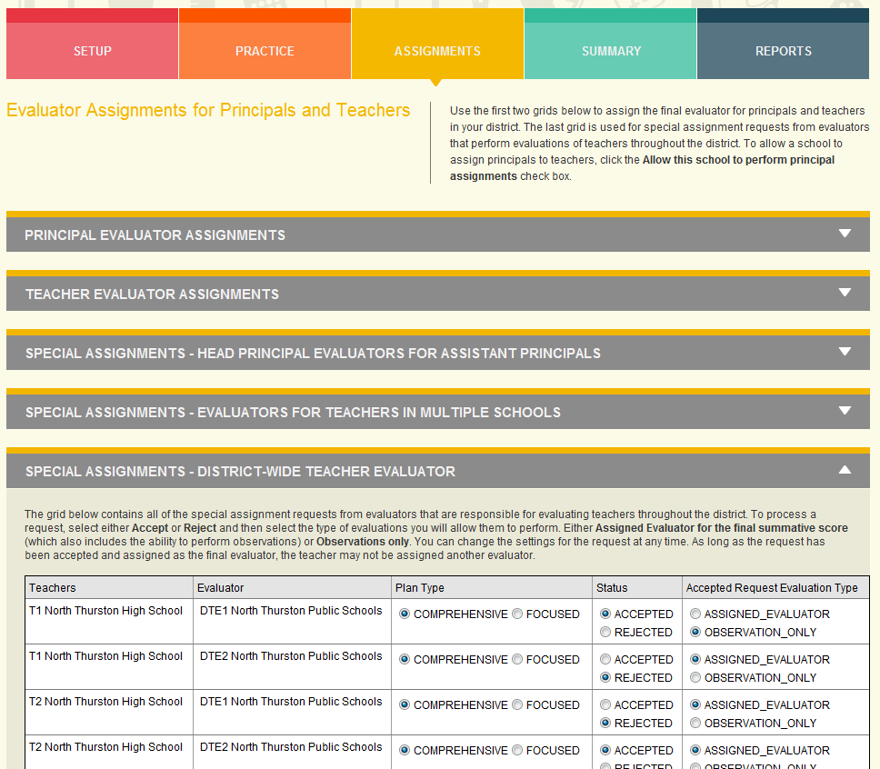

* Once a special request is accepted and the evaluator is the assigned evaluator for the teacher, the teacher will be removed from the TEACHER EVALUATOR ASSIGNMENTS section so that the teacher is not mistakenly re-assigned to a principal at the school.
* If the special request is accepted, but the evaluator is only given permission to perform observations, then the teacher will still be visible in the TEACHER EVALUATOR ASSIGNMENTS section so that a final evaluator can still be assigned.

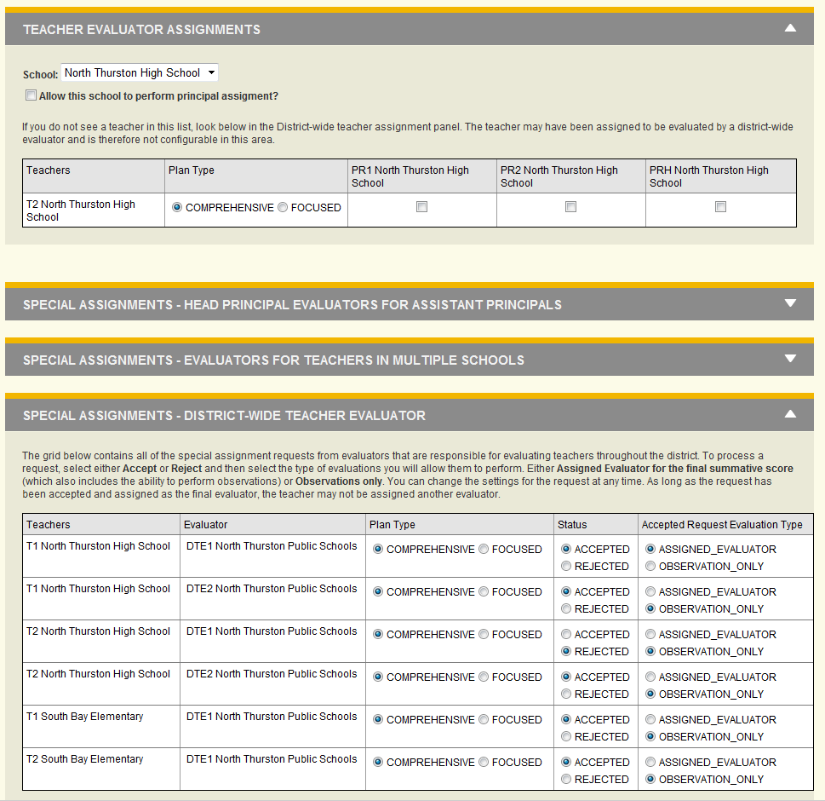

**DTE Observation Dashboard**

The DTE will be able to perform observations for all teachers for which they have been assigned as the final evaluator and/or been given permission to perform observations only.

**DTE Summary and Reports Screens**

The DTE will have access to all teachers for which they have been assigned as the final evaluator. They will not have access to teachers for which they have only been given permission to observe.