**Head Principal Evaluator (PRH)**

A large school often has a head principal and several assistant principals. For these schools a district administrator can assign the head principal as the assigned evaluator for assistant principals in his school instead of the district evaluator. This assignment can only be done by the district administrator. It cannot be delegated to the school.

**District Administrator Assignment Processing – Assignments**

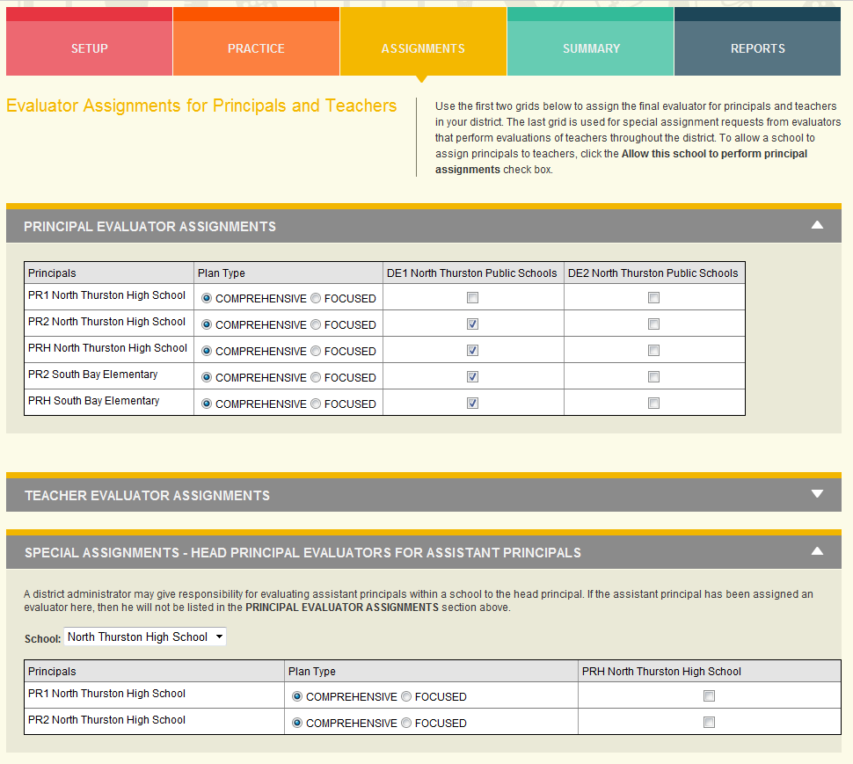

The Assignment screen has two sections for configuring evaluators for principals at a school.

* PRINCIPAL EVALUATOR ASSIGNMENTS – This is where district evaluators are assigned to school principals. This is the standard assignment process.
* SPECIAL ASSIGNMENTS – HEAD PRINCIPAL EVALUATORS FOR ASSISTANT PRINCIPALS – This is where a head principal can be assigned to a assistant principal instead of a district evaluator.

Once a special assignment is made for a head principal to an assistant principal, the assistant principal will be removed from PRINCIPAL EVALUATOR ASSIGNMENTS section so that the principal is not mistakenly re-assigned to a district evaluator.

**Head Principal – Evaluating Principals**

If a principal has been configured to be able to evaluate assistance principals at their school, then they will have an additional role in the ROLE dropdown in the upper right of the screen call “Evaluate Principals”. Selecting this option will present them with an evaluator view, similar to what they see when “Evaluate Teachers” is selected, but for evaluating principals.

The Head Principal will have access to all principals for which they have been assigned as the final evaluator.