**Practice Session Basics**

**Anchor Scores**: Anchor scores are entered by the session administrator. They represent “expert” scores used as a baseline to compare against. The administrator who manages the practice session enters the anchor scores through the Observe/Score screen on their view of the session.

**Participant Scores**: Participant scores are entered by users that have been invited to participate in the practice session. The administrator invites as many participants as they wish and then makes the session visible to the participants. The session will then appear in the participant’s session list. For an evaluator (teacher and district evaluator) practice sessions appear in the Practice section. For an evaluatee (principal or teacher) practice sessions appear in the Observations section. Participants enter scores through the Observe/Score screen for the session.

There are two types of summative scores:

**Observation Summative Score**: The summative score given for the observation as a whole. When an evaluator is on the Observe/Score screen it is on the Observe panel header as shown below.

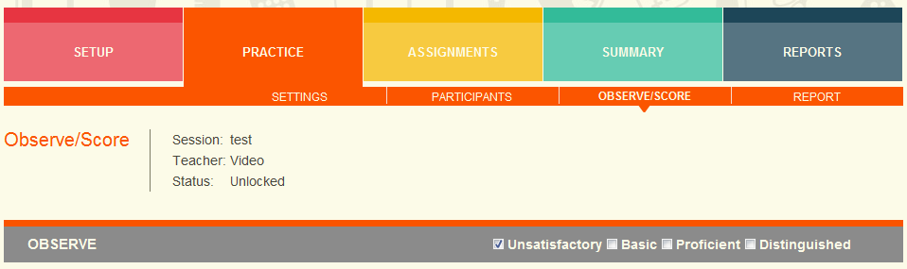

The observation summative score is displayed in the OBSERVATION column in the table.

**Criteria Summative Score**: The summative score given to the criteria as a whole. When an evaluator is on the Observe/Score screen it is on the Criteria panel within the State or Instructional Rubrics tab.

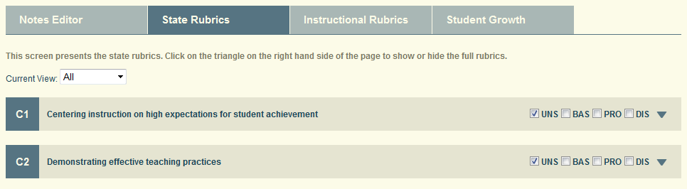

**State vs Instructional Framework**

At the top of the report there is a dropdown to select the Framework to display. For those districts using an instructional framework in addition to the state framework, the report viewer can change from the default view of State Framework to view the Instructional Framework. The sections in the report are the same, but the criteria are different. For example, for the Danielson Instructional Framework the criteria are D1, D2, D3, and D4 instead of the C1-C8 state framework criteria.

**Observation and Criteria Summative Score Summary Panel – Level 1**

This table displays the summative scores entered by each of the participants for the practice session. The purpose of the table is to compare the scores across each of the participants and against the anchor scores entered by the session administrator.

The OBSERVATION column displays the observation summative score and the C1-C8 columns display the criteria summative scores.

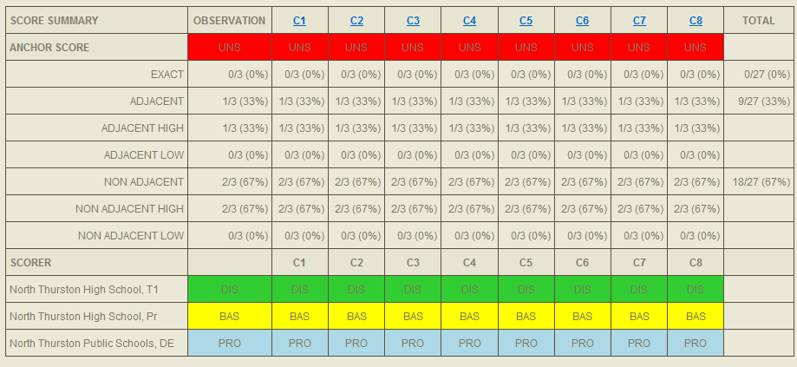

**Anchor Score Row**: This row displays the summative scores for the anchor scores. Anchor scores are optional. If they are not entered this row will not appear.

**Anchor Score Alignment Rows**: The next seven rows (EXACT->NON ADJACENT LOW) display the alignment between the anchor scores and the participant scores. If the anchor scores do not exist, then these rows will not be displayed.

* **Exact**: What percentage of the participant scorers exactly aligned with the anchor summative scores? This means they got the exact same score.
* **Adjacent**: What percentage of the participant scorers had scores that were within one point (either up or down) of the anchor score? For example, the anchor score is a 2, then an adjacent score would be either a 1 or a 3.
* **Adjacent High, Adjacent Low**: Further details on the percentage of adjacent scores that were either above or below the anchor score by one point.
* **Non**-**Adjacent**: What percentage of participant scorers had scores that were more than one point (either up or down) of the anchor score? For example, if the anchor score is a 2, then a non-adjacent score would be a 4.
* **Non**-**adjacent High, Non-adjacent Low**: Further details on the percentage of non-adjacent scores that were either above or below the anchor score by at least two points.

**Scorer Rows**: At the end of the table there are rows for each of the participants to display their summative scores. Depending on who is viewing the table, the names of the participants are either visible or obscured.

* If the administrator is viewing the table, all of the names are fully visible.
* If a participant is viewing the table, then their own name is fully visible, but all the other participant names are obscured. They have the pattern “S#”. Below is the view presented to the principal participant. S1 and S3 are two other participants.

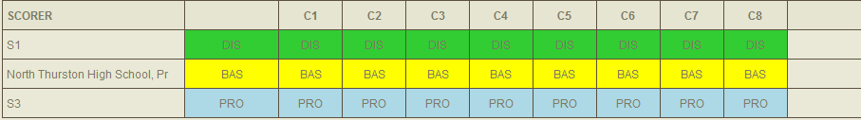

**Level 2 Detailed Scores**: The column headers for each of the criteria are active links that when clicked bring the viewer to a new screen that displays a more detailed view of the scores, including an individual score distribution and rubric element scores. The description of the Level 2 screen is described after the Level 1 screens.

**Observation and Criteria Non Anchor Summative Score Distribution – Level 1**

This table displays the distribution of summative scores for the participants. The first bar titled “OBS” displays the distribution for the Observation summative scores. In this example, there were just three participants and they each entered a different score (UNS, BAS, PRO) so there is an equal distribution (33% each). The remaining bars “C1-C8” display the distribution for the criteria summative scores.

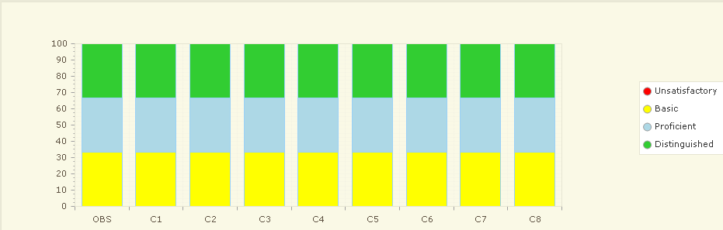

**Level 2 Detailed Scores**: The bars for C1-C8 are active links that when clicked bring the viewer to a new screen that displays a more detailed view of the scores, including an individual score distribution and rubric element scores. The description of the Level 2 screen is described after the Level 1 screens.

**Observation and Criteria Anchor Summative Score Distribution – Level 1**

This table displays the alignment between the participant scores and the anchor scores. The first bar title “OBS” displays the alignment between the anchor and participant Observation summative scores. In this example, 2/3 of the Observation summative scores where Non-Adjacent High compared with the anchor scores and 1/3 of the Observation summative scores were Adjacent High compared with the anchor scores. The anchor scores are all UNS (1) vs the participants scores being either BAS (2), PRO (3) or DIS (4).

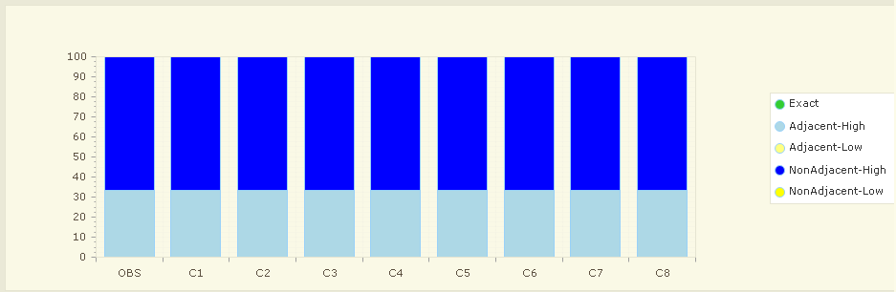

**Individual Summative Criteria Score Distribution – Level 2**

This table displays the individual score distribution for all of the participants and the anchor score. This bar chart helps the viewer easily see where the distribution of individual scores falls and which individual scores are at various points in the distribution.

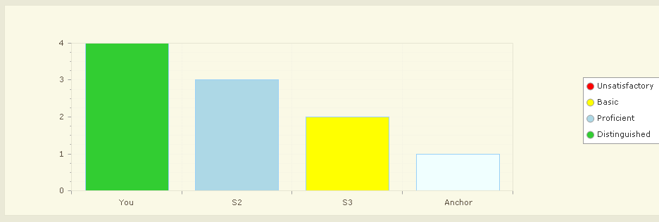

Rubric Element Score Summary – Level 2

This table displays the rubric element summative and individual scores entered by each of the participants for the practice session. The purpose of the table is to compare the scores across each of the participants and against the anchor scores entered by the session administrator. In this example the table is displaying the detailed information for criteria C1 that resulted when the user clicked on the column header in the ***Observation and Criteria Summative Score Summary – Level 1*** or the bar in the bar chart ***Observation and Criteria Non-anchor Summative Score Distribution – Level 1***.

The format of this table is equivalent to the format of the ***Observation and Criteria Summative Score Summary – Level 1*** table. The differences are:

* Instead of the Observation summative score, the criteria summative score is displayed. In this case it is C1.
* Instead of all of the criteria summative scores being displayed (C1-C8), the rubric element scores are displayed. In this example, the rubric elements within C1 are as follows:
  + 1c – Setting Instructional Outcomes
  + 2b – Establishing an Culture for Learning
  + 3a – Communicating with Students

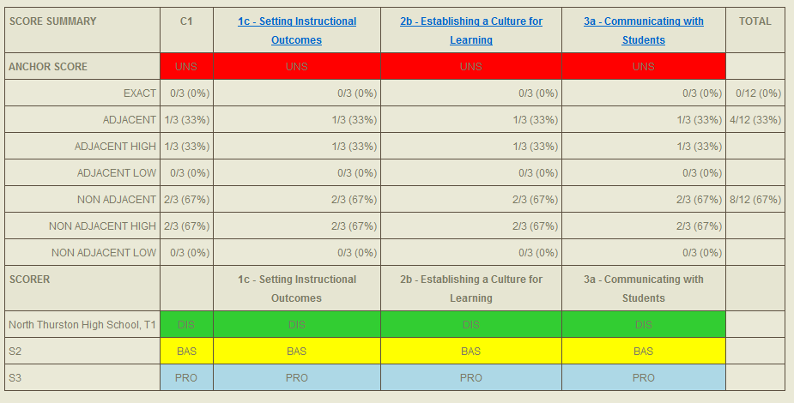

**Rubric Element Non-anchor Score Distribution – Level 2**

The format of this table is equivalent to the format of the ***Observation and Criteria Non anchor Summative Score Distribution – Level 1***. Similarly to the other tables at Level 2, the data that is being displayed is for a specific criteria and the rubric elements associated with that criteria.

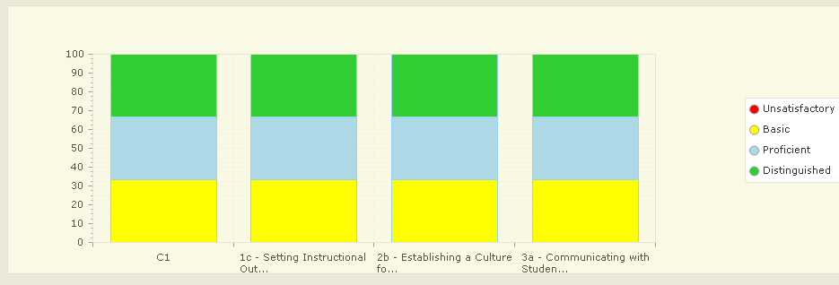

**Rubric Element Anchor Score Distribution – Level 2**

The format of this table is equivalent to the format of the ***Observation and Criteria Anchor Summative Score Distribution – Level 1***. Similarly to the other tables at Level 2, the data that is being displayed is for a specific criteria and the rubric elements associated with that criteria.

