**Question Bank**

The Question Bank is a place where districts, schools, and evaluators can create and store questions (user prompts) for future use in Goals, Pre and Post-Conference Questions, and Final Evaluation Questions. In this release the underlying architecture for these questions has been unified so that they all follow a common interface for working with them.

1. District Administrators can create prompts in the bank that can be used by:
   1. superintendents to assign when evaluating principals
   2. principals to assign when evaluating teachers
2. School Administrators can crate prompts in the bank that can be used by:
   1. Principals to assign when evaluating teachers
3. Superintendents can create prompts in the bank that can be assigned to principals they are evaluating.
4. Principals can create prompts in the bank that can be assigned to teachers they are evaluating.

In addition, evaluators (superintendents and principals) can create prompts that are private to an individual evaluate. For example, create a specific pre-conference prompt for a specific observation session. These prompts are not stored in the Question Bank. They are only visible and managed within the context of where they are assigned (pre or post-conference, goals, final evaluation screens).

At each level (district, school and evaluators) the user viewing the bank can see all prompts that they defined and those inherited:

1. District Administrators can only see prompts created by district administrators
2. School Administrators
   1. Can see prompts created by district administrators in their district
   2. Can see prompts created by school administrators in their school
3. Evaluators
   1. Can see all prompts that school admins and district admins see
   2. Can see all prompts created by them.

Question Bank Location: District Administrators, School Administrators, and Evaluators (Principals and Superintendents – District Evaluator) all have access to the Question Bank through the Setup navigation menu.

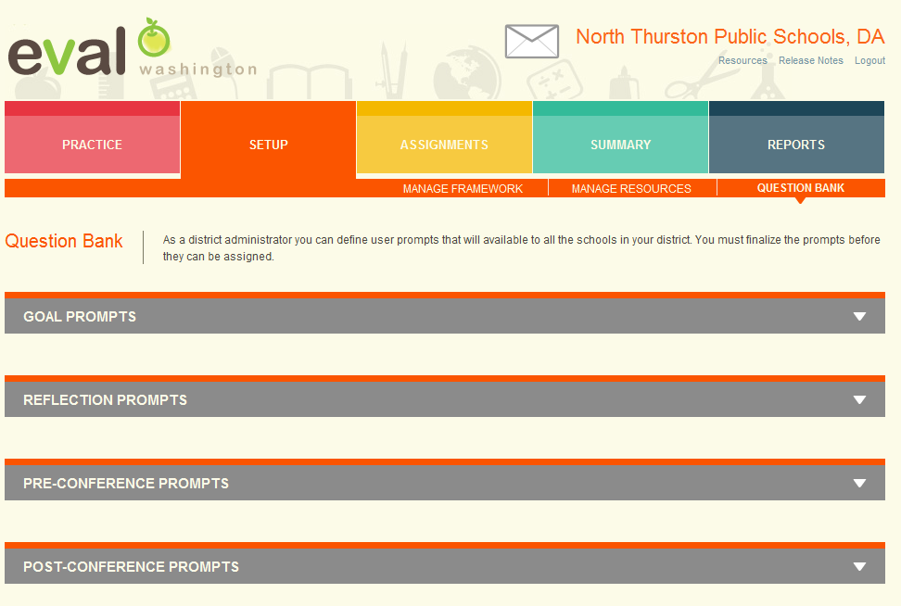

Above is a screenshot of a District Administrator’s view of the Question Bank (I have collapsed the prompt panels so that they are all visible).

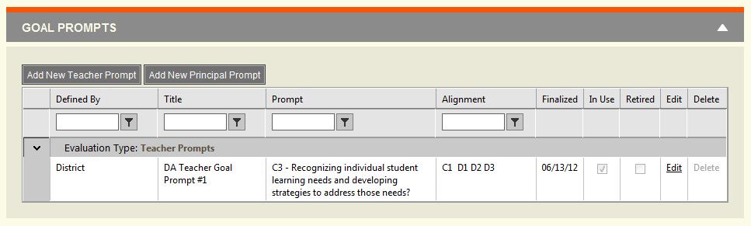

Above is a screenshot of the Goal Prompts grid. All prompts (Goals, Pre and Post-Conference, Reflections) have the following characteristics:

1. Defined By:
   1. What level defined the prompt?
      1. District – a district administrator defined it
      2. School – a school administrator defined it
      3. My Question Bank – an evaluator (principal or district evaluator) defined it.
2. Title
   1. This is only used in Goals
   2. Maxlen: 200 characters
3. Prompt
   1. The question presented to the user to respond to
   2. Unlimited length.
4. Alignment
   1. The creator of the prompt can align the prompt to the state and/or instructional framework to specify a focus for the prompt.
5. Finalized
   1. A finalized prompt is ready to be used and assigned. Prompts that are not finalized will not be available to be assigned.
   2. It can be continued to be edited after it has been finalized, but a warning message will be displayed on the edit screen, if the prompt has been assigned, to be cautious editing the prompt.
   3. A finalized prompt will .
6. In Use
   1. A prompt is in use if it has been assigned. It does not have to have been responded to.
7. Retired
   1. A retired prompt can no longer be assigned. If it is already assigned then it can still be used, but it will not be able to be assigned from the date of retirement forward.
8. Edit
   1. The owner of the prompt can edit the prompt.
   2. All district administrators can edit prompts created by district admins in their district
   3. All school administrators can edit prompts created by school admins in their school.
   4. Evaluators (principals and district evaluators) can edit prompts created by themselves only.
9. Delete
   1. The owner of the prompt can delete the prompt if it is not in use.
   2. All school admins are considered the owner of school admin-defined prompts
   3. All district admins are considered the owner of district admin-defined prompts.

Creating new Prompts

1. Add New Teacher Prompt – prompts that will be assigned to teachers by principals
2. Add New Principal Prompt – prompts that will be assigned to principals by district evaluators

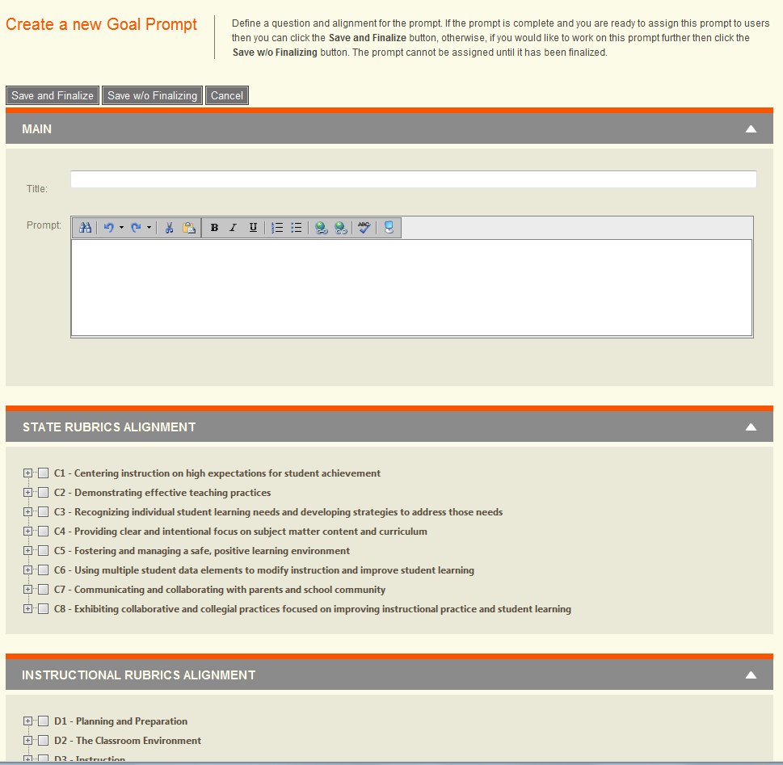

Above is a screenshot for creating a new prompt.

1. Title – Required
2. Prompt – Required
3. Alignment – Optional
4. Save and Finalize Button – The prompt will be available for assignment.
5. Save w/o Finalizing Button – The prompt will not be available for assignment yet.

**Batch Assignment Prompts**

As an evaluator you are able to assign multiple prompts to multiple users in a single step through the Setup/Assign Questions screen.

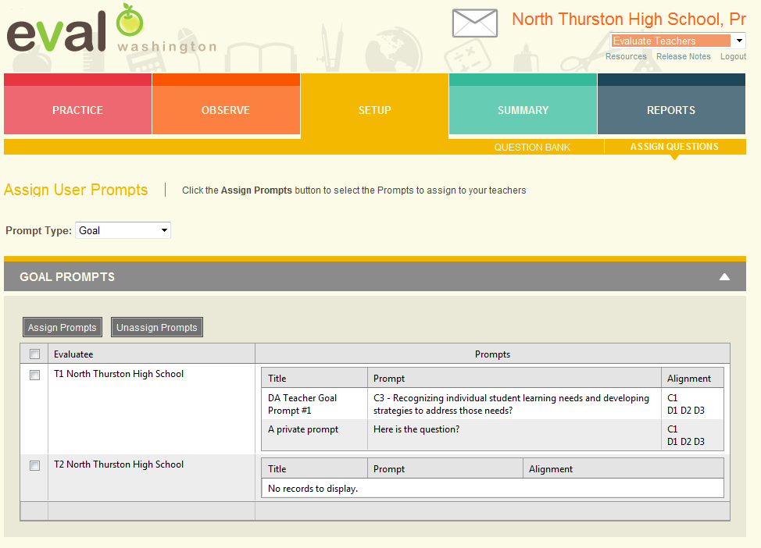

The first column is the Select column. By selecting the column header you select all of the rows below. Once the rows are selected you can choose to either:

1. Assign Prompts – allows you to choose which prompts from the Question Bank you want to assign to each of the selected users.
2. Unassign Prompts – allows you to choose which prompts from the Question Bank you want to un-assign for each of the selected users.

When you click the Assign or Unassign Prompts button, a dialog will appear that allows you to choose which of the questions in the question bank you want to assign to the selected users. After you close the dialog, those prompts will be assigned and displayed in the Prompts grid on the right.

1. Goal and Reflection prompts are assigned directly to the user because there is on one set of goals and reflections per user.
2. For Pre and Post-Conference prompts, you are selecting the assignment that will be made each time a new observation session is created. The assignment will not be applied to any observation sessions that have already been created.

**Goal Prompts**

The Evaluator and Evaluatee interact with goals through the Goal Settings Screen. Evaluators navigate to this screen through the Evaluator Dashboard (Observe section), by clicking on the link in the Goal column for a given evaluatee. Evaluatees navigate to the Goal Settings screen by clicking on the Goals section.

The Goal setting screen for a teacher is shown below. It is the interface from the Evaluator’s perspective.

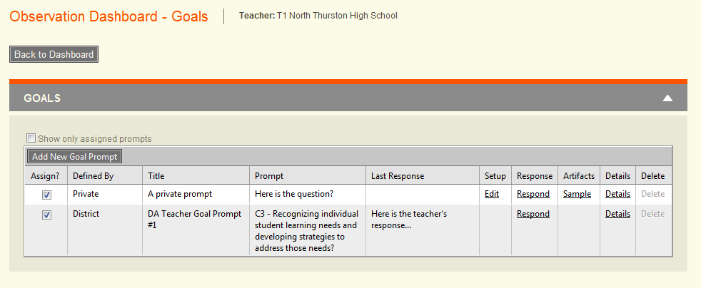

Here is the same screen from the Evaluatee’s perspective.

The Evaluator’s view includes these additional columns:

1. Assign? - The ability to assign the prompt
2. Defined by
3. Setup – The ability to further configure the prompt

The common columns are:

1. Title
2. Prompt
3. Last Response – Both the evaluator and the evaluatee can respond to the prompt and all responses are recorded. Only the last response entered is displayed in the grid here. If there is more than one response, then the Last Response value will include an ellipsis ‘…’ following the response. The remaining responses can be viewed through the Details link.
4. Artifacts – A link to each of the artifacts that the evaluatee has uploaded in association with the prompt. The evaluatee can upload artifacts through the Details link.
5. Details – The link drills down into a details page that contains all of the information about the prompt. Since the most common scenario is for just the prompt/response to be used, the extended items are only accessible through the Details view. Here you can respond to the prompt, align to the framework, and upload artifacts.

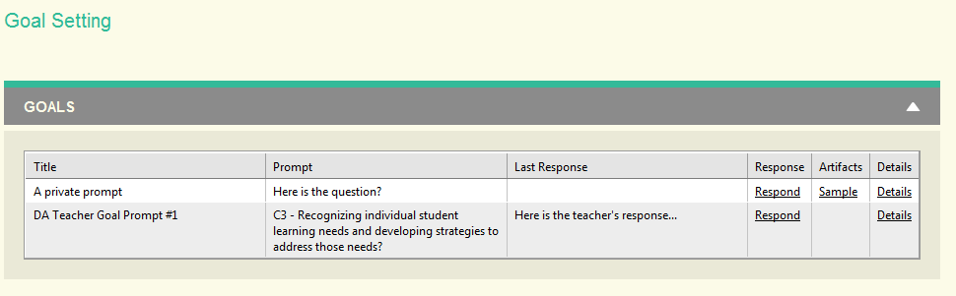

Responding/Viewing Prompts

When you respond to a prompt you just click the Respond link and the following response section will appear. After the response

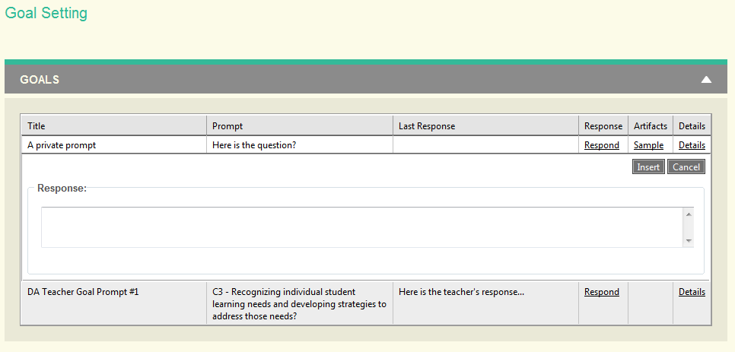

**Reflection Prompts**

The Evaluator and Evaluatee interact with reflections through the Summary Screen. Evaluators navigate to this screen through the Summary Section and then by clicking on the View link for a specific user. Evaluatees navigate to the Summary screen by clicking on the Summary section. Once on the Summary screen scroll down to the bottom of the page and expand the Reflections panel.

Reflections follow the same pattern as goals.

Pre and Post-Conference Prompts

The Evaluator and Evaluatee interact with pre and post-conference prompts through the Evaluator Dashboard Screen. Once an observation session has been created, the user can drilldown into the observation and click on the Pre or Post-Conference sub-navigation. Evaluatees can navigation through the Observations section and drilling down into an observation in their dashboard. For both pre and post-conference questions, there is a panel at the bottom of the screen. Here is a screenshot of the principal’s view of the pre-conference questions.

Pre and post-conference questions follow the same pattern as reflections and goals. The only difference is that a new session will have the prompts assigned that were assigned through the batch assignment on the Assign Questions screen.

