Artifacts

There are different types of Evidence that contribute to a teacher’s evaluation.

1. Observations
2. Student Growth Goals
3. Self-Assessments
4. Other Evidence

An Artifact is something that you create, do or gather that is related to your evaluation. An artifact can be used as evidence to demonstrate performance in the area that is being evaluated. An artifact can either be a stand-alone piece of Evidence (Other Evidence) or something that supports another type of evidence, such as an Observation, Self-Assessment or Goal.

Artifacts that are attached to Observations, Goals, or Self-Assessments are just supporting documentation for the primary type of evidence. Examples might include a lesson plan used during the observation, a goal-planning worksheet, a photo taken during taken during the observation, or assessment data to support the student growth goals.

Artifacts that are not associated with these primary types of evidence are “Other Evidence”. Most often this type of evidence consists documentation of activities that take place outside of the classroom, such as documenting a professional practice. An example might be that the teacher wants to document that she is in a leadership position at her school. Or a classroom newsletter might be used to demonstrate communication with parents.

**The Artifact creation process**

All artifacts are created/managed through the Artifacts section. For a teacher’s evaluation, both the teacher and principal can create artifacts. They each create the Artifacts section. The principal must first select the teacher to work on. Then all of the artifacts that he creates are related to that teacher’s evaluation.

While working in the Artifacts section, the artifacts are private. They are not visible to the other person. The teacher or principal must submit the artifact as “Evidence” to move it into the public view so that it becomes part of the evaluation. From then on

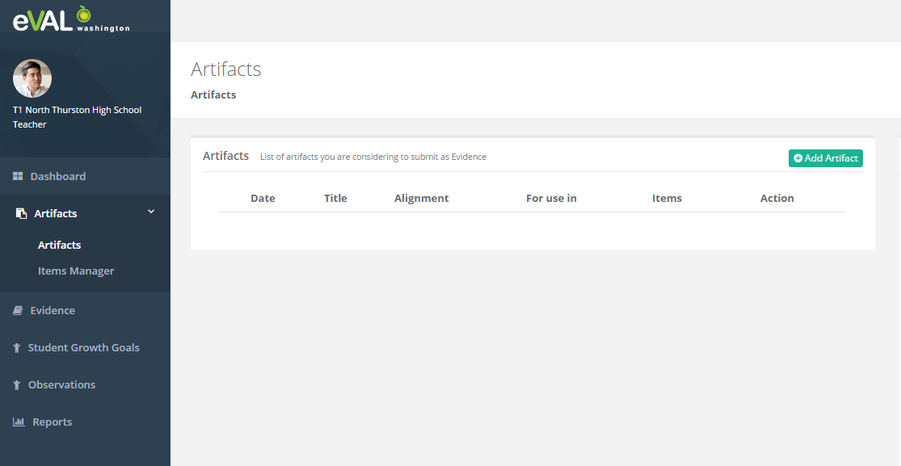

Creating an artifact: Go to Artifacts area and click the “Add Artifacts” button in upper right.

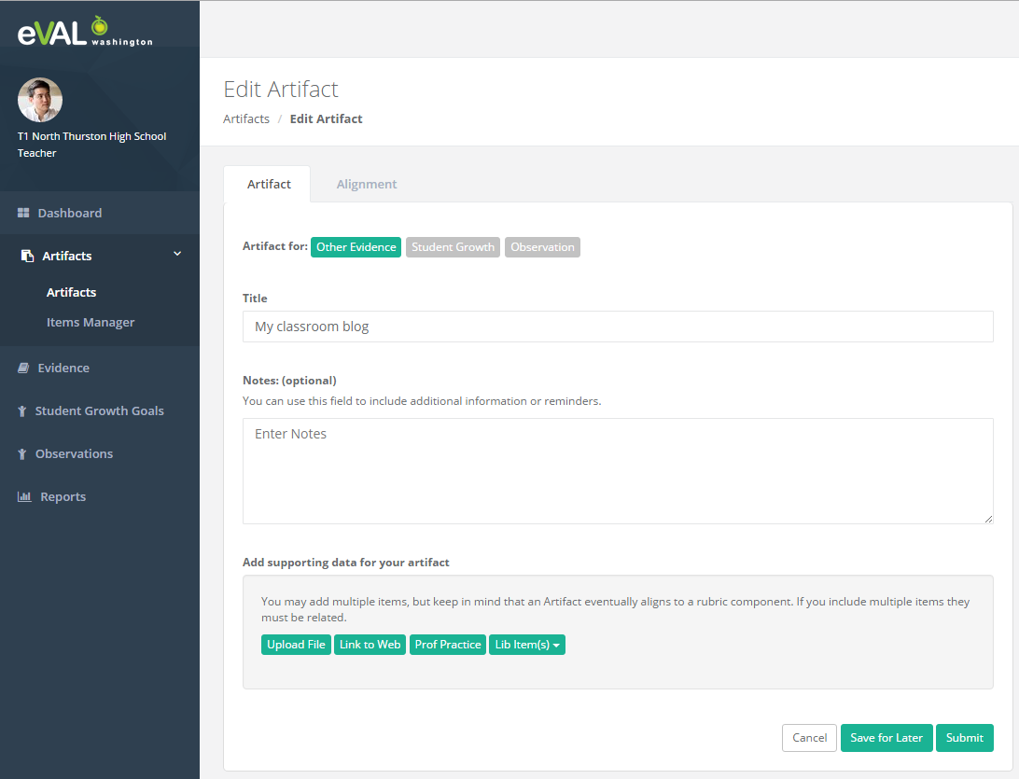

Selecting the type of artifact: The user must specify the type of artifact (Other Evidence, attached to an Observation, attached to a Student Growth Goal). Other Evidence will move through a different flow than artifacts that are attached to an observation or a student growth goal.

Attaching items: Each artifact is attached to one or more external items; such as an uploaded document, a link to a website, or self-documented activity (called Professional Practice) that they describe as a narrative in the artifact. Each attached item is held in the Item Manager and they can be re-used across artifacts.

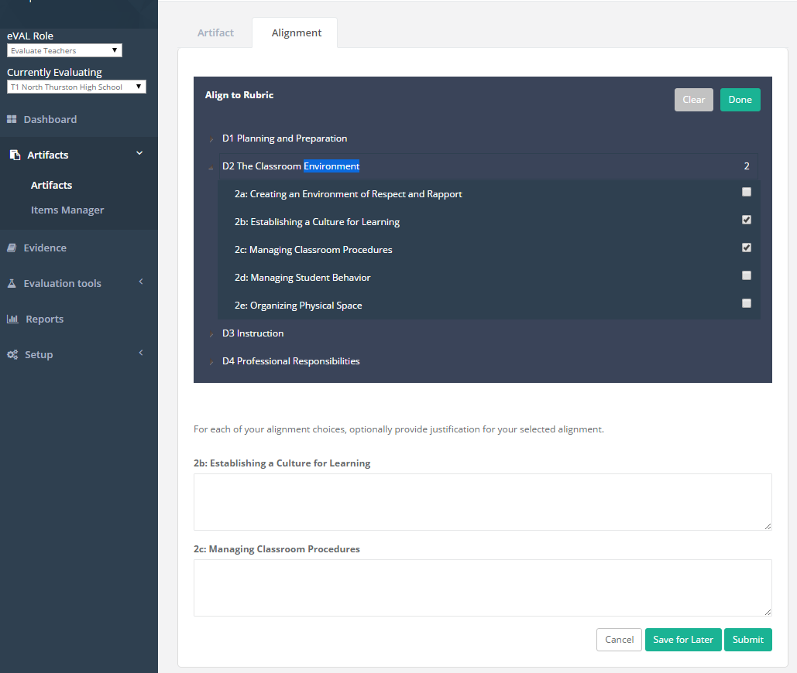

Alignment to the Rubric: Next, the teacher needs to align the artifact to the rubric and optionally input some contextual information to help the principal understand the artifact and her alignment choices.

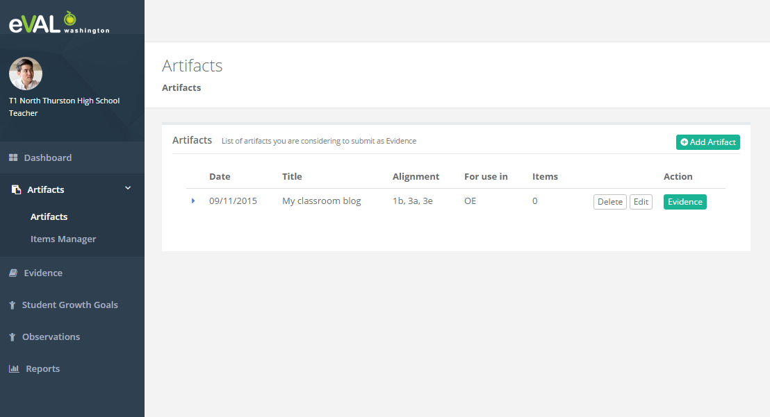

Now click on the “Evidence” button to submit the Artifact so that it will become Evidence and is visible to the principal.

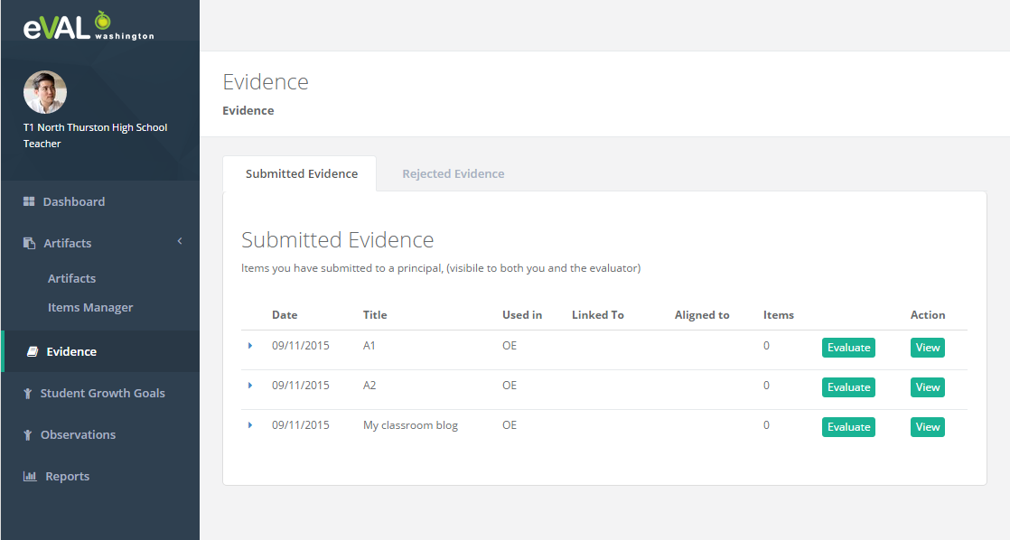

Now change to the “Evidence” area on the left nav. These are the artifacts that have been submitted for public view by the evaluator and can be evaluated by either the principal or the teacher. It will be rare that a teacher will self-evaluate a submitted artifact, but we are offering that functionality so that we have a unified approach to evaluating all evidence items that are aligned to a rubric component.

**Evaluating “Other Evidence”**

Evidence that is not attached to another eVAL item (such as an observation or goal) is evaluated as “Other Evidence”. The teacher can initiate this process directly from the Evidence section. The principal can do it from there, but he would typically do it from within the “Evaluation Tools->Other Evidence” section, where he can also evaluate observations and student growth goals.

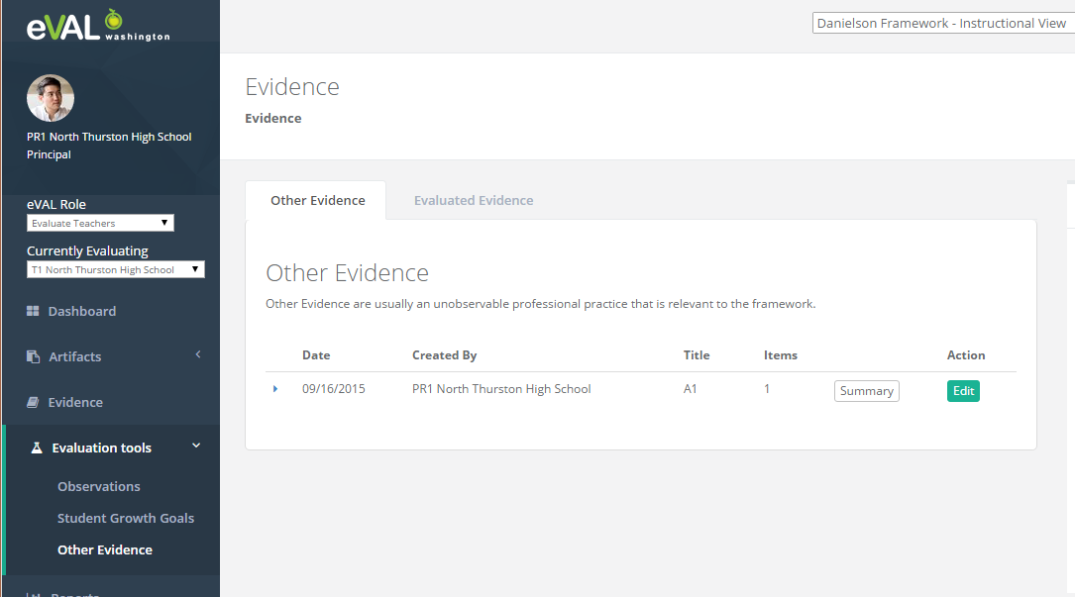

From this screen there are two choices. You can either drilldown into a summary screen, which shows a read-only view of the current state of the evidence. It will include all of the evaluation data to-date. The edit view allows the user to drilldown to the screen to evaluate the evidence. (NOTE: this is my best-guess at how the screens will be laid out, the mock-ups have not been done for Other Evidence evaluations yet. I am basing this on the observation evaluation screens).

Clicking on the Edit button will bring you to the scoring screen that enumerates the aligned rubric components and gives you a status of which ones have been evaluated to-date.

There are a couple of things involved with scoring.

1. You can click the checkbox on the header to indicate the performance level.
2. You can select some of the text in the rubric descriptor and then you can create an “Aligned Evidence” item.

After clicking on the checkbox it will look like this.

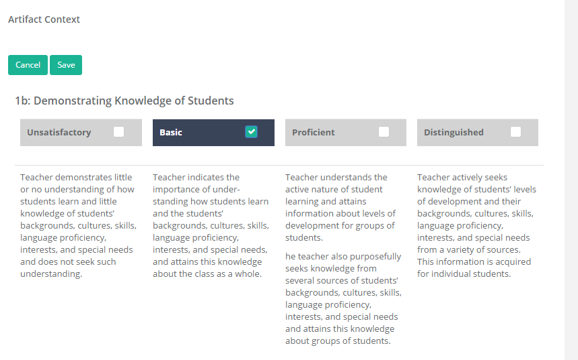

Now do the “Aligned Evidence”

1. Select a section of the rubric text.
2. An input area should appear below the rubric (sometimes it is out of view).
3. At the top of the input area is the Rubric Statement , which is just the selected text. At the bottom is a textbox for you to Input some text in the text box. Input some text and then click “Save”.
4. There will now be an “Aligned Evidence” item below the rubric. There will also be yellow highlighting in the rubric descriptor text matching what you selected.

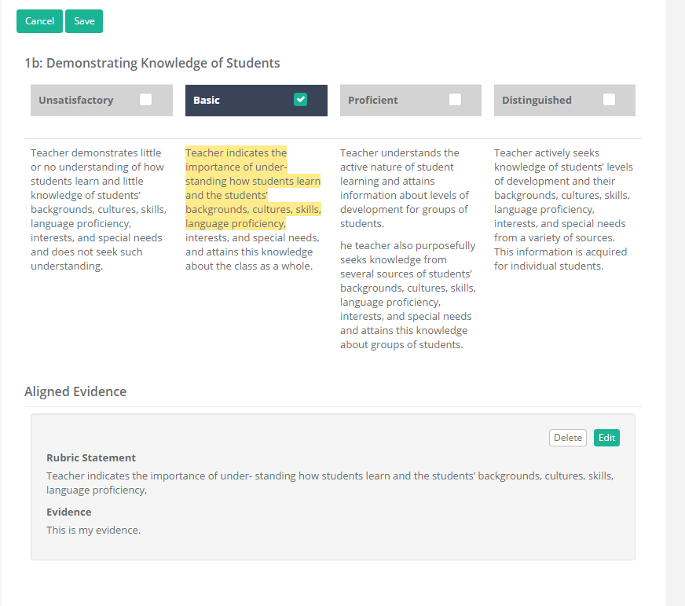

This is what it should look like after you have set the performance level and added one Aligned Evidence item. The user can add as many Aligned Evidence Items as he wants. The highlighting will merge all of the selected text together.

Now click the “Save” button to finish the scoring and return to the summary scoring screen.

Now if you navigate to the Evaluation Tools ->Other Evidence and then click on the Summary screen the new evaluation data should be included.

The directives that are used in this are:

* Core/directives/show-rubricrow-eval: this is what is displaying the rubric details on the summary screen.
* Core/directives/score-rubricrow: this is what is used in the drilldown scoring page.

There are two classes in the back-end that support this functionality.

RubricRowEvaluation and RubricRowEvaluationEvidence. There is a one-many relationship between them. The RubricRowEvaluation links to the rubric row, and stores the performance level for the rubric row. Then there can be zero or more “Aligned Evidence” (RubricRowEvaluationEvidence) items related to it.

There is a RubricRowEvaluation instance for each scoring instance associated with a rubric row. So for an observation that has an artifact aligned to the rubric row, there could potentially be four RubricRowEvaluation instances in the collection. The principal and the teacher could both score the aligned artifact as well as score the observation for that rubric component.

So any item in eVAL that can be aligned to a rubric row and scored will have a collection of RubricRowEvaluation objects. We don’t create them until they start to “Evaluate” the item in the context of the rubric row.

In the case of stand-alone evidence/artifacts and student growth goals, they will only score rubric rows for which they have aligned the item. For example, a student growth goal might be aligned to rubric row “SG 3.2”. The goal will only be scored for “SG 3.2”.

But in the case of observations, we need to allow them to score rubric rows that they may not have aligned initially. This is because their intentions before the classroom observation don’t always work out and they have to change what they observe based on what is happening in the classroom at the time of the observation

RubricRowEvaluation:

* RubricRowId: aligned rubric row
* EvaluationId: evaluation it relates to
* LinkedItemType: what type of item is this rubric row aligned to? Observation, Self-Assessment, Student Growth Goal, Stand-alone Artifact.
* LinkedToObservationId, LinkedToArtifactBundleId, etc…
* PerformanceLevelID: the score for the rubric row
* CreatedByUserId:

RubricRowEvaluationEvidence: one of these for each “Aligned Evidence” associated with the scoring instance.

* RubricStatement: the highlighted text from the rubric descriptor text.
* Evidence: the supporting text for the statement. This would typically come from the “CodedEvidence” taken from the classroom observation notes.
* StatementPerformanceLevel: which rubric section did it come from so we can go back and highlight the text.