BRD 7.1 - Display current year's evaluation cycle on Observation screen, Observation report, Scoring screen and Evaluation report.

1. Add the Evaluation Plan Type to the “Type” field on the Observation heading that is displayed on for all of the pages within the OBSERVE section.

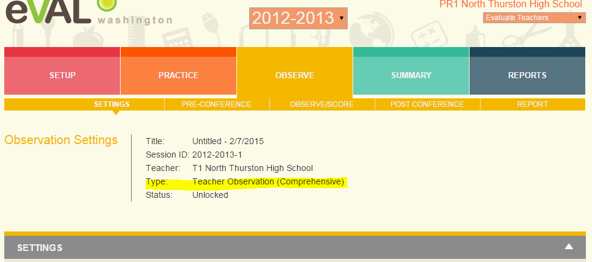

2. Add Evaluation Plan Type to the Observation Report header section.

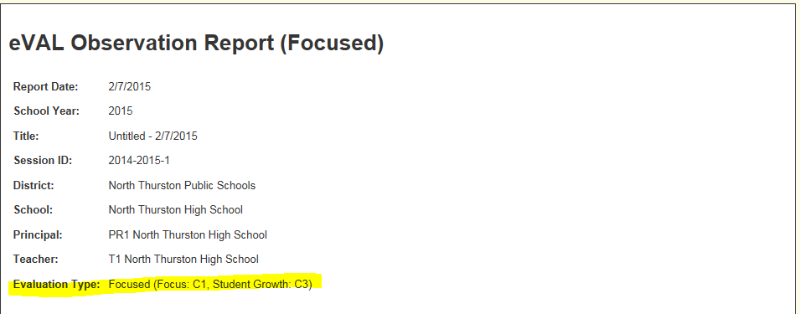

3. Add to Evaluatee Summary page.

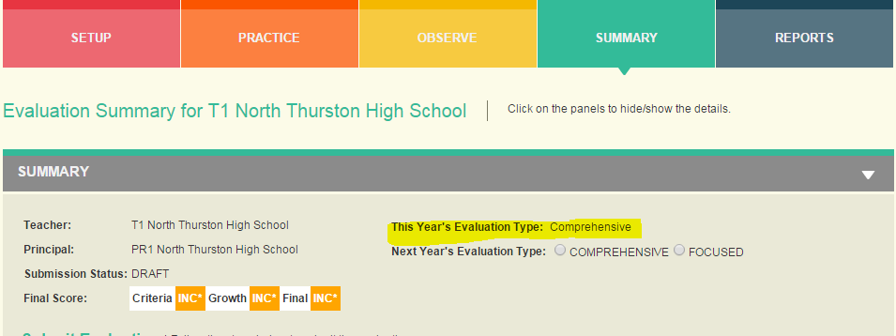

4. Add to Final Report Header.

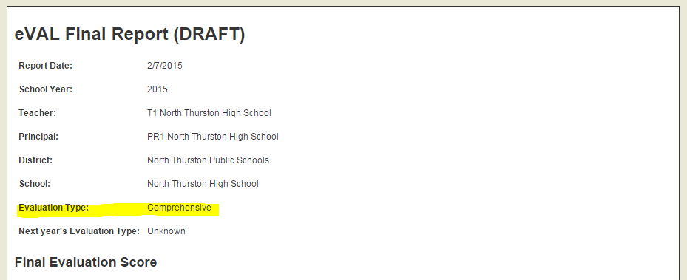

BRD 4.1 - Removal of any functionality that assumes the start or end time of an observation.

1. On the Observation Settings page change from direct input fields to a “Change Date” button and a dialog to set the date.

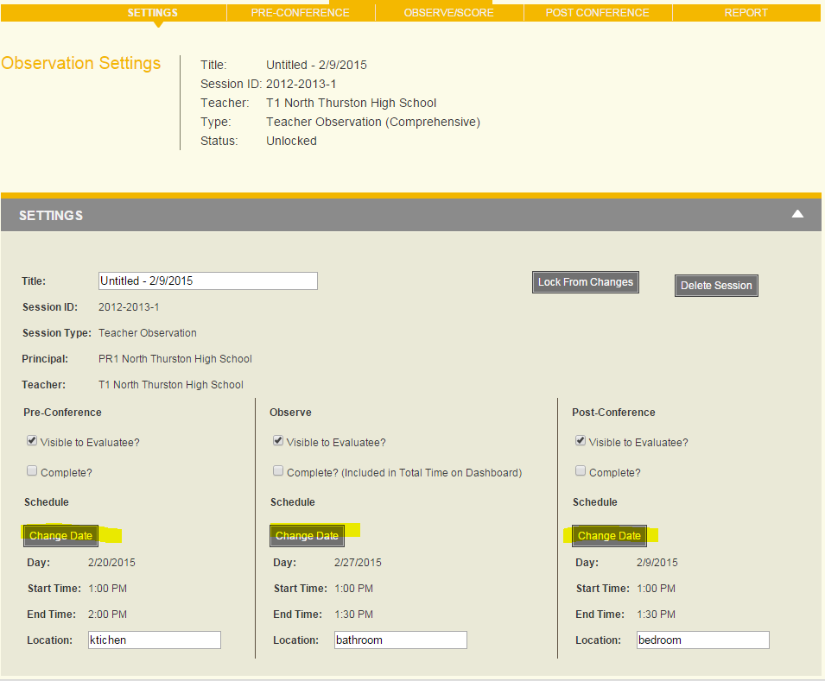

Do not provide default values for the start and end times.



 