**Session Complete**

Like Session Visibility, each phase of the session’s lifecycle can be marked as complete. For the pre-conference and post-conference phases, marking the phase as complete is optional and only used as an aide in tracking progress by the evaluator. The observe complete flag has additional meaning and will be discussed after showing how to configure the complete flags.

**Configuration**

**Observation Settings Screen**: The sub-navigation for the observation session also contains a Settings link to go to a screen where the evaluator can configure the complete flag for each of the different sections.

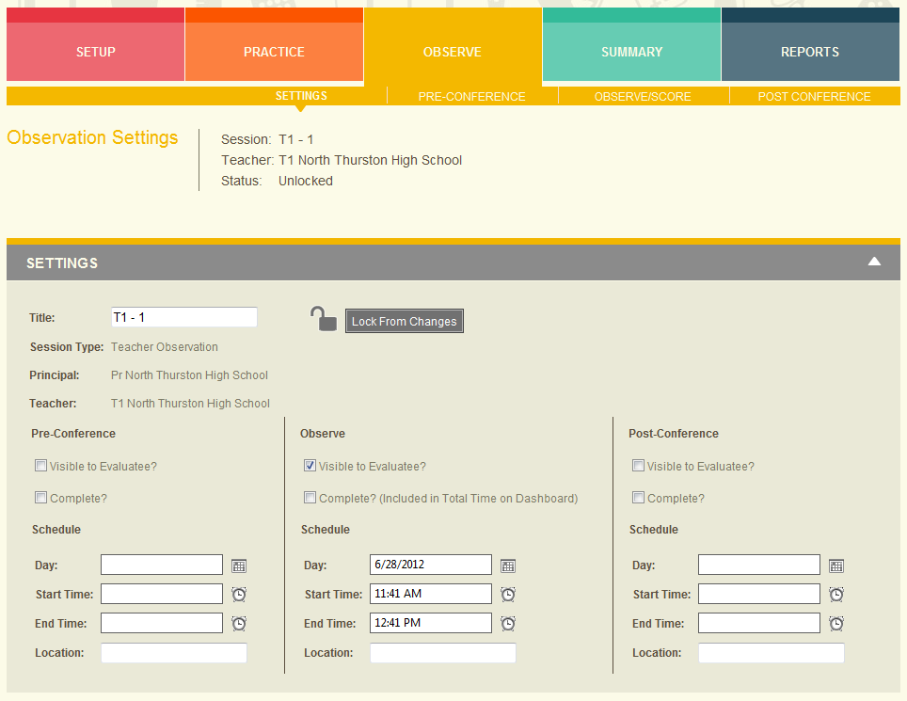

**Evaluator Dashboard Session Settings**: In addition to the Observation Settings screen, the complete flags can also be configured on the Evaluator Dashboard within the expanded panel for each evaluatee.

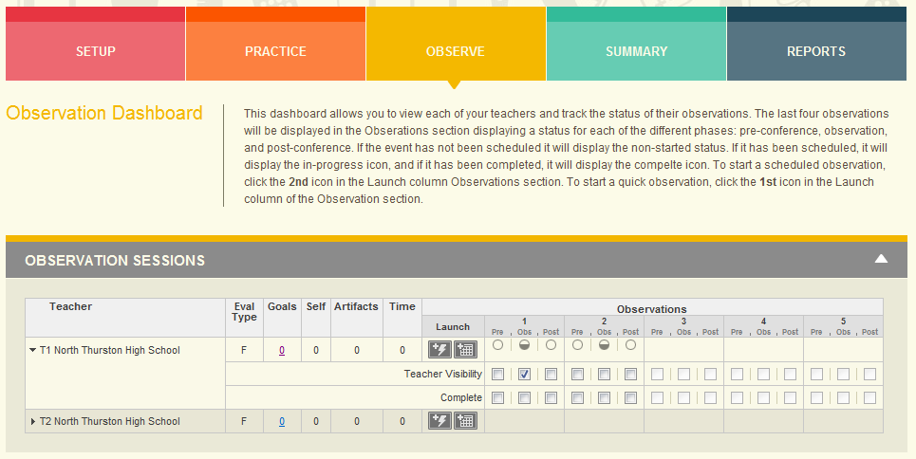

**Viewing Sessions - Evaluatee**

The complete flag is not used in determining whether an evaluate can view a session.

**Session Observe Visibility**

The session’s Observe Complete setting has the following implications:

* Discrepancy Report - Only visible and complete sessions are included in the Discrepancy Report
* Final Evaluation Summary Screen
  + Evaluator - Only complete sessions are included. Sessions do not need to be marked as public to be visible to the evaluator on this screen.
  + Evaluatee – Only visible and complete sessions are included.
* Final Report - Only visible and complete observations are included in the Final Report.
* Evaluation Dashboard Total Time – Only complete sessions are included in this calculation.