**Session Locks**

Sessions can be locked by the evaluator to prevent changes. Once a session is locked, a request can be made to unlock the session from either the evaluator or the evaluate, but the request must be agreed to by the other party before the unlock request is executed.

* Evaluator Locks -> Session is Locked
  + Evaluator Requests Unlock
    - Evaluator Remove Request -> Session remains Locked
    - Evaluatee Accepts -> Session is Unlocked
    - Evaluatee Declines - >Session remains Locked
  + Evaluatee Requests Unlock
    - Evaluatee Removes Request ->Session remains Locked
    - Evaluator Accepts ->Session is Unlocked
    - Evaluator Declines -> Session remains Locked

**Lock-related Alerts**

With each change in session lock status an alert message is sent to the other person in the session. For example, when a principal locks a session, the teacher receives an alert of the event. And when a teacher accepts an unlock request from the principal, the principal will receive an alert of the event.

Each alert will appear in the users message inbox. The details contain information about the event, and an url that can be pasted into the browser and takes you to the session settings page where you can see and possibly change the sessions lock status.

The alert indicator (red box with number of new unread messages) will be removed when the inbox is viewed, or when the user visits the settings screen for the sessions that generated the alert.

**Locking Workflow Screenshots**

Starting Point: Session is Locked – Evaluator can Lock From Changes

The evaluator can lock the session by clicking the ***Lock From Changes*** button. He will be prompted to confirm and then the session will become locked.

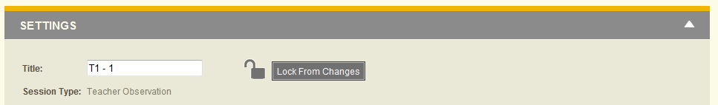

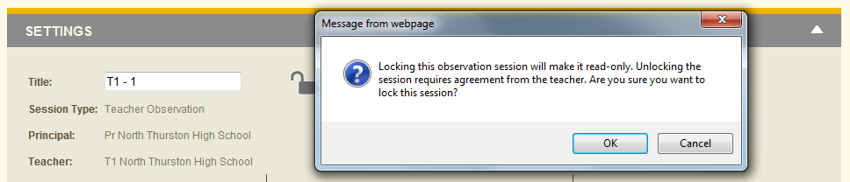

The evaluatee will receive the following alert in their message inbox. Pasting the url in the browser will bring the user to the session’s Settings screen.

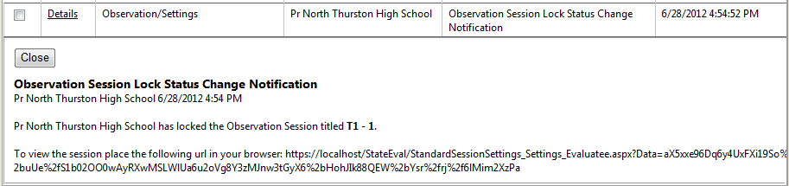

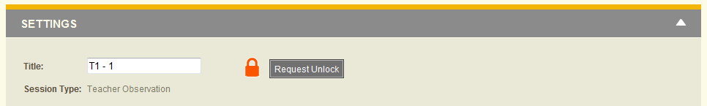

At this point either the evaluator or the evaluate will be presented with the same option to request the session be unlocked.

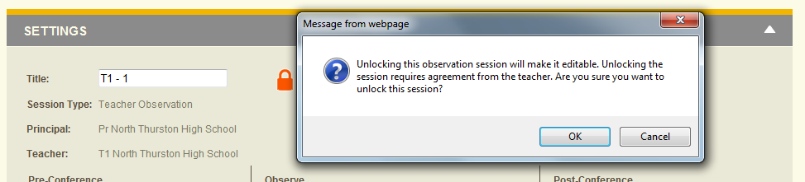

Clicking the Request Unlock button will prompt to confirm and then the session will be in a lock state waiting for the other person to accept or decline the request. The evaluator will be given the option to cancel the request.

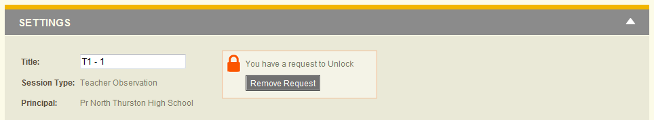

The person receiving the request will receive an alert message shown below.

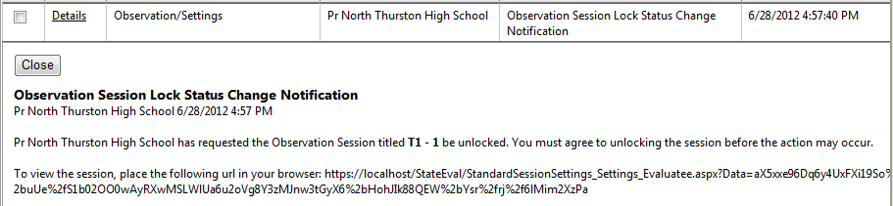

And the other person will be presented with the options of either accepting or declining the request.

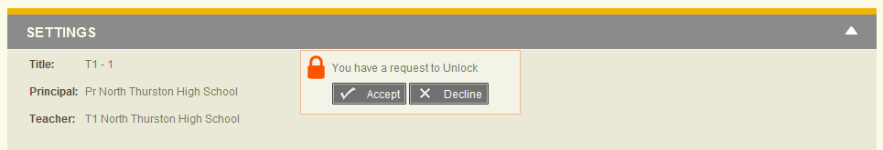

Clicking on the ***Accept*** button prompts to confirm and then unlocks the session.

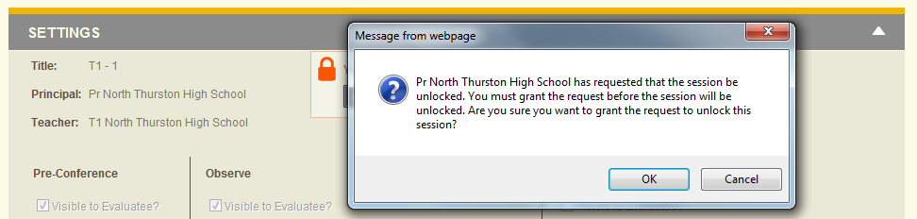

Clicking on the ***Decline*** button prompts to confirm and then leaves the session locked and removes the request.

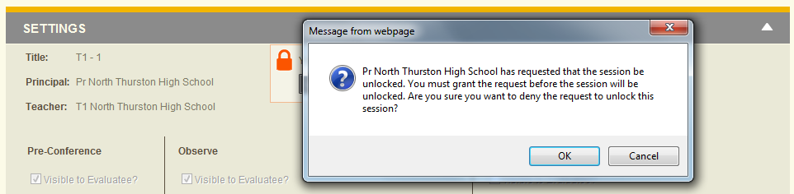

The following alert will be sent to the other party. This one is for a decline, but it is the same for an accept, except for the work declined is replaced with accepted.

