**Session Visibility**

Session Visibility is a feature used by the session evaluator to control visibility to the different phases of an observation lifecycle to the evaluate. An observation session has three distinct phases that are represented in the Observation View as different sections/screens.

* Pre-Conference
* Observe/Score
* Post-Conference

Once an evaluator has created an observation session through the Evaluator Dashboard, he can drill down into a detailed view of the session. There will be a separate screen for each of the three sections and they are accessible through the Observe sub-navigation menu as seen in the screenshot below.

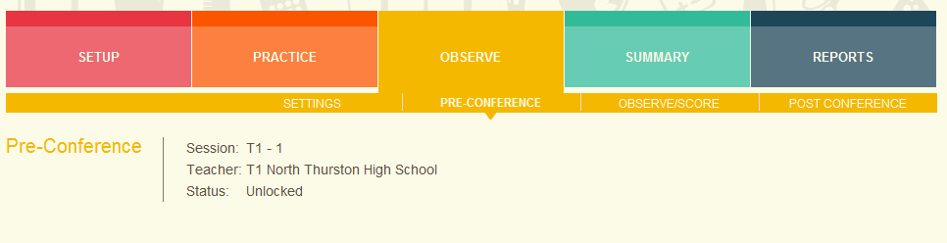

**Configuring Visibility - Evaluator**

**Observation Settings Screen**: In addition to the screens for the different sections, the sub-navigation for the observation session also contains a Settings link to go to a screen where the evaluator can configure the visibility for each of the different sections.

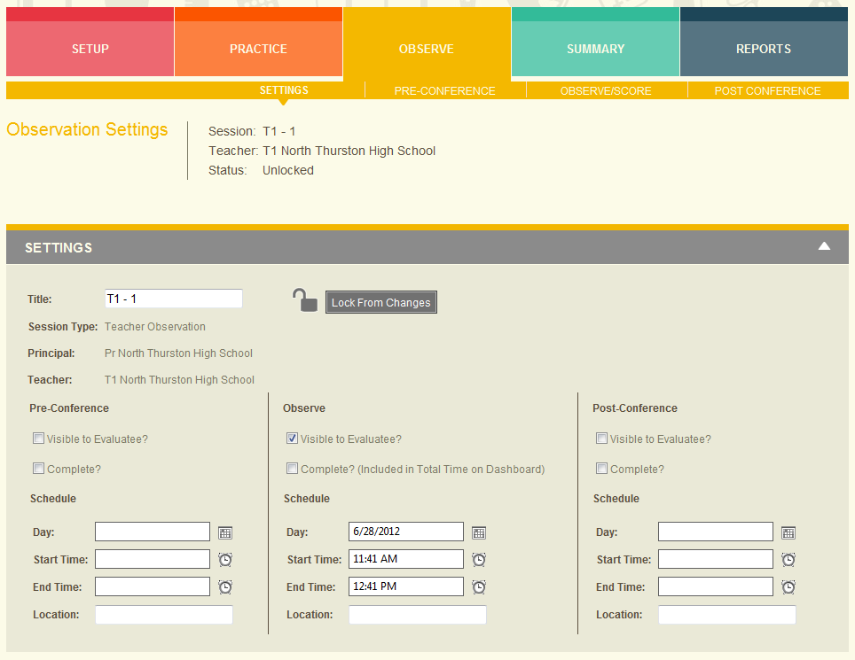

**Evaluator Dashboard Session Settings**: In addition to the Observation Settings screen, the visibility can also be configured on the Evaluator Dashboard within the expanded panel for each evaluatee.

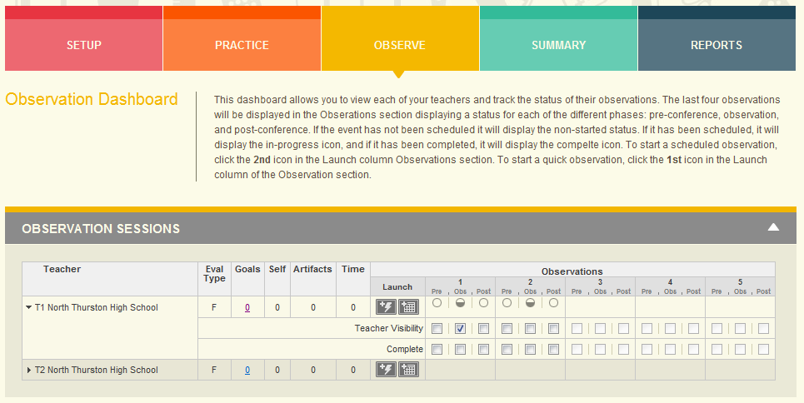

**Viewing Sessions - Evaluatee**

The evaluatee can only view an observation session, and the drilldown detail screens, if they have been made visible by the evaluator.

* If none of the sections (pre, observe, post) is marked as visible, then the entire session is not visible to the evaluate in their Dashboard.
* If at least one of the sections (pre, observe, post is marked as visible, then the session is visible in their Dashboard and for those phases that are marked as visible, the link is active in their Dashboard.

In the screenshot below you can see that only the Pre-Conference sub-navigation link is visible. That is because the Observe and Post-Conference sections were not marked as visible.

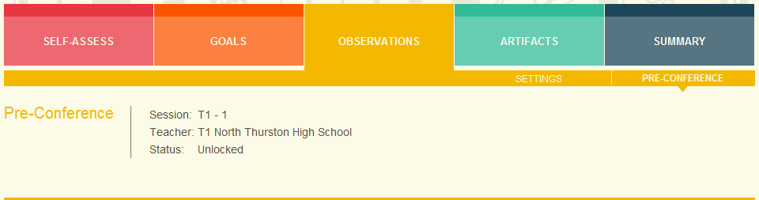

**Session Observe Visibility**

The session’s Observe visibility setting has additional meaning beyond whether the evaluate can see the different section pages within the observation’s screens.

* Discrepancy Report - Only visible and complete sessions are included in the Discrepancy Report
* Final Evaluation Summary Screen
  + Evaluator - Only complete sessions are. Sessions do not need to be marked as public to be visible to the evaluator on this screen.
  + Evaluatee – Only visible and complete sessions are included.
* Final Report - Only visible and complete observations are included in the Final Report.