**Teacher In Multiple Schools (TMS)**

Some teachers, especially those that teach subjects such as Music and PE, teach in more than one school within their district. We now support this scenario. At each school where the teacher works, all principals will be able to observe the teacher, and the district administrator will be able to assign a principal from one of the schools where the teacher works as the final evaluator.

**District Administrator Assignment Processing – Assignments**

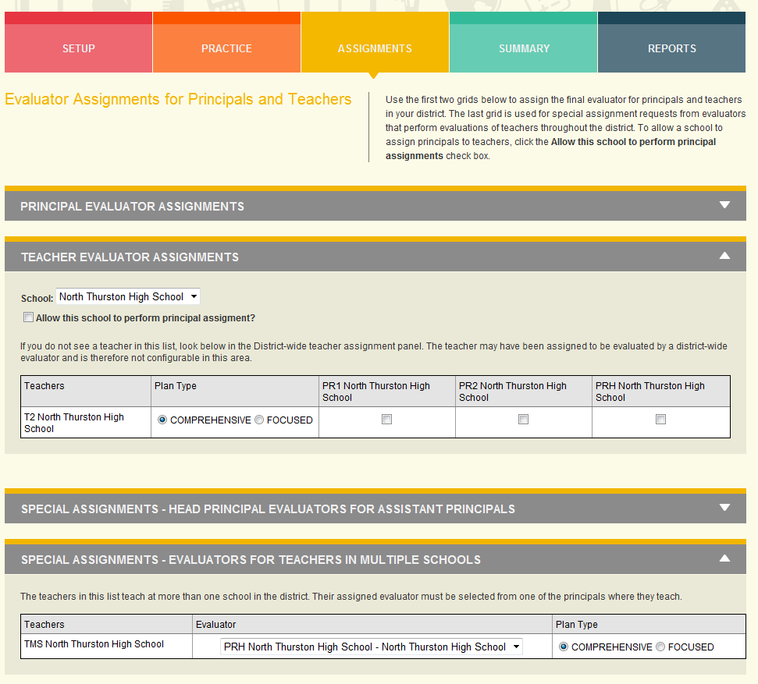

The Assignment screen has two sections for configuring evaluators for principals at a school.

* TEACHER EVALUATOR ASSIGNMENTS – This is where principals are assigned to school principals. This is the standard assignment process. A teacher that teaches at more than one school will not be visible in this section.
* SPECIAL ASSIGNMENTS – EVALUATORS FOR TEACHERS IN MULTIPLE SCHOOLS– This is where a principal can be assigned to a teacher who teachers in multiple schools.

**Teacher Preparation for Evaluation**

A teacher that works in multiple schools still has a single interface for preparing for their evaluation. They do not need to switch schools.

Principal Evaluations

Principals can see all teachers that work at their school, including when the teacher works at more than one school.