**District-specific Testing**

**Performance Levels**

Within eVal there are a lot of places where the user inputs scores. These scores are always in the form of a performance level. A performance level is a numeric value between 1 and 4, but is displayed to the user with a more meaningful title and description.

The scores are sometimes summative, i.e. the user is supposed to consider all the scores below this level and “roll-up” these scores to come up with a summative score. The roll-up is a manual process. They do not need to mathematically match. The scores are just used as a guide to arrive at the rolled-up score. For example, after the principal has scored all of the individual rubrics they can then “roll-up” the scores from a given rubric within a criterion, say C1, and give the C1 a summative score. Likewise, after all of the criteria summative scores have been given, those scores can be “rolled-up” to arrive at a summative score for the observation.

Each district defines the meaning of the four performance levels for all but the final summative score.

The places in the application where performance-level scoring occurs are the following:

|  |  |  |  |  |
| --- | --- | --- | --- | --- |
| **#** | **Screen** | **Location** | **Description** | **District-defined?** |
| 1 | Observe | Summary Panel | Summative Observation Score. Rolled-up from all of the individual summative criteria panel scores. | Yes |
| 2 | Observe | Criteria Panel | Summative Observation Criteria Score. Rolled-up from the individual rubric-row scores within the criteria panel. | Yes |
| 3 | Observe | Rubric Row within a Criteria Panel. | Observation Rubric Row Score. This is not a rolled-up score. | Yes |
| 4 | Summary - L1 | Final Score check boxes on the Summary Panel. | Summative Final Score. This represents the final score for the teacher for the entire year and what will be submitted to the state. | No |
| 5 | Summary – L2 | Summary Panel | Summative Final Score | No |
| 6 | Summary – L2 | Criteria Panels | Summative Criteria Score | Yes |
| 7 | Summary - L2 | Rubric Row | Summative Rubric Row Score | Yes |

**Screen #1:**



**Screen #2, #3:**

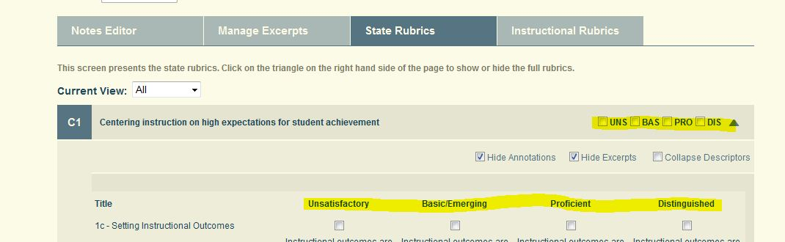

Screen #4:

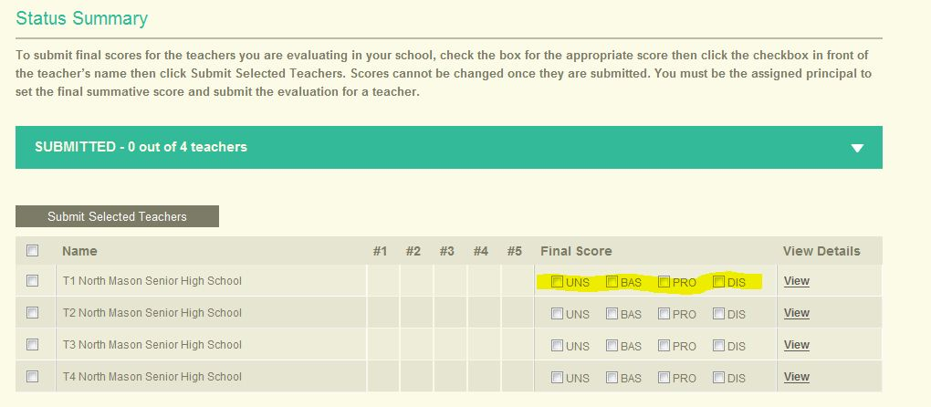

**Screen #5:**

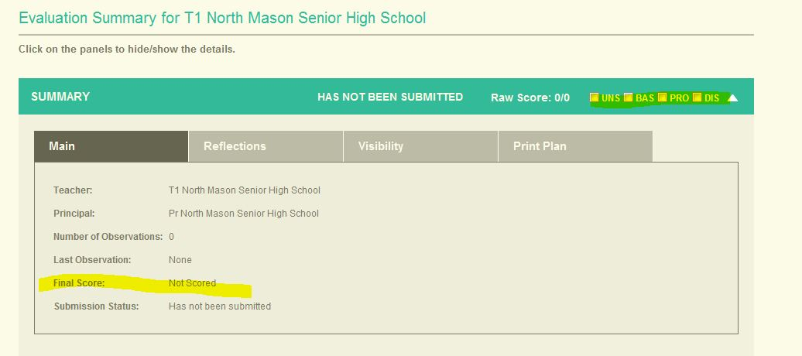

Screen #6, #7:

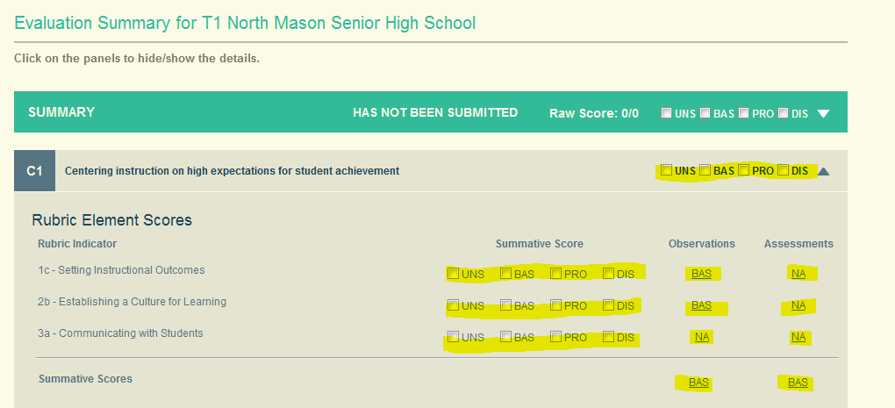

The following are the definitions for the state-defined Final Summative Score performance levels.

**P1: UNS – Unsatisfactory** - Professional practice at Level 1 does not show evidence of understanding or demonstration of the concepts underlying individual components of the criteria. This level of practice is ineffective and may represent practice that does not contribute to student learning, professional learning environment, or effective teaching practice. This level requires immediate intervention and specific district support. Failure to show adequate growth is grounds for dismissal/nonrenewal.

**P2: BAS – Basic** - Professional practice at Level 2 shows a developing understanding and demonstration of the concepts underlying individual components of the criteria but performance is inconsistent. This level may be considered minimally competent for teachers early in their careers or experienced teachers in a new assignment, but insufficient for more experienced teachers. This level requires specific and relevant support.

**P3: PRO– Proficient** - Professional practice at Level 3 shows evidence of thorough knowledge of all aspects of the profession. This is successful, accomplished, professional, and effective practice. Teachers at this level thoroughly know academic content, curriculum design/development, their students, and a wide range of professional resources. Teaching at this level utilizes a broad repertoire of strategies and activities to support student learning. At this level, teaching is strengthened and expanded through purposeful, collaborative sharing and learning with colleagues as well as ongoing self-reflection and professional improvement.

**P4: DIS– Distinguished** - Professional practice at the Level 4 is that of a master professional whose practices operate at a qualitatively different level from those of other professional peers. Teaching practice at this level shows evidence of learning that is student directed, where students assume responsibility for their learning by making substantial, developmentally appropriate contributions throughout the instructional process. Ongoing, reflective teaching is demonstrated through the highest level of expertise and commitment related to all students’ learning, challenging professional growth, and collaborative leadership.

The following table lists the different values for the Performance Levels for each district. At this point the principal evaluation rubrics have only been published in a few districts and in those cases the same performance level definitions are used for both the teacher and principals. There will be cases where there are different titles and/or descriptions for the principal rubrics but we do not have that information at this time.

|  |  |  |  |  |
| --- | --- | --- | --- | --- |
| **District** | **P1** | **P2** | **P3** | **P4** |
| Anacortes - Teacher | **UNS – Unsatisfactory**  Teacher Fails to Demonstrate Minimum Application of the Criteria | **EME – Emerging**  Teacher Demonstrates Inconsistent Application of the Criteria | **PRO – Proficient**  Teacher Demonstrates Consistent Understanding and Application of the Criteria | **EXE- Exemplary**  Teacher Seeks and Initiates Strategies Beyond the Criteria |
| Wenatchee – Teacher & Principal | **UNS – Unsatisfactory**  Consistently does not meet expected levels of performance | **BAS – Basic**  Occasionally meets expected levels of performance | **PRO – Proficient**  Consistently meets expected levels of performance | **DIS- Distinguished**  Clearly and consistently exceeds expected levels of performance |
| Central Valley | **UNS – Unsatisfactory**  Not Demonstrated/Unsatisfactory | **DEV – Developing** | **PRO – Proficient**  Proficient/Meets Expectations | **ACC - Accomplished** |
| Othello – Teacher & Principal | **UNS – Unsatisfactory**  Consistently does not meet expected levels of performance | **BAS – Basic**  Occasionally meets expected levels of performance | **PRO – Proficient**  Consistently meets expected levels of performance | **INN - Innovative**  Clearly and consistently exceeds expected levels of performance |
| North Mason |  |  |  |  |
| North Thurston | **UNS – Unsatisfactory**  Consistently does not meet expected levels of performance | **BAS – Basic**  Occasionally meets expected levels of performance | **PRO – Proficient**  Proficient/Meets Expectations | **DIS- Distinguished**  Clearly and consistently exceeds expected levels of performance |
| Kennewick | **UNS – Unsatisfactory**  Teacher Fails to Demonstrate Minimum Application of the Criteria | **EME – Emerging**  Teacher Demonstrates Inconsistent Application of the Criteria | **PRO – Proficient**  Teacher Demonstrates Consistent Understanding and Application of the Criteria | **EXE- Exemplary**  Teacher Seeks and Initiates Strategies Beyond the Criteria |
| Consortium | **UNS – Unsatisfactory**  Professional practice at the unsatisfactory level shows evidence of not understanding the concepts underlying individual components of the framework. This level of practice is ineffective and inefficient and may represent practice that is harmful to student learning progress, professional learning environment or individual teaching practice. This level requires immediate intervention. | **BAS – Basic**  Professional practice at the basic level shows evidence of knowledge and skills of the framework required to practice, but performance is inconsistent over a period of time due to lack of experience, expertise, and/or commitment. This level may be considered minimally competent for teachers early in their careers but insufficient for more experienced teachers. This level requires specific support at both the non-tenured and tenured level of teaching. | **PRO – Proficient**  Professional practice at the proficient level shows evidence of thorough knowledge of all aspects of the profession. This is successful, accomplished, professional and effective practice. Teachers at this level thoroughly know academic content and curriculum design/development, their students, and have a wide range of professional resources. Teaching at this level utilizes a broad repertoire of strategies and activities to support student learning. At this level, teaching is strengthened and expanded through purposeful, collaborative sharing and learning with colleagues and ongoing self-reflection and professional improvement. | **DIS- Distinguished**  Professional practice at the distinguished level is that of a master professional whose practices operate at a qualitatively different level from those of other professional peers. Teaching practice at this level shows evidence of learning that is student directed, where students assume responsibility for their learning by making substantial contributions throughout the instructional process. Ongoing, reflective teaching is demonstrated through the highest level of expertise and commitment to all students’ learning, professional challenging growth, and collaborative leadership. |
| Snohomish | **UNS – Unsatisfactory**  The instructional practice, planning and classroom environment and professional demeanor of the unsatisfactory certificated classroom teacher is characterized by: low expectations for learning and behavior; does not encourage effort or learning and may discourage it; instructional strategies are employed with little or no regard to student needs or interests; lessons and goals are generally not aligned, focused or appropriate to students; students are dependent on teacher control or don’t respond to teacher direction; student learning information is rarely or never used to inform or shape instruction; little or no effort is made to participate in collegial or collaborative work; little or no evidence of professional growth to improve student learning. | **EME – Emerging**  The instructional practice, planning and classroom environment and professional demeanor of the emerging certificated classroom teacher is characterized by: not yet proficient; expectations are applied unevenly or not yet consistently; learning expectations are not communicated or not high; working to set goals; learning to communicate in a timely, relevant manner and with clarity; interactions are generally appropriate in most areas; minimal alignment with standards and curricula; a limited repertoire of instructional skills or strategies that generally accommodate only the whole class or large groups; rudimentary use of instructional information or resources to encourage learning. The teacher whose skills are categorized as emerging is learning the profession or a new position or is attempting to adapt to changes in professional expectations. | **PRO – Proficient**  The instructional practice, planning and classroom environment and professional demeanor of the proficient certificated classroom teacher is characterized by: consistency; high expectations; clarity in goals and communication; relevant and appropriate plans; respectful interactions in all areas; a variety of instructional strategies that accommodate student needs and interests; emphasis upon student progress and achievement; student learning information is considered in decision making. | **EXE- Exemplary**  The instructional practice, planning and classroom environment and professional demeanor of the exemplary certificated classroom teacher will look very much like the proficient, but is further characterized by: positive teacher behaviors modeled and evident in student behaviors; student responsibility; anticipation of student and parent needs; personalization of instruction; positive risk-taking and exploration. |

Testing Performance Levels

It is only during the pilot that the districts are going to be allowed to define their own performance level titles/descriptions. For the full release next fall, they will agree on a unified set of definitions. The mechanism by which the district-specific performance levels are loaded and displayed throughout the application does not require testing every district on every test-pass. What is requires is to verify that the district-specific performance levels are correct when the district is initially loaded into production.

Additionally we want to verify that the site displays district-specific performance levels in all the appropriate places. To test this I would suggest we pick two districts that have very different performance level titles/descriptions and verify that those definitions are displayed in the correct places listed in the table above.

Lastly, we should verify that the Final Summative Score performance level is NOT using the district-defined values, but instead using the state-defined values.