# Test specification for – Artifact/Rubric Row Alignment Display on Summary Screen -Bug 2614

**Test Case Id:** 2614

**Background:**

Teachers and Principals are both evaluated annually. Part of the evaluation process is for the evaluatee to create artifacts (evidence as documents or urls) to include in their final evaluation. They do this in the "Artifacts" section of the tool (which is private to the evaluatee). The artifacts that have been made public by the evaluatee are then visible to their evaluator on the evaluatee's Summary Screen (which both the evaluator and evaluatee can see).

Each school district has an evaluation framework, which is basically a set of evaluation critieria with performance expectations.

When adding artifacts the evaluatee can align the artifact to elements within the evaluation framework. For example, they could align it to the State Rubric criteria "C1 - Centering instruction on high expectations for student achievement", or they could align it to one of the sub-components such as "Communicating with student".

**Test Purpose:**

We need to display Artifact/Rubric Row Alignment display on the Summary screen in a tabular view.

**Pre Requisites:**

1. You need have suitable environment to run **StateEval** application.
2. Proper business domain will be required.

**Steps:** Please follow the bellow steps to test this business requirement.

1. Run **StateEval** application.
2. A login screen will be visible in front of eyes.

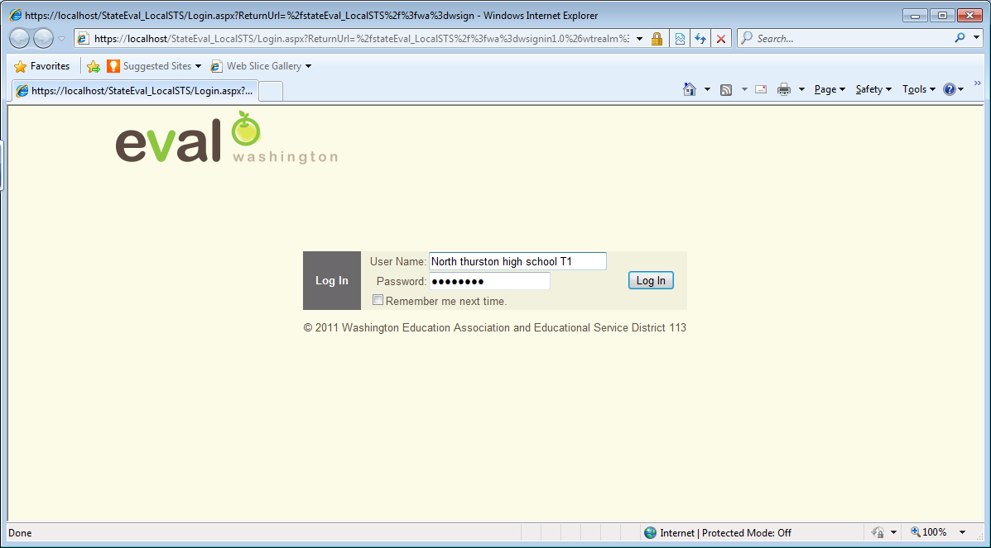

Figure 1:

1. Login as a teacher
2. After successful login into the **StateEval** system, teacher evaluatee screen will appear.

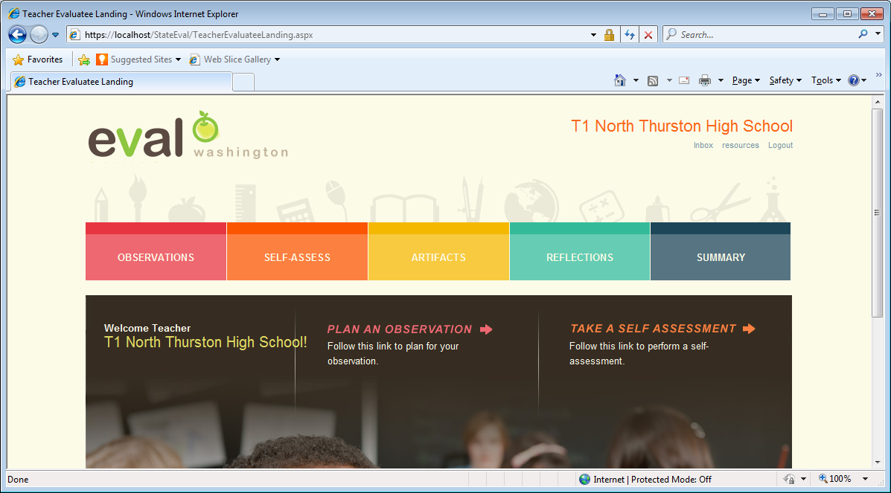

Figure 2:

1. Click on **ARTIFACTS** tab.

Yes, bellow is the **ARTIFACTS** screen. This screen is used to add Artifacts aligned with evaluation framework.

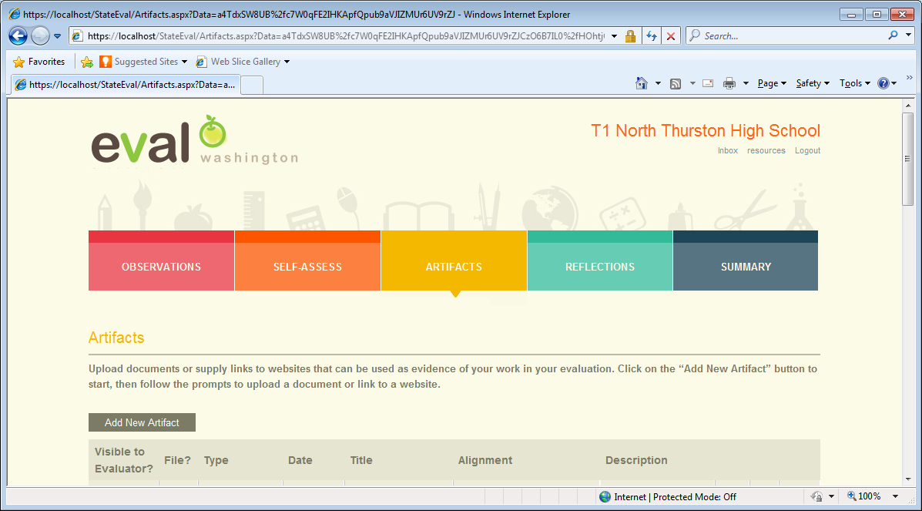

Figure 3:

1. Click on **Add New Artifact** button. **Edit Artifact** screen will be displayed.

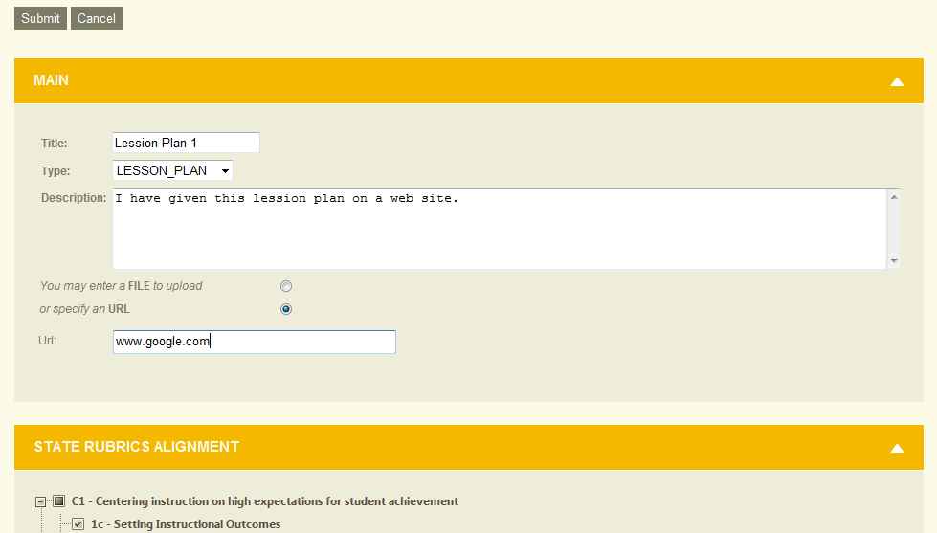

Figure 4:

* 1. Enter **Title**  for this new Artifact
  2. Select a relevant **Type** from drop down list.
  3. Enter **Description**
  4. Please choose ***You may enter a FILE to upload*** if you want to upload a file for this artifact or choose ***Specify a URL*** if you want to provide an URL reference for this artifact.
  5. Select rubric from rubric tree which is under **STATE RUBRICS ALIGNMENT** section to align this artifact with rubrics. You can also select rubric from **INSTRUCTIONAL RUBRICS ALIGNMENT.**

But our aim is to display only rubrics that are aligned with State criteria on the Summary screen.

* 1. Click on **Submit** button which is top of the Main section. Newly saved artifact will be displayed as a tabular format on the Artifact screen.

1. Now **check** the **Visible to Evluators** checkbox so that evaluator can view this artifact on the evaluatee's Summary screen.

bar

Figure 5:

1. Click on **Summary** tab.

**Expect:**

We expect all artifacts will be displayed on the evaluatee's Summary screen under aligned criteria tab in grid view of artficats section which is bottom of the tab.

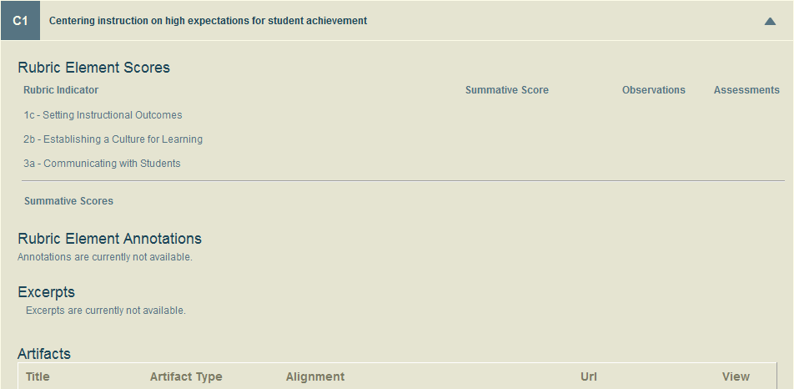summary2

Figure 6:

Please ensure that all artifacts are displayed under its aligned criteria tab. In this case, artifact ‘*Lession Plan 1*’ under state criteria ‘*C1- Centering instruction on high expectations for student achievement*’. In the grid’s **Alignment** column should show all rubrics that are aligned with related state criteria. The view link in the grid will open assigned web site to the selected artifact in a separate browser. Separate browser also opens file if file is assigned to the selected artifact. This procedure will be same for all of State criteria which are C1 to C8.

**IMPORTANT** - On this grid only display the alignment to the State Criteria (C1-C8), not the ones to the Instructional Criteria (D1-D4 for the district we've used in this example).