Final Report Test Document

The Final report displays the scores across all of the observations and self-assessments for a selected teacher. It also allows the user to customize what additional sections are included in the report. The report can be viewed within the site or printed to a PDF document.

The terms principal and teacher will be used for the evaluator and evaluatee throughout this description, but it should be kept in mind that the report also applies to the district evaluator and principal relationship.

* Launching the report
  + The report can be launched by both the teacher and a principal.
  + The teacher and the principal launch the report from the Summary Panel/Print Final Report tab via the "Print Final Report" button.
* Configuring the Report
  + There is a "Print Final Report" button that launches a PDF version of the report when clicked.
  + Configuring what is included in the report. The user can configure what data they want to include in the generated report by checking the checkboxes on the Print Final Report tab. The settings configured are applied to the "Print Final Report" launched from this form. They are not saved, unless the user clicks the "Save Print Settings" button. In that case, the settings are saved and the next time the user comes to this screen the saved settings will be loaded.
  + The sections that can be configured to be included in the report.
    - Session Scores - Session scores are displayed in the "Session Summary" table and in the "State Framework Criteria" and "Instructional Framework Criteria" tables. If the "Instructional Framework" checkbox is unchecked, then the "Instructional Framework Criteria" table will not be present.
      * Summative session scores across all observations/self-assessments from the Observe/Self-Assess screen.
      * Summative criteria scores across all observations/self-assessments from the Summary screen
      * Criteria scores for each observation/self-assessment from the Observe/Self-Assess screen.
      * Rubric element scores for each observation/self-assessment.
    - Evidence/Notes from Observations/Self-Assessments (entered on observation, self-assessment screen through the "State Rubrics" or "Instructional Rubrics" tabs.
    - Excerpts from Observations (entered on observation screen through the "Notes Editor" tab.
    - Final Evaluation Notes (entered on the Summary screen through the "Evaluation Notes panel)
    - Prioritized Excerpts from Observations (entered on the observation screen through the "Notes Editor" tab and then by checking the prioritized checkbox on the "Excerpts" section within the criteria panel on the "State Rubrics"/"Instructional Rubrics" tabs.
    - Final Reflections (entered on the Summary screen)
    - Additional Measures (entered on the Summary screen)
    - Instructional Framework - There is a checkbox titled "Instructional Framework" to indicate whether the report should include any data that is specific to the Instructional Framework. If it is unchecked, then for each of the sections above that come from observations/self-assessments (Framework Criteria, Evidence/Notes, Excerpts, Prioritized Excerpts), there will only be a section for the State version. If the Instructional Framework checkbox is checked, then there will be section for the State Framework and the Instructional Framework for each of the sections that are checked. For example, if Instructional Frameworks is unchecked, any Observation Excerpts that were entered on Instructional criteria will not be included in the report. There will not be a section titled "Instructional Observation Excerpts".
    - If a section is checked for inclusion, but there is not data (for example there is no evidence/notes) then the section will not be included in the report.
* Which observations/self-assessments are included?
  + Only those self-assessments that have been made visible to the principal and have reached the scoring work state.
  + Only those observations that have been made visible to the teacher and are in the scoring.
  + Make sure that no data is included in the report for a private self-assessment or observation. The different sections are each built up independently so, for example, it is possible that there could be an error in the code that builds the Evidence/Notes section so that it includes Evidence/Notes from sessions that are not public.
* Criteria Tables Section
  + The format of this table is similar to that displayed in the "Score Alignment Report" with the following addition: There is a column for the Summative Score for each criteria and each rubric row. In the "Score Alignment Report" the criteria tables just show scores within a specific session, but this report shows the summative scores that are added on the Summary screen.
  + 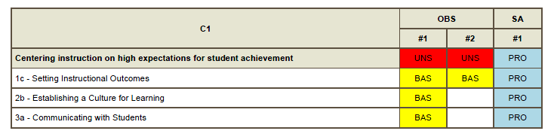
  + 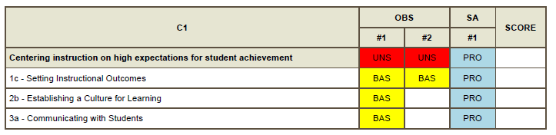
* Special Tests
  + Make sure ONLY observations and self-assessments that are to the "SCORING" work state or further are included in the report. This includes verifying that there is no data in any of the sections, not just the Session Summary and Framework Criteria tables.
  + Make sure only observations and self-assessments that have been checked to be visible are included in the report. This includes verifying that there is no data in any of the sections, not just the Session Summary and Framework Criteria tables.
  + Test with multiple observations and self-assessments, with some being marked as visible and some not, and some in the correct work state and some not to make sure the rules for inclusion in the report are being followed correctly.
  + Verify that the scores entered through the application and visible on the observation, self-assessment, and summary screens are equal to the scores displayed in the report.
  + Verify that each of the sections is correctly included in the report when checked.
  + When the "Instructional Framework" checkbox is checked and the corresponding section is also checked and there is data for the section, the following sections will be included in the report.
    - * Instructional Framework Criteria
      * Instructional Observation Evidence/Notes
      * Instructional Observation Excerpts
  + For both State and Instructional sections, if there is no data to be displayed, then the section will not be displayed. For example, if there are no "Prioritized Observation Excerpts" from the Instructional Rubrics, then there will not be a "Instructional Prioritized Observation Excerpts" section in the report.
* The report should have page numbers on the bottom of each page.
* The report should have a page header that includes the date, the teacher, the school, and the district.
* Verify that the "Save Print Settings" functionality works correctly. Save the settings for more than one user and make sure that saving/restoring doesn't affect any settings except for the current user saving/restoring.
* Verify that a district that does not have an instructional framework (Othello School District) does not have a checkbox for "Instructional Framework" on the Print Settings and that there are no instructional sections in the report.