Project: Moffat Bay Lodge | Sean Christman, Kadar Gayle, Rachel Nelson, Elijah Wilkinson
Course: CSD460 Capstone in Software Development | Module 8
Description: Functional Tests of Room Reservation, About Us, Reservation Summary Pages
Date: 11/19/23
To complete the test case plan, fill out the information for Project, Course, Description and Date in the header below.
.
TABLE OF CONTENTS
About Us Page Test Case 1 2
About Us Page Test Case 2 3
Reservation Summary Page Test Case 1 4
Reservation Summary Page Test Case 2 ...................................................................................................................................................................... 6

For each test, the developer should: provide a test description, a test objective, the developer name and date tested. For each step, fill out the actions to be taken and describe the expected results, and indicate yes or no for each step depending upon the result. The peer tester should provide their name, date tested, indicate yes or no for each step depending upon the result, and a screenshot (thumbnail) of the result.

Test 1 | About Us Page Test Case 1
 | Test Objective: Ensure about us and principle contact loads appropriately. | Developer: Elijah Wilkinson  Date tested: 2023/11/19 | Peer tester: Rachel Nelson  Date tested: 2023/11/19
Step | Action | Expected results: | Developer pass/fail | Tester pass/fail
1 | Navigate to About Us Page | About Us page loads as expected with header, footer, and two rows of content with images on opposite sides. | PASS | PASS  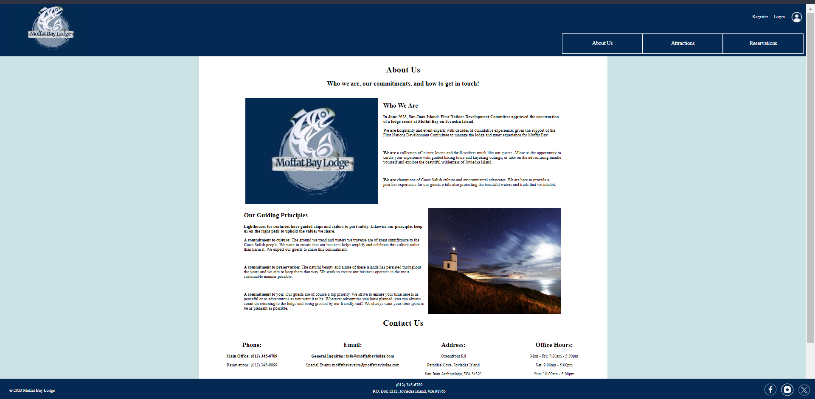
2 | User is able to read each section of About Us | Paragraph content loads on the right side of the first image, and left side of the second image, between header and footer. | PASS | PASS  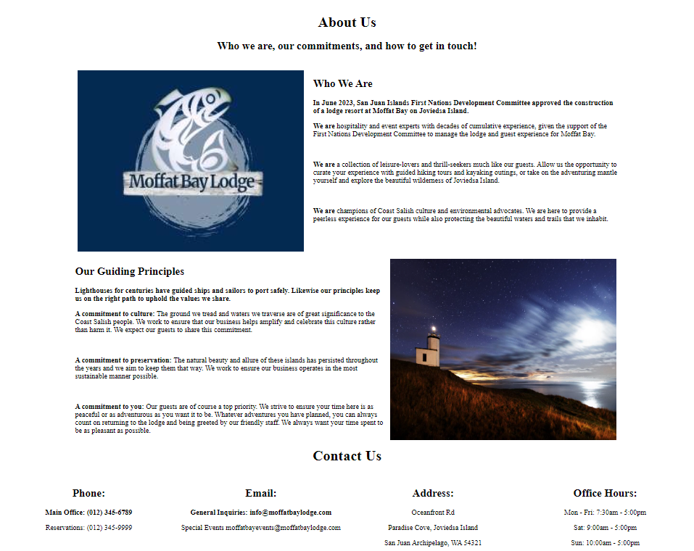
3 | User can locate scrollbar | Scrollbar is accessible for the user on the page. | PASS | PASS
Comments | Tested on Windows 11 Home using Brave 1.60.118 as browser. Page loads with two pictures and no errors. Paragraph content loads on the right side of the first image, and left side of the second image, between header and footer.

Test 2 | About Us Page Test Case 2
 | Test Objective: Ensure Contact Us information loads appropriately and is readable. | Developer: Elijah Wilkinson  Date tested: 2023/11/19 | Peer tester: Rachel Nelson  Date tested: 2023/11/19
Step | Action | Expected results: | Developer pass/fail | Tester pass/fail
1 | Navigate to About Us Page | About Us page loads as expected with header, footer, and paragraph content with accompanying images on appropriate sides. | PASS | PASS  
2 | Scroll down to Contact Us | Contact Us header should be towards the bottom of the page. Should be accessible through mouse wheel scroll or drag/drop scroll bar. | PASS | PASS  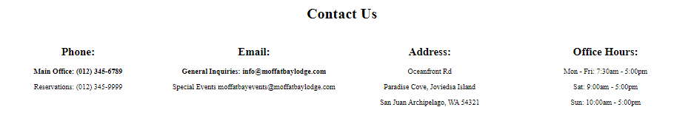
3 | Review Contact Information | Contact information should load in a column format, with headers for Phone, email, address, and office hours | PASS | PASS  
Comments | Tested on Windows 11 Home using Brave 1.60.118 as browser. Page loads with header, footer, and body content in intended spaces. “Contact Us” information is accessible using scroll bar and loads in columns with information for phone, email, address, and office hours.

Test 1 | Reservation Summary Page Test Case 1
 | Test Objective: Verify MoffatBay Reservation Table contains same information as Reservation Summary page. | Developer: Rachel Nelson  Date tested: 2023/11/18 | Peer tester: Elijah Wilkinson  Date tested: <2023/11/19>
Step | Action | Expected results: | Developer pass/fail | Tester pass/fail
1 | Login to MySQL using username and password.  MySQL -u Alpha -p  Capstone | Username and password allow access to MySQL databases | PASS | PASS
2 | Navigate to MoffatBay database.  USE MoffatBay; | MoffatBay database located in MySQL | PASS | PASS
3 | Select all or select by email address used to create test in Reservation table.  SELECT * FROM Reservation; | Results populate for the reservation made with test email. | PASS | FAIL
4 | Compare all information from database table to the information on Reservation Summary page to confirm identical information. | All results populated accessing MySQL database directly match identically with information displayed on Reservation Summary page. | PASS | FAIL
Comments | While we’re able to connect to the database, it’s populated with our previous personas and the test case reservation does not show up in the database. As such, we are unable to match the test case reservation with the reservation summary.

Test 2 | Reservation Summary Test Case 2
 | Test Objective: “Cancel” button deletes reservation from Reservation table | Developer: Rachel Nelson  Date tested: 2023/11/18 | Peer tester: Elijah Wilkinson  Date tested: <2023/11/19>
Step | Action | Expected results: | Developer pass/fail | Tester pass/fail
1 | Click “cancel” button on Reservation page | Cancel button redirects to reservation-page.html | PASS | FAIL
2 | Login to MySQL using username and password.  MySQL -u Alpha -p  Capstone | Username and password allow access to MySQL databases | PASS | PASS
3 | Navigate to MoffatBay database.  USE MoffatBay; | MoffatBay database located in MySQL | PASS | PASS
4 | Select all or select by email address used to create test in reservation table.  SELECT * FROM reservation; | No results populate for the reservation made with test email. | PASS | PASS
Comments | The cancel button does not redirect from summary.html back to reservation.html. Again, we are able to access our database and we can see in the reservation table that nothing has changed.

