Assignment 2.2: Data Modeling

Link to my repository on GitHub:

<https://github.com/MichaelChristman1999/MichaelChristman1999.github.io>

(Navigate to web-335 folder for to view web-335 folders and files)

Link to my personal portfolio website:

<https://michaelchristman1999.github.io/web-330/Personal-Portfolio/index.html>

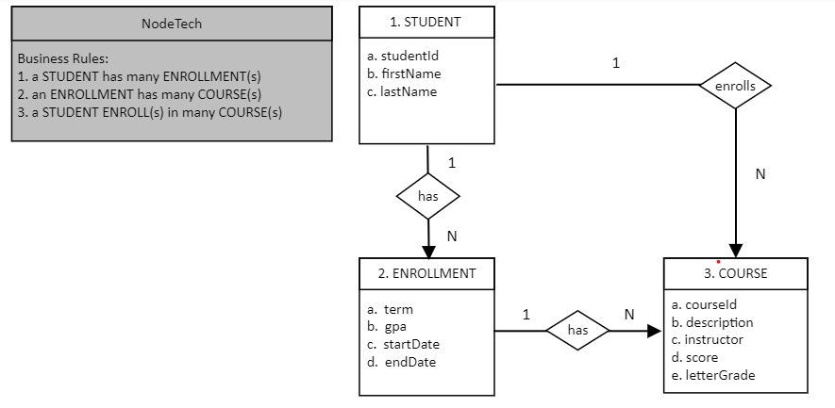

Converted the proposed NodeShopper ORD into NoSQL data structures:

(I typed in my own values into the VS Code .json file, but the Data Model fields are not empty so I believe I’m following the specs in the assignment document)

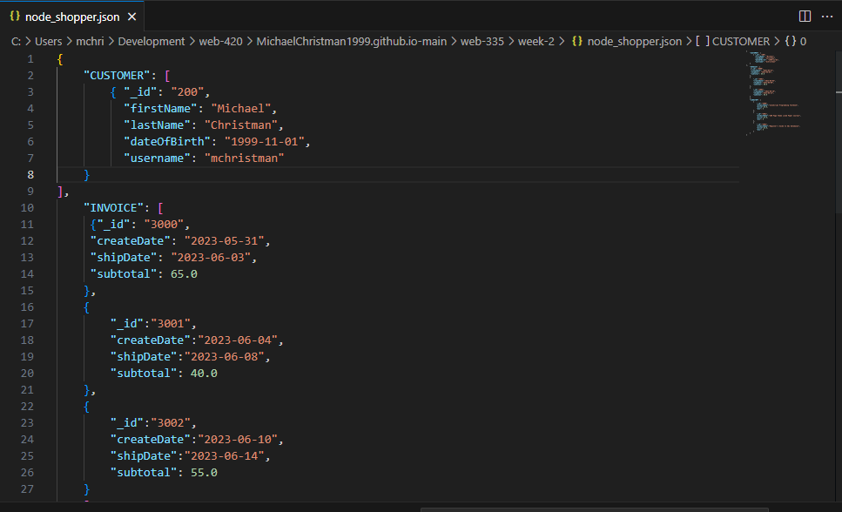

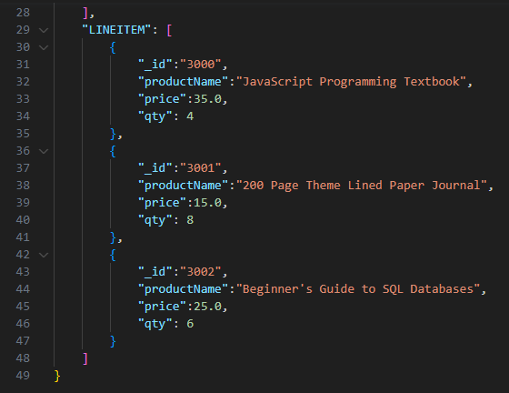

Converted the proposed NodeTech ORD into NoSQL data structures:

(I typed in my own values into the VS Code .json file, but the Data Model fields are not empty so I believe I’m following the specs in the assignment document