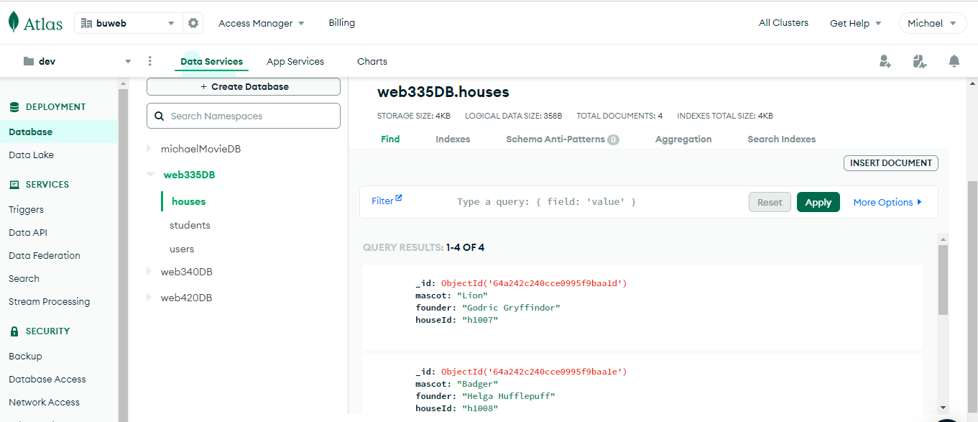

This is a query that lists every document in the ‘houses’ collection

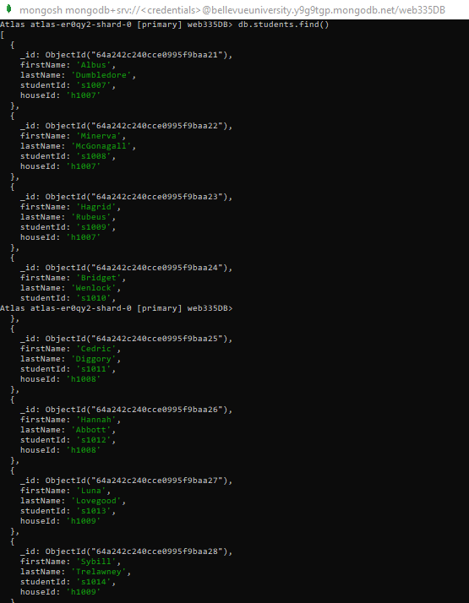

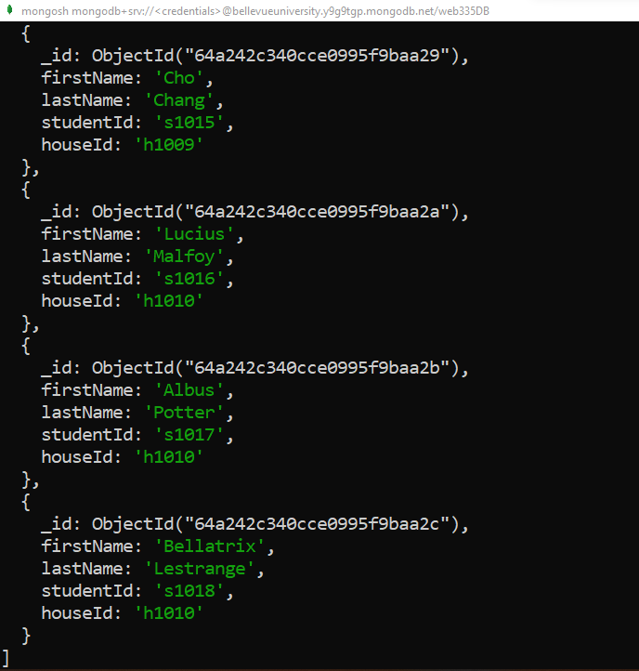

This query lists every document in the ‘students’ collection. I captured two screenshots since I couldn’t fit all the data onscreen.

The first query displayed in the screenshot that inserts data for a new ‘student’ document and the other query shown finds any ‘student’ document with the id value, “s1019”

The first query in this screenshot deleted the newest document that was created and the second query will retrieve any student document with the houseId value of ‘h1010’

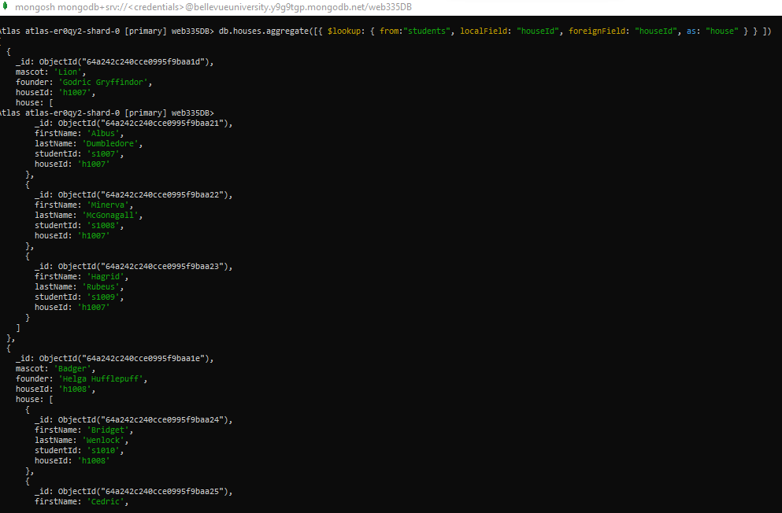

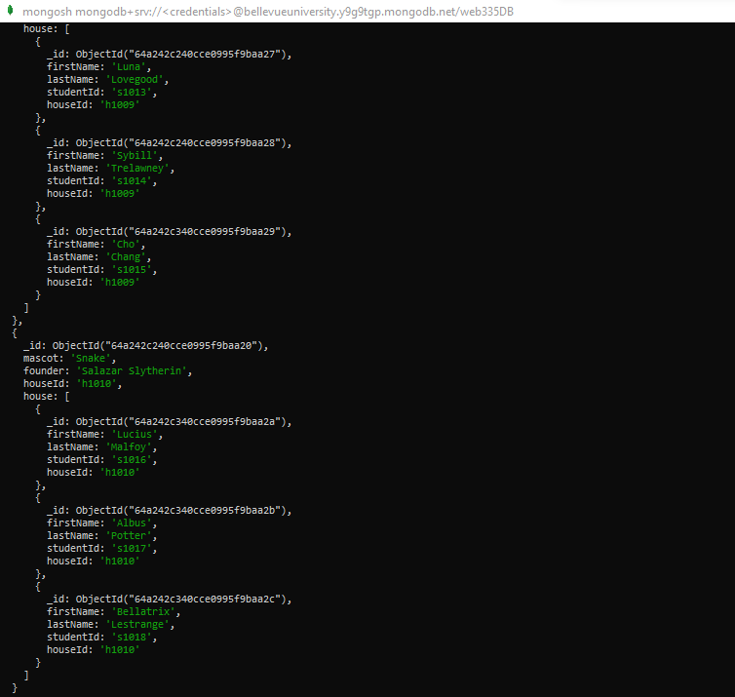

This query sorts/”aggregates” all the documents in the student collection by ‘houseId’

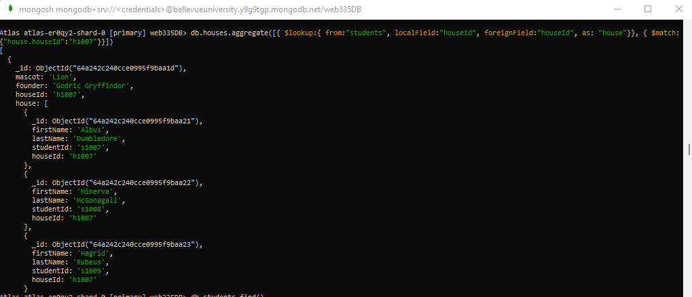

This query lists all documents including the mascot with the houseId ”h1007” (or from the house Gryffindor)

This query lists the documents including the mascot with the ‘mascot’ value of ‘Eagle’