Michael Christman

5/27/2023

Assignment 1.4 – Business Rules

**Disclaimer**

The ORD’s, database scripts, programming files, etc., must be saved in your GitHub repository.

**ORD:**

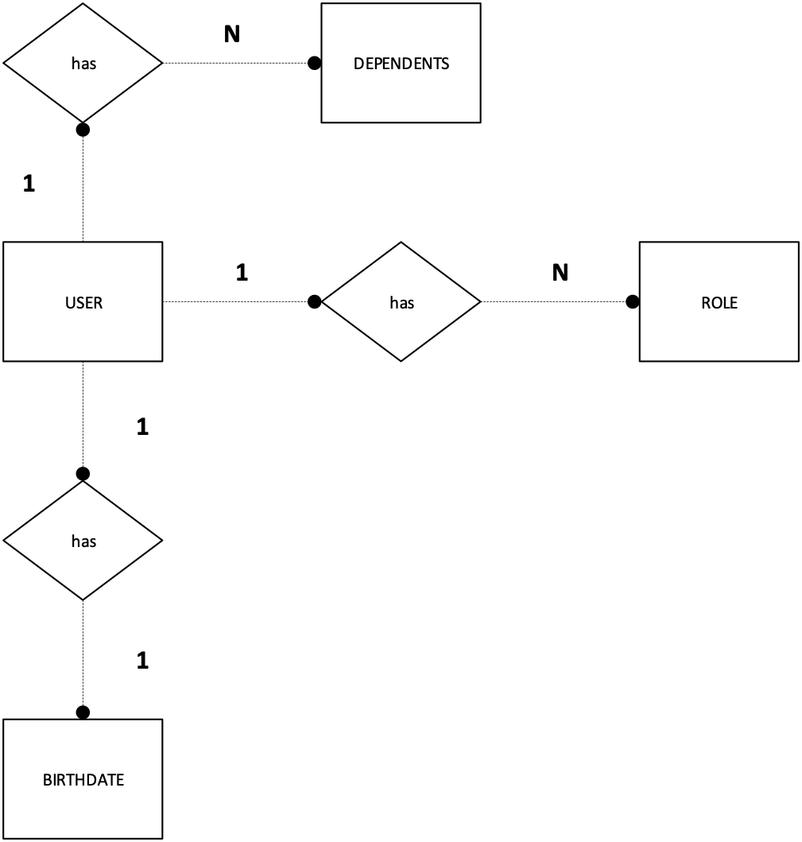

**Instructions**

1. Covert the above ORD into business rules.

The ORD has three main business rules which are displayed here:

1. A USER has many DEPENDENTS

1

N

DEPENDENT

has

N

USER

DEPENDENT

1. A USER has many ROLES

1

N

N

has

USER

ROLE

USER

has

1. A USER has one BIRTHDATE

1

1

BIRTHDATE

has

USER