This is the title

Heading with reference to google
This is the text under heading 1.

Another heading
Another paragraph

Heading 2
Paragraph for heading 2.
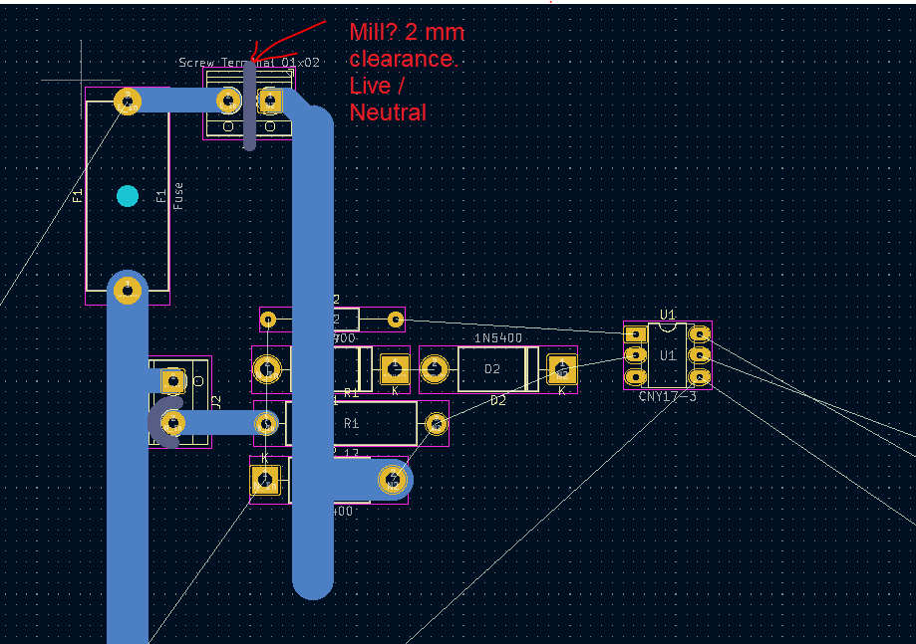Figure 1: This is the figure caption

Here’s some more text.
Table 1: This is the table caption
Column 1 | Column 2
Cell(1, 1) | Cell(1, 2)
 | Cell(2, 2)
End of heading 2.

Section 3.
Here’s a numbered list:
- Item 1
- Item 2
- Item 3
Table of Contents
1 Heading with reference to google 1
2 Another heading 1
2.1 Heading 2 1
3 Section 3. 2

A page break is coming
Here’s a reference to Table 1 and Figure 1.
That was a page break.
Now we will break to landscape:
Now on landscape

Back to default (portrait)
- sdf
- 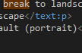

- Normal text
- Code listing
// main function
int main(int argc, char** argv)
{
spdlog::info("Hello world");

testing::InitGoogleTest(&argc, argv);
return RUN_ALL_TESTS();
}

here is more source code

even more
- asdf

