HAPTIC PATTERN REPRESENTATION USING MUSIC TECHNOLOGIES Michael Cumming1, Adam Tindale2, Sara Diamond3
123 OCAD University Toronto, ON M5T 1W1 Canada Correspondence should be addressed to: mcumming@ocadu.ca, atindale@faculty.ocadu.ca, sdiamond@ocadu.ca

Abstract: Wrist-wearable vibrotactile arrays can serve many functions: typically they are used for non-disruptive notiﬁcation from social media. They can also be used for direction ﬁnding, gaming and entertainment. Authoring and programming of wrist-wearable vibrotactile arrays can be difﬁcult because of the lack of standardized notational systems and ﬁle formats. Typically, each implementation of haptic arrays uses bespoke programming, which tends to isolate creative and technical development into non-communicating silos that discourage standardization and sharing. We propose that standard musical notation is an appropriate method for standardization and compositional expressiveness.
1. INTRODUCTION
We are developing a MIDI-driven, wrist-wearable device that integrates with a gaming app on an accompanying smartphone. The wrist device includes LED lights, vibe motors and buttons that activate when vibe motors are touched. It is controlled by a Bluetooth-enabled (low energy) LightBlue Bean microprocessor with a 3-axis accelerometer. This device combines several functions, including the control of gameplay from a smartphone or tablet, visual display of user’s heart rate and interesting visual and vibrational patterns for entertainment and wearer adornment value [?].
The gaming app involves a collections and discovery game for children aged 8-14 called Time Tremors in which children collect crystals in order to unlock treasures that they then view on the accompanying smartphone. There is also a television series that is integrated with this gameplay [?]. Crystals are earned by the player through simple puzzle-solving, artifact discovery and physical activities. The end result is a sensory-intensive, transmedia game intended to encourage physical ﬁtness and cultural exploration in children. On the device vibrotactile patterns play a major part in user interaction and the method of authoring patterns in a shareable and standardized way becomes an important consideration.
A wrist-wearable vibrotactile device, or what we call a ’vibe bracelet,’ needs activation patterns to operate. It is unclear how to design such patterns in a standardized way using the technology closest at hand, which in our case is low-level code written in the C or Wiring languages. The design of vibe patterns for such devices is a specialized, yet multi-disciplinary domain that straddles concerns for design of human computer interfaces suitable for wearables, and for potentially artistic patterns that look and feel attractive on the wrist. Basic use cases for the wrist-wearable device include:
- Interpret wrist gestures and recognize overall physical activity of the wearer (using the Bean’s accelerometer),
- notify the wearer when crystals and treasures are earned,
- offer vibrotactile clues about where crystals and treasures can be found, and
- provide aesthetically attractive and evocative vibe and light displays corresponding to narrative points in a story.

It is use case no. 3 that we consider for its potential musicality and the applicability of musical-inspired pattern design. These patterns must be suitable for low resolution vibrotactile arrays – in our case a 2x5 circular array of vibe motors, or tactors, that encircle the wrist (Figure ??).
Mapping of types of things that are commonly expressed using Figure 2: A user playing a vibrotactile Simon Says game on an earlier prototype.
Figure 1: Bracelet design with 2x5 tactor array.
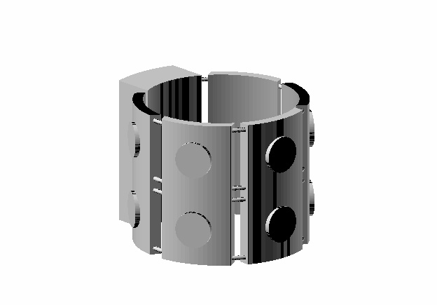
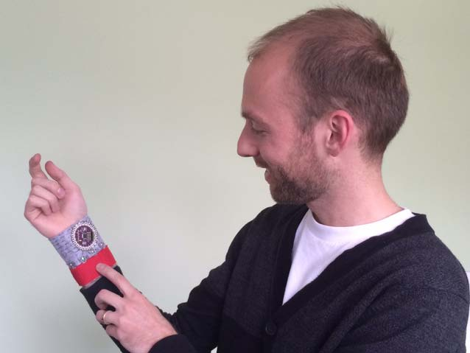
standard musical notation (music notation), entities such as notes with durations, parts, and instruments need to translated, or mapped, from the music domain to that of vibrotactile devices. This mapping has proven to be useful and appears to lead to interesting possibilities for pattern design for these devices.
2. RELATED WORK
2.1. Haptic feedback and communication
Haptic communication through force feedback is a common technique used in gaming. Its purpose is to introduce the sense of touch to interactions such as movement through space, collision with and proximity to objects, notiﬁcation of awarding of game points and of proximity to dangerous situations. Touch can add sensual aspects and realism to computer interactions for devices too small to have large visual displays and may be useful in reducing sensory overloads from other perceptual modalities such as those used in complex graphical interfaces [?]. The largest organ of the human body is the skin and has great potential for the transmittal of information and sensation [?][?]. Oakley provides a useful taxonomy of haptic-related terms, such as proprioceptive, kinesthetic and tactile. Haptic is a general term relating to the sense of touch, while tactile is more speciﬁc and relates to the sensation of pressure rather than that of temperature or pain [?].
Haptic feedback has a long history in the design of computer mice and of other hand controllers [?]. Touch of course is useful in generating intimacy in normal social situations [?]. The new Apple Watch also enables wearers to communicate their heartbeat to others wirelessly [?]. Touch can also be used to coordinate action in online or gaming situations [?].
2.2. Wearable vibrotactile devices
Typically, haptic devices beyond experimental contexts are either wearable or holdable. One challenge of wearable devices is how to encourage people to wear them. People tend to be very particular about the look and feel of devices that provide potentially intimate notiﬁcations. The purposes of such devices are varied and include emulation of attention-getting practices such as the squeezing of wrists, touching of shoulders and pats on arms. As Baumann notes, such social gestures may include a wealth of sub-texts including urgency, affection and reinforcement of social hierarchies [?].
Due to their potentially non-disruptive nature, vibrotactile devices could aid in tasks in which the user’s attention might be devoted to some other task, such as navigation, or gameplay, or in situations where visual information is scarce or non-existent, as with the blind [?]. Devices vary in the degree of body contact they provide. The ability of he body to perceiver vibrotactile stimuli varies greatly between regions of the body dues to variation in skin receptor density [?]. Work has been also done in wide-area stimulation instead of areas of the body where receptor density is greatest, such as the tips of the ﬁngers and lips.[?]. Vibrational patterns suitable for a wrist device are much less complex than those designed for auditory perception due to the constrained perceptual channel of the cutaneous and kinaesthetic possibilities of the wrist compared to that of our ears.
2.3. Tactile authoring for vibrotactile devices
Wearable tactile devices are increasing in popularity, especially for handsfree applications. Tools for authoring of tactile patterns for these devices makes the job much easier. Pan�
eels, et al. describe a system for easy prototyping of tactile patterns based on a graphic representation of the shape of the device. A vibrotactile editor represents vibration pitch by vertical placement of notes, as in music notation. They describe the difﬁculty in designing such patterns by non-experts since it pre-supposes knowledge of music notation as well as other technical area like waveform design. Nor does the system support tactile design for multiple actuators [?]. Brown examines how musical techniques can be applied to tacton design. Tactons are structured vibrotactile messages designed to communicate information non-visually. They are the tactile counterpart of visual icons [?]. She examines the role of tactile dynamics and concludes that they should be combined with consideration of other vibrotactile parameters such as duration, roughness and rhythm [?]. Gunther explores the notion of tactile composition, which he views as a novel coupling of haptics technology and music, for the purpose of creating aesthetically appealing tactile compositions. He notes the close relation between sound and touch in all musical performance. He later describes the complex psychophysics that informs the composition of spatio-temporal patterns on the skin [?].
2.4. Multiple actuator devices
Devices that contain several vibrotactile actuators are common in the literature[?][?][?][?][?]. These devices tend to be placed at various locations around the body, or in tiny pin arrays suitable for ﬁngertip stimulation [?]. The design of tactile patterns depends on the conﬁguration and placement of the actuators. The purpose of having multiple actuators is distribute notiﬁcations of events in places around the body that will be noticed while people do other physically or cognitively demanding activities [?], to transmit symbolic information similar to the ﬁngertip sensing of braille [?], to develop skills with polyphonic rhythms [?], providing feedback for digital musical instruments [?][?], or to create aesthetically appealing patterns for the skin [?]. A wrist-worn bracelet similar to our device is described in [?].
3. DESIGNING PATTERNS USING MUSIC NOTATION
3.1. Introduction
This research employs the text-based music engraving and compositional tool Lilypond [?]. The application Frescobaldi [http://frescobaldi.org] was used as a front-end to Lilypond. Writing music using Lilypond is a similar process to writing papers using the document preparation system LaTex. Like LaTex, its textual input can be easily version-controlled. The output of Lilypond follows music notation conventions and is of high quality. Once learned to a rudimentary level Lilypond is a useful tool for experimenting with music notation. Lilypond can easily output MIDI code. This MIDI is used to drive the actuator array in the vibrotactile bracelet using the standard Arduino MIDI library. The complete workﬂow is to ﬁrst compose music in Frescobaldi/Lilypond, then output a MIDI ﬁle from the Lilypond source, import this MIDI ﬁle into a track in Ableton Live, send a MIDI stream out from Ableton into a dedicated USB MIDI cable and then read this MIDI data in Arduino, using MIDI-read() function. The workﬂow proved to be quite workable as an experimental technique.
3.2. Basic mapping conventions
Our notational approach for our wrist-wearable device is to follow music notation conventions and to see where these conventions lead us in the domain of vibrotactile devices:
- Represent time horizontally from left to right. Notes to the right occur later.
- A note represents an activation of a component. A component can be of several types (vibe motor, LED, etc.). Place notes on normal, ﬁve line staves.
- Represent note durations by note type (for example, quarter, half and whole notes), dots and by ties between notes of the same pitch.
- If notes are pitched, indicate their pitch through their vertical placement on a staff. If notes are unpitched, represent different components (e.g. different types of vibe motors or LEDs) using various note heads or annotations.
- Different parts are on separate staves. One tactor type playing the same notes at the same time represents playing in unison. For example, eight vibe motors playing in unison can be represented as one part.
- Simultaneous notes, or chords, are stacked vertically as in

music notation. We also need to translate the nomenclature from the domain of wrist wearables to that of music notation. This mapping is shown in the following table:
Table 1: Vibrotactile vs Music notation terms
Vibrotactile term | Music notation term
Activation of one component | Note
Activation duration | Note duration
Frequency of an activation | Pitch
One type of component | Instrument
Series of activations for one component | Part
Simultaneous activations w/ multiple pitches | Chord
Integrated series of activations | Composition

Therefore, the basic components of music are present even with a wrist-wearable vibrotactile device that does not, at ﬁrst, seem to have a musical aspect: notes with durations, pitched notes played on various discrete instruments (vibe motors and LED lights), various parts, or voices, played in polyphonic compositions and the dynamics of various parts playing together.
3.3. Pitch
Vertical placement for normal, pitched notes in music notation indicates their pitch. Pitch differentials are possible with tactors, as their frequency can be modelled using standard pulse-width modulation (PWM) techniques [?]. The pitch of a note is one of its primary psychoacoustic attributes, along with its duration, loudness and timbre. Unpitched notes are those for which the frequency is indeterminate, too complex or unrelated to the pitch contours of melodic or harmonic parts. The perception of pitch in vibrotactile devices differs from that of normal acoustic instruments. The number of frequency differences is much reduced and depends on amplitude. The skin’s maximal frequency response occurs around 250 Hz [?]. There may be as few as ﬁve frequency distinctions possible with cutaneous perception, or as many as ten [?]. So, the chromatic range of pitches and frequencies over many octaves as normally represented using music notation is not suitable for cutaneous perception, but that some, relatively minor variation in pitch is possible. These considerations would seem not to preclude the use of music notation for our purposes.
3.4. Intensity
As with aural music, suitable intensities for vibrotactile devices range from those that are barely perceptual to those that become uncomfortable. The intensity of a vibrotactile stimulus is deﬁned by the strength or magnitude of its vibration. Classic work in this area was done by measuring Weber fractions and just noticeable differences (JNDs). Frequency and intensity parameters interact in vibrotactile studies in that differences can be ascribed to combinations of parameters [?]. The intensity threshold is adaptable and depends on a variety of parameters such as actuator used, location of the stimulation, person, or frequency of the vibration [?]. Geldard discovered that while we can discriminate 15 levels of vibrotactile stimuli intensity but that no more than three intensity levels can be identiﬁed absolutely [?]. Considerations of the amplitude envelope (amplitude, delay, sustain, release, or ADSR) and with amplitude modulations such as tremolo or pitch modulations like vibrato are also important with vibrotactile stimulation [?].
3.5. Duration
The term duration refers to the length of the tactile stimulus – from onset to the termination of the stimulus. There exist various reference values for duration and and is generally measured in milliseconds [?]. It is important to ensure that the individual vibrotactile stimuli are within a reasonable range of durations. Geldard found that stimuli duration roughly between 0.1 and two seconds is reasonable [?]. If vibrotactile notes are of short duration they are perceived as sharp taps or jobs in the skin [?], while stimuli that lasted longer than the upper limit of two seconds delays communication [?]. Dynamic properties of a vibration signal such as its envelope, duration, and the presence of masking stimuli may also affect perceptual threshold levels [?].
3.6. Spatial patterns and vibrotactile clues
As noted above one of the primary use cases for our vibrotactile device is offer vibrotactile clues about where crystals and treasures can be found within transmedia-inspired gameplay. These clues are intended to provide the following messages to the game-player: Go this way / don’t go that way; You’re getting warmer / you’re getting colder; and You’re performing the correct movement / you’re performing the wrong movement. The ﬁrst two of these are spatial and metaphorical in nature and refer to navigating through some kind of virtual space. The last one is kinesthetic and encourages the player to move their limbs in some preferred way. Ideally these gameplay clues would be either self-explanatory or easy to learn.
Music does not lend itself, on ﬁrst examination, to these sorts of concepts or metaphors. It is unclear at ﬁrst what music that could be interpreted as ’go this way’ might look like. It seem though that it should incorporate some notion of movement through a space. Although music that has spatial aspects is common, such as Thomas Tallis’ Spem in Alium [1570], music notation tends not to focus too much on such spatial considerations. There is no speciﬁcation of where instruments or performers are arranged in space. Instruments are usually placed together in clusters, as opposed to being evenly distributed, but this is a performance convention and is outside of the notation itself.
3.7. Music with one spatial dimension (1D = linear)
Music with one dimension is that which instruments follow some kind of spatial linear progression, such as pan or a sweep. Figure ??. shows one vibe motor activating in a simple rhythm with a simple, rhythmic pitch change. By the conventions of music notation it is clear that there is a regular repetitive rhythm represented. Of course, to know even this requires at least a rudimentary knowledge of music notation.
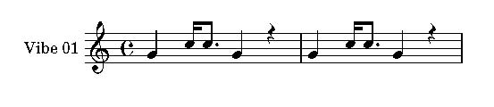
Figure 3: One vibe motor playing a simple rhythm.
Figure ??. shows three vibe motors activating in a sequential motion. Note that all three are playing the same pitch. If the three separate parts where placed on the same staff there would be confusion about which note applies to which motor. If the three motors were placed next to each other then their pulsation would have a directionality due to the physical placement of the motors. However, this directionality is less apparent in the notation itself.
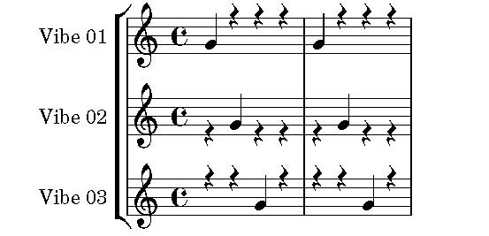
Figure 4: Threes vibes activating sequentially.
The only indication that Vibe 02 might be placed after Vibe 01 is because of the numbering system. Note that the spatial dimension described is only one dimensional. The vibe motors are arranged along a line. With vibe bracelets what is desirable is to represent two dimensions such that patterns can be created across the skin. It would be useful if the spatial dimension Is there any dimension is music notation that indicates 2D spatial placement of instruments?
3.8. Music with two spatial dimensions (2D = planar)
This highlights a problem with using musical notation for describing the activation of spatially separate vibe motors: when you want to describe the movement of vibrations spatially then where the vibe motors are located in space is essential to represent using the notation. With pitched notation the pitch, timing and rhythm of the music tends to be its most important aspect. The spatial placement of the instruments playing different parts is less of a concern. How then can vibe motors activating in a spatially differentiated manner be represented – compactly and efﬁciently – using standard music notation?
4. FUTURE WORK
Our work consists of quick iteration of devices and authoring of activation patterns for a several devices. This work is motivated by both research as well as aesthetic considerations. Pattern authoring depends crucially on the nature of the device being authored for and its purpose. We consider two aspects that seem particularly promising for future development in this area: the design of vibrotactile patterns to enhance and inform transmedia narratives, and the creation of aesthetically appealing vibrotactile patterns in a variety of musical ’genres.’ Our research here only scratches the surfaces in those two areas.
5. CONCLUSION
Music notation is a ﬁnely structured notational system. It requires an expert-level of competence to read its ﬁnest level of detail, however, this type of expertise is not hard to ﬁnd in cultures where notated musical composition and performance is well-established. What is much less common is cross-expertise in both music notation and vibrotactile technologies. Standard musical notation includes many dimensions but in its standard forms does not easily lend itself to inclusion of more non-musical dimensions such as required for the speciﬁcation of 2 and 3D patterns for vibrotactile arrays. Howver, it appears that will some minor additions to music notation this type of authoring technique is much more appealing and culturally evocative than the alternatives.
6. ACKNOWLEDGEMENTS
This work has been supported by the International Science and Technology Partnerships Canada Inc (ISTP) on the project Multi-platform Game Distribution System for Popular and Experimental Technologies (MGDS-PET) and by grants from the National Sciences and Engineering Research Council of Canada (NSERC). We would also like to thank Xenophile Media Inc., Vicki Clough, Shin-you Hou, Tegan Power, Ryan Maksymic, Takis Zourntos for the their help in the development of this project.
REFERENCES
[1] A. Tindale, M. Cumming, H. Pridham, J. Peter, and
S. Diamond: Wearable haptic gaming using vibrotactile arrays. In Proceedings of the 16th international conference on Human-computer interaction with mobile devices & services, pages 435–438. ACM, 2014.
[2] C. Holler, P. Crowe, A. Mayhew, A. Tindale, and S. Diamond: Time tremors: developing transmedia gaming for children. In Proceedings of the 16th international conference on Human-computer interaction with mobile devices & services, pages 601–603. ACM, 2014.
[3] I. Oakley, M. R. McGee, S. Brewster, and P. Gray: Putting the feel in’look and feel ‘. In Proceedings of the SIGCHI conference on Human factors in computing systems, pages 415–422. ACM, 2000.
[4] R. W. Lindeman, Y. Yanagida, H. Noma, and K. Hosaka:
Wearable vibrotactile systems for virtual contact and information display. In Virtual Reality, volume 9(2-3):203–213, 2006.
[5] S. Brewster and L. M. Brown: Tactons: structured tactile messages for non-visual information display. In Proceedings of the ﬁfth conference on Australasian user interface-Volume 28, pages 15–23. Australian Computer Society, Inc., 2004.
[6] G.-H. Yang, K.-U. Kyung, Y.-J. Jeong, and D.-S. Kwon: Novel haptic mouse system for holistic haptic display and potential of vibrotactile stimulation. In Intelligent Robots and Systems, 2005.(IROS 2005). 2005 IEEE/RSJ International Conference on, pages 1980–1985. IEEE, 2005.
[7] S. J. Bronner: The Haptic Experience of Culture. In Anthropos Freiburg, volume 77(3-4):351–362, 1982.
[8] P. Marks: On the pulse. In New Scientist, volume 223(2987):22, 2014.
[9] C. Ho, C. Basdogan, M. Slater, N. Durlach, and M. Srinivasan:
An experiment on the inﬂuence of haptic communication on the sense of being together. In BT Presence Workshop. Citeseer, 1998.
[10] M. A. Baumann, K. E. MacLean, T. W. Hazelton, and
A. McKay: Emulating human attention-getting practices with wearable haptics. In Haptics Symposium, 2010 IEEE, pages 149–156. IEEE, 2010.
[11] S. Ertan, C. Lee, A. Willets, H. Tan, and A. Pentland: A wearable haptic navigation guidance system. In Wearable Computers, 1998. Digest of Papers. Second International Symposium on, pages 164–165. IEEE, 1998.
[12] R. W. Lindeman, R. Page, Y. Yanagida, and J. L. Sibert: Towards full-body haptic feedback: the design and deployment of a spatialized vibrotactile feedback system. In Proceedings of the ACM symposium on Virtual reality software and technology, pages 146–149. ACM, 2004.
[13] S. Paneels,�M. Anastassova, and L. Brunet: TactiPEd: easy prototyping of tactile patterns. In Human-Computer Interaction–INTERACT 2013, pages 228–245. Springer, 2013.
[14] L. M. Brown, S. A. Brewster, and H. C. Purchase: Tactile crescendos and sforzandos: applying musical techniques to tactile icon design. In CHI’06 extended abstracts on Human factors in computing systems, pages 610–615. ACM, 2006.
[15] E. Gunther and S. O’Modhrain: Cutaneous grooves: composing for the sense of touch. In Journal of New Music Research, volume 32(4):369–381, 2003.
[16] L. M. Brown: Tactons: structured vibrotactile messages for non-visual information display. Ph.D. thesis, University of Glasgow, 2007.
[17] S. Holland, A. J. Bouwer, M. Dalgelish, and T. M. Hurtig: Feeling the beat where it counts: fostering multi-limb rhythm skills with the haptic drum kit. In Proceedings of the fourth international conference on Tangible, embedded, and embodied interaction, pages 21–28. ACM, 2010.
[18] M. T. Marshall and M. M. Wanderley: Vibrotactile feedback in digital musical instruments. In Proceedings of the 2006 conference on New interfaces for musical expression, pages 226–229. IRCAM—Centre Pompidou, 2006.
[19] M. Schumacher, M. Giordano, M. Wanderley, and S. Ferguson: Vibrotactile Notiﬁcation for Live Elecrtonics Performance. In Proc. of the 10th International Symposium on Computer Music Multidisciplany Research, pages 516–525. 2013.
[20] H.-W. Nienhuys and J. Nieuwenhuizen: LilyPond, a system for automated music engraving. In Proceedings of the XIV Colloquium on Musical Informatics (XIV CIM 2003), pages 167–172. Citeseer, 2003.
[21] J. B. van Erp and M. M. Spap�e: Distilling the underlying dimensions of tactile melodies. In Proceedings of Eurohaptics, volume 2003, pages 111–120. Citeseer, 2003.
[22] M. Jonas: Tactile Editor: A Prototyping Tool to Design and Test Vibrotactile Patterns. Ph.D. thesis, Master’s thesis, Computer Science Department, RWTH Aachen University, 2008.
[23] F. A. Geldard: Some neglected possibilities of communication. In Science, 1960.
[24] D. M. Birnbaum: Musical vibrotactile feedback. Ph.D. thesis, McGill University, 2007.
䘀椀最甀爀攀㄀㨀䈀爀愀挀攀氀攀琀搀攀猀椀最渀眀椀琀栀㈀砀㔀琀愀挀琀漀爀愀爀爀愀礀⸀

