INF221 - [Modern] Web Design & Development
Isaac S. Mwakabira
Learning Outcomes
The aim of this lecture is to:
- Introduce you (students) to the Web Design and Development module, and discuss students’ commitments and general expectations
- Provide students with an understanding of web design and development general concepts and principles which guided the growth of web technology as we it today
  - Discuss genesis and the nature of the Web: the World Wide Web (WWW)
  - Discuss challenges and benefits of the Web as a tool for effective communication and information sharing on the Internet
- Introduce you (students) to modern tools, methods, standards and technologies in website and web-application design and development.
Indicative Content
- General Expectations
- The nature of the Web
- Challenges
- Benefits or Advantages
- Tooling
- Soft skills
- Summary
- References
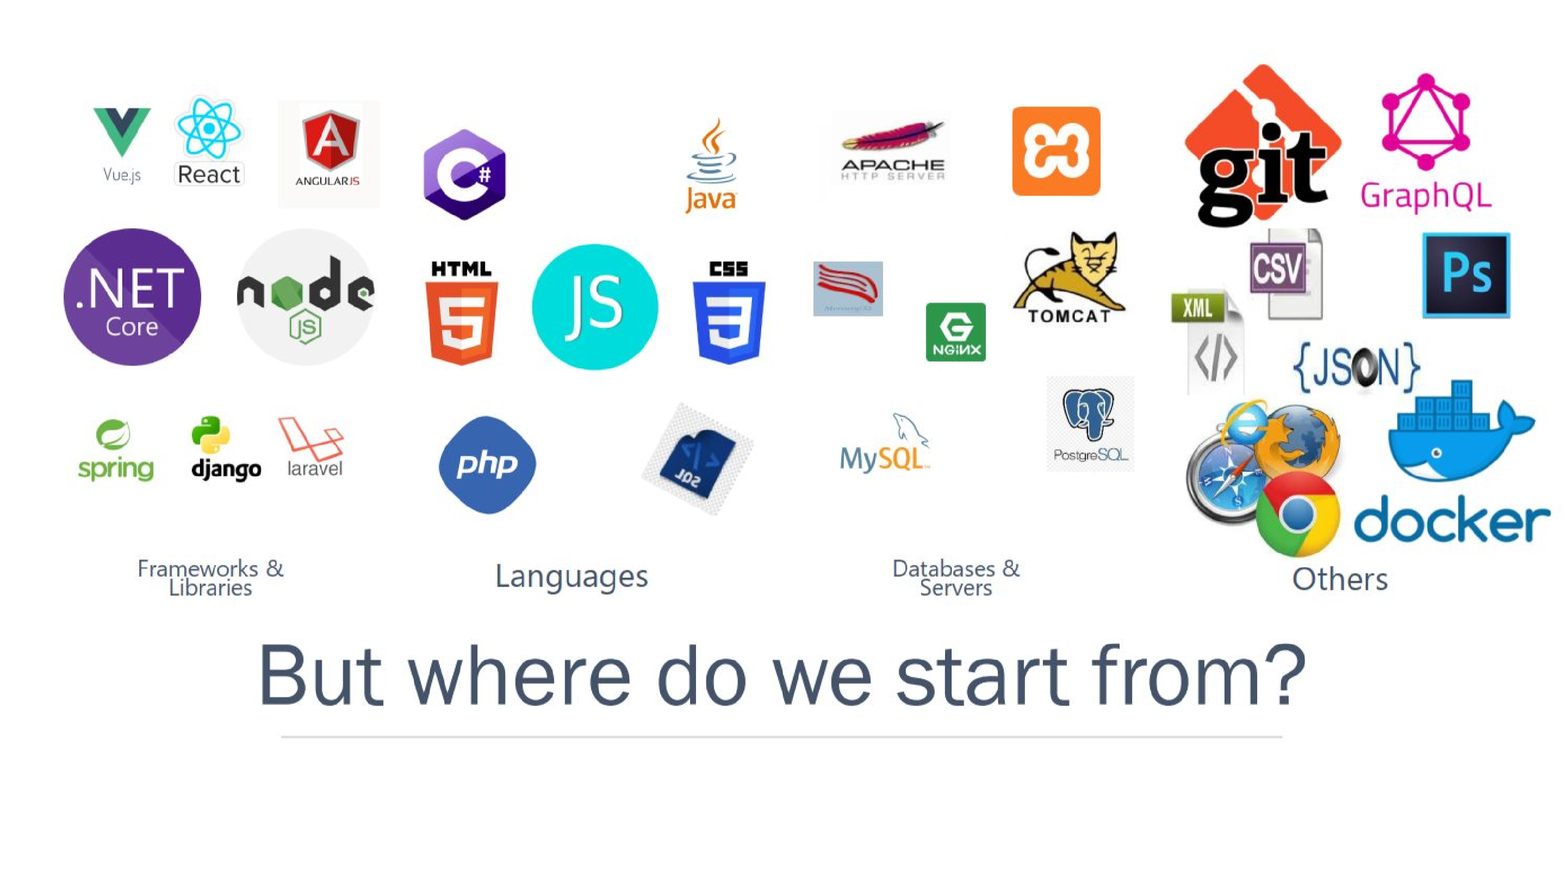
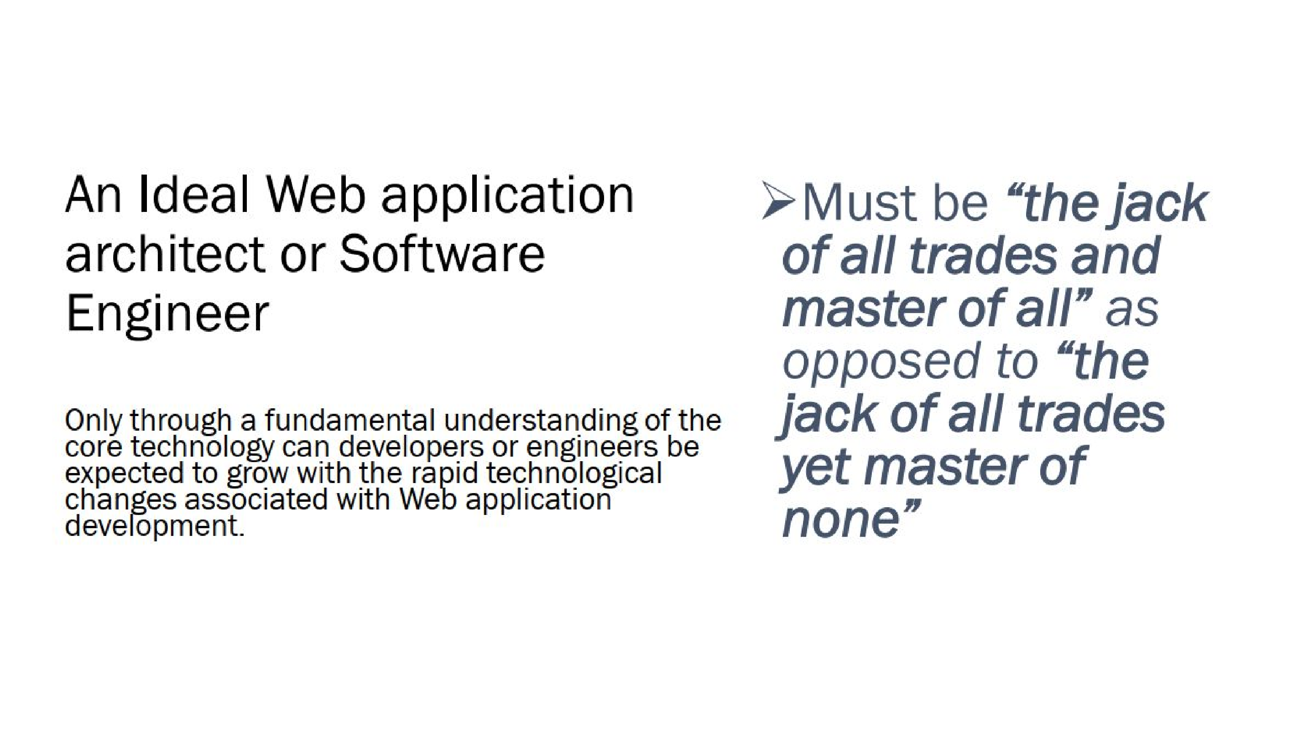
The Nature of the Web
There are 3 essential components which defines the web technology – Tim Berners-Lee (1990). He also wrote the first web editor and server - httpd (Google up).
- MarkUp
  - HTML: HyperText Markup Language.
  - The markup (structure) language for formatting & cross-referencing hypertext document via hypertext links on the web
- Protocol
  - HTTP: Hypertext Transfer Protocol.
  - Allows for the retrieval of linked resources from across the web.
  - Protocol for transporting specialized messages over a network - core foundation of the WWW
- Uniform resource access notation
  - URI: Uniform Resource Identifier.
■ A kind of “address” that is unique and used to identify to each resource on the web. It is also commonly referred to as a URL.
  - Uniform resource notation for addressing accessible resources over the network (URI – Uniform Resource Identifier or URL – Unified Resource Locator)
■ Generalized notation - URLs
■ scheme://host[:port#]/path/.../[;url-params][?query-string][#anchor] – to be explored later on
The Nature of the Web…
Therefore, the WWW is the universe of network-accessible resources, which may be interlinked by hypertext (connection of documents and information resources through links)
- and are accessible on the Internet using the Hypertext Transfer Protocol
(HTTP), & other communication protocols
  - “The World Wide Web (known as "WWW', "Web" or "W3") is the universe of network-accessible information”
  - an information space where documents and other web resources are identified by Uniform
Resource Locators (URLs, i.e. https://www.example.com/)
■ which may be interlinked by hypertext, and accessible via the Internet”
- “The WWW is combination of all users and resources on the Internet that are accessible via the Hypertext Transfer Protocol (HTTP).”
The Web - Key Initial Guiding Principles
- Decentralisation
  - No central authority to control creation and access of documents
  - No single point of failure
  - Implying freedom from indiscriminate censorship and surveillance
- Non-discrimination
  - Similar quality of communication by all parties regardless of what tools everyone is using to connect ➢ Principle of equity is also known as Net Neutrality.
- Universality
  - Communication of any two computers must be based of a common language ■ no matter what different hardware people are using;
■ where they live; or
■ what cultural and political beliefs they have.
  - Allows diversity to flourish
- Consensus
  - For universal standards to work, everyone had to agree to use them
  - Tim and others achieved this consensus by giving everyone a say in creating the standards, through a transparent, participatory process at W3C.
Genesis of the Web
- The Web, as we know it today, can partially be attributed to its grass roots proliferation as a tool for personal publishing ❖ The technology was simple:
  - A computer connected to the Internet,
  - Running a Web server,
  - Serving stored documents or files to Web clients (computers too)
- Initial technology was quite simple in nature
  - During its infancy, web sites served static content - found in files/documents
  - Very few information services were truly considered dynamic
- Dynamic information services:
  - Services that connected the Web to relational databases enabled the web to become truly dynamic.
  - No longer was it sufficient to say that you were designing a ‘Website’ (as opposed to a mostly collection of ‘Web pages’)
  - It became necessary to designing & developing Web applications
Categories - Web Products
Web products may take many forms, but can be categorised into two main categories
- Website
- Web application
The difference is in how each category can be developed
- organization or
- architectural attributes or
- nature of the resulting artefact - product or
- in each instance, the nature of what is returned as response when the product is run in the client application
Categories - Web Products
- Web site
  - A website is a collection of related web resources, such as web pages, multimedia content, which are typically identified with a common domain name, and published on at least one web server
  - Defined by their content and information
  - A Web site simply delivers content from static files
- Web application
  - A web application or web app is a dynamic software/computer program defined by user interactions (driven by user actions) running on client computers in either web browsers or web servers ( Examples??? )
  - It presents dynamically tailored content based on request parameters, tracked user behaviors, and security considerations
By definition, a web application is a client/server application that uses a Web browser as its client program, and performs an interactive service by connecting with servers over the Internet (or Intranet) to generate dynamic web pages based on request parameters, tracked/stored user behaviors, and security considerations
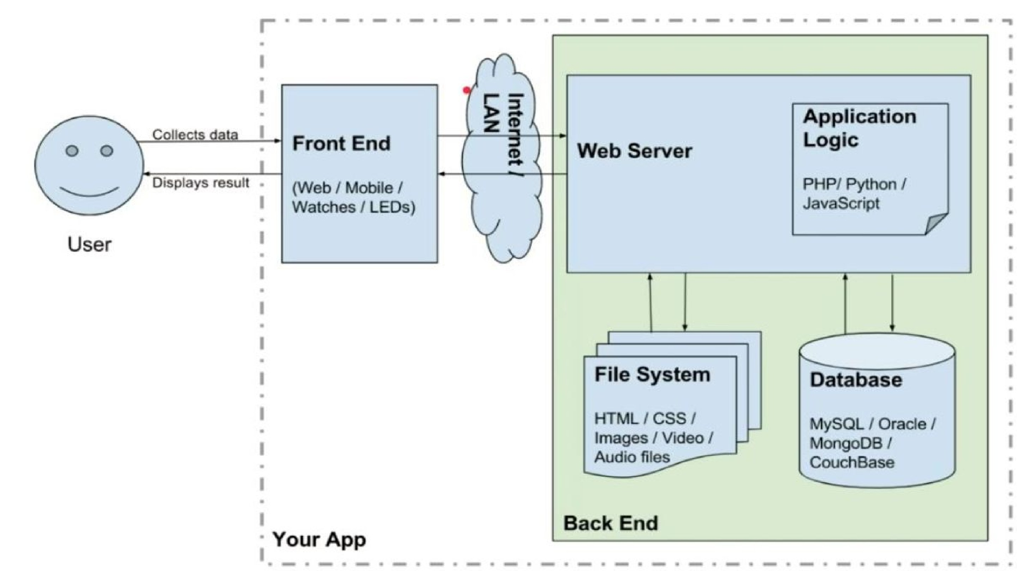
Definitions - Design vs Development
Web design and development are broad concepts. Which require breaking down into key sub-concepts
- Web design
  - A process or activity which involves the application of various disciplines and skill sets for the production or maintenance of websites or web applications
  - Web design encompasses many different skills and disciplines in the production and maintenance of websites or applications. These include but not limited to:
■ Graphic design; Software Programmers or Developers;
■ User Interface (UI) design; User Experience (UX) design;
■ Search engine optimization (SEO);
- Web development
  - Set of activities involved in the development of a website or web application for the Internet (World Wide Web) or an intranet (a private network). May include several activities such as planning - ideation and discovery, design, testing, maintenance and support.
  - Actual work process activities involved in the production of a website or web application ■ not limited to web design
Key Components of a Web Application
- Webpage - Set of User Interface Elements
  - Structured and designed using a markup language, presentation styles and scripting languages
- Web Server
  - For hosting a collection of web pages
- Database
  - Storage of data and any user generated information
Take note that in this module you are required to have glean essential understanding of all these components
- Individual purpose in any singular application
- And how they work together in any particular web application?
Challenges - Web Design & Development
- Collaboration
  - Professional web development is not an individual task
■ Development team members may reside in different time zones and geographical locations
■ Project management may proof a complex and difficult activity
  - Thus, may require the use of collaborative tools like GIT and its services
■ such as GitHub, GitLab, BitBucket etc
- Technological Complexity
  - Web development involves navigating a vast landscape of programming languages, frameworks, libraries, and tools, each with its own learning curve and best practices
- Browser Compatibility and Accessibility
  - Ensuring that websites function correctly across different web browsers and devices can be challenging
■ Their design must take into consideration variations in rendering engines, standards support, and user preferences
- Performance Optimization
  - Optimizing website performance for speed, responsiveness, and scalability requires careful consideration of factors such as ■ Code efficiency, server configuration, caching strategies, and content delivery networks (CDNs).
- Security Concerns
  - Websites are vulnerable to various security threats, including malware, data breaches, cross-site scripting (XSS), and SQL injection attacks.
  - Web developers must implement robust security measures, such as:
■ encryption, authentication, and access controls,
  - These are essential in protecting sensitive information and maintain user trust.
- Maintenance, Support and Updates
  - Websites require ongoing maintenance to ensure they remain functional, secure, and up-to-date with evolving technologies and user expectations.
  - This includes performing regular backups, applying security patches, fixing bugs, and adding new features as needed.
Benefits - Web Design & Development
- E-commerce
  - enables business users to engage in online business transactions
  - facilitates market expansion by reaching traditional brick-and-mortar locations through digital store fronts and channels
- Accessibility
  - Efficient storage and delivery of information
■ provides an accessible platform for information and services, allowing people to connect, communicate, and conduct transactions regardless of geographic location or physical limitations
- Communication
  - Websites serve as a vital communication tool, allowing organizations to share news, updates, and resources with their audience,
  - as well as gather feedback through interactive features like contact forms and comment sections.
- Marketing
  - Websites play a crucial role in digital marketing strategies ■ providing a platform for
    - content marketing and monetisation,
    - search engine optimization (SEO),
    - social media integration, ● and online advertising campaigns.
  - Enhances online visibility, engagement
Tooling - Web Design & Development
- Project Planning and Management
- Collaboration and Software Development
- Design ❖ Testing
- Deployment
Soft Skills [MUST HAVEs]
The web constantly evolves and technologies and trends are always changing. As a UNIVERSITY student you need to constantly update your knowledge to keep up.
- Constant learning mindset
  - Subscribe to key information outlets on the web ie technical news, blogs, and release notes to key technologies like languages, frameworks.
■ Recommendations: medium, ByteByteGo, Codecademy, freeCodeCamp, MDM etc
  - Engage in reading tasks or small research projects regularly and periodically
  - Be curious and set aside specific times for acquiring new knowledge and skills. Be deliberate.
- Open to embracing failure
  - The fear of failure limits many new developers and students alike from experimentation and risk taking
  - What is the value of failure? What lessons can you learn now that can be relevant in future similar situations?
■ Lessons from the past, should determine how we live in the present life and future possibilities.
  - Tips for improvement?
■ Peers,
■ Look to Communities and group meetups for moral and technical support,
■ Get feedback from your lecturers/instructors/tutors on personal or academic assignments.
Soft Skills [MUST HAVEs]...
- Constant learning mindset
- Open to embracing failure
- Effective research(er)
  - Spend a good amount of time searching for relevant information and possible solutions to web project problems. ■ Do not pester your peers or colleagues to help you every time you meet a roadblock.
  - Strategies to effectively conduct your research:
■ Consulting the documentation
■ Search engines - Google Scholar and others
■ Make effective use of an experienced contact's time.
■ Choosing valid information sources
    - look for modern approaches to problem solving, some are obsolete…consider not using them
■ Using social media effectively - benefit from professional networks and contribute to professional communities
■ Cautiously use AI - familiarise yourself with its strengths and weaknesses
    - understand that this is an academic institution where you are required to to do research and generate knowledge for the good of the nation and communities you are coming from.
- Collaboration and teamwork
  - Professional web development is not an individual task - learn to work in teams, conduct code reviews. Learn to be humility, conflict resolution, and cooperation.
  - Learn to be an effective communicator. Feedback must be constructive and respectful.
  - Join a Slack channel, Discord, or a similar space, ask peers for help, share resources.
Soft Skills [MUST HAVEs]...
- Constant learning mindset
- Open to embracing failure
- Effective research
- Collaboration and teamwork
- Build relevant skills today for tomorrow’s job interview
- Relevant contextual information
  - Understand why things happen they way they do.
  - Understand where to use what concept and how…:
■ loops - understand how and when to use then,
■ objects (OOP - javascript) - their relevance in web system modelling, design and development
■ functions (javascript/typescript)
Soft Skills [MUST HAVEs]...
- Constant learning mindset
- Open to embracing failure
- Effective research
- Collaboration and teamwork
- Build relevant skills today for tomorrow’s job interview
- Relevant contextual information
- Workflows and processes
  - Understand a bigger picture about a web project - having knowledge about a specific language alone is not enough.
■ Learn about various frameworks, tools, systems, and job roles that go together to deliver an entire web application
■ Understand the following at a high level:
    - technology combinations and application architectures
    - processes for a technical project, including where different tools are used in those processes
    - job roles, and where they are involved in those processes
    - Common project management models and methodologies, such as agile and waterfall etc.
Summary
References
- History of the Web - World Wide Web Foundation
- https://github.com/mdn/curriculum/blob/main/curriculum/1-getting-started/1-so ft-skills.md
- https://github.com/mdn/curriculum/blob/main/curriculum/1-getting-started/2-en vironment-setup.md

