**HLA:**

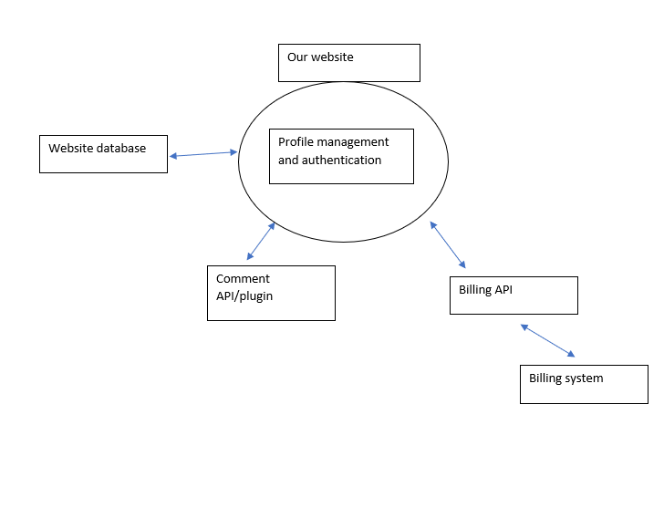

**Class Diagrams:**

|  |
| --- |
| **Article** |
| display  edit |
| displayArticle()  editArticle()  comment()  deleteComment()  addToDatabase() |

|  |
| --- |
| **Code Generation** |
| activeCodes |
| generateCode()  assignCode() |

|  |
| --- |
| **User** |
| username  password  email  code  confirm |
| signUp()  updateName()  updatePassword()  updateEmail()  cancelAccount() |

|  |
| --- |
| **Admin database** |
| users |
| roleManagment() |

|  |
| --- |
| **Payment** |
| card Number (last 4?)  securityCode  expDate  billingAddress  amountCharged  currency |
| pay() |

**Interface Diagrams:**

|  |
| --- |
| <<interface>> Code Generation |
| **generateCode**(activeCodes): Code generated  **assignCode**(): Code assigned |

|  |
| --- |
| <<interface>>  User |
| **signUp** (Username, Password, Email, Code): Account  **updateEmail** (email): Email confirmed/updated  updatePassword (password, users): password updated  updateName (users): username updated  **checkCode** (Code): Code validated  **addToDatabase** (Username, Password, Email, Code): Account added  cancelAccount (users): account is cancelled |

|  |
| --- |
| <<interface>>  Admin database |
| **roleManagment**(roles, users): updates a role of a user |

|  |
| --- |
| <<Interface>>  Payment |
| **pay**(cardNumber, securityCode, firstName, lastName, expDate, billingAddress, amountCharged): donation paid |

|  |
| --- |
| <<Interface>>  Cancel Account |
| **cancelAccount**(username): account cancelled |

|  |
| --- |
| <<interface>>  Article |
| **displayArticle**(users, display): Displays certain things to certain roles  **editArticle**(users): Edits the article  **comment**(users): Allows the user to comment on an article  **deleteComment**(users): Moderator or above can delete a comment  **addToDatabase**(): adds an article to the websites database |