**Use Cases:**

1. **Register/sign up**

The user can go to our website to sign up. On the main screen, they will see [Log in], [Sign up], and the rest of the website’s content.

**Option 1: An unregistered user accesses the site:**

An unregistered user will be allowed to *see* the articles. However, they will **NOT** be able to *use* what the website provides (comment, donation, other features). If an unregistered user tries to access the comment section or any other features, they will be taken straight to the registration form.

**Option 2: Click the [Sign up] button:**

If the user clicks the [Sign up] button, it will take them to a registration form. The user MUST enter their email, username, and password. If the user is registered, if the username is available, and if the password meets complexity requirements, then they will be able to access the comment section as well as other features. If the user is a moderator and if all previous requirements are met, then they will now have access to all the registered user features as well as having the ability to delete comments and ban any bad registered users after getting reviewed by the admin role. The writer role gets access to all of moderator abilities and can write as well as edit articles after getting reviewed by the admin role. The admin role has all abilities of previous roles and the ability to add/remove assigned rolls.

**Option 3: Click the [Log in] button:**

If the user clicks the [Log in] button, then the user will then be prompted to enter their email/username and password. If email/username and password match what is stored in the database, the user will then be granted access to the website’s services.

1. **Registered user comments**

Once the registered user logs in (refer to case #1, option 3), they will see the main page. On the main page, there will be articles to click on and there will be a comment section below any article. They will be able to type their comment and click the comment button. This button will take the users comment and make it public for everyone to see.

1. **Moderator deletes comment or bans registered user**

**Option 1: Moderator deletes a comment**

Once the moderator logs in (refer to case #1, option 3), the moderator can delete a comment when they are on the comment section and click on the [delete comment] button in the top right of the comment. The comment will then be deleted.

**Option 2: Moderator bans a registered user**

Once the moderator logs in (refer to case #1, option 3), and are on the comment section. They can then, click [Ban]. This button will ban the user and the user will lose access to all features. The admin will have the ability to unban.

1. **Writer writes/edits an article**

**Option 1: Writer publishes article**

After the writer logs in (Refer use case #1 option 3), they will be able to click the [Write article] button. Then, they will be taken to a different screen where they can compose an article and can click [publish]. When they click publish the article will then be public for all users to see.

**Option 2: Writer edits article**

After an article is published. The writer has the ability to edit an article by clicking the [edit] button on the top right of the article. If clicked, the website will take the writer to a page to edit the article. Once done, they can click [confirm changes] at the bottom of the page.

1. **Admin change’s user’s role**

After the Admin logs in (Refer use case #1 option 3), there should be a [Change roles] button on the main page. After clicking this button, the site will take the admin to a page that lists the users in alphabetical order and by role and the admin will be able to add/remove roles using a dropdown menu that is beside the users’ name. They will also have a search bar to search for a specific user. If the admin changes a role, there will be a confirmation button and once confirmed the role will be updated.

**Sequence diagrams:**

**Case 1:** **Register/signup**

**Option 1: An unregistered user attempts to access the website’s content**

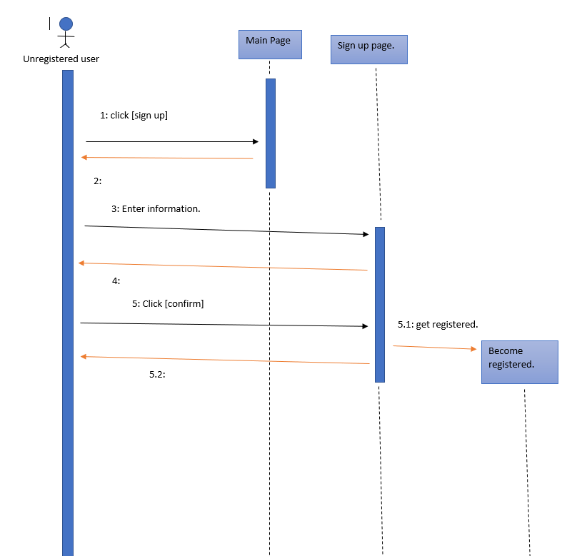

**Option 2: Click the [Sign up] button - [user]**

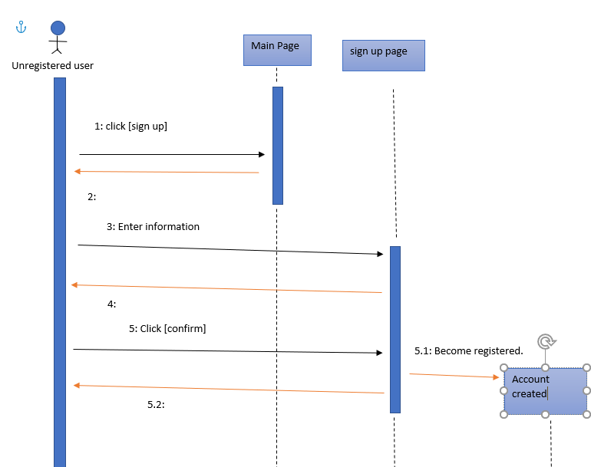

**Option 3: Click the [Log in] button**

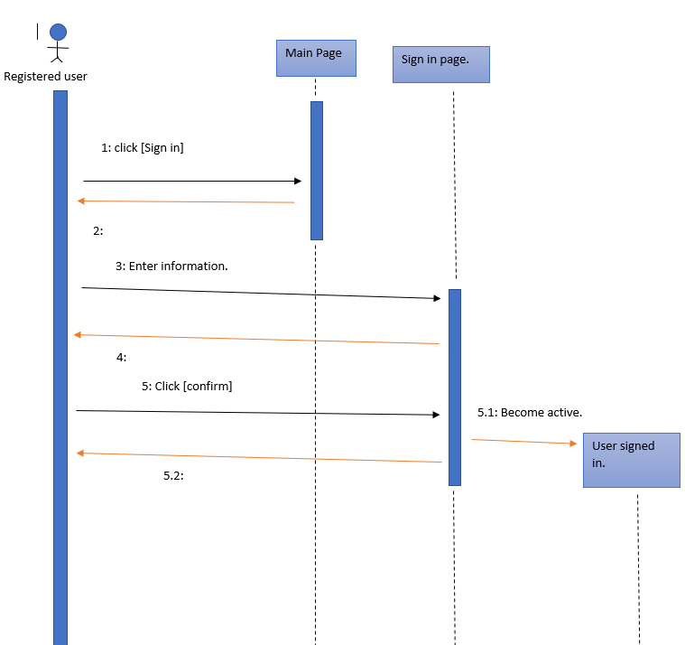

**Case 2:** **Registered user comments**

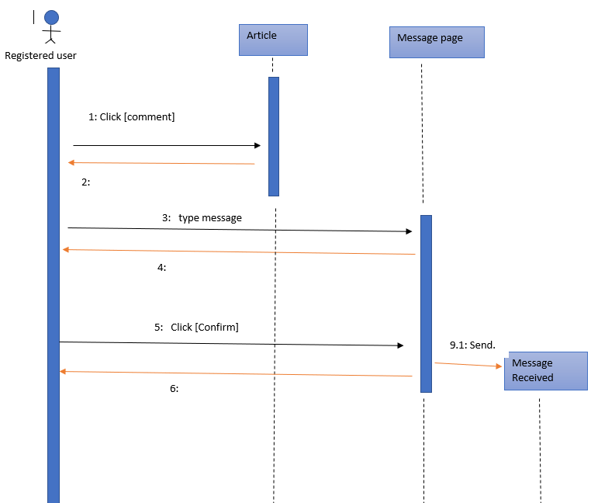

**Case 3:** **Moderator deletes comment or bans registered user**

**Option 1: Moderator deletes a comment**

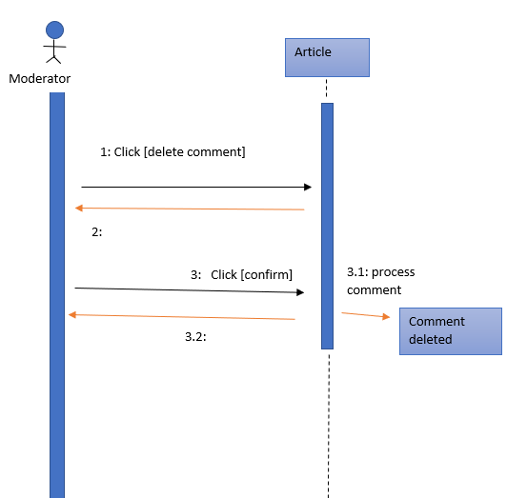

**Option 2: Moderator bans a registered user**

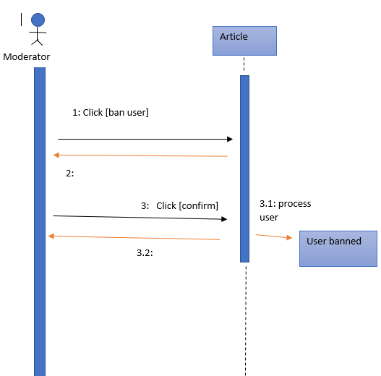

**Case 4:** **Writer writes/edits an article**

**Option 1: Writer publishes article**

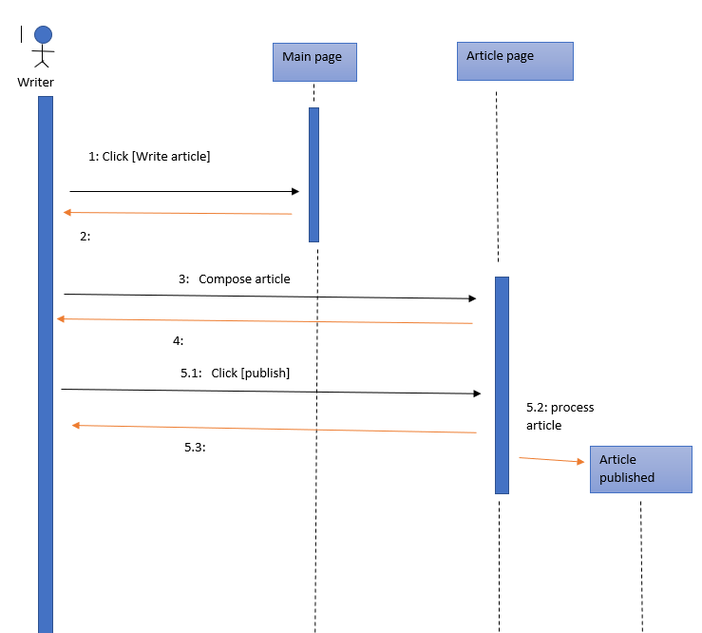

**Option 2: Writer edits article**

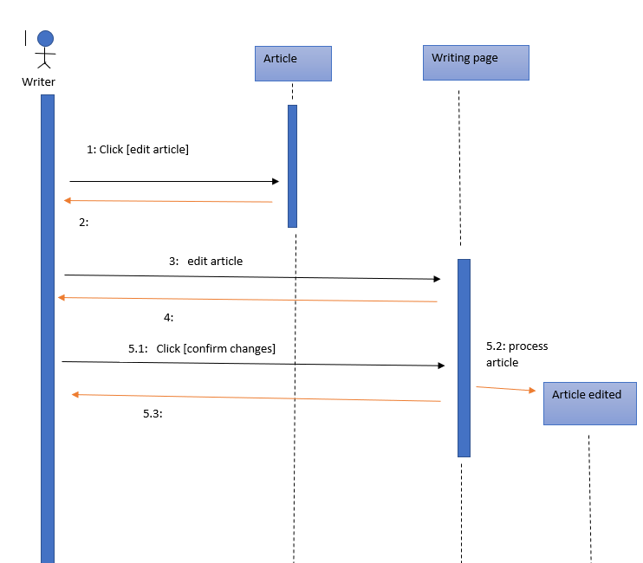

**Case 5:** **Admin change’s user’s role**

