DSUK Smart Marker v1.0 Manual.

This manual provides information on how to use the Smart Marker program to evaulate one or more student's Karotype analyses against a Reference answer provided by the teacher.

When you start the program you will see the main screen:

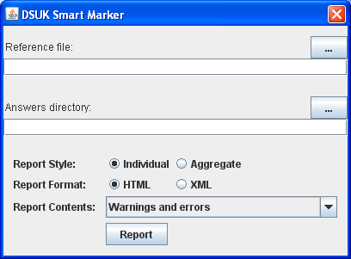

1) Input data: Selecting the kry files for analysis

Firstly, select the Reference file against which all the other answers will be marked. Click on the Reference File Selection button (marked in the next picture) to access the File Selection Dialog. Within this dialog navigate to the appropriate file, select it and click Open.

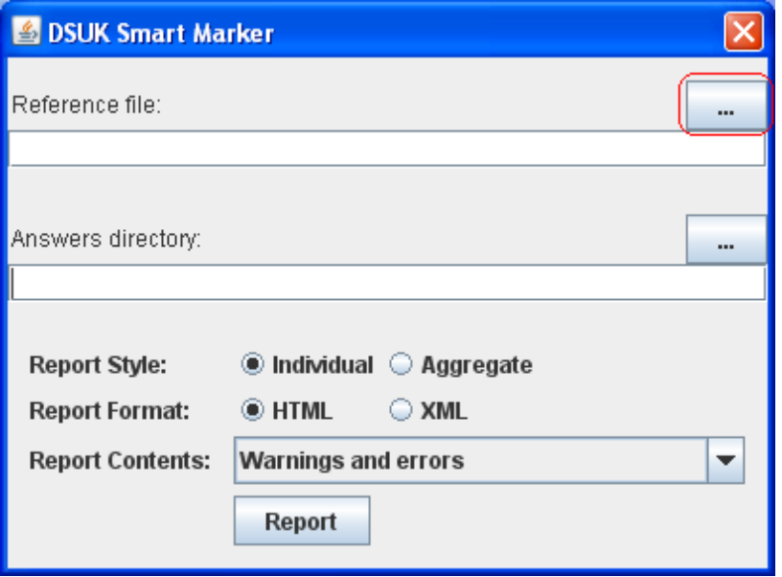

Now that the Reference file has been selected its filename and path will be displayed on the main screen.
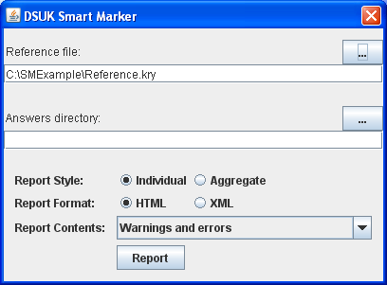

You now have two options:

a) If the students' answers are in the same directory as the Reference file (in this example in the C:\SMExample directory) then you do not need to specify this to the program. You can move on to deciding what report features you require (See section 2 Output data).

b) If the students' answers are in a different directory then you will need to select this Answers directory. To do this click on the Answers Directory Selection button (marked in the next picture) to access the Directory Selection Dialog. Within this dialog navigate to the appropriate directory, select it and click Open.

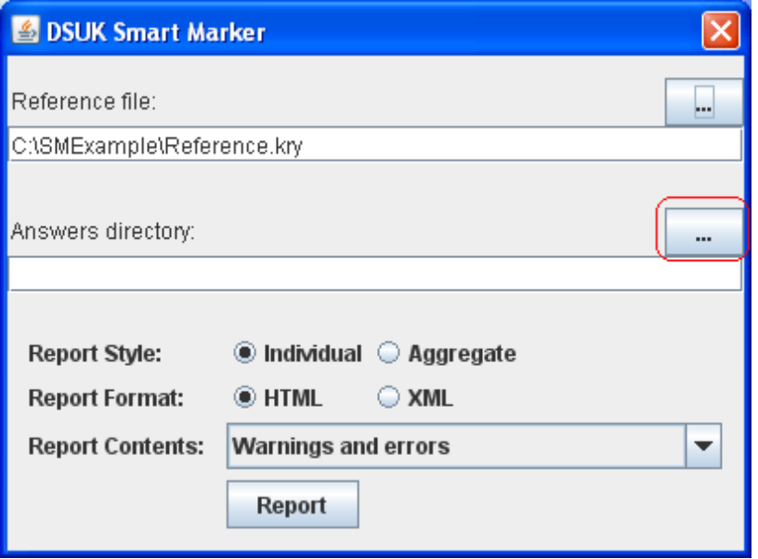

Now that the Answers directory has been selected its path will be displayed on the main screen.

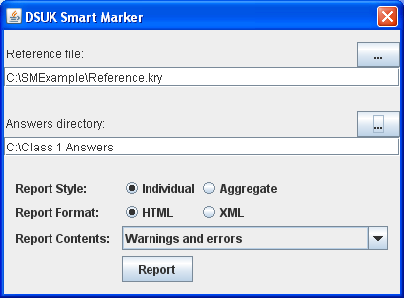

2) Output data: Selecting the report features you require.

The Reporting functionality provides a range of report formats and styles.

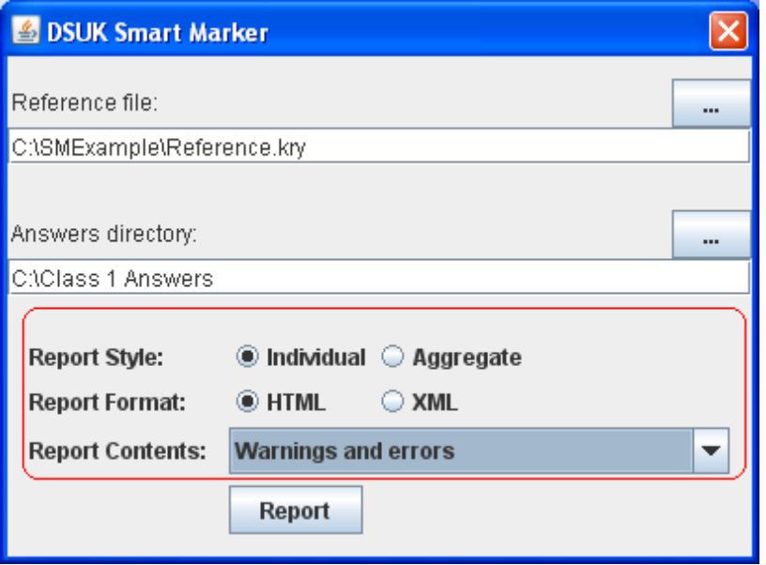

Report Style

a) Individual – this will create a report for each student file
b) Aggregate – this will create one report containing results from all the student files in the Answers directory.

Report Format

a) HTML – this option produces html file(s) – this is the default option and will automatically be selected when you start the program.
b) XML – this option produces xml files(s) – this is the advanced option which allows you to produce customised reports.

Report Contents

a) Errors only – this option produces report file(s) containing only errors.
b) Warnings and errors – this option produces report file(s) with warnings and errors. It is the default option and will automatically be selected when you start the program.
c) All – this option produces report file(s) containing warnings, errors and correct answers.

Once you have chosen from the above options, click on the Report button to run the analysis and produce the desired report files. These will be stored in the Answers directory in a sub-directory called SmartType reports.

