Design Document: ResumeFit
Course: MSAI631-M92, Artificial Intelligence for Human-Computer Interaction
Project: Residency Group Project, Conversational ATS Resume Converter
Date: 07/25/2026.

1. Purpose and Scope
ResumeFit takes a messy resume draft and turns it into a clean, ATS-standard rewrite through a short conversation. A user pastes text or uploads a PDF or DOCX file, answers a handful of targeted questions about what the draft is missing, and receives a rewritten resume they can download as plain text, DOCX, or PDF. The project exists to satisfy a specific course requirement: build a chatbot that integrates a traditional, rule-based layer with an AI-as-a-service layer, and use that integration to demonstrate prompt engineering, accessibility, and applied AI ethics.
This document describes what was built and why, not what was originally proposed. It explains the architecture, the reasoning behind each design decision, and the tradeoffs the team weighed while building it.
Two things were deliberately left out of scope. The tool does not build a resume from a blank page; it only improves an existing draft. It also does not score a resume against a specific job posting. Both are natural extensions of the same architecture and are noted in Section 7.

2. System Architecture
The application runs as a single Streamlit process (app.py) that steps a user through five stages: intake, analyzing, quiz, rewriting, and done. Each stage hands off to one of two processing layers. The traditional layer is plain Python: regex-based parsing and rule checks, with no network calls. The AI-as-a-service layer makes two separate calls to the OpenAI Chat Completions API, one to generate content-specific quiz questions and one to produce the final rewrite. Figure 1 shows the intake and stage-tracking UI that drives this flow.
Figure 1: Streamlit UI stages, from intake through done
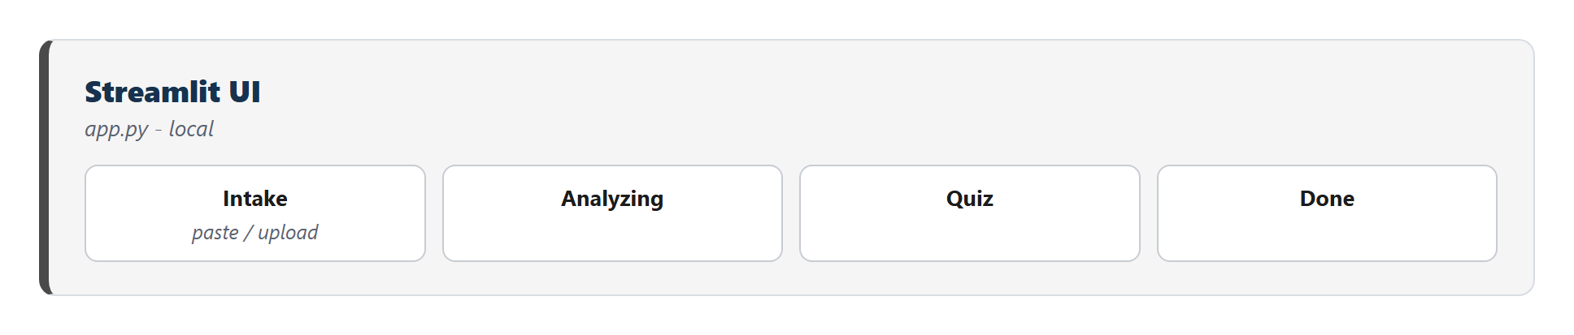
Intake accepts either pasted text or an uploaded PDF/DOCX file. src/document_parser.py extracts plain text from an upload and separately flags formatting that breaks ATS parsing (tables, embedded images, text boxes), surfacing those as warnings before the user even starts the quiz. Figure 2 shows this stage alongside the rule-based gap detector it feeds into.
Figure 2: Document parsing and rule-based gap detection, entirely local
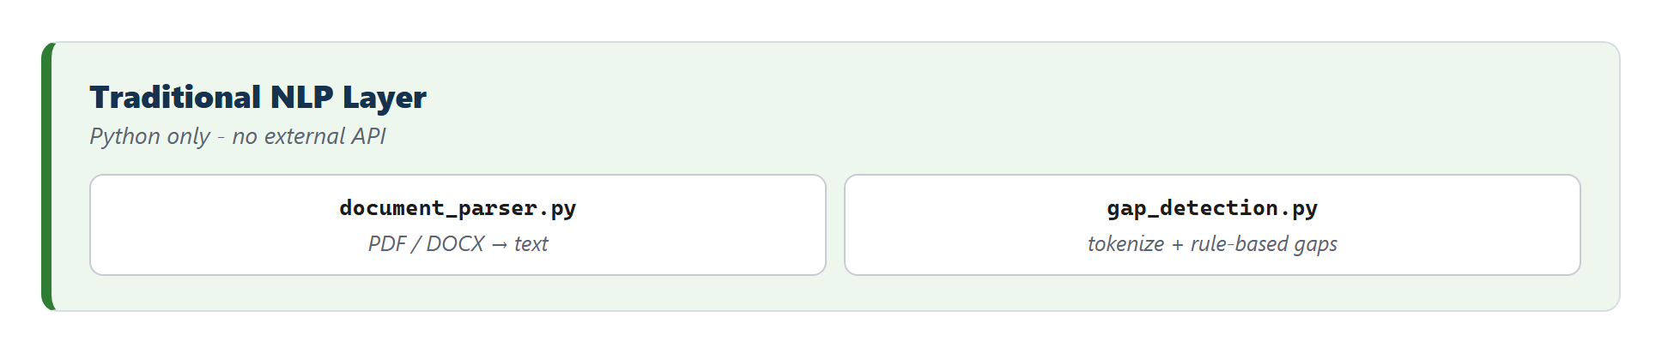
src/gap_detection.py is the traditional chatbot layer proper. It splits the draft into lines and runs three independent checks: missing or inconsistent dates near a role header, vague job titles (“Team Member,” “Associate”), and bullet points with no quantified result. Each check produces a Gap object carrying the offending line and a question to ask about it. The three categories are interleaved round-robin before a cap of five questions is applied, so a resume with many missing dates and no vague titles still gets a mixed question set rather than five date questions in a row. If rule-based detection turns up fewer than two gaps, generic questions (add a summary, name a target role, list additional achievements or skills) top up the queue, so the quiz step always runs even against an already well-formatted resume.
The rule-based questions alone were the original design. During testing against a real, already-decent resume, the checks found nothing to flag, and the app skipped the quiz entirely, silently dropping the feature the course asks the project to demonstrate. src/question_generator.py was added to fix this: it sends the draft plus the rule-based questions already queued to the OpenAI API and asks for additional questions specific to what that particular resume actually says, an ambiguous scope of responsibility, an unexplained gap between roles, a title that seems to mismatch its described duties. Figure 3 shows this stage.
Figure 3: Content-specific question generation via the OpenAI API
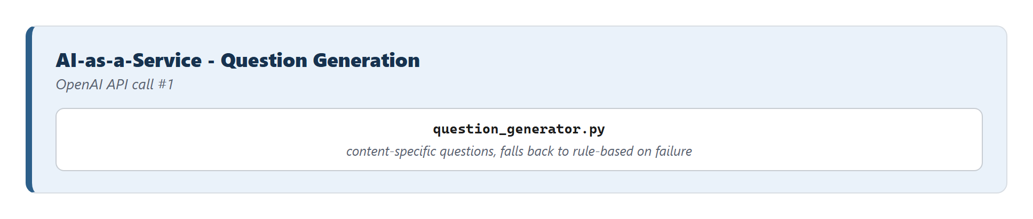
The two question sources are merged the same way the rule-based categories are, interleaved and capped, so neither source can crowd out the other. If the API call fails, build_quiz_queue catches the exception and falls back to rule-based-only questions, padded with the same generic top-up used when rule-based detection alone comes up short. The quiz never blocks on this call being available.
Once the queue is built, the app presents one question at a time in a chat interface (Figure 4), tracks each answer against the gap it resolves, and lets the user skip a question, step back to a previous one, or jump straight to an earlier answer to revise it, rather than force a fabricated answer or restart the whole quiz over one mistake (Section 3.5).
Figure 4: One question at a time, with answer tracking and skip support
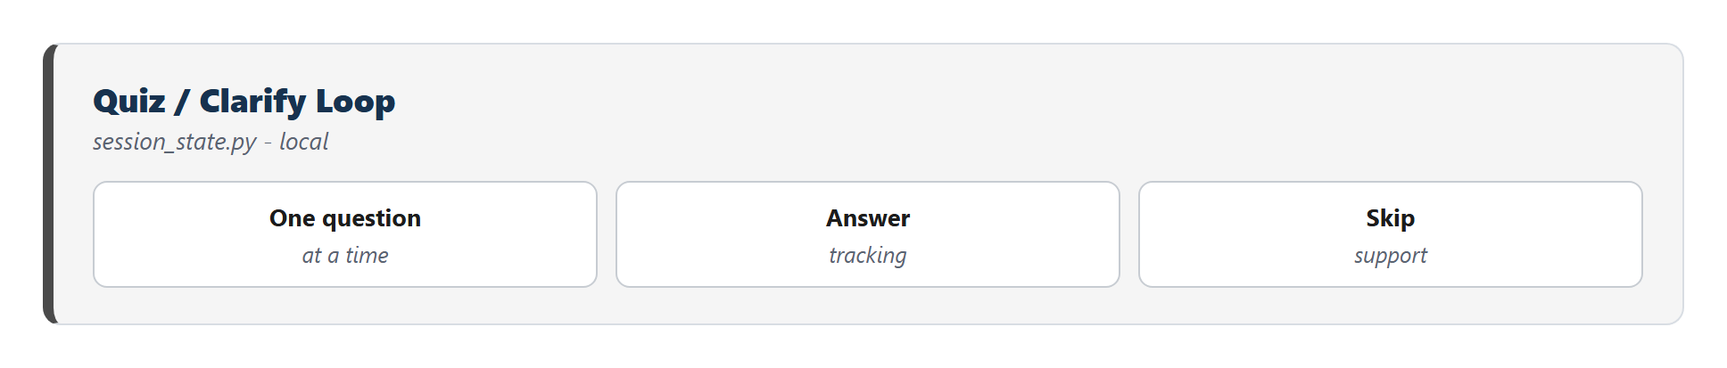
When the quiz is complete, the draft and every collected answer go to src/rewriter.py, the second AI-as-a-service call (Figure 5). Its system prompt fixes the ATS constraints directly: single-column layout, the four standard section headers, consistent date formatting, and an explicit instruction not to invent employers, titles, dates, or achievements beyond what the draft or the quiz answers actually contain. rewrite_resume_with_retry wraps the call with one automatic retry on failure, since the most common live-demo failure mode is a transient rate limit or network blip rather than an actual outage.
Figure 5: The ATS rewrite call, with a structured prompt and one retry
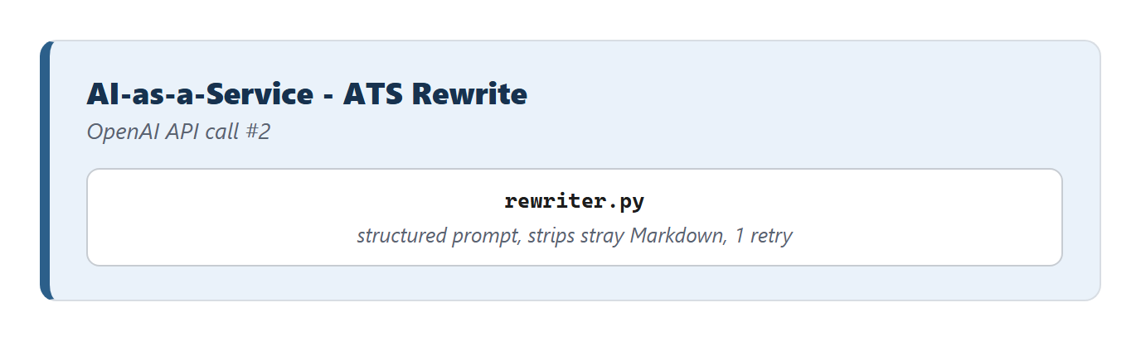
If both attempts fail, the app falls back to a cached response rather than showing a bare error, described in Section 4. The final text is rendered in a before/after view and made available for download in three formats, covered in Section 3.6.

3. Component Design and Rationale

3.1 Why two rounds of AI-as-a-service, not one
The architecture calls the OpenAI API twice: once to help generate questions, once to rewrite. An earlier version of the design called it only once, for the rewrite. That version worked, but it made the “traditional chatbot” half of the project do all the interesting work and left the AI-as-a-service half doing something a single well-crafted static prompt could have done just as well. Splitting question generation into its own API call gives the AI layer a job the rule-based layer structurally cannot do: reading the actual content of a specific resume and asking about what's ambiguous in it, as opposed to matching fixed patterns like missing dates or vague titles. The two calls also demonstrate two different prompting problems: one that must produce a short, bounded list of novel questions without repeating a supplied list, and one that must produce a long, structurally constrained document while inventing nothing. That contrast is part of the intended prompt-engineering material for the course discussion.

3.2 Gap detection thresholds and the round-robin cap
Capping the question queue at five and flooring it at two were both judgment calls, not derived from user testing. Five was chosen as an upper bound on how many questions a user would tolerate answering before the “let a chatbot fix my resume” pitch starts to feel like homework. Two was chosen as the minimum needed for the quiz to feel like it did something, rather than a single throwaway question. The round-robin interleaving across the three rule-based categories exists because an early version of the detector, tested against a resume with several missing dates and only one vague title, produced a queue of four consecutive date questions and cut off before reaching the vague-title or unquantified-bullet checks at all. Interleaving before capping fixed that without changing any individual detector's logic.

3.3 The Markdown-stripping fix
During testing, the rewrite output started showing up with literal ** characters around job titles and company names in every export format: TXT, DOCX, and PDF. The cause was the model defaulting to Markdown bold syntax in its response, a habit picked up from chat-formatted training data, despite the system prompt never asking for it. None of the three export paths interpret Markdown, so the asterisks passed through as literal text, exactly the kind of artifact a real ATS parser would also choke on. The fix has two parts. The system prompt in rewriter.py now explicitly forbids Markdown formatting and states why: the output is exported as-is and literal formatting characters will appear in the final resume. A regex-based strip_markdown_emphasis function also runs on every API response before it reaches session state, removing any **bold** or __bold__ markers that get through anyway. Prompt instructions alone were not treated as sufficient, since instruction-following on a single stylistic constraint is not guaranteed on every call, and the cost of a defensive regex pass is small next to the cost of a visibly broken resume during a live demo.

3.4 Output formats: TXT, DOCX, and a LaTeX-rendered PDF
The output layer (Figure 6) originally supported plain text and DOCX. A third format, PDF, was added afterward, and it required resolving a real tension in the requirement itself.
Figure 6: Output layer, including the LaTeX-rendered PDF export added after the initial build
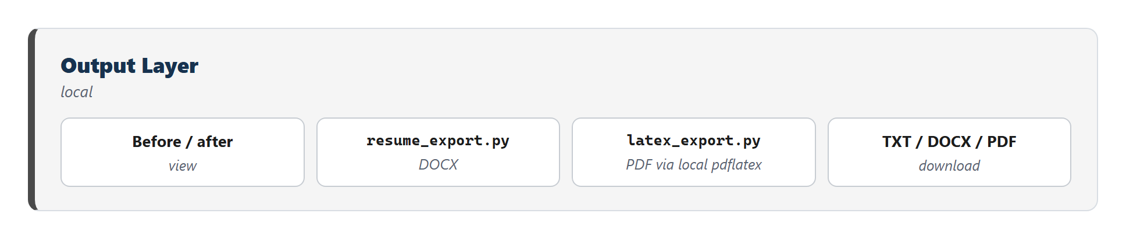
“Clean, professional PDF” and “ATS-safe” pull in different directions. Most polished-looking LaTeX resume templates use multi-column layouts, custom fonts, or graphical elements, exactly the formatting choices that break automated resume parsers. Rather than pick a visually rich template and lose ATS safety, src/latex_export.py generates a deliberately minimal, single-column LaTeX article document: bold section headers, plain itemize bullets, no packages beyond basic margins and font substitution. The same plain-text structure that resume_export.py already parses for DOCX (section headers, - bullets, plain paragraph lines) feeds both exporters, so all three download formats stay in sync without duplicating the parsing logic three times.
Compilation happens by shelling out to a local pdflatex, run with -no-shell-escape to keep the compiled input from being able to execute arbitrary commands, since the LaTeX source is built from model output that the team does not fully control. This was a deliberate choice among three options considered: a local LaTeX engine (chosen), Tectonic (a self-contained LaTeX binary that still requires an external dependency and a first-run network fetch), and a pure-Python PDF library with no system dependency at all. The team picked the local-engine approach because MiKTeX was already installed on the development machine and produced real LaTeX-typeset output (not an approximation), at the cost of adding a system dependency the demo environment must have. That cost is mitigated two ways: the PDF button is wrapped in a try/except in app.py, so a missing pdflatex degrades to a caption explaining the PDF is unavailable rather than crashing the page, and README.md documents per-OS installation steps (MiKTeX, MacTeX/BasicTeX, or the texlive packages on Linux) for anyone setting up the project fresh.
One design decision was made deliberately conservative: LaTeX generation stays entirely in application code, not in the model. The rewriter's output is still plain text; build_latex is the only thing that ever produces .tex source. Letting the LLM emit raw LaTeX directly would risk malformed commands breaking compilation and would turn the PDF export into a code-injection surface, since compiling LLM-authored LaTeX means compiling unvalidated input.

3.5 Quiz navigation: back, skip, and inline editing
The quiz originally moved in one direction only. Skipping a question meant typing the literal word “skip” into the chat input, and there was no way to revisit or correct an earlier answer short of restarting the whole flow. Both limits got fixed together, since they turned out to share the same underlying problem.
Two explicit buttons, Back and Skip, replaced the typed convention. Back steps current_gap_index down by one and re-presents the previous question; whatever answer was already recorded for it stays in place until the user types a new one or hits Skip. Skip clears any existing answer for the current question and advances, marking it explicitly unresolved rather than silently keeping a stale value. A third control, a small edit button next to each answered question in the transcript, jumps the index directly to that question instead of requiring one Back click per step, useful once the quiz runs several questions deep and the mistake was near the start.
Adding real backward navigation exposed a bug in how the transcript was built. The original code displayed every entry in st.session_state.answers in dict insertion order, which works fine as long as answering only ever moves forward. Once a user could jump backward and re-answer a question, that same dict could hold an answer for a question the user had not reached again yet on this pass, and the transcript would show it anyway, or show a stale answer twice next to the question being re-asked. The fix was to stop trusting the dict's own order and derive the transcript from gaps[:idx] instead, looking up each gap's answer with .get(...) as it goes. What renders is always exactly the questions already passed on the current pass through the quiz, independent of whatever else is sitting in the answers dict. The full answer, skip, back, and re-answer sequence was checked in a standalone script before it went into the UI, confirming the transcript and the stored answers stayed in sync across a back-then-reanswer round trip.

3.6 Diff highlighting between draft and rewrite
The before/after view originally showed the draft and the rewrite as two blocks of plain text side by side, with nothing marking what had actually changed beyond what the reader could spot by eye. src/diff_view.py adds a word-level diff, computed with Python's own difflib.SequenceMatcher rather than a new dependency, comparing the two texts token by token. Tokens are split on \S+|\s+ rather than on whitespace alone, so line breaks survive as their own tokens and the reconstructed text keeps its original layout.
Words the matcher marks as removed get a struck-through red span in the original-draft panel; words marked as added get a highlighted green span in the rewrite panel. Both panels are HTML-escaped before the highlight spans go in, since the diff output is rendered through unsafe_allow_html and the underlying resume text is user-supplied. A small legend sits above both panels using the same two span classes, so the color key is never separate from what it explains. Colors are drawn from the same light/dark palette selection as the rest of the app's custom styling, described in Section 3.7.
Because the rewrite is a full regeneration rather than a light edit, new section headers appear, content gets reordered, and bullets get rewritten rather than lightly touched. A word-level diff against that much structural change will show large stretches as removed-and-added rather than small in-place edits. That reflects what actually happened to the resume; it is not a sign the diff logic needs sentence- or paragraph-level alignment instead.

3.7 A UI polish pass: status widgets, the sidebar stepper, and theme switching
A later pass focused on making the app read as a finished product rather than a working prototype, since the two audiences for this build, the course instructor and anyone the team demos it to afterward, will judge it on how it feels to use as much as on whether the AI-as-a-service integration underneath is correct.
Both stages that call the OpenAI API used a bare st.spinner() originally: a spinning icon and one static line of text for the whole duration of the call. That is honest but thin, especially in the rewriting stage, which has three genuinely different outcomes: a clean success, a cached-fallback success after the live call failed, and a hard failure with nothing to show. Both stages now use st.status(..., expanded=True), which narrates what is happening (“Calling the OpenAI API...”) and resolves to a distinct label and icon for each of those outcomes instead of collapsing them into one generic “done.”
The sidebar's step list moved from plain emoji and markdown text to a small stepper built from injected HTML and CSS: numbered circles connected by a line, filled in for completed steps, outlined and highlighted for the active one. It reuses the #1a5276 accent already set as the app's primary color rather than introducing a new one, through the same custom-CSS mechanism already used to round the corners on chat bubbles.
Theme switching turned out to be the one place where the obvious approach, a custom light/dark toggle wired to the app's own CSS, was the wrong call. Streamlit's native widgets (buttons, the file uploader, the text area) are themed through a JavaScript context provider, BaseWeb's ThemeProvider, not through plain CSS custom properties, so a hand-rolled CSS override can restyle the app's own custom elements but cannot reach those native widgets. Shipping that approach would have produced a page that was half-dark: the stepper and buttons switching, the file uploader and text area staying light. .streamlit/config.toml now defines [theme.light] and [theme.dark] sections instead, Streamlit's own supported mechanism, so its Settings menu re-themes every widget correctly because Streamlit's own tested code does the work, not a CSS patch layered on top of it. A “⚙️ Theme” button, pinned to the bottom of the sidebar, opens a popover showing the currently active theme, read server-side through st.context.theme.type, and points to that Settings menu. It does not open the menu automatically. Doing that would mean scripting a click into Streamlit's internal, undocumented DOM structure from outside its public API, the same category of fragile, unverifiable hack avoided everywhere else in this project.
A few smaller changes round out the pass. “Start over” previously wiped the draft, answers, and result on a single click; it now asks for confirmation first. Each of the three download buttons fires a short st.toast confirming which format started downloading. The hover lift and shadow on buttons sit behind @media (prefers-reduced-motion: no-preference), so a user with that operating-system setting gets the same buttons without the motion. One item was considered and deliberately dropped: a dedicated keyboard shortcut for skipping a question, for the same reason the theme button does not auto-open Streamlit's menu. It would require injecting JavaScript that reaches into the page from outside Streamlit's component API. Enter-to-submit needed no work at all, since st.chat_input already submits on Enter by default.

4. Reliability Design: The Live-Demo Fallback
A live demo depends on a network call to a third-party API succeeding at a specific moment in front of an audience, so the system was built with three layers of degradation instead of one path that either works or doesn't (Figure 7).
Figure 7: Retry once, then serve a cached response, clearly labeled and never silent
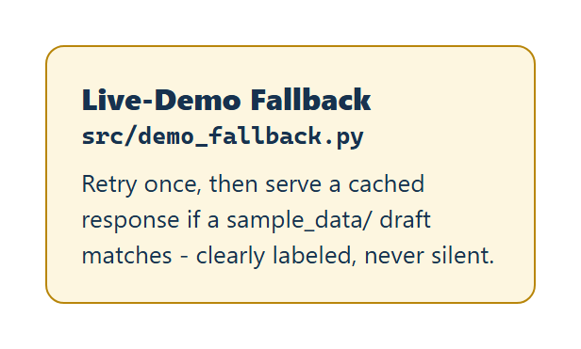
The first layer is the automatic retry already described in Section 2. The second, src/demo_fallback.py, activates only if both attempts fail: it scans every draft file bundled in sample_data/, using the same parser the app uses for uploads, and checks whether the current draft text matches one of them. On a match, it serves that file's pre-generated cached rewrite instead of an error, and the UI displays a visible banner stating the response is cached, not a fresh live rewrite. This fallback is intentionally narrow. It only ever fires for a file the team actually bundled ahead of time; a real resume typed in live by an audience member has no cached counterpart and still surfaces an error if the API is down. That narrowness matters for demo honesty as much as for engineering correctness, since the project's own ethics discussion argues for AI transparency, and a fallback that silently pretended to be live would contradict that stance in the same demo meant to illustrate it. A third layer, a recorded backup video of a full successful run, is planned but not yet captured as of this writing; it remains the last resort if the entire environment, not just the API, fails during the presentation.

5. Data Handling, Accessibility, and Ethics
Nothing in the application persists beyond the active browser session. Session state lives entirely in Streamlit's in-memory store; there is no database and no external storage of resume content. The API key is read from an environment variable via python-dotenv, kept out of the repository through .gitignore.
Accessibility was treated as a design constraint rather than an afterthought, largely because it overlaps almost exactly with the ATS-safety requirement the project already needed to satisfy. A single-column, table-free, plain-text-structured resume is close to what a screen reader also needs to parse a document correctly, so the same rewrite prompt serves both goals. On the interface side, app.py injects CSS for a larger base font size and a visible keyboard focus outline, and .streamlit/config.toml sets a high-contrast theme.
The ethics discussion the course asks for has concrete hooks in this specific build, not just abstract principles. Privacy is a live concern because sample_data/ currently contains one real resume with real personal details, added during testing; the team still needs to decide whether to gitignore that file or replace it with a synthetic example before the repository is shared or submitted. Transparency is handled directly through the fallback banner described in Section 4, which never lets a cached response pass as a live one. Accountability against fabrication is handled at the prompt level: the rewrite instructions explicitly forbid inventing employers, titles, dates, or achievements not present in the draft or the quiz answers, and any gap the user skips is passed through as unresolved rather than guessed. Biased resume-screening AI has real precedent, most visibly Amazon's internal screening model, scrapped in 2018 after it penalized resumes containing the word “women's.” This project builds a resume rewriter rather than a screening or ranking tool, which sidesteps that particular failure mode, but the team treats it as a reason to be deliberate rather than a reason the risk doesn't apply here.

6. Implementation Status
All functional requirements for this project are implemented and smoke-tested as of this writing, with two exceptions still open ahead of the Day 2 and Day 3 milestones.
Area | Status
Intake (paste and file upload) | Done
Rule-based gap detection, interleaved and capped | Done
Content-specific question generation via API, with fallback | Done
Quiz loop (one question at a time, skip support, answer tracking) | Done
ATS rewrite prompt and retry | Done
Markdown-stripping fix (Section 3.3) | Done
Output: TXT, DOCX, and PDF (Section 3.4) | Done
Quiz back/skip buttons and inline answer editing (Section 3.5) | Done
Before/after diff highlighting (Section 3.6) | Done
Status-widget progress narration, sidebar stepper, theme switching (Section 3.7) | Done
Confirm-before-reset, download toasts, reduced-motion support (Section 3.7) | Done
Live-demo fallback, Layers 1 and 2 (Section 4) | Done
Live-demo fallback, Layer 3 (recorded backup) | Not yet done
Live browser walkthrough of the full flow | Not yet done
End-to-end timing against the two-minute target (NFR1) | Not yet formally timed

7. Limitations and Future Work
Three limitations are deliberate scope cuts rather than defects: the tool does not build a resume from nothing, it does not score a draft against a job description, and it does not detect true multi-column page layout in an upload, since the PDF and DOCX parsing libraries in use do not expose that cleanly, only tables, embedded images, and text boxes. Both scope cuts are compatible with the existing architecture if picked up later; the quiz-and-rewrite pipeline does not need to change shape to add a job-description-matching step, only a new comparison stage after the rewrite.
Two things are open questions rather than firm decisions. The five-question cap and two-question floor described in Section 3.2 have not been validated against how an actual user reacts to the quiz length, only against the team's own judgment during testing. And the recorded backup video for the third fallback layer, needed before the live presentation, has not yet been captured.
One more limitation is deliberate rather than an oversight: there is no keyboard shortcut for skipping a question, discussed in Section 3.7. Building one would mean injecting JavaScript that reaches into the page from outside Streamlit's public component API, the same kind of unverified, version-fragile approach the team avoided for the theme-switch button. Enter-to-submit already works without it, since st.chat_input handles that natively.

8. Interface Screenshots
The diagrams in Sections 2 through 4 describe the architecture. These screenshots show the actual running application, captured from a live session against a real resume rather than the synthetic sample. Figure 8 is the intake screen before any input, with the sidebar stepper and the “⚙️ Theme” button both visible in their idle state. Figure 9 shows the same screen after uploading a DOCX, the extracted text populating the paste-in text area exactly as FR2 requires.
Figure 8: Intake screen, sidebar stepper and theme button idle
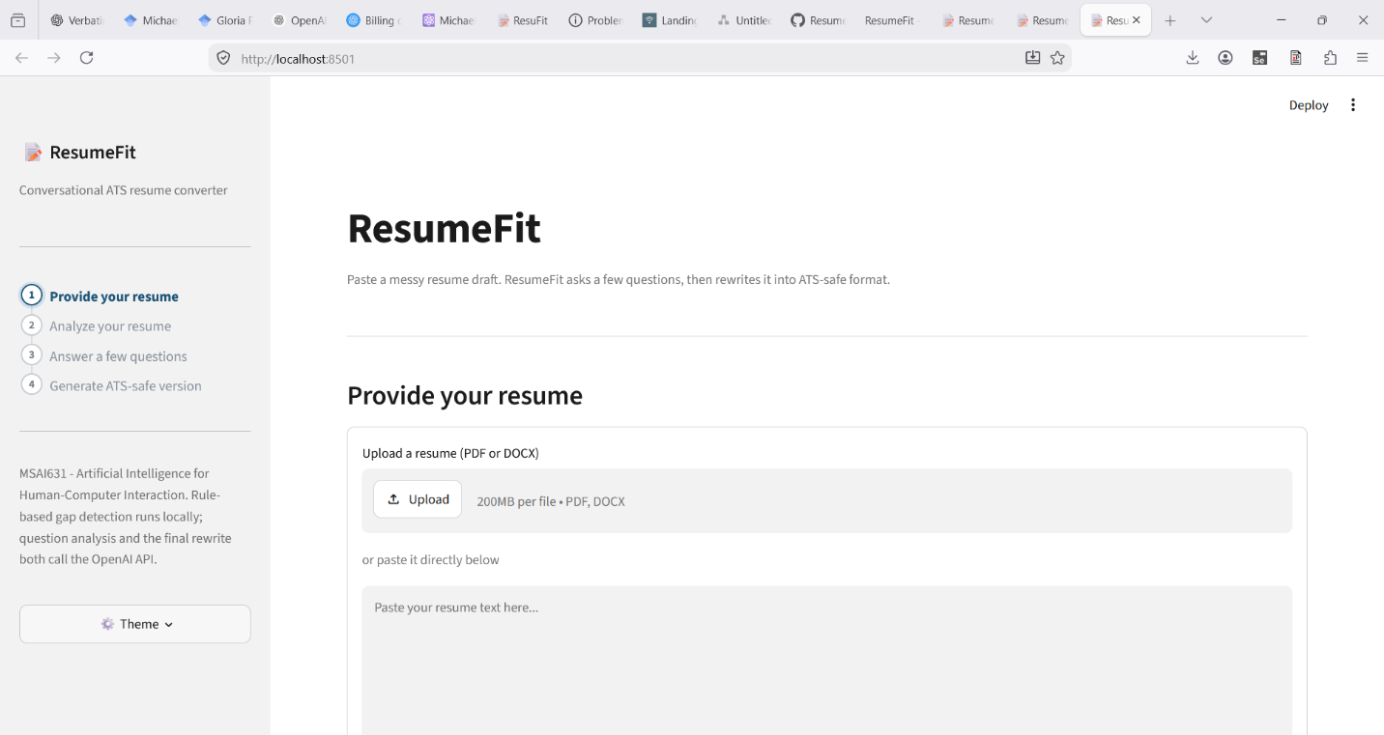
Figure 9: A DOCX upload, extracted into the editable draft text area
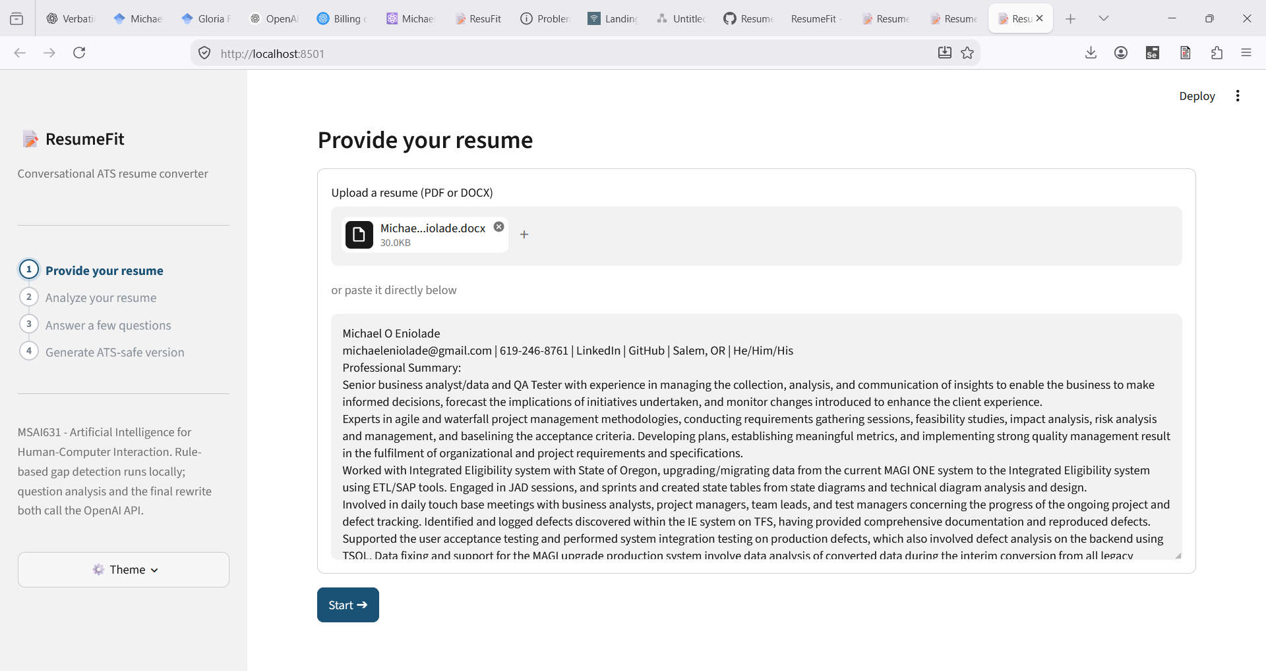
Figures 10 and 11 cover the quiz. Figure 10, question 2 of 4, shows the transcript for a question already answered next to its inline edit button, the pencil icon from Section 3.5, the current question below it, and the Back and Skip buttons under the chat input. Figure 11 shows the quiz complete, including two questions the user chose to skip, each rendered as “(skipped)” in the transcript rather than a fabricated answer, next to the “All questions answered” confirmation and the Generate button.
Figure 10: Mid-quiz, with the inline edit button on an already-answered question
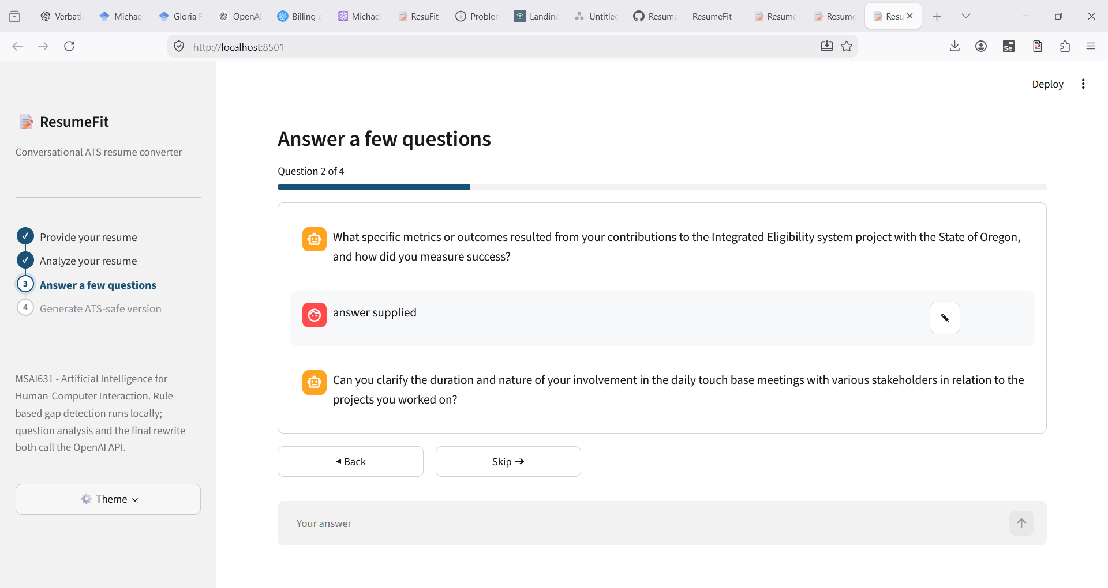
Figure 11: Quiz complete, with two skipped questions shown honestly rather than guessed
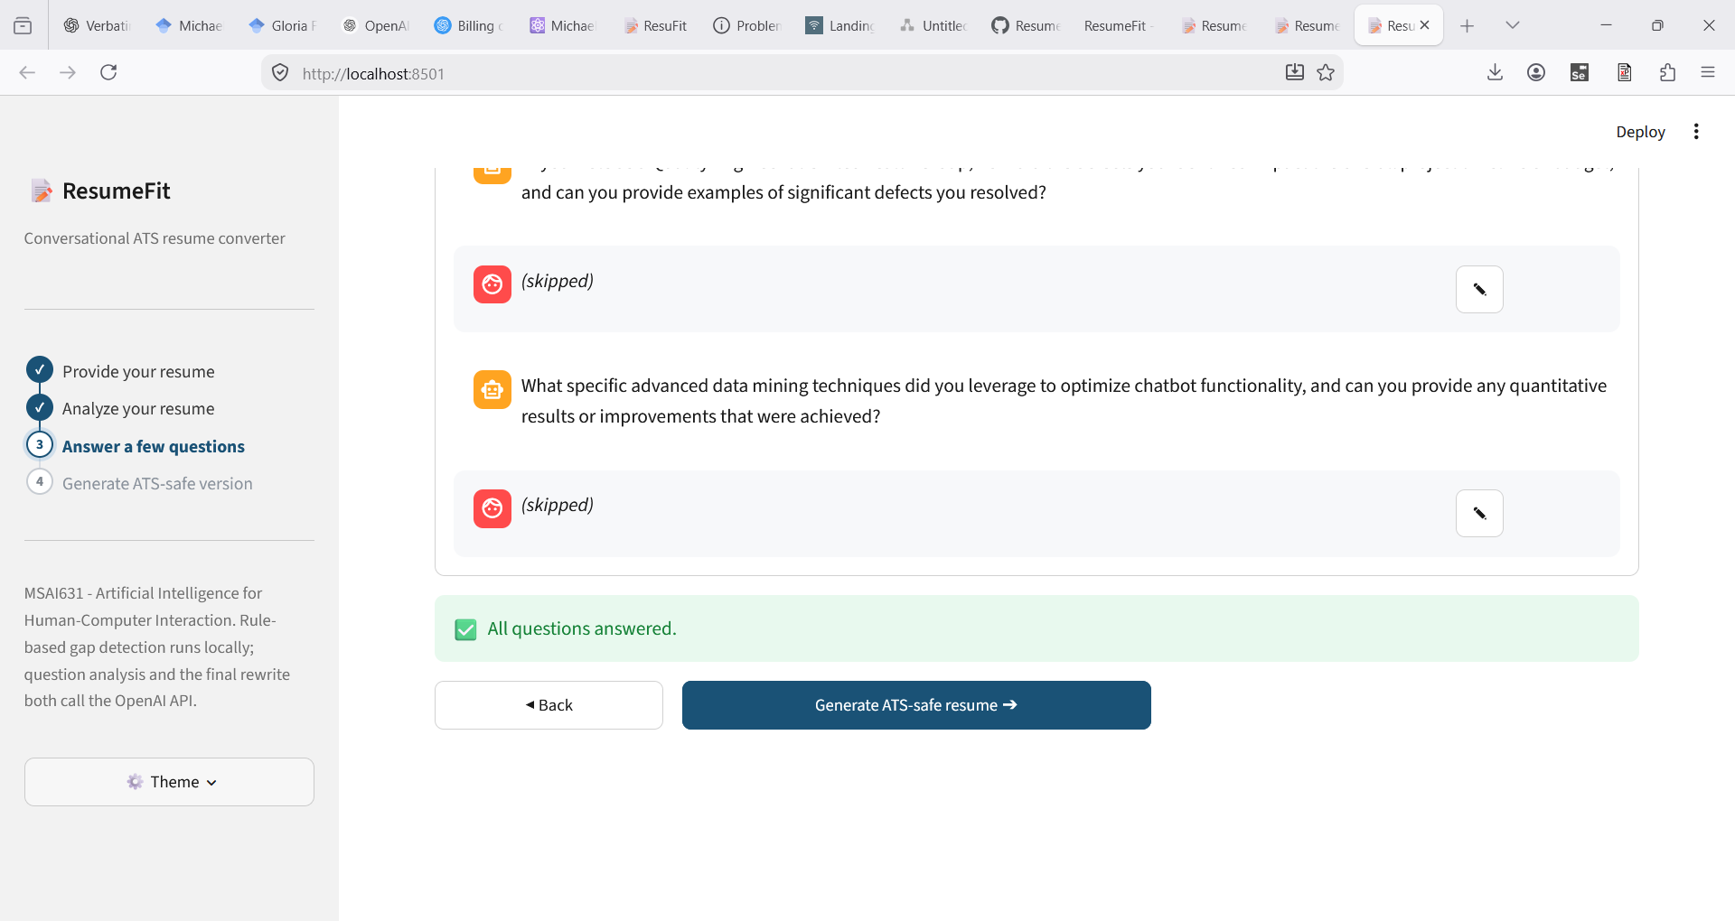
Figures 12 and 13 cover the result. Figure 12 shows the diff-highlighted before/after view from Section 3.6 mid-scroll, the removed/added legend above both panels and the strikethrough and highlight spans visible on real rewritten content: contact details and a job title stripped out on the left, quantified phrasing added on the right. Figure 13 shows the bottom of that same screen, the rest of the diff followed by the “Export your resume” card from Section 3.4, the PDF button marked “(recommended),” and each format's one-line caption underneath it.
Figure 12: Diff-highlighted before/after view, with the removed/added legend
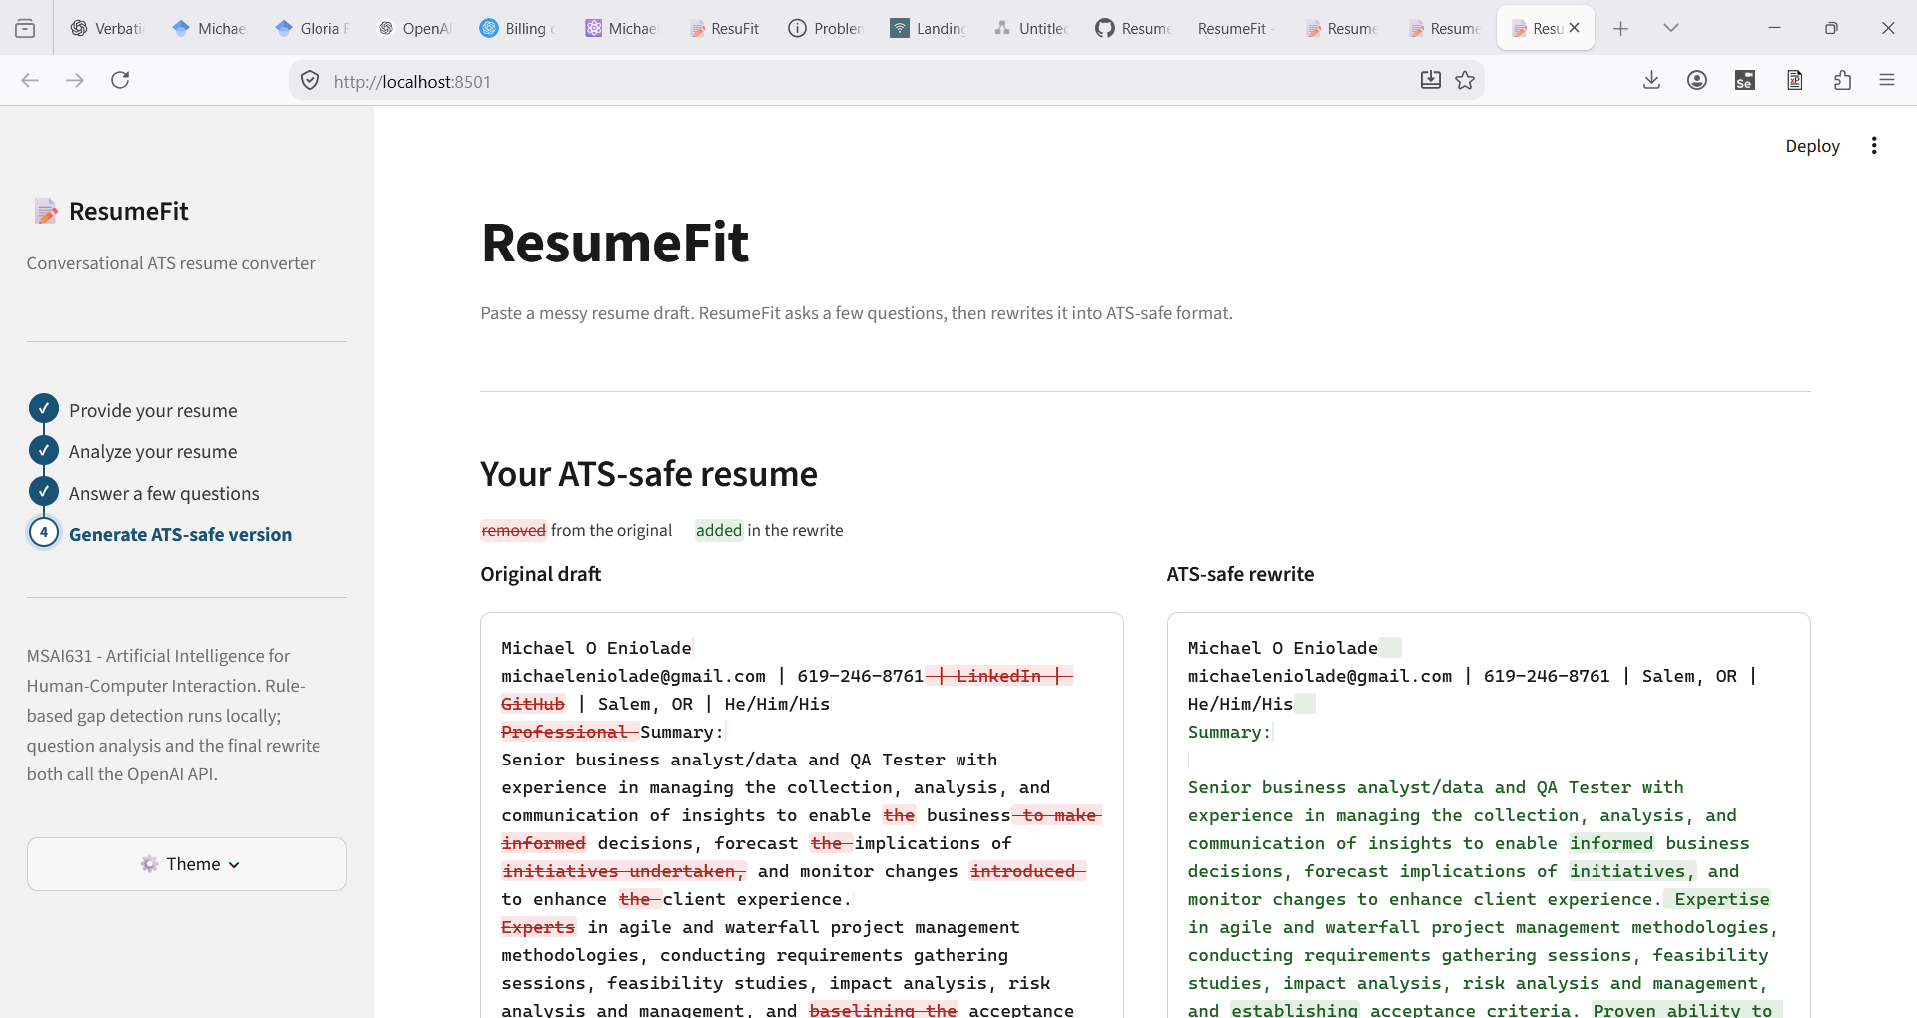
Figure 13: The export card, PDF marked as the recommended format
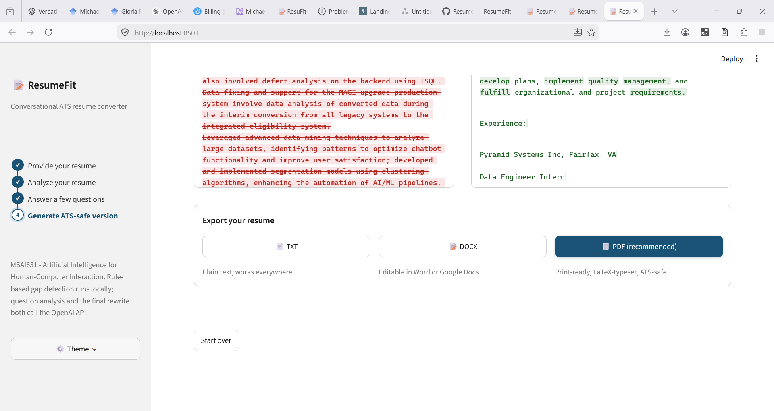

9. Conclusion
ResumeFit demonstrates the specific integration the course assignment asks for: a rule-based chatbot layer that runs entirely locally, coupled to an AI-as-a-service layer that makes two distinct, purpose-built calls to an external API. The two-layer split is not just structurally present but functionally load-bearing, since the rule-based layer catches known patterns the AI layer would be redundant at checking, while the AI layer catches resume-specific issues no fixed rule set could anticipate. The reliability work in Section 4 and the accessibility overlap in Section 5 were both treated as first-class design constraints, not late additions, because a live, in-person demo has zero tolerance for a bare stack trace or an inaccessible interface. What remains before the Sunday presentation is testing under real conditions rather than new functionality: a live browser walkthrough, timing validation, and the recorded fallback video.

