Pazzak

Michael Essmyer

Developer

Revision History
Last User to make Changes | Date | Summary of Changes

Table of Contents
Vision Statement 4
Sprint #4 7
Design 9
Coding Standards 10

Vision Statement
Anyone who has played Knights of The Old Republic knows the card game Pazzak. Commonly played in a cantinas and spaceships, this app brings the thrill of the game anywhere in the galaxy. Rodian, Jawa or even Wookies, all alien species with an Android phone can play!

Actor | Goal
User | Load the game
 | Play Pazak against an opponent
 | Add computer players to the table
 | Be able to play hand
 | Be able to bet on each game

Story ID | Story | Story Points | Priority | Status
S1 | Allow user to start a game at a seat and be  Dealt variables to act as cards | 10 | 1 | Done
S2 | Develop dealer logic and make cards | 8 | 2 | Done
S3 | Refactor program to isolate classes | 7 | 3 | Done
S4 | Develop user layer | 5 | 4 | Done
S5 | Allow user to bet credits and save their credits after app is closed. | 6 | 5 | Done
S6 | Add excpetion handling to betting and buttons | 4 | 4 | Done

The program shall allow the player to receive four random tokens.
The program shall allow the player to select tokens, end turn or stand to end the round.
The program shall allow player to place their bets.
The program shall randomly control a bot to act like an unskilled player.
The program shall always save the players credits when they exit the game.
The program shall display images for the player’s tokens and hide the opponent’s tokens.
The program shall clear tokens that have been played.
The program shall be able to handle errors with betting and button activity

Sprint #6
Before you can plan a sprint you need a prioritized list of user stories (the product backlog). Factors to consider when prioritizing stories include [Cohn, Agile Estimating and Planning]:
- Business value of feature
- Cost of implementation (story points or ideal days)
- Amount and value of new knowledge gained by developing the feature
- Risks resolved as a consequence of implementing the feature

Another important step in sprint planning is estimating project velocity. Project velocity is a measure of how much work is being completed each iteration (sprint). It is usually expressed using the same unit of measure used to estimate story effort (typically story points). For the first iteration, project velocity must be estimated based on past projects. After the first iteration, project velocity can be predicted based on the completed iterations.

The Sprint Backlog identifies stories planned for the sprint along with tasks necessary to complete each story.

Sprint Backlog
Story ID | Story / Task | Estimated  Hours | Actual  Hours
S1 | Allow player to see their score and wins | 2 | 4
 | Allow player to end turn or stand to terminate round | 2 | 2
S2 | Create clicks for the player to play its tokens | 2 | 8
 | Create a function to run images as tokens change | 3 | 12
 | Create an initial screen to explain the rules | 2 | 2
S3 | Refactor everything into appropriate classes | 5 | 15
S4 | Update background | 2 | 2
 | Create initial environment to bet | 10 | 12
S5 | Allow user to bet | 8 | 13
S6 | Exceptions for betting and buttons | 4 | 4

I had problems with changing the images once the values were in separate classes. The image display function worked if the values were all in the main but once I refactored everything into the appropriate classes connecting the values to the proper images was difficult. I also had challenges saving the state of credits to allow for proper betting in conjunction with various activity spaces since to bet was on a different screen.

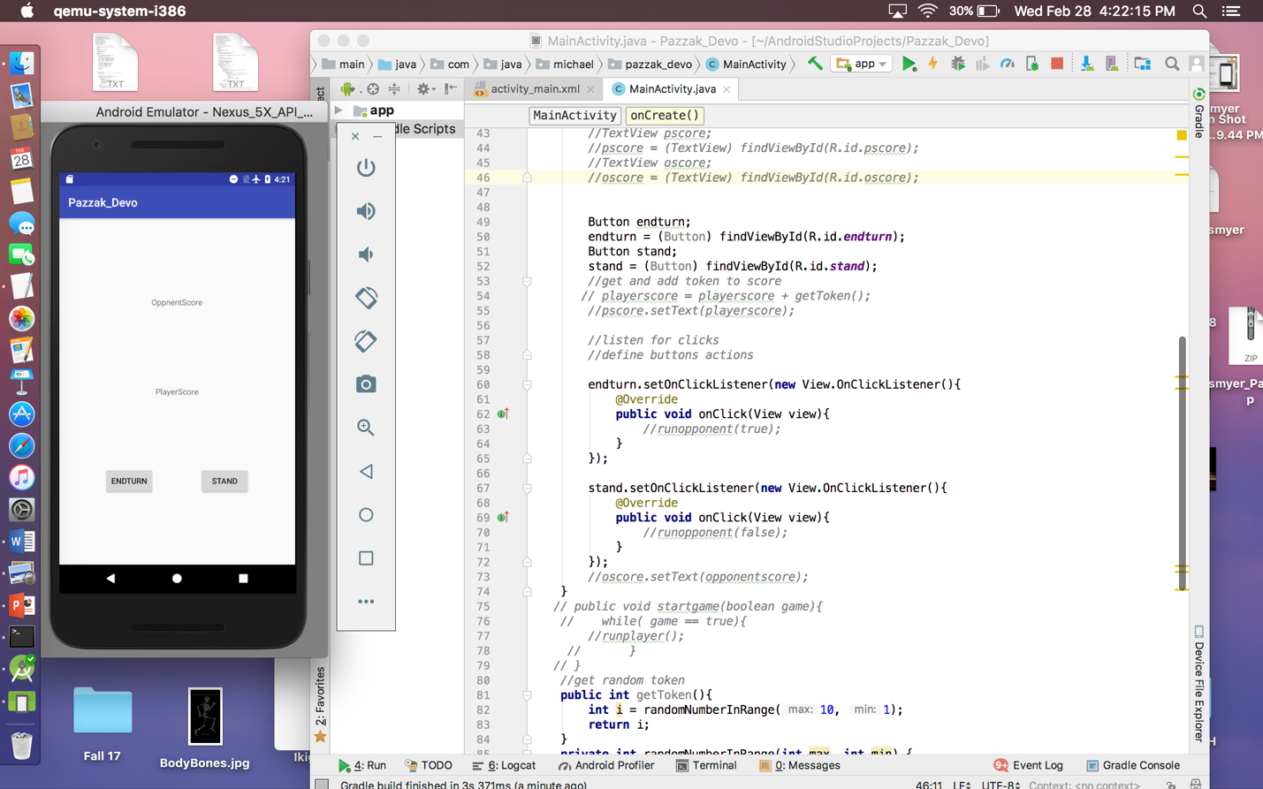
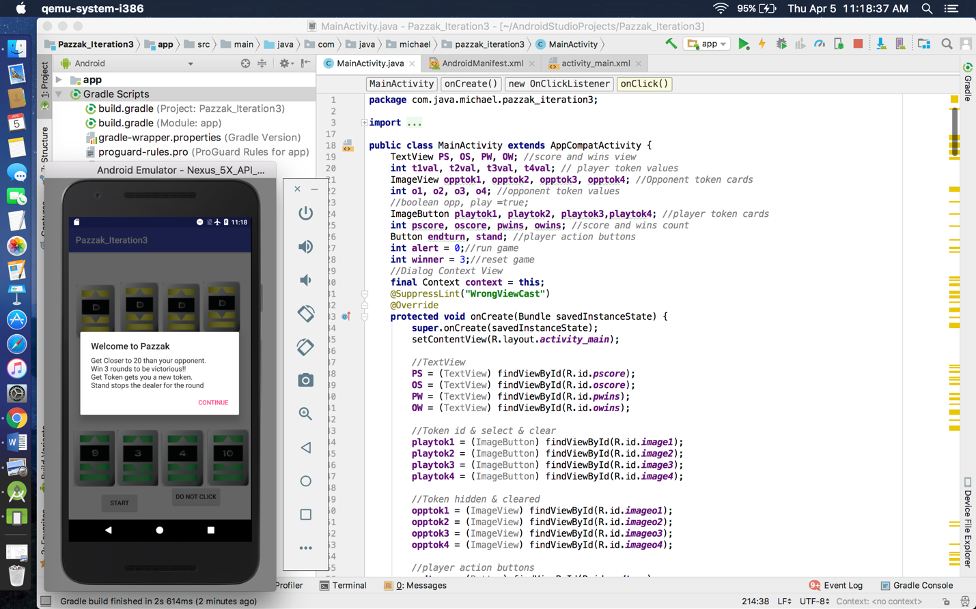
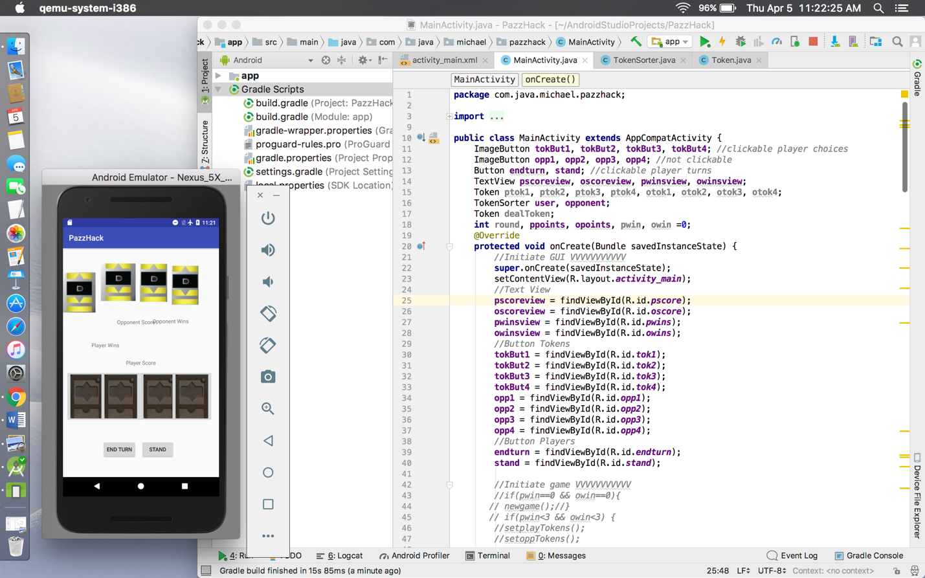

Design
My application should be a simple design. The screen shall have an initial screen to bet credits. The end and stand buttons will be there for the player to control its turns. The player will also have tokens on the table displayed to them that they can select to play during any round of the game. The tokens will be randomly assigned to both the player and its opponent. The graphics of the tokens are directly from the game, so they look realistic. They can make poor or good decisions without cost. When the user is done playing they may save the credits they have acquired for the next time they open the app, or they can clear their bank so that they start fresh when they re-open the application.

Coding Standards
Coding standards improve readability. They make it easier to understand code written by others. Good coding standards also improve reliability.

