Michael Evanchik

Setup

Not much, I do not have to send you the database, as long as you have Visual Studio 2015 and Microsoft SQL Server mssqllocaldb , the first CreatePhoto creates the database for you, I will send you an export of the database anyway, but you will have to change the connection string in the database.

What I am using is much simpler ORM Entity Code First Framework (EntityFramework) here is the proof

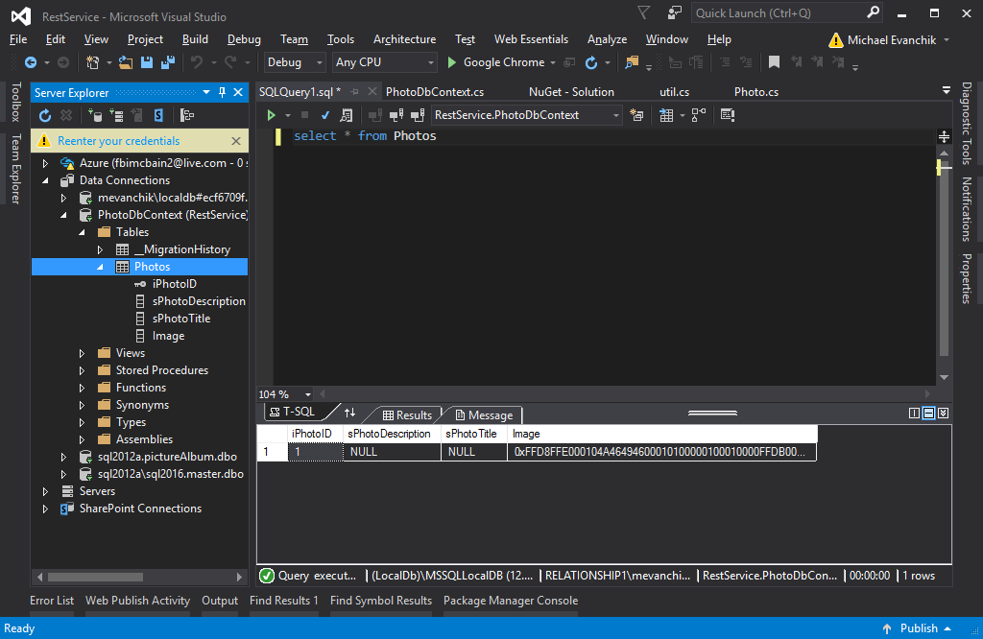

If you want to know if you can use this try connecting to this with SQL Management Studio “(LocalDb)\MSSQLLocalDB”

I know you asked for no interface, but in order to create the database you need to create a record. Create.html (which seems to only work in IE 11) due to security issues(you will have to allow the javascript security message) calls the api/CreatePhoto/ (the slash at the end was important.