**Data Modeling**

**Part 1: Conceptual Planning**

**Step1**

**Brainstorming**

* Users
* Passwords
* Recipes
* Occasions
* Ingredients
* Photos
* Grocery Lists
* Security

**Step2**

* User - profile of user – each row is a different user, store email
  + User ID (integer)
  + Name (text)
  + Email (text)
  + Password (text)
* Recipe – recipe profile – store ingredients
  + Recipe Name (text)
  + Recipe ID (integer)
  + Instructions (text)
  + Private/Public (private/public)
  + User (ref User ID)
* Recipe Ingredients
  + Recipe Ingredients ID
* Ingredient
  + Ingredient Name
  + Ingredient ID
* Grocery List – hold ingredients needed for recipe
  + Grocery List Name
  + Grocery List ID
* Occasions – assign recipes to specific occasions
  + Occasion Name
  + Occasions ID
* Recipe Photo – photo of completed recipe, no other photos needed
  + Recipe Photo Name
  + Recipe Photo ID

**Step 3 – Relationships**

* User - profile of user – each row is a different user, store email
  + **One to Many**
  + User ID (integer)
  + Name (text)
  + Email (text)
  + Password (text)
* Recipe – recipe profile – store ingredients
  + **Many to Many**
  + Recipe Name (text)
  + Recipe ID (integer)
  + Recipe Ingredients (ref recipe ingredients ID)
  + Instructions (text)
  + Private/Public (private/public)
  + Recipe Photo (ref to recipe photo ID)
  + User (ref User ID)
  + Grocery List (ref grocery list ID)
* Recipe Ingredients
  + **Many to Many (Ingredients ~> Recipe)**
  + Recipe Ingredient ID
  + Ingredient (ref to ingredient ID)
  + (ref) Recipe ID
* Ingredient
  + **One to Many**
  + Ingredient Name
  + Ingredient ID
* Grocery List – hold ingredients needed for recipe
  + **Many to Many**
  + Grocery List Name
  + Grocery List ID
  + User (ref User ID)
  + Ingredient (ref to ingredient ID)
* Occasions – assign recipes to specific occasions
  + **Many to Many**
  + Occasion Name
  + Occasions ID
  + User (ref User ID)
  + Recipe (ref to recipe ID)
* Recipe Photo – photo of completed recipe, no other photos needed
  + **One to One**
  + Recipe Photo Name
  + Recipe Photo ID
  + User (ref User ID)

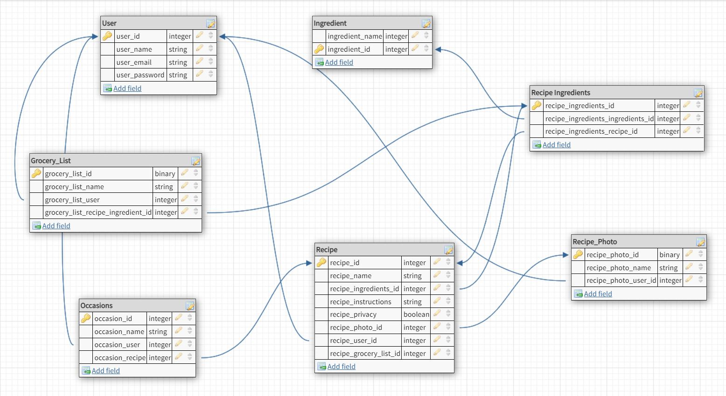

**MAKE TABLES**

CREATE TABLE users (

user_id SERIAL PRIMARY KEY,

user_name VARCHAR(30),

user_email VARCHAR(60),

user_password VARCHAR(60)

);

CREATE TABLE users (

user_id SERIAL PRIMARY KEY,

user_name VARCHAR(30),

user_email VARCHAR(60),

user_password VARCHAR(60)

);

CREATE TABLE ingredient (

ingredient_id SERIAL PRIMARY KEY,

ingredient_name VARCHAR(60)

);

CREATE TABLE recipe_ingredients (

recipe_ingredients_id SERIAL PRIMARY KEY

);

CREATE TABLE grocery_list (

grocery_list_id SERIAL PRIMARY KEY,

grocery_list_name VARCHAR(60)

);

CREATE TABLE occasions (

occasions_id SERIAL PRIMARY KEY,

occasions_name VARCHAR(60)

);

CREATE TABLE recipe_photo (

recipe_photo_id SERIAL PRIMARY KEY,

recipe_photo_name VARCHAR(60)

);

**Intermediate**

INSERT INTO users (user_name, user_email, user_password)

VALUES ('Mike', 'mfender000@hotmail.com', 'BOOYA'),

('Kay', 'suggamomma@hottie.com', 'SuckATash')

;

INSERT INTO recipe (recipe_privacy, recipe_name, recipe_instructions)

VALUES (TRUE, 'Cereal', 'Add cereal and milk to bowl'),

(FALSE, 'Poptart', 'Put poptart in toaster')

;

INSERT INTO occasions (occasions_name)

VALUES ('MudFest Bake Sale'),

('Garage Sale')

;