**Bird vs Meteor**



Disusun Oleh :

Michael Filbert Tanadi

A11.2019.11715

Daftar Isi

BAB I 2

TENTANG GAME 2

1.1 Deskripsi 2

BAB II 3

DETAIL PENGEMBANGAN APLIKASI 3

2.1 Flow Chart 3

2.2 Class Diagram 4

2.3 Screenshot Lengkap 4

BAB III SUMBER 8

3.1 Referensi 8

# BAB I

# TENTANG GAME

## Deskripsi

Game ini saya buat dengan konsep menghindari obstacle dan mendapatkan score sebanyak mungkin. Fitur-fitur yang ada di game ini seperti :

1. Pemilihan Karakter
2. Music On atau Off
3. Pause
4. Mengecil besarkan suara
5. Highscore
6. Gameplay main

Dibawah ini screenshot awal mulai memainkan game ini

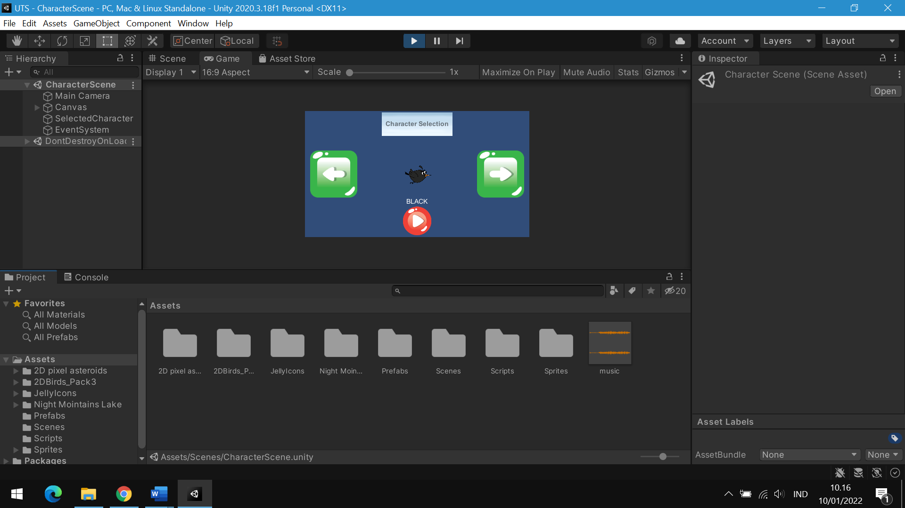

# BAB II

# DETAIL PENGEMBANGAN APLIKASI

## 2.1 Flow Chart

Character Selection

Input karakter yang dipilih

Start

If die

Restart

Volume Slider

Music On/Off

Pause

In Game

Start

Game Scene

## 2.2 Class Diagram

|  |
| --- |
| Camera |
| camSpeed : Float |

|  |
| --- |
| Player |
| - playerSpeed : float + rb : Rigidbody2D  + playerDirection : Vector2  - characterDB : CharacterDatabase  - artworkSprite : SpriteRenderer |
| + UpdateCharacter() + Load()  - FixedUpdate() |

|  |
| --- |
| CharacterManager |
| - characterDB : CharacterDatabase - nameText : Text  - artworkSprite : SpriteRenderer  + selectedOption : int |
| - NextOption() - BackOption()  + UpdateCharacter(int)  + Load()  + Save()  - ChangeScene(int) |

|  |
| --- |
| Obstacle |
| + player : GameObject |
| + OnTriggerEnter2D (Collider 2D) |

|  |
| --- |
| SpawnObstacle |
| - obstacle : GameObject - maxX : float  - minX : float  - maxY : float  - minY : float  - timeBetweenSpwan : float  - spwanTime : float |
| - Spwan() |

|  |
| --- |
| PauseMenu |
| - pauseMenu : GameObject |
| - Pause() - Resume()  - Home(int) |

|  |
| --- |
| GameOver |
| - gameOverPanel : GameObject - text : Text |
| - Restart() |

## 2.3 Screenshot Lengkap

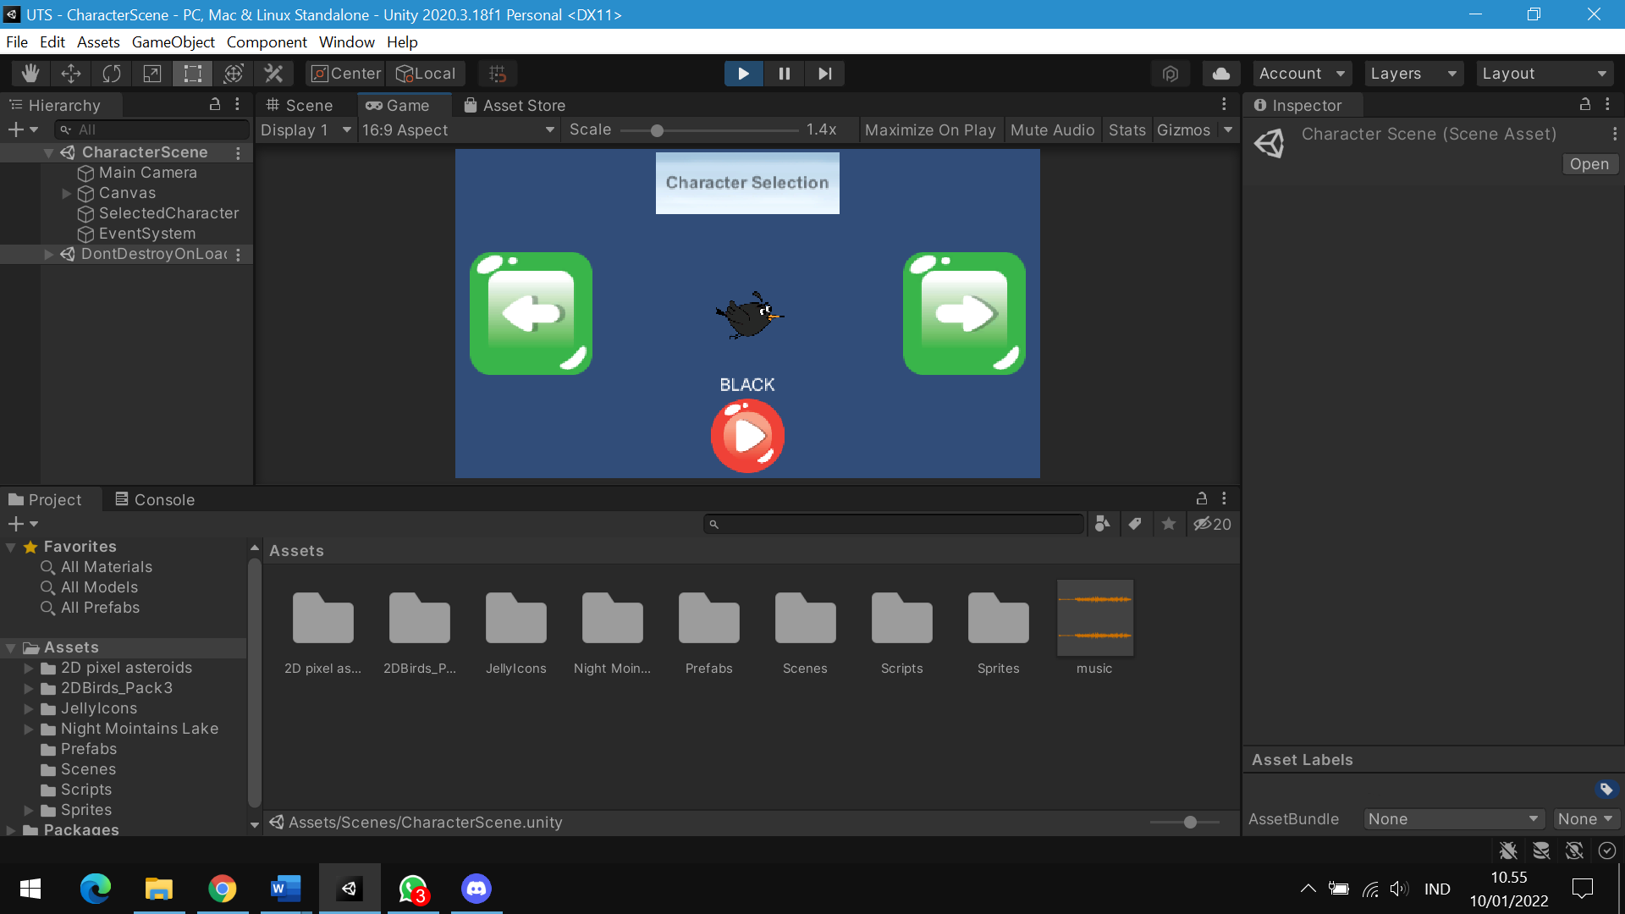

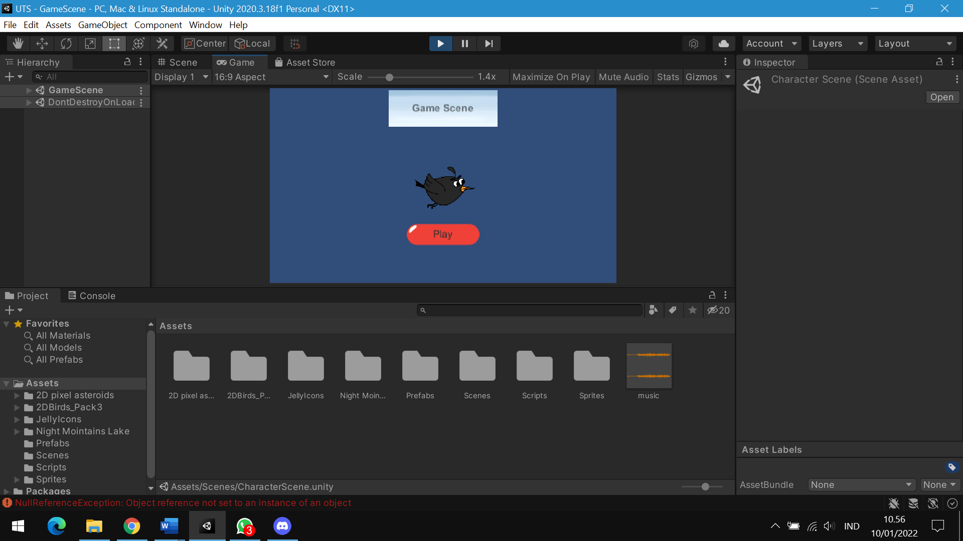

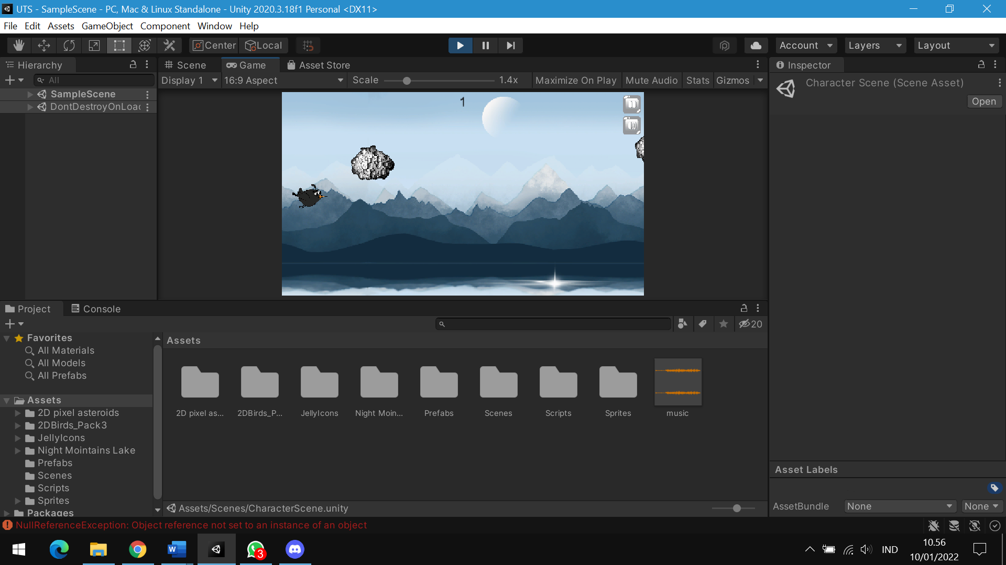

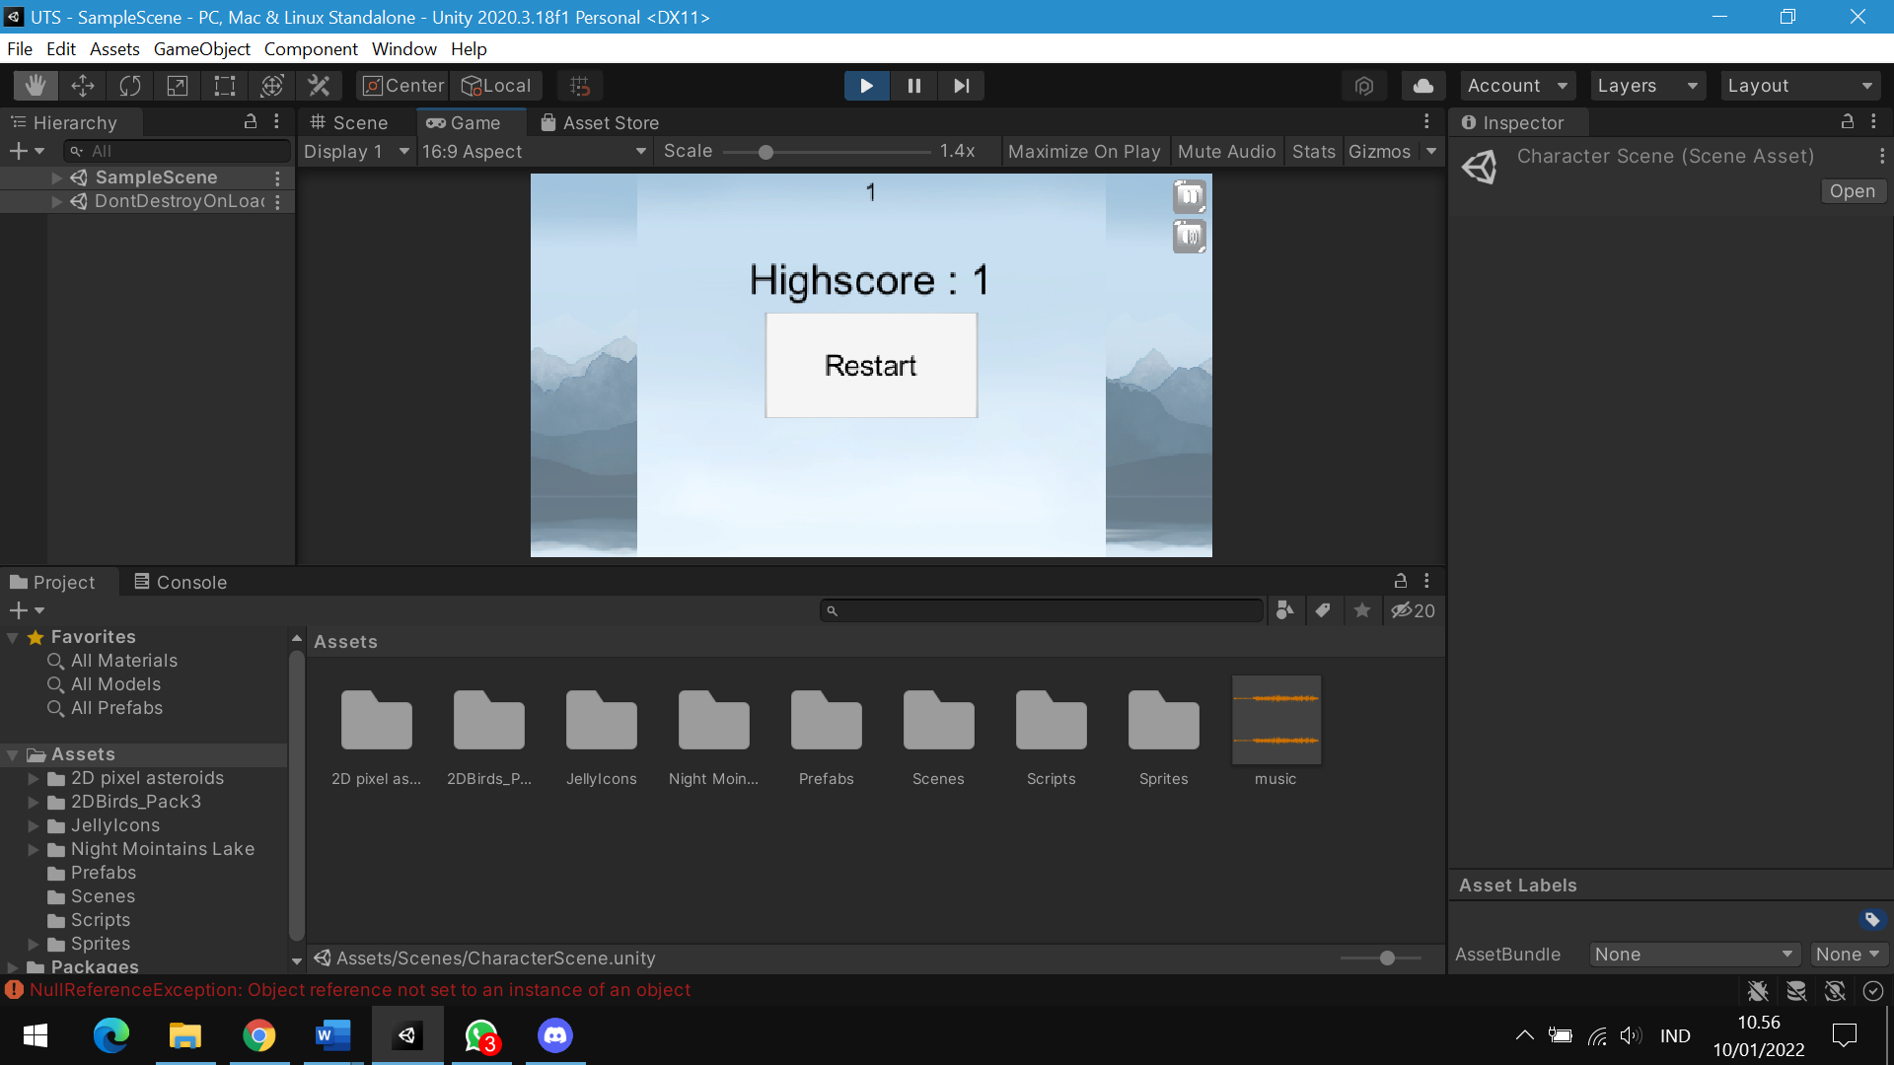

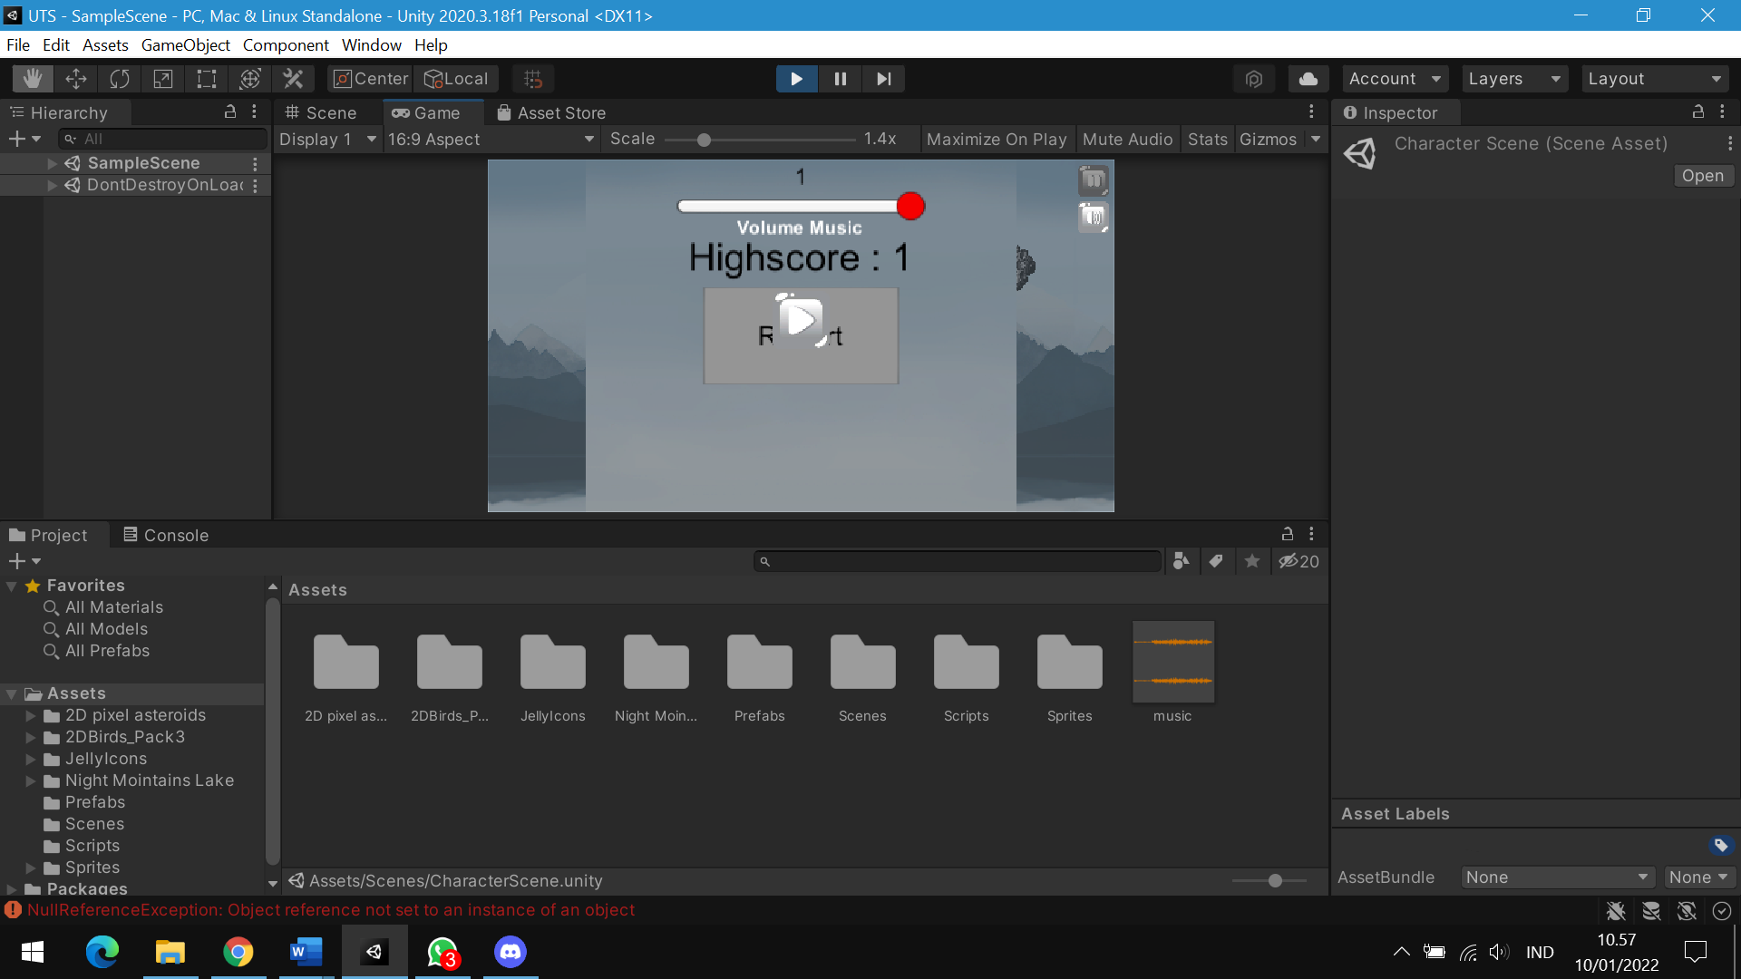

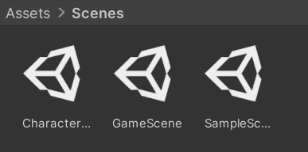

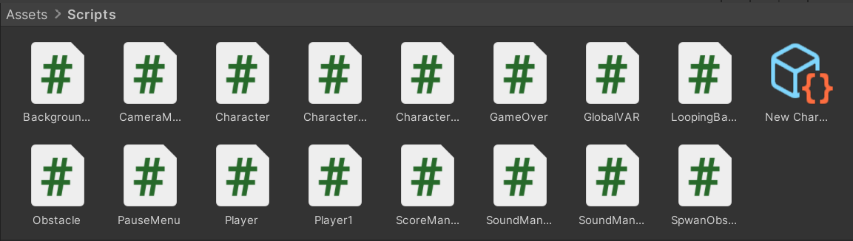

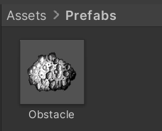

# BAB III SUMBER

## 3.1 Referensi

Gameplay :

1. <https://www.youtube.com/watch?v=U3sT-T5bKX4&ab_channel=Hooson>
2. <https://www.youtube.com/watch?v=tfzwyNS1LUY&t=87s&ab_channel=Hooson>
3. <https://www.youtube.com/watch?v=AFcHsKd_aMo>
4. <https://www.youtube.com/watch?v=yWCHaTwVblk&ab_channel=Hooson>
5. <https://www.youtube.com/watch?v=2PKBChN10us&t=601s&ab_channel=Hooson>

Skin :

Untuk skin saya mencari dari Web Unity

<https://assetstore.unity.com/>