MMPH6117 Final Examination

Question 1

Name: Mingze Gao

UID: 3035426241

Read data sets.

library(readr)  
exam1 <- read_csv("../Final/exam_question1.csv")

##   
## -- Column specification --------------------------------------------------------  
## cols(  
## study = col_character(),  
## country = col_character(),  
## sample_size = col_double(),  
## cfr = col_double(),  
## cfr.lb = col_double(),  
## cfr.ub = col_double()  
## )

exam2 <- read_csv("../Final/exam_question2.csv")

##   
## -- Column specification --------------------------------------------------------  
## cols(  
## id = col_double(),  
## male = col_double(),  
## age = col_double(),  
## phy.index = col_double(),  
## bmi = col_double(),  
## low.income = col_double(),  
## low.calc = col_double(),  
## poor.bone = col_double()  
## )

exam3 <- read_csv("../Final/exam_question3.csv")

##   
## -- Column specification --------------------------------------------------------  
## cols(  
## id = col_double(),  
## age = col_double(),  
## comorbid = col_double(),  
## death = col_double()  
## )

1. A

exam1$logcfr <- log(exam1$cfr)  
exam1$se.logcfr <- (log(exam1$cfr.ub) - log(exam1$cfr.lb + 1e-6)) / (2 * 1.96)  
  
library(metafor)

## Loading required package: Matrix

## Loading 'metafor' package (version 2.4-0). For an overview   
## and introduction to the package please type: help(metafor).

exam1.fe <- rma(yi = logcfr, sei = se.logcfr, slab = study, method = "FE", data = exam1)  
exam1.fe

##   
## Fixed-Effects Model (k = 20)  
##   
## I^2 (total heterogeneity / total variability): 96.81%  
## H^2 (total variability / sampling variability): 31.37  
##   
## Test for Heterogeneity:  
## Q(df = 19) = 595.9848, p-val < .0001  
##   
## Model Results:  
##   
## estimate se zval pval ci.lb ci.ub   
## 4.3399 0.0109 399.3042 <.0001 4.3186 4.3612 ***   
##   
## ---  
## Signif. codes: 0 '***' 0.001 '**' 0.01 '*' 0.05 '.' 0.1 ' ' 1

with(exam1.fe, exp(c(b, ci.lb, ci.ub)))

## [1] 76.70029 75.08369 78.35170

The overall estimate is 76.70 (95% CI = 75.08 - 78.35)

1. B

Q <- exam1.fe$QE  
I2 <- (Q - (exam1.fe$k - 1)) / Q * 100  
  
I2

## [1] 96.812

There is evidence of significant heterogeneity since the Higgins’ I^2 is substantial high.

1. C

exam1.re <- rma(yi = logcfr, sei = se.logcfr, slab = study, method = "REML", data = exam1)  
exam1.re

##   
## Random-Effects Model (k = 20; tau^2 estimator: REML)  
##   
## tau^2 (estimated amount of total heterogeneity): 0.1291 (SE = 0.0530)  
## tau (square root of estimated tau^2 value): 0.3593  
## I^2 (total heterogeneity / total variability): 95.33%  
## H^2 (total variability / sampling variability): 21.39  
##   
## Test for Heterogeneity:  
## Q(df = 19) = 595.9848, p-val < .0001  
##   
## Model Results:  
##   
## estimate se zval pval ci.lb ci.ub   
## 3.9718 0.0927 42.8627 <.0001 3.7902 4.1535 ***   
##   
## ---  
## Signif. codes: 0 '***' 0.001 '**' 0.01 '*' 0.05 '.' 0.1 ' ' 1

with(exam1.re, exp(c(b, ci.lb, ci.ub)))

## [1] 53.08231 44.26635 63.65403

The overall estimate is 53.08 (95% CI = 44.27 - 63.65)

1. D

forest(exam1.re, atransf = exp, refline = 0, at = log(c(0.1,10,1000,10000,100000)), showweights = T)

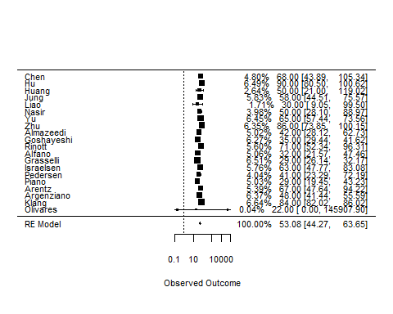

1. E

funnel(exam1.re, atransf=exp)

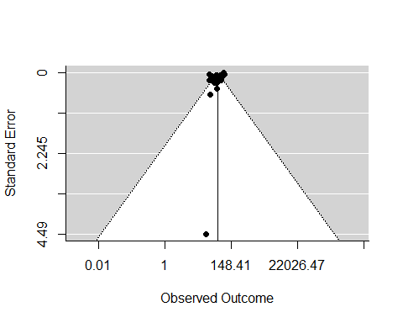

regtest(exam1.re)

##   
## Regression Test for Funnel Plot Asymmetry  
##   
## model: mixed-effects meta-regression model  
## predictor: standard error  
##   
## test for funnel plot asymmetry: z = -1.2252, p = 0.2205

The funnel plot shows no significant asymmetry and Egger’s test null hypothesis is rejected since p > 0.01. So no strong evidence of publication bias.

1. F

exam1$mark <- 0  
exam1$mark[c(1,2,3,5,7,8,12,13,16,17,18,19)] <- 1  
  
exam1.center <- exam1[exam1$mark==1,]  
exam1.re.center <- rma(yi=logcfr, sei=se.logcfr, slab=study, method="REML", data=exam1.center)  
with(exam1.re.center, exp(c(b, ci.lb, ci.ub)))

## [1] 54.31167 41.80234 70.56440

exam1.non <- exam1[exam1$mark==0,]  
exam1.re.non <- rma(yi=logcfr, sei=se.logcfr, slab=study, method="REML", data=exam1.non)  
with(exam1.re.non, exp(c(b, ci.lb, ci.ub)))

## [1] 50.36814 40.32929 62.90589

Based on the model applied to seperate regions, the hypothesis is correct as CFR from epicenters can be higher than non-epicenters with overall estimate 54.31 (95% CI: 41.80 - 70.56) compared with 50.37 (95% CI: 40.33 - 62.91)

1. G
2. The CFR of Covid-19 patients requiring IMV globally is quite high, after adjusting the heterogeneity of differenct studies, the overall CFR is 53.08.
3. The CFR differs quite obvious between epicenters and non-epicenters, suggesting the overwhelmed healthcare system would deteriorate the situation.
4. Although no stong publication bias was reported by funnel plot and following assessments, but some datasets contains small smple size which poses question on the validity of the resutllt.
5. The Olivares data has 0 on lower bound of CI which cannot perform log function, thus might not be credible and a 1e-6 is added to avoid that. Similarly, forest plot also assigned minimal weight on this data.