|  |  |  |  |  |  |  |  |
| --- | --- | --- | --- | --- | --- | --- | --- |
| **Name** | **Resources** | **Guidance** | **Network** | **Dependence upon stakeholders** | **Their power** | **Your power** | **Total Power of Stakeholder** |
| Client | 8 | 9 | 9 | 26 | 60 | 80 | 20 |
| Sponsor | 10 | 6 | 8 | 24 | 80 | 50 | -30 |
| Advice Faculty Member | 9 | 10 | 8 | 27 | 60 | 50 | -10 |
| Industrial Review Board Members | 5 | 3 | 8 | 6 | 60 | 40 | -20 |
| Team Members | 9 | 9 | 9 | 27 | 70 | 80 | 10 |
| Hotel Manager Testers | 2 | 6 | 6 | 14 | 50 | 10 | -40 |
| Bank Testers | 2 | 6 | 6 | 14 | 50 | 10 | -40 |
| Faculty Audience | 0 | 2 | 2 | 4 | 0 | 100 | 100 |

|  |  |
| --- | --- |
| **Accommodate**  Sponsor (24,-30)  Advice Faculty Member (27,-10) | **Work with**  Client (26,20)  Team Members (27,10) |
| **Work around**  Industrial Review Board Members (6,-20)  Hotel Manager Testers (14,-40)  Bank Testers (14,-40) | **Ignore**  Faculty Audence (4,100) |

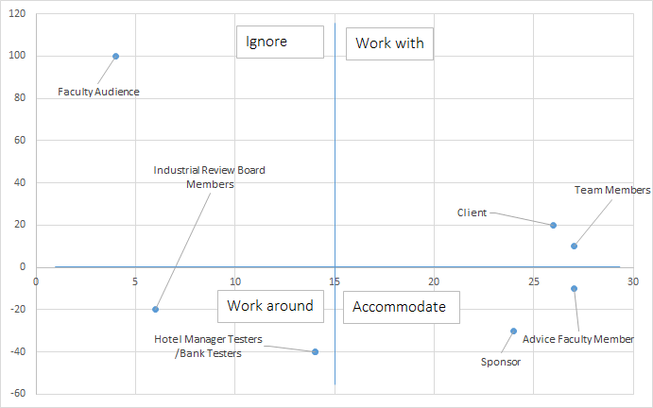

|  |  |  |  |  |  |  |  |  |
| --- | --- | --- | --- | --- | --- | --- | --- | --- |
| **Name** | **Interest** | **Agreement** | **Support** | **Overall Support** | **Integrity** | **Trust** | **Influence** | **Relationship quality (sum)** |
| Client | 10 | 10 | 10 | 30 | 75 | 90 | 90 | 255 |
| Sponsor | 5 | 7 | 10 | 22 | 75 | 100 | 100 | 275 |
| Advice Faculty Member | 5 | 4 | 7 | 16 | 80 | 100 | 90 | 270 |
| Industrial Review Board Members | 6 | 6 | 3 | 15 | 50 | 40 | 10 | 100 |
| Team Members | 10 | 10 | 10 | 30 | 80 | 90 | 100 | 270 |
| Hotel Manager Testers | 6 | 9 | 6 | 21 | 70 | 50 | 10 | 130 |
| Bank Testers | 6 | 9 | 6 | 21 | 70 | 50 | 10 | 130 |
| Faculty Audience | 3 | 3 | 3 | 9 | 40 | 50 | 40 | 130 |

|  |  |
| --- | --- |
| **Yes Men**  Hotel Manager Testers (21,130)  Bank Testers (21,130) | **Allies**  Client (30,255)  Sponsor (22,275)  Advice Faculty Member (16,270)  Team Members (30,270) |
| **Fence Sitters**  Industrial Review Board Members (15,100) |
| **Challengers** |
| **Adversaries**  Faculty Audience (9,130) |

|  |  |  |  |  |  |  |
| --- | --- | --- | --- | --- | --- | --- |
| **Name** | **Functions** | **Interests** | **Email/Phone** | **Ally?** | **Comm Freq** | **Last Comm** |
| Client | Feedback | Progress | Phone | Yes | Weekly |  |
| Sponsor | Funding | Progress | Phone | Yes | Monthly |  |
| Advice Faculty Member | Progress | Accomplishments | Email | Yes | Weekly |  |
| Industrial Review Board Members | Functionality | Security | Email | No | Once |  |
| Team Members | Implementation | Progress | Email | Yes | Daily |  |
| Hotel Manager Testers | User Experience, Functionality | Progress | Phone | Yes | Monthly |  |
| Bank Testers | Security | Progress | Phone | Yes | Monthly |  |
| Faculty Audience | None | Accomplishments | Email | No | Once |  |