

IT342-Section
SYSTEMS INTEGRATION AND ARCHITECTURE 1

FUNCTIONAL REQUIREMENTS SPECIFICATION (FRS)

Project Title: Symbi
Prepared By: Michael Grant Libato
Date of Submission: February 3, 2026
Version: 1

Table of Contents
1. Introduction 2
1.1. Purpose 2
1.2. Scope 2
1.3. Definitions, Acronyms, and Abbreviations 2
2. Overall Description 3
2.1. System Perspective 3
2.2. User Classes and Characteristics 3
2.3. Operating Environment 3
2.4. Assumptions and Dependencies 3
3. System Features and Functional Requirements 3
3.1. Feature 1: 3
3.2. Feature 2: 4
4. Non-Functional Requirements 4
5. System Models (Diagrams) 4
5.1. ERD 5
5.2. Use Case Diagram 5
5.3. Activity Diagram 7
5.4. Class Diagram 7
5.5. Sequence Diagram 8
6. Appendices 9

Introduction

Purpose
The purpose of this document is to define the software requirements for Symbi, a crossplatform system that bridges physical health with a virtual simulation. This document is intended for stakeholders, developers, UI/UX designers, and QA testers to guide the development of the gamified calorie tracking system across mobile and desktop environments.

Scope
Symbi acts as a multi-platform gamified health application that tracks a user's nutritional intake and translates that data into the status of a virtual digital pet. The system focuses on tracking calories and macronutrients to encourage portion control through positive reinforcement and behavioral modification mechanics. The boundaries of the system are limited to nutritional tracking and simulation, meaning it does not provide professional medical advice, diagnostic services, or detailed fitness coaching.

Definitions, Acronyms, and Abbreviations
A Symbiote is defined as the virtual digital pet that serves as the user's health companion and avatar throughout the application experience. TDEE, or Total Daily Energy Expenditure, refers to the estimated number of calories a user burns in a single day based on their activity level and physical statistics. Macros are the three major nutrient categories of carbohydrates, proteins, and fats that the system tracks to determine the quality of food intake.

Overall Description

System Perspective
Symbi operates as a unified cross-platform system accessible via both mobile devices and personal computers, utilizing cloud synchronization to ensure data consistency across all user login points. The system integrates with external food databases to retrieve accurate nutritional information and functions within the larger context of personal wellness management by allowing users to manage their health profile from their preferred device.

User Classes and Characteristics
The primary user class consists of individuals who struggle with dietary discipline and require external motivation or gamification to maintain healthy habits. A secondary user class includes gamers who are motivated by collection, evolution, and customization mechanics and view food logging as a means to progress in the game.

Operating Environment
The mobile version of the application operates on standard smartphones running Android 10 or higher and iOS 15 or higher to ensure compatibility with modern touch interfaces. The desktop version requires a personal computer running Windows 10, macOS 11, or a Linux distribution with access to a modern web browser such as Chrome, Firefox, or Edge. The system requires a stable internet connection on all devices to access cloud-based food databases and synchronize the user's progress and pet status between their phone and computer.

Assumptions and Dependencies
The system assumes that users will log their food intake truthfully and accurately to ensure the virtual pet's health reflects reality. The application depends on the availability and accuracy of third-party APIs for nutritional data and relies on the user's continued engagement with the visual assets of the pet for retention.

System Features and Functional Requirements
Describe each major feature of the system and its functional requirements.

Feature 1:
Description: This feature serves as the primary input mechanism where users search for, select, and record their daily food consumption via a mobile interface or a desktop dashboard.

Functional Requirements:
- The system shall allow users to search for specific food items using text input on the desktop or barcode scanning and text on mobile to retrieve nutritional data from the database.
- The system shall automatically calculate the total calories and macronutrients for a selected portion size and deduct this amount from the user's daily allowance.
- The system shall synchronize food logs in real-time between the mobile app and the PC dashboard to ensure the user's progress is up to date on all devices.

Feature 2:
Description: This feature is the core gamification engine that translates the user's nutritional data into the virtual pet's health, mood, and physical evolution.

Functional Requirements:
- The system shall increase the health points and happiness level of the Symbiote when the user remains within their daily calorie limit and meets nutritional goals.
- The system shall trigger visual changes or negative status effects on the pet if the user exceeds calorie limits significantly or fails to log food for more than twenty-four hours. - The system shall initiate an evolution event for the Symbiote after the user maintains a specific streak of successful logging days to reward consistency.

Non-Functional Requirements
The system must load search results from the food database in under two seconds on both mobile and desktop connections to ensure a smooth user experience. User data regarding weight and dietary habits must be encrypted to ensure privacy and compliance with data protection standards. The application interface should be designed with responsive layouts that adapt naturally to both small mobile screens and large desktop monitors to maintain usability.

System Models (Diagrams)
Insert the necessary diagrams for the system:

ERD
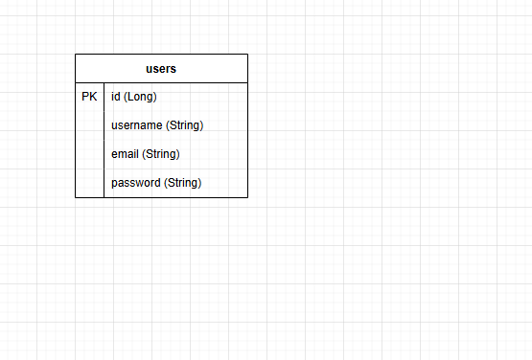

Use Case Diagram

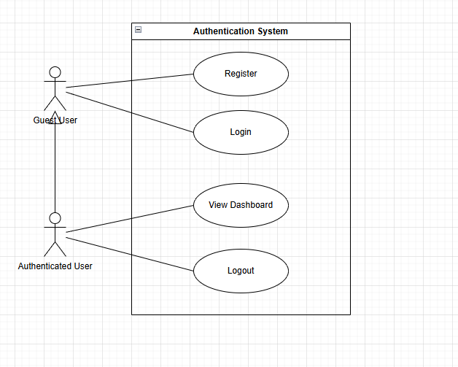

Activity Diagram
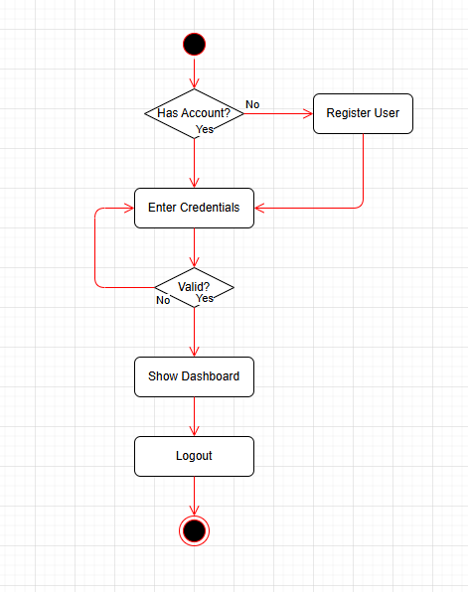

Class Diagram

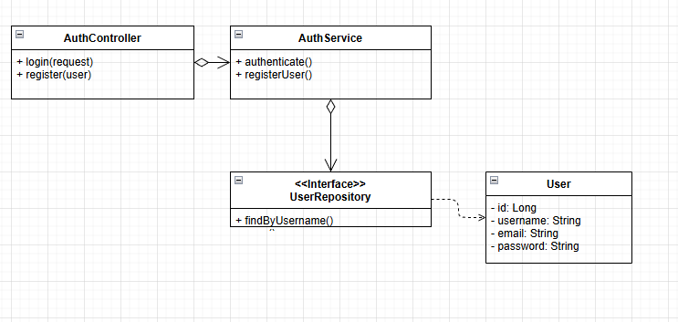

Sequence Diagram

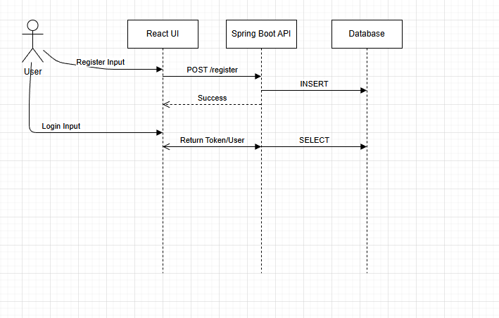

Appendices
Include any additional information, references, or support materials.

