**In-Game Menu System**

**(Aka: Magic Book personal tutor**)

*Note: This will be implemented in real android game, not paper based version.*

At the beginning of the game, your 'Personal Tutor' will be introduced to you (looks based on the 'hocus pocus' films magic book, shown below).

Your personal tutor just so happens to be about 3 centuries old, and has been magically preserved in the form of a helper book that can talk to you to guide you through your journey, and record your achievements and semester grades in it's QSIS section.

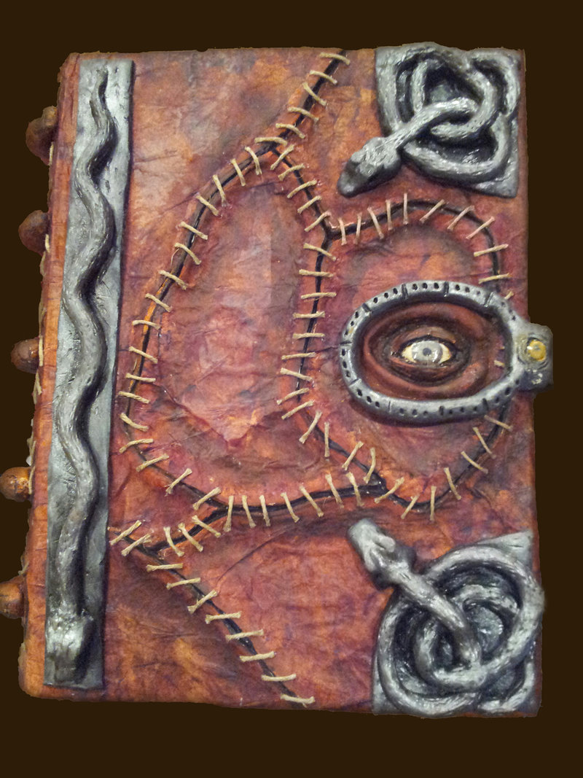

The personal tutor will help you, but after the centuries of being carried around by 'snot nosed little students', he has a bit of a sassy character.

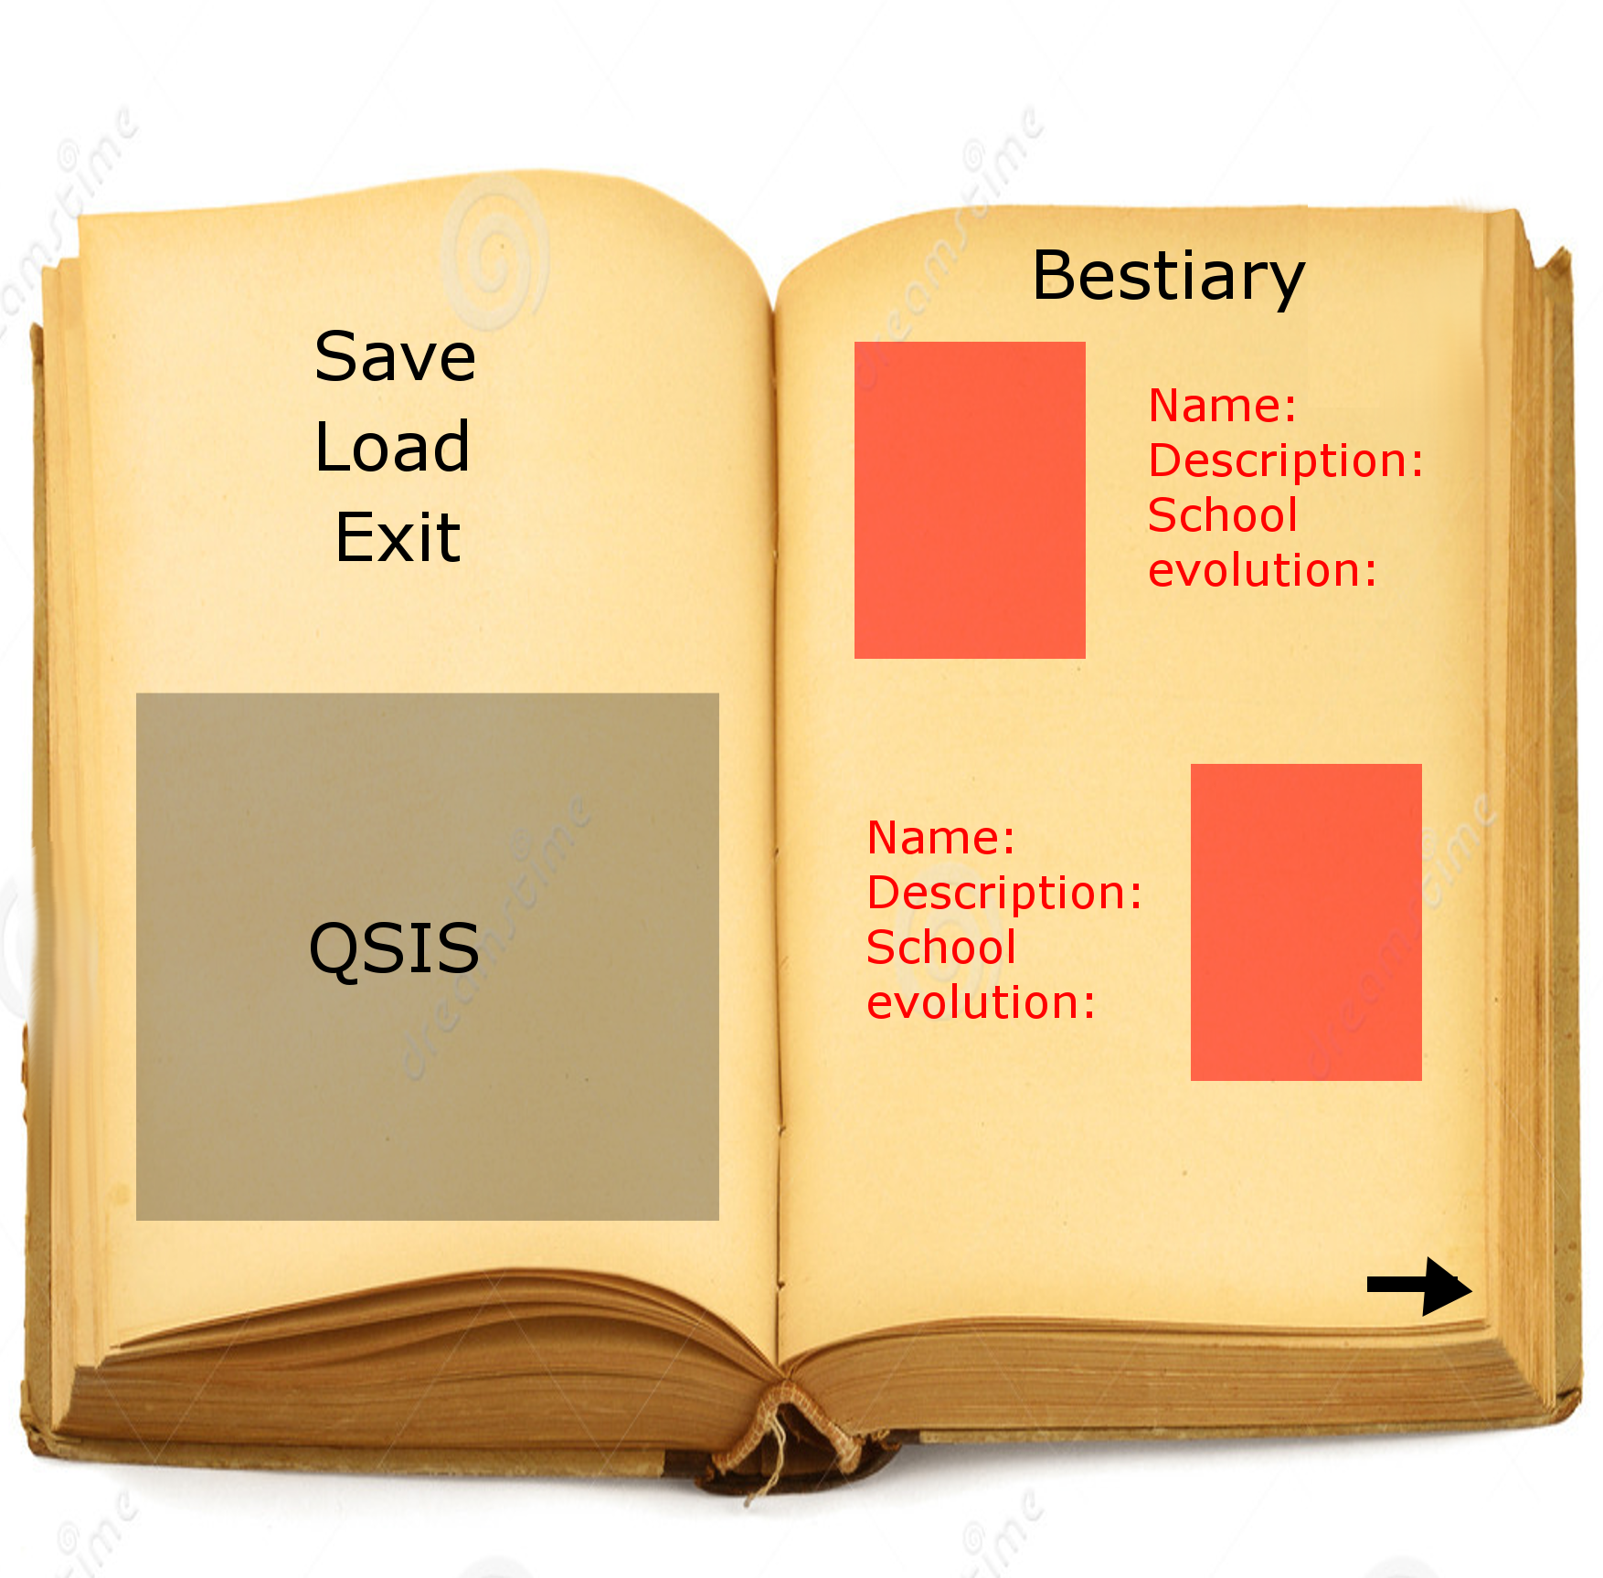

Above shows the general outline of the magic book when it is opened. The book will remain at the top right of the screen and can be clicked to open the book at any time.

The magic book will contain the game save and load options, will pause the game and will offer addition features.

The 'QSIS' area shown above will contain a table of grades that the layer has achieved for each semester as they battle their way through their degree (this is a desirable option. If the game does not have specific grades (e.g. 2:1) calculations, a simply tick will appear to show that level has been passed).

The book will also contain the 'game guide', aka the help pages with the game rule, as well as the desirable feature of a 'bestiary' which will update when you discover a new unimon card. The red square shows where the unimon card will be shown, and their stats will appear alongside them. These will be greyed out if they have not yet discovered that unimon.