Unimon

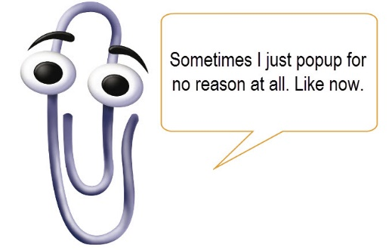Clippy – the paperclip

* Basic attack: gives the enemy useless advice – confuses the enemy
* Special attack:
  + Medical – binds the enemy
  + STEM – annoying pop-ups – attacks the enemy through popup windows appearing
  + Humanities – buries the enemy in stacks of paper

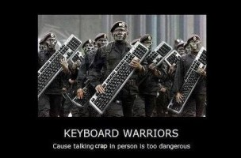

Keyboard warrior

* Basic attack: verbally abuses the opponent
* Special attack
  + Medical – gives unwanted medical advice
  + STEM – points out syntax error
  + Humanities – argues invalid point

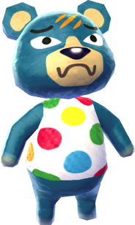Groucho

* Basic attack: bites the enemy
* Special attack
  + Medical – gives the enemy a food allergy
  + STEM – rage quits/throws game controller at enemy
  + Humanities – spits spitballs at enemy

Buzzy

* Basic attack: shocks the enemy
* Special attack
  + Medical – paralyses enemy
  + STEM – causes electrical shortage – electrical moves become weakened
  + Humanities – causes a fire/burns enemy

Sir sleeps-a-lot

* Basic attack: puts the enemy to sleep
* Special attack
  + Medical – causes nightmares/sleep paralysis
  + STEM – causes insomnia/paranoia
  + Humanities – Plays white noise machine – irritates opponent