Michael Guarino

Alan Labouseur

CMPT308

Assignment: Lab 9 ‘Normalization3’

**ER Diagram**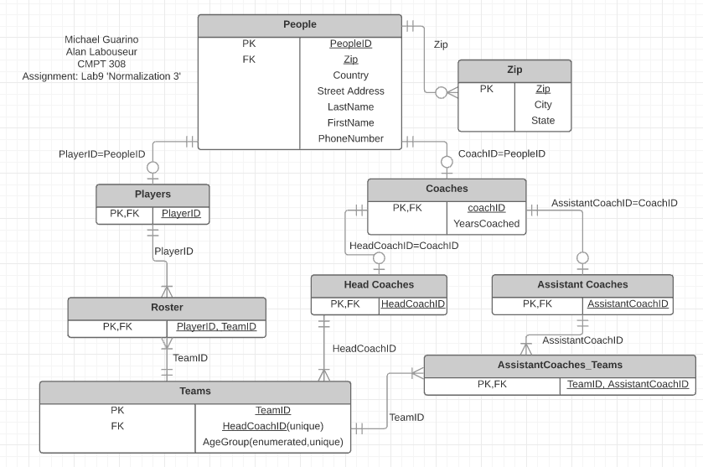

**Functional Dependencies**

(PeopleID) ➡ Zip, Country, Street Address, LastName, FirstName, PhoneNumber

(PlayerID) ➡ TeamID, AgeGroup, HeadCoachID, TeamID

(TeamID) ➡ HeadCoachID, AgeGroup, AssistantCoachID(s)

(Zip) ➡ City, State

(CoachID) ➡ YearsCoached

**Third Normal Form**

This design is in third normal form because:

* It is in first normal form because all intersections of rows and columns contain an atomic element.
* It is in second normal form because there are no partial key dependencies.